New Air Entertainment – Future Plan

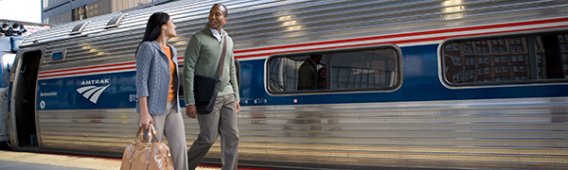

**Introduction**

New Air Entertainment has committed to accomplish two goals within the next five years. We plan to expand internationally starting with China. China has the largest and fastest growing gaming market in the world. Our second goal is to expand to other transportation options such as trains (Amtrak) and buses (Greyhound, Peter Pan). Both transportation options are in need of additional sources of revenue and providing customer entertainment is an area neither has explored before. This document provides brief summary of the opportunities and issues of each goal.

**International Expansion: China**

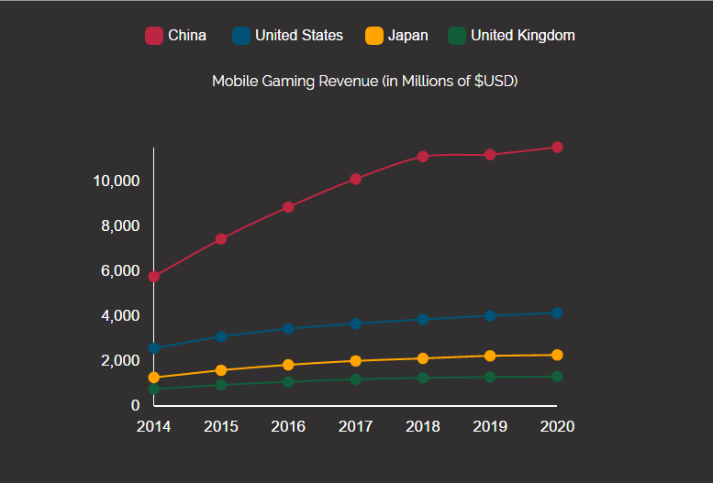China’s gaming market is the largest and fastest growing gaming market in the world. In 2016, China experienced $24.4 billion in total game sales ranking number one of that year. The Asia-Pacific region experienced $46.6 billion in total game sales that year with an 11% growth rate YoY. The Asia-Pacific gaming market accounted for 47% of total global game sales that year. According to bigfishgames.com, China was number one in mobile gaming revenue in the world in 2016 with ~$8.9 billion in total revenue, which is 36% of total game sales of that year. Based on our research and the data above, we believe there is numerous opportunities to explore in the Chinese airline industry. The only issue and concern we have with the goal is culture adaptation. This is the reason why we have yet to explore this obvious opportunity. Our company has no experience and skills in expanding a business globally. We are aware of the problems that can arise when doing so. We hope to hire a third-party company to support us in with this issue.

**Expand Client Base: Trains & Buses**

Transportation industries like trains and buses experience numerous problems when it comes to money and customer satisfaction. Just this past year, Amtrak filed for bankruptcy and had to collect government subsidies in order to continue operations. Unlike airplanes, trains and buses can take a long time for their customer to reach their destination. This means more time sitting in a seat and more time to waste until you get off. This goal has not been researched as in depth as the expansion to China. The opportunities we have mapped out are similar to the opportunities with the airline industry. We decided not to pursue this goal until we are satisfied with the performances of our airline products. Issues that may come with this goal is the additional costs. These organizations are not as profitable as airlines and may have problems losing money for the first and, possibly, second year. Another issue is the Wi-Fi connection on trains and buses. The Wi-Fi connection on airlines has improved since they were implemented. Based on our employee’s experience using trains and buses, the Wi-Fi connection is poor to the point where using the Internet is a hassle. Again, this goal is not as developed as our first goal, but we plan to gather more information and revise our plan within the next two years.