Executive Summary

To CEO or Whom It May Concern,

After considering your single-product inventory system (s,S), consisting of a probability of a demand for J units during week n, we have reached an optimal solution for your objective. With the service level constraint being of .75, and the expected total cost including the fixed order cost, purchasing cost, and the inventory holding cost, being at minimum, the range of optimality of s,S values is of 4,15. This states that 15 is S, holding the inventory position of your company, and 4 is the position of re-ordering; if inventory, X_{n}, is below 4, then the company will reorder up until S-X_{n}, 15 being the highest amount to be held in inventory. Through thorough coding within softwares such as MatLab and Excel, we reached a fraction of demand lost being greater than .75 (Figure 4), as well as the expected total cost reaching around $883.19 (Figure 1).

Problem Definition:
Our company was asked to analyze a single- product inventory system through Markov-Chain modeling to minimize the expected total cost. The total cost includes: fixed order cost, purchasing cost, and inventory holding cost; we can change the total cost by changing the reorder threshold (s) and the maximum inventory limit (S). We also must stay within the constraint of Beta, which is the fraction of the demand lost. Through this analysis we were trying to determine the long run fractions of demand lost, weeks in which an order is placed, and weeks in which a shortage occurs; the long run amounts of demand lost, orders placed per week, and the average total cost; and finally we wanted to determine the optimal values for s and S.
We used our knowledge of Markov chains, Matlab, and Excel to conduct this analysis. Specifically, we used Matlab to create the TPM including all the probabilities, then used these values in Excel to determine the expected total cost for each iteration where we changed the s and S values.

Analysis
Phase I:
We first discovered that the problem was a Discrete Markov Chain and created a TPM. Based on our intuition, we created Formulas for each long run value that involved the limiting distribution, the demand probabilities, and the cost values that were provided. The formula for expected total cost is as follows:
$\sum_{i=0}^{s-1}{Πi}$[800+40(s-i)]+ 5[$\sum_{i=0}^{s-1}{Πi}$ x $\sum_{j=0}^{∞}{P}$(D=j)(s - j) + $\sum_{i=s}^{s-1}{Πi}$ x $\sum_{i=0}^{∞}{P}$(D=j)(i - j)⁺]
Phase II:
We started by drawing a transition diagram showing that {X_{n}, n ≥ 0} is one class (irreducible), aperiodic, and positive recurrent. By definition, this means the class is ergodic.
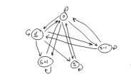
We then used our Matlab code to create the TPM and the TPM raised to the 100th power and determine the limiting distributions (see Figure 2 and Figure 3). We plugged these values into our Excel document to determine the expected cost and β value for s = 4 and S = 15 (stated in conclusions). Refer to figure 1 in the appendix.
Phase 3:
To reach our conclusions, we used excel to find our Beta and expected total cost. We broke the expected total cost equation into three parts, A, B,C, found in our excel data sheet. For beta, we broke it down step by step to multiply things out thoroughly without making mistakes. Excel seemed the most reasonable software to use for such a task of inventory due to the minimal amount of errors to overcome.

Conclusions:
- Long run fraction of weeks in which an order is placed is represented by
$\sum_{i=0}^{s-1}{Πi}$
- Long run fraction of weeks in which a shortage occurs is represented by
$\sum_{i=0}^{s-1}{Πi} P(D>s)$ + $\sum_{i=0}^{s-1}{Πi} P(D>i)$
- Long run average amount of demand lost per week is represented by
$\sum_{i=0}^{s-1}{Πi} x \sum_{j=s+1}^{∞}{\left(j-s\right)P\left(D=j\right)}+\sum_{i=0}^{S}{Πi} x \sum_{j=i+1}^{∞}{\left(j-i\right)P\left(D=j\right)}$
- Long run fraction of demand lost per week is represented by
$\sum_{i=0}^{s-1}{Πi} x \sum_{j=s+1}^{∞}{\left(\frac{j-s}{j}\right)P\left(D=j\right)}+\sum_{i=s}^{S}{Πi} x \sum_{j=i+1}^{∞}{\left(\frac{j-i}{j}\right)P\left(D=j\right)}$
- Long run amount of order placed per week is represented by
$\sum_{i=0}^{s-1}{Πi}$(s-i)
- Long run average total cost is represented by
$\sum_{i=0}^{s-1}{Πi}$[800+40(s-i)]+ 5[$\sum_{i=0}^{s-1}{Πi}$ x $\sum_{j=0}^{∞}{P}$(D=j)(s - j) + $\sum_{i=s}^{s-1}{Πi}$ x $\sum_{i=0}^{∞}{P}$(D=j)(i - j)⁺]
- {X_{n}, n ≥ 0} is ergodic.
- The expected total cost for (4,15) is $883.19 with a lost demand of12.587%.

Appendix:

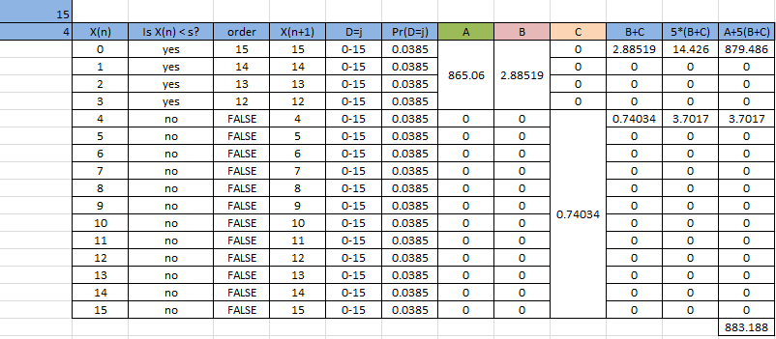
Figure 1

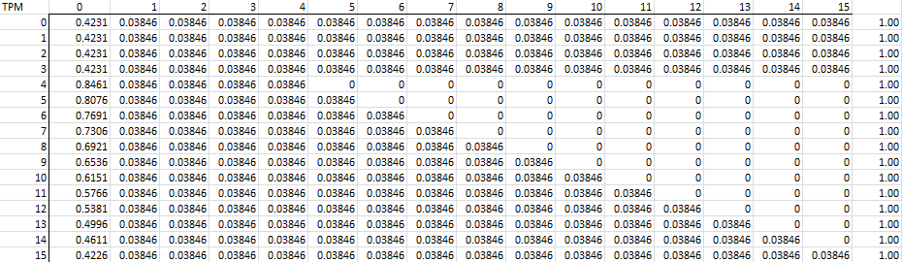
Figure 2

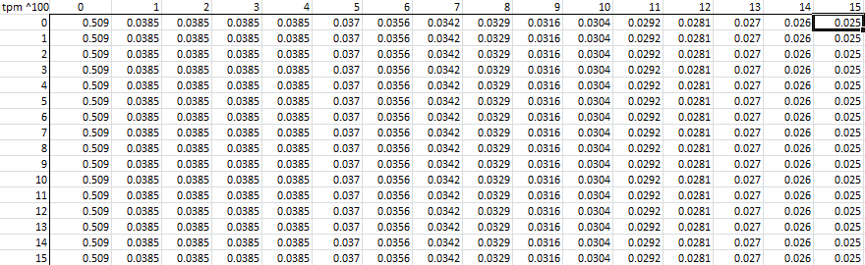
Figure 3

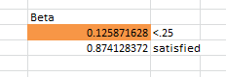
Figure 4

