V2V - Vehicle to Vehicle Technology
Amanda Krauth
905532403
CEE 3604 – Semester Project

Abstract
This paper outlines the research and importance behind vehicle to vehicle technology to prevent future collisions and fatalities on present roadways. The U.S. Department of Transportation, as well as other major automobile manufacturers and companies such as Autotalks and Ford, have begun approaching a new form of usage of technology within vehicles to speak amongst one another to avoid such occurrences.
Background
For the past 50 years within transportation and vehicle safety, the main focus has been how to survive vehicle crashes. For the next 50 years, the focus for major vehicle companies is to figure out ways on how to prevent these fatalities and accidents.
From 1994 until the year 2005, the amount of fatal crashes in the United States increased from 36,254 to 39,252 [4]. These fatalities have a direct correlation to the increase of vehicles on the roadway. After the year 2005, there has been a decrease in the death toll of about ten thousand crashes [4]. According to the U.S. Department of Transportation, a statistical projection of traffic fatalities for the first quarter of 2013 estimates that 7,200 people died in motor vehicle traffic crashes, showing a decrease during this time last year in 2012 [1].
For every vehicle motor accident, there lie multiple reasons behind the cause of it, such as drunk driving, distracted driving, as well as sudden emergency contact via nature. According to MADD, in 2011, 15% of all drivers involved in fatal crashes during the week were drunk in comparison to 31% on the weekends [3]. Every day in America another 27 people die as a result of drunk driver accidents – almost every 90 seconds a person is injured in a drunken driving crash [3].
Studies have shown that approximately 60% of roadway collisions could be prevented if the person in control of the automobile was warned a half second before it happened. In 2012, an estimated 421,000 people were injured in motor vehicle crashes involving a distracted driver, a nine percent increase from the estimated 387,000 people injured in 2011 [5]. Since 2010, approximately 660,000 drivers are using cell phones or manipulating electronic devices while driving [5]. From the VTTI, it was found that sending or receiving a text takes a driver’s eyes from the road for an average of 4.6 seconds, the equivalent at 55 mph of driving the length of the entire football field, blind [5].
A high proportion of fatal crashes have been found in a 45 mph zone, but the majority of collisions occurred in a 55 mph zone [6]. These accidents frequently happened on straight rural roadways rather than in urban areas, and on dry roads under normal conditions [6].
Within modern cars, there are built-in car crash survival systems, such as seatbelts, shoulder harnesses, airbags, crumple zones, as well as a rollover passenger compartment protective case. These were designed to keep passengers in place so other crash survival systems can perform their functions properly. Having crash survival systems exist in our modern day, present automotive companies now pursue research towards car to car communication, which can help prevent the increase of such losses and accidents by about 76 percent.
Research
Most injuries occurred during a crash are prevented from becoming terminal due to each vehicle being provided with a crash survival system, resulting one percent of the 5.5 million car crashes in 2010 in a death [7]. Within the 5.5 million crashes, approximately 28 percent resulted in an injury. To progress towards the prevention and to aid in warning the driver of a vehicle of a future collision, research has been done on the wireless exchange of data between vehicles in nearby distance that enables a motor vehicle to sense threats and hazards within a 360 degree position. Such an idea can be referred to as vehicle to vehicle communication (v2v). It is believed that if these vehicles had had communication technology implemented, it would better keep these vehicles from crashing into other automobiles and other objects as well.
The US Department of Transportation has been collaborating with vehicle manufacturers since 2002 to better assess the importance and effect of crash avoidance systems that operate vehicle to vehicle communications [2]. This research addresses critical crash scenarios, providing engineering prototypes including emergency brake light warning, forward collision warning, intersection movement assist, blind spot and lane change warning, do not pass warning, and control loss warning. To represent the major research requirements needed to accelerate the usage of V2V based safety systems within motor vehicles, eight tracks are identified within this investigation: crash scenario framework, interoperability, benefits assessment, application development, driver issues, vehicle to vehicle communications policy issues, commercial vehicle applications, transit vehicle applications [2]. The USDOT has proposed future research to prevent additional crash scenarios from vehicle to vehicle to bring into account with this technology. These scenarios include head-on collisions, intersection collisions, pedestrian crash warning, as well as the potential to avoid motorcycle impacts. Such scenarios would involve vehicle to x communication, the communication between a vehicle and any of its surroundings.
The U.S. Department of Transportation provides information backing up an idea if each car could tell every other car, “Here I am,” avoidance systems could prevent the cars from hitting each other, shown in Figure 1 [7]. This message being sent and received via vehicle to vehicle could be provided using non-vehicle based technologies.
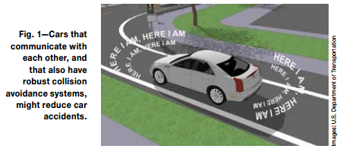
These technologies include such that of a GPS to identify the speed and location of the vehicle, or a vehicle-based sensor data, where the location and speed is derived from the own vehicles computer and further combined with other data for a more elaborate situational caution of position of other automobiles shown in Figure 2.
Figure 2
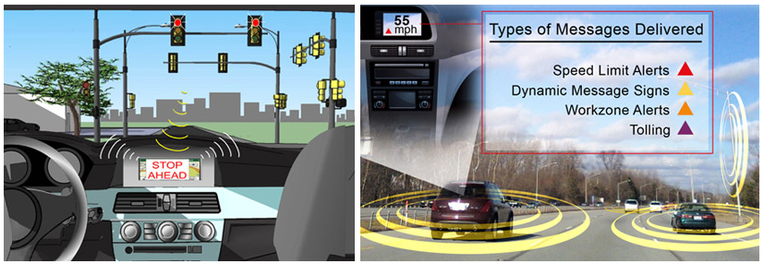
Cameras combined with sensors and video screens are executed into modern day vehicles by certain car manufacturers to aid the driver while backing up and parking without hitting objects, and to warn the driver if one is crossing into the other lane, shoulder of the road, or if something is in a blind spot. Active breaking systems are also provided that will automatically slow the vehicle down or stop it completely if the system is in sight of a crash. The US Department of Transportation for see’s the efforts and effects the next generation crash technology could impact on future roadways; testing to determine if accidents and driving times could be reduced and gasoline being saved if cars could speak amongst each other, as well as with traffic lights and other highway and city infrastructure, as shown in Figure 3 [7].
Figure 2
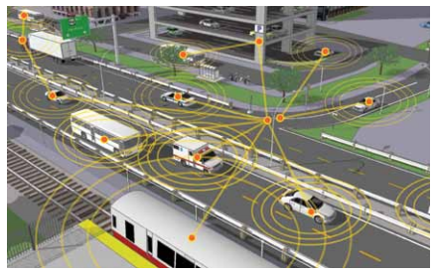
To sustain USDOT’s idea, there exist companies that further equip technology chips to be integrated within automobiles. Such a company is known as Autotalks, a semiconductor company that provides a solution for vehicle to vehicle and vehicle to infrastructure communication. This solution compromises of two devices within a chipset for vehicle to vehicle communication: CRATON, a v2x communication processor, PLUTON, a v2x RF transceiver [8]. CRATON is responsible for solving the challenges of vehicular communication; meanwhile PLUTON satisfies the strictest requirements of this telecommunication [8]. In order to verify the functionality of this equipment within vehicles, Autotalks has created a network test platform, displayed in Figure 4.
Figure 3
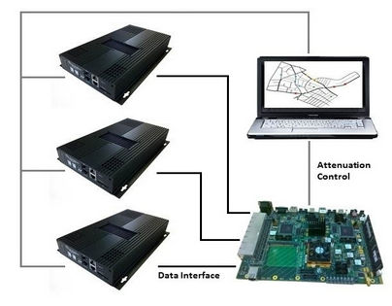
Debugging of these messages, via the two devices, that are being received at random, unpredictable times is very difficult and complicated. With Autotalks creating such a platform, a task may be corrected by connecting integrated safety communication processor devices, supporting multi-channel operation with transmission power control [8]. This withholds extensive off and on-line log capabilities, tracking communication between devices and synchronizing devices internal SW traces log. Within this network platform, there lays a development platform, consisting of Autotalk’s third generation platform: Pangaea 3. It supports On-Board-Unit (OBU) or Road-Side-Unit (RSU) functionality. Pangaea 3 small size allows simple mounting for field tests, as well as being provided with a complete SW development tool-chain tablet application for real-time performance monitoring and range analysis tools [8].
Figure 4
Figure 3
There exists devices being stabilized within vehicles to prevent further collisions, and there exists communications between space robots and Earth to enhance such technology. According to Ford, research is being done to further the company’s commitment to industry leadership in the development of connected vehicle communications to help reduce traffic congestion and aid in the advancement of emergency vehicle communication methods [9]. This research includes a three-year commitment with the telematics department of St. Petersburg Polytechnic University in Russia with that country’s space industry.
Ford’s focus being that of emergency advancement, they are analyzing more so on how the messages should be sent if, in fact, a network failure were to occur. Technical leader in system analytics for Ford, Oleg Gusikhin, states, “The research of fallback options and robust message networks is important. If one network is down, alternatives need to be identified and strengthened to reliably propagate messages between networks.” Not only do vehicle to vehicle communications and vehicle to infrastructure networks exist in such criteria, Ford has created the idea of a vehicle to cloud communications. If V2C were to break, due to how the vehicle was struck, it would then rely on V2V communications to provide the vehicle access to some sort of network. These communications blend multiple networking technologies together: dedicated short-range communication (DSRC), cellular LTE wireless broadband, and mesh networking to ensure optimal signal strength [9].
Future research is being done within companies such as Google, engineering vehicles that drive themselves with humans sitting behind the wheel, having no control. With USDOT and Ford currently researching how to prevent the increase of collisions, reducing fatalities in the United States, and perhaps internationally, there is hope one day that humans will be driving on a safer road. Such an idea in a world of ours seems possible, yet the question of hackers into these wireless data communicators is the next task for these companies to attack.
References
[1] National Highway Traffic Safety Administration. (2013, August). Early Estimate of Motor Vehicle Traffic Fatalities for the First Quarter of 2013. [Online]. Available: http://www-nrd.nhtsa.dot.gov/Pubs/811808.pdf
[2] U.S Department of Transportation Research and Innovative Technology Administration. (2018, July 18). Vehicle-to-Vehicle (V2V) Communications for Safety [Online]. Available: http://www.its.dot.gov/research/v2v.htm
[3] MADD. (2013). Statistics. [Online]. Available: http://www.madd.org/statistics/
[4] NHTSA Data Resource Website. (1994-2011). National Statistics. [Online]. Available: http://www-fars.nhtsa.dot.gov/Main/index.aspx
[5] Official US Government Website for Distracted Driving. (2013). Key Facts and Statistics. [Online]. Available: http://www.distraction.gov/content/get-the-facts/facts-and-statistics.html
[6] Jenny Guarino and Amrut Champaneri. (2010, September). Factors Involved in Fatal Vehicle Crashes. [Online]. Available: http://www.rita.dot.gov/bts/sites/rita.dot.gov.bts/files/publications/bts_technical_report/september_2010/html/entire.html
[7] Alan Pierce. (2011, December). Crash Survival Systems + Car-to-Car Communication = A Next Gen Crash Avoidance System. [Online]. Available: http://www.its.dot.gov/press/pdf/Car_to_Car_Communication.pdf
[8] Autotalks. (2013). Products Overview. [Online]. Available: http://www.auto-talks.com/
[9] Philippe Crowe. (2013, Aug 22). Ford Studies Space Robots for V2V Communications. [Online]. Available: http://www.hybridcars.com/ford-studies-space-robots-for-v2v-communications/

