Alat Mustafa 12/03/2018

SharePoint

When we invest in SharePoint we will see a $1,846,250 net benefit over a period of three years. SharePoint is a document management and storage system that will enable us to work in an organized and efficient way. Investing in SharePoint will increase our productivity and increase billable hours by 400 hours per year.

The key capabilities of SharePoint are that it provides shared access, interaction, and collaboration. SharePoint is a system that helps manage content and brings the internal organization together. It's a secure place to store, organize, share, and access information from any device. SharePoint will provide our PMPs the ability to manage their documentation and easily share their documents with each other and with clients. Utilizing SharePoint will increase our PMPs billable hours to 1,900 hours, resulting in them billing out 95% of their time.

The cost of SharePoint over three years is $253,750 comprising of purchasing the hardware and software, maintenance and billable hours administering/supporting the system. Over three years SharePoint will have a cost avoidance benefit of $2,100,000 due to the increase in productivity. The net benefit for SharePoint is $1,846,250 over three years.

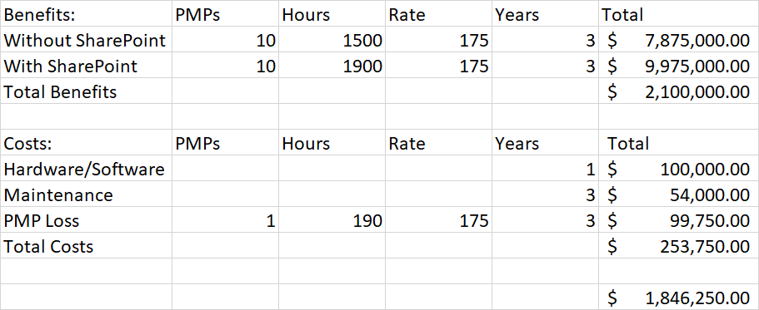

Works Cited
“Microsoft SharePoint: What It Is and Why It Matters.” R & G Technologies, rgtechnologies.com.au/resources/microsoft-sharepoint/.
“SharePoint Server 2019.” Microsoft Teams – Group Chat Software, products.office.com/en-us/sharepoint/sharepoint-server.
“What Exactly Is SharePoint?” SharePoint Stack Exchange, sharepoint.stackexchange.com/questions/35958/what-exactly-is-sharepoint.

