Anne McMaster

Professor Doyle

Flash Research Paper 1: Datacenters and Networking

January 28, 2015

Datacenters and Networking

By upgrading to a Tier III data center, we will save over 13 million dollars in the next three years. Unlike Tier I, a Tier III data center has redundant capabilities so that we can easily perform system maintenance and better allow the system to keep running through possible system outages and unplanned events. If our company upgrades from a Tier I data center to a Tier III data center, we will gain priceless system protection while saving millions of dollars in the next three years.

By switching from Tier I to Tier III, our data center availability will increase from 99.67% to 99.98%. This is due to Tier III’s redundant capabilities. Redundant capabilities are essentially system backups that allow the data center to continue running during both planned, such as system maintenance, and unplanned outages. This will result in less destruction and interruption to equipment and processes during outages. If an outage occurs, Tier III uses these backups to pick up that slack for up to 72 hours. Furthermore, all Tier III data centers are dual powered so if one input fails, the backup system picks up the work. This contrasts Tier I, which only has one reliable power source.

The Tier III data center will cost $35 million to implement over the first year, but over the following two years, the switch from Tier I to Tier III will give us a benefit of $48.2 million, resulting in net benefit of $13.2 million. These benefits come from the cutback of downtime 3-year Tier III will provide, saving 24.1 million for each year after implementation. If we do not upgrade to Tier III, we will ultimately lose over 75 million in the next 3 years in downtime as opposed to profiting 13.2 million.

|  |  |  |  |  |
| --- | --- | --- | --- | --- |
|  | Min/Year | Availability | Downtime | Total Downtime/year |
| Tier I | 525,600 | 99.67% | 1,734.48 | $25,670,304 |
| Tier III | 525,600 | 99.98% | 105.12 | $1,555,776 |
|  |  |  | **Benefit** | **$24,114,528** |

|  |  |  |  |  |
| --- | --- | --- | --- | --- |
|  | Year One | Year Two | Year Three | Totals |
| Cost | 35,000,000 | 0 | 0 | 35,000,000 |
| Benefits | 0 | 24,114,528 | 24,114,528 | 48,229,056 |
|  |  |  | **Net Benefit** | **13,229,056** |

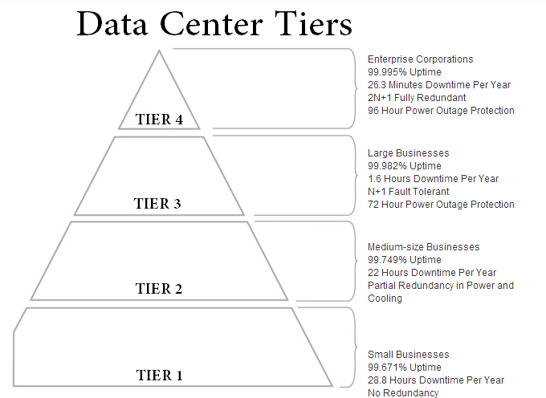

References

"Data Centre Tiering: Tier 1, 2, 3 & 4 Data Centres: Tiering Info." *Data Centre Tiering: Tier 1, 2, 3 & 4 Data Centres: Tiering Info*. Coreix. Web. 25 Jan. 2015.

"Tier Standards Overview: Data Centers: Colocation America." *Colocation America*. Web. 25 Jan. 2015.

Uptime Institute, LLC. "Data Center Site Infrastructure Tier Standard: Topology." (2009-2012). Web. 25 Jan. 2015.