The J.M. Smucker Company Financial Analysis Report

Ami Parekh & Ngoc Tran Tran (Tracey)
ACCT 2901-003
Table of Contents

- The J.M. Smucker Company Overview 2
  - Overview 2
  - SWOT Analysis 2
- The Food Manufacturing Industry Overview 3
  - Market Share 3
  - Market Trend 3
- J.M. Smucker’s Financial Analysis Ratios, Competitors, and Trend Analysis 4
  - Liquidity Analysis 4
    - Current Ratio 4
    - Quick Ratio 5
    - Working Capital 6
    - Cash Flow from Operations to Current Liabilities Ratio 6
    - Inventory Analysis 7
    - Liquidity Analysis Conclusion 8
  - Profitability Analysis 8
    - Gross Profit Ratio 8
    - Return on Sales 9
    - Return on Assets 9
    - Price Earnings Ratio 10
    - Profit Margin 10
    - Asset Turnover 11
    - Return on Common Stockholders’ Equity 12
    - Earnings per Share 12
    - Dividend Payout Ratio 13
    - Dividend Yield Ratio 14
    - Profitability Analysis Conclusion 14
  - Solvency Analysis 14
    - Debt to Equity 15
    - Time Interest Earned Ratio 15
    - Solvency Analysis Conclusion 16
- Key Risks 17
- Conclusion 18

- J.M. Smucker Overview
  - Overview
The J.M. Smucker Company (the Company), incorporated in 1921, is currently one of the leading American food marketers and manufacturers of consumer and natural foods, coffee, as well as pet food and snacks. Founded in 1897 by Jerome Monroe Smucker in Ohio, the Company has always strived their best in “helping to bring families together to share memorable meals and moments”. The Company owns many brands, including Smucker’s, Dunkin’ Donuts, Crisco and several Canadian brands. J.M. Smucker involves in U.S. Retail Coffee, U.S. Retail Consumer Foods, U.S. Retail Pet Foods, and International and Foodservice segments. Every year, they produce a wide variety of products such as coffee, pet food & snacks, peanut butter, jellies, jams, shortening, oils, baking mixes, flour, baking ingredients, ready-to-spread frostings and beverages, which are sold in stores and restaurants throughout the world. Some of their competitors are ConAgra Foods, Inc., The Kraft Heinz Company, Starbucks Corporation, JAB Holding Company, Welch Foods, Inc., General Mills, Inc., Pinnacle Foods Inc., and Nestle Purina PetCare Company. Throughout their history, J.M. Smucker presents a strong commitment to corporate responsibility, with a focus on limiting waste and purchasing palm oil from certified sources.
1.2 SWOT Analysis
Strength | Weakness
- Strong and long-standing brand name, in America and Canada  - Wide range of high quality products  - Reasonable prices available  - Ability to smoothly acquire other business  - Strong environmentally-friendly culture | - Limited global exposure  - Small scale compared to other competitors in the market  - Limited product innovation  - Dependence on brand messaging and marketing to differentiate
Opportunity | Threat
- Growing organic and healthy food market  - Product diversification through acquisition  - Growing sectors of business in Snacks, Pet Food and Coffee  - Capabilities of expanding internationally | - Big competitors secured their market share through acquisition (Kraft Heinz)  - Increasing private-label food manufacturers  - Fluctuations in raw materials' price & quality

- Industry Overview
2.1 Market Share
The current food products industry is fragmented. The top 10 largest companies in the industry comprise of 78.4% market share, 21% and 14.5% of which is from Kraft Heinz Co. and Mondelez International, Inc., respectively. In this market capitalization weightings, the J.M. Smucker account for a 3.4% share (S&P Global Market Intelligence).
Food Products Market Capitalization Weightings by Company, as of April 13, 2016
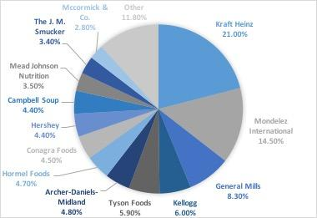
Data Source: S&P Global Market Intelligence
2.2 Market Trend
In recent years, the food industry has become very competitive and experienced a -0.2% compound annual growth rate over three years ending in 2015. Many companies depend on acquisitions and take advantage of economies of scale to reduce cost, increase sales growth and diversify product portfolios. The recent merger of H.J. Heinz and Kraft Foods into Kraft Heinz Co., currently the biggest food company with 21% market share, is a solid example of the current situation. Some companies, on the other hand, try to focus only on their most profitable products and cut down transportation costs.
Moreover, as consumers are becoming more aware of food providing health benefits, many companies shift their strategies to develop gluten-free, non-GMO, organic food. For example, while General Mills is planning to eliminate GMOs in its Cheerios, Campbell Soup chooses to provide an organic and healthier V8 juice alternative. It is now normal for big companies to open or acquire smaller organic brands, such as Cascadian Farm by General Mills or Kashi by Kellogg.
In addition, snacks are replacing meal as many more people prefer meal on-the-go. Tyson Food’s division in snacks has taken full advantage of this trend by offering a variety of bite-size products such as packs of grilled chicken bites (Hoovers). Starbucks is also one of the companies actively promoting snacking meal with eco-friendly and attractive packaging.
Finally, the growth in middle income class around the world gives many food company great incentives to expand overseas to take advantage of customers’ preference for American imported brands.
- J.M. Smucker’s Financial Analysis Ratios, Competitors, and Trend Analysis
Per J.M. Smucker, as their fiscal year runs from May 1 to April 30, the data as of April 30 2016 will be considered as 2015/2016 fiscal year. Their competitor, ConAgra, whose fiscal year begins June 1 and ending May 31 the following year, also applies this counting system. The industry ratio average used in the analysis below is taken from the most recent report for middle-size companies in the Food Manufacturing industry on Hoover.
  - Liquidity Analysis
Liquidity ratios is a strong indicator of a company's capability to pay its current financial obligations and its margin of safety (Investopedia). Therefore, liquidity analysis holds an important role in determining if a company will be able to continue as a going concern.
    - Current Ratio
The Company's current ratios as of April 30, 2016, 2015 and 2014 are 1.30, 1.94 and 1.74 respectively. From April 2015 to April 2016, the current ratio has decreased 0.64 (33.14%) while from April 2014 to April 2015, it has increased 0.20 (11.66%). The decrease in current ratio between 2014/2015 and 2015/2016 fiscal year is due to a decrease in Finished Product (815 Millions to 560 Million) and an increase in Short-term Borrowing (226 Millions to 284 Million). On the other hand, the increase in ratio from April 2014 to April 2015 mostly results from an increase in Trade Receivables (309.4 Millions to 430.1 Million), in Finished Product (571.5 Millions to 815 Million) and finally in Other Current Assets (145.2 Millions to 333 Million).
Comparing to the current ratio of medium businesses in the Food Manufacturing industry as of 2016 (1.96), J.M. Smucker is not doing as good (1.30). Meanwhile, one of its biggest competitors, ConAgra has the current ratios of 1.41 for the fiscal year 2015/2016, 1.11 for 2014/2015 and 1.6 for 2013/2014 (S&P Global Market Intelligence). Based on the current ratio only, J.M. Smucker is more capable of paying its financial obligations in 2013/2014 and 2014/2015, but ConAgra has had a larger proportion of assets than liabilities in 2015/2016 fiscal year.
Using the data of the two companies in the 5 most recent years, we have created the line graph as follow:
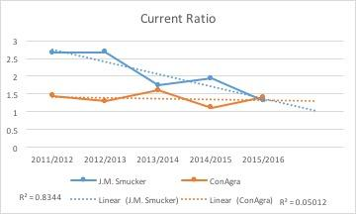
The graph shows that in the next fiscal year, J.M. Smucker’s current ratio will continue to drop while its competitor will be holding still. The J.M. Smucker should pay more attention to managing current its assets efficiently and limiting its current liabilities to maintain the financial well-being.
    - Quick Ratio
J.M. Smucker’s quick ratios are 0.46 in April 2016, 0.54 in April 2015 and 0.52 in April 2014. The quick ratio has the same trend as the current ratio: increasing from 2014 to 2015 (by 3.98%) and decreasing from 2015 to 2016 (by 15.05%). As explained above, it is a result of an increase in Short-term Borrowing (2015-2016) and an increase in Trade Receivables (2014-2015).
The average quick ratio of medium companies in the Food Manufacturing industry is 1.08, 133.97% higher than J.M. Smucker's most recent ratio. ConAgra's quick ratios for the most three recent years are 0.66 (May 2016), 0.35 (May 2015) and 0.60 (May 2014). When taking inventory out of the equation, J.M. Smucker seems to be more liquid than its competitor only in 2014/2015 and slightly less liquid in the two other fiscal years. Together with the current ratio, this means that the Company’s ability to repay short-term debt is not as good as other companies.
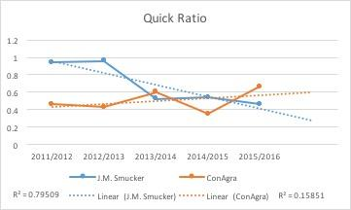
As predicted by the trend line, while ConAgra’s quick ratio will become slightly lower in the next fiscal year, J.M. Smucker’s ratio will continue to decrease, unless change is introduced to its asset management policy.
    - Working Capital
The Company’s Working Capital increased from 653.3 million (2013/2014) to 961.3 million (2014/2015) but then decreased to 360.4 million (2015/2016). It encountered the same trend as current ratio and quick ratio, decreasing from April 2015 to April 2016 (by 62.51%) and increasing from April 2014 to April 2015 (by 47.15%). The line graph below depicts J.M Smucker from the fiscal year 2011/2012 to 2015/2016 and predicts its working capital for the next fiscal year, 2016/2017:
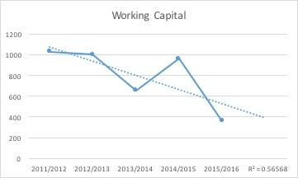
As the trend line shows, 2016/2017 fiscal year might see a slight increase in the working capital of the Company.
    - Cash Flow from Operations to Current Liabilities Ratio
J.M. Smucker's cash flow from operations to current liabilities ratios as of April 2016, 2015 and 2014 are 1.30, 0.77, and 1.15 respectively. The ratio decreased by 33.45% from April 2014 to April 2015 but then increased 69.78% by the end of April 2016. The significant increase from 2015 to 2016 is caused by the 98.90% increase in net cash provided by Operating Activities. Meanwhile, the decrease from 2014 to 2015 is a result of the 16.75% decrease in net cash provided by Operating Activities and the increase of 28.72% in Average Current Liabilities.
From summary of the ratios since 2011/2012 fiscal year, J.M Smucker’s flow of cash to cover the debts due has recently improved, despite the decreasing trend:

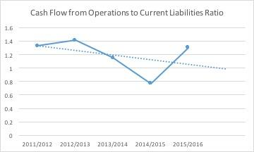
    - Inventory Analysis
J.M. Smucker has inventory turnover ratio of 4.70 times, 3.56 times and 3.82 times in 2016, 2015 and 2014 respectively. Based on the ratio, the Company has become more efficient in managing its inventory in 2016 than in 2015 and 2014. This is better reflected by the number of days' sales in inventory of 76.60 in 2016, 101.12 in 2015 and 94.24 in 2014.
Since J.M. Smucker is a food manufacturer and usually distributes its product to supermarkets as well as restaurants, it is normal for the company to turn over its inventory around 4-5 times per year. However, J.M. Smucker’s ratio is lower than that of the average of middle-size companies in the same category (8.45 times). However, when comparing to ConAgra's inventory turnover ratio of 4.52 in May 2016, 5.57 in May 2015 and 5.97 in May 2014, we can see an improvement in J.M Smucker’s efficiency in the 2015/2016 fiscal year.
The summary of the two companies' inventory turnover rate in 5 recent fiscal years is as follow:
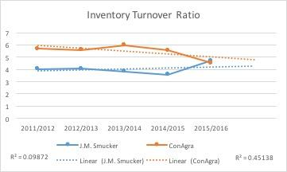
Consequently, their number of days' sales in inventory is reflected:
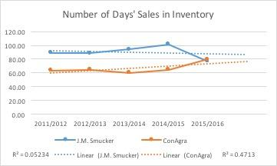
    - Liquidity Analysis Conclusion
Despite experiencing a decreasing trend in liquidity in the recent three years, J.M. Smucker has shown some improvement in their financial status, especially the inventory turnover rate with a 32.02% increase, and cash flow from operation to current liabilities ratio with a 68.82% increase since the last fiscal year. Based on their financial statements from the 5 most recent years, although they may stand a higher financial risk, we believe J.M. Smucker will be able to continue to operate as an ongoing concern.
  - Profitability Analysis
The profitability of a company is a result of the company’s management team making the appropriate decisions based on the resources the company has. Profitability is important because if the management teams over or underestimate the capacity of the company, stockholders and investors may not earn a return on their investment.
    - Gross Profit Ratio
Smucker’s gross profit ratio for 2016, 2015, and 2014 are 0.3799, 0.3458, and 0.3620 respectively. This ratio reveals the proportion of money left over from revenues after accounting for the cost of goods sold (COGS). From 2015 to 2016, the ratio increased by 0.0341 (or 9.86% increase from the previous year). From 2014 to 2015, the ratio decreased by 0.0162 (Or by 4.48% from the previous year). The industry median is 0.2733. Generally, there is no preferred number that the gross profit ratio should be, but a higher number does show a stronger company. A continuous improvement year after year is a sign of a strong company. JM Smucker is a strong company respective to the industry, even with the brief decrease in 2015. The chart below depicts how Smucker’s compared to one of its competitors, Conagra.
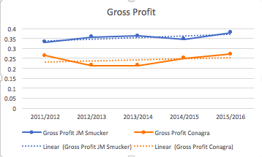
    - Return on Sales
The return on sales for the company is 11.01% for 2016, 7.46% for 2015, and 11.49% for 2014. This ratio measures earnings before making payments to creditors. From 2014 to 2015, the ratio decreased by 4.03 (or by 35%). From 2015 to 2016, it increased by 3.55 (or by 47.59%) from the previous year. This means that for 2014 and 2016, for every dollar of sales, the company was able to earn $.11 and in 2015 for every dollar they sold they earned approximately $.07.
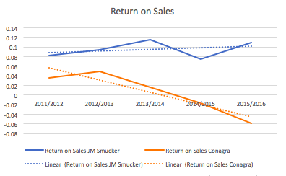
As shown in the graph above, compared to Smucker’s competitor Conagra, they are doing quite well. Smucker’s has a mostly positive trend whereas Conagra has been negative for the past four years.
    - Return on Assets
The return on assets tells us how profitable a company is in regards to its total assets. Return on assets for Smucker is 5.24% for 2016, 3.28% for 2015, and 7.13% for 2014. From 2014 to 2015, return on assets decreased by 3.85 (or by 54 percent). From 2015 to 2016, it increased by 1.96 (or by 60%). The industry median is 0.43%. In reference to the industry, Smucker’s is doing very well. The higher the ratio is, the better the company is in generating income with their assets. The graph below shows that compared to their rival Conagra, Smucker’s return is greater.
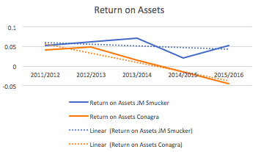
    - Price Earnings Ratio
The P/E ratio is 22.01, 34.81, and 17.84 for JM Smucker for the years 2016, 2015, and 2014 respectively. The ratio for the industry is 19.16. The P/E ratio shows the relationship between market price and how much a company is earning per share. A relatively high number may mean that the stock is overpriced by the market. A relatively low number causes an opposite effect. Compared to the industry, JM Smucker has a high P/E.
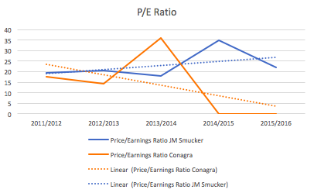
As shown in the graph above, Conagra has had a P/E of 0 for the past 2 years, which is a bad sign. In the 2013/2014 year, Conagra’s P/E peaked and then suddenly fell. If this pattern continues and shows a parallel with Smucker’s, shareholders may see the P/E decrease in the next few years.
    - Profit Margin
Net profit margins show how much of each dollar collected by a company as revenue translates into profit. The company’s profit margin ratio is 8.82% for 2016, 6.06% for 2015, and 10.07% for 2014. From 2014 to 2015, there was a 4.01% decrease in the ratio number (or a 39.82% decrease from the previous year). From 2015 to 2016, there was an increase of 2.76% (or a 45.55% increase from the previous year). The industry median is 3.67%. Compared to the industry, Smucker’s is doing quite well. The table below shows how Smucker’s compares to its competitors. Though the graph represents data from 2015, Smucker’s margin that is represented is for the 2015/2016 fiscal year.
Annual Sales and Profit Margin of Smucker and Competitors (2015)
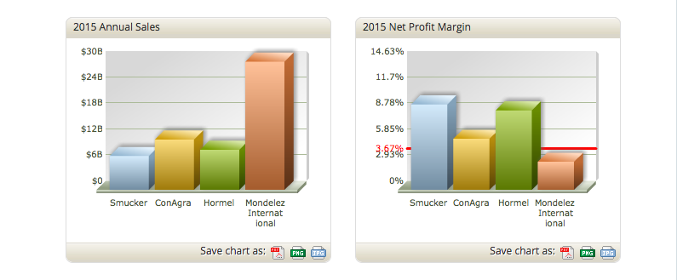
Data Source: Hoovers.com
    - Asset Turnover
Smucker’s asset turnover is 0.48, 0.44, and 0.62 for 2016, 2015, and 2014 respectively. Asset turnover represents how much a company generates from each dollar in the company’s assets. For example, 2016’s ratio being 0.48 means that for each dollar in assets, $.48 are made in sales. From 2014 to 2015, asset turnover decreased by 0.18 (29.03%). From 2015 to 2016, it increased by .04 (9.09%). The industry median asset turnover is 0.98, which is more than double of JM Smucker. Ways that Smucker can increase their asset turnover include increasing their sales without buying more assets, and not purchasing an excessive amount of inventory. Though the asset turnover is not terribly low for Smucker, it is quite below the industry median. This means that they may not be using their assets in the most efficient way possible. Asset turnover is one of the few measures where Smucker’s performs below average compared to its competitors.
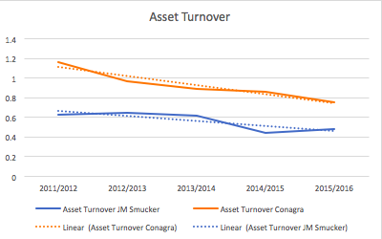
    - Return on Common Stockholders’ Equity
The return on stockholder’s equity for JM Smucker is 9.77% for 2016, 5.69% for 2015, and 11.11% for 2014. This ratio measures the company’s success in earning a return for its common stockholders. From 2014 to 2015, the return decreased 5.42 (or 48.78%). From 2015 to 2016, the return increased by 4.08 (or by 71.7% from the previous year). The industry median is 0.77%. Investments typically offer less than 10% return, so in relation to the industry and return of stockholder’s equity in general, JM Smucker is doing very well.
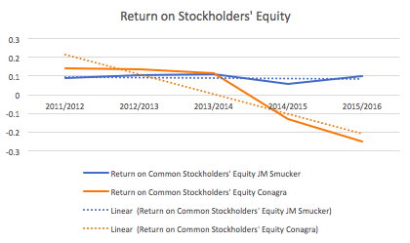
As seen in the graph above, Smucker’s return on stockholder’s equity has been steady compared to its competitor Conagra. This is a good sign for stockholders because their shares with Smucker have a greater chance of return.
    - Earnings per Share
Earnings per share is a statistic that is very important for publically traded companies because this statistic represents the profits per share of the company. Earnings per share for the JM Smucker company are 5.77 for 2016, 3.33 for 2015, and 5.42 for 2014. The industry median is 3.24. There was an decrease in earning of 2.09 (38.56%) from 2014 to 2015 and an increase from 2015 to 2016 of 2.44 (73.27%).
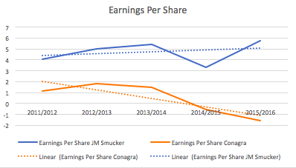
As seen in the graph above, earnings per share have been increasing for Smucker over the last 5 years. Though there was a slight drop in 2015, they picked up again the following year. They are doing much better than their competitor Conagra, who has had a steady decline and performs below the industry average.
    - Dividend Payout Ratio
The dividend payout for Smucker is 46.45%, 76.88%, and 42.80% for 2016, 2015, and 2014 respectively. Dividend payout is the percentage of earnings paid out as dividends. It is good for this number to be high, but the higher it gets the more suspicion that stockholders may not be getting a payout the next fiscal year. Per csimarket.com, the average for the industry is around 12%. The ratio increased significantly (by 79.62%) from 2014 to 2015 and decreased from 2015 to 2016 by 39.58%.
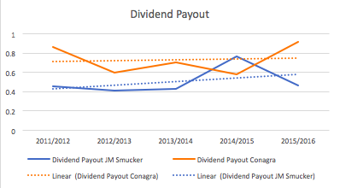
The sudden spike in dividend payout for Smucker’s in the 2014/2015 fiscal year could have been a red flag (ex. How Conagra has spiked this year) for stockholders. As payout increased in an instant manner, it could have meant that the company was in trouble. However, the 2016 year shows that the company is stabilizing.
    - Dividend Yield Ratio
Dividend yield is the relationship between dividends and the market price of stock. Per NYU’s Stern School of Business dataset, the Dividend yield ratio for the industry falls at 1.52% for 2016. The dividend yield rate for JM Smucker is 2.11% for 2016, 2.21% for 2015, and 2.40% for 2014. Compared to industry medians, both JM Smucker and its competitor Conagra are doing well. However, just as most of the relationships and statistics from previous ratios showed, Smucker’s is shows a steady rate while Conagra is in a declining state.
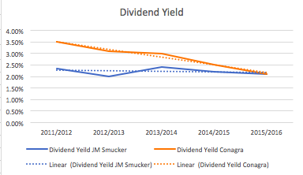
3.2.11. Profitability Analysis Conclusion
As we have seen from the profitability ratios discussed above, JM Smucker does fairly in the profitability segment of its business. Compared to one of its major competitors, Conagra, and to the industry, Smucker’s performs very well consistently. If the company continues to have a positive trend with these ratios in coming years, their profitability will be mirrored in stockholders’ return. Specifically, JM Smucker did very well in recent years with gross profit, profit margin, and earnings per share. Though they are performing steadily for dividend yield and stockholder’s return, these measures have not increased dramatically over the past 5 years.
  - Solvency Analysis
Solvency and liquidity both concern about a company's ability to stay financially healthy. However, while liquidity analysis focuses mainly on the company's capability to raise cash as well as to pay its short-term liabilities, solvency analysis predicts the company chances of having financial problems in the near future by paying attention to its long-term financial obligations and commitments.

    - Debt to Equity
J.M. Smucker’s debt to equity ratios in the 3 most recent financial years are 1.28 (2016), 1.37 (2015) and 0.80 (2014). The three ratios indicate that for every $1 stockholders provided, creditors provided $1.28, $1.37 and $0.80 in 2016, 2015 and 2014 respectively. Based on the ratios, the Company has become more solvent since April 2015 but has not recovered to its state in April 2014. J.M. Smucker still depends greatly on outside funds to finance its business. Taking on debt causes the financial standing of the Company to become risky.
ConAgra, with the debt to equity ratios are 1.32, 1.52, and 1.67 as of May 2016, 2015 and 2014 respectively, is riskier than J.M. Smucker on this aspect. They are both borrowing fund from creditors more than the average medium firms in the industry, whose debt to equity ratio is 1.17.
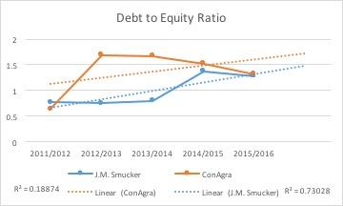
    - Time Interest Earned Ratio
As of April 2016, 2015, and 2014, J.M. Smucker earned the time interest earned ratios of 6.7154, 7.5457 and 11.7015, respectively. Since the time interest earned ratio represent the number of times the company can cover its interest charges on a pretax earnings basis (Investopedia), the higher the ratio, the better the company's financial status. J.M. Smucker has experienced a decreasing trend in time interest earned ratio since 2014. Despite the decreasing trend, the Company is relatively better than the industry average with the ratio of 3.94. J.M. Smucker’s ratios are also higher than those of ConAgra with 2.95 in May 2016, -0.49 in May 2015 and 2.51 in May 2014.
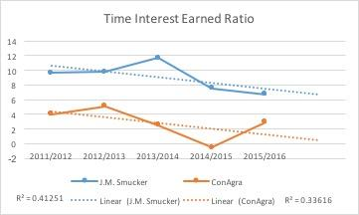
Based on their recent trend, in the 2016/2017 fiscal year, both companies will have time interest earned ratio continue to decrease.
    - Solvency Analysis Conclusion
Even though J.M. Smucker is becoming less solvent, the Company is doing slightly better than its competitor, ConAgra Foods in the most recent debt to equity ratio and relatively better than the industry average in the time interest earned ratio. J.M. Smucker’s solvency ratios are varying within acceptable margin, but we should pay more attention to how the Company plans to improve its situation soon.
- Key Risks
A major key risk that impacted JM Smucker Co is climate change and its effects on coffee production. Smucker's owns the Folgers brand, which is one of largest instant coffee brands in the United States, per statista.com. Fluctuations in temperature and unpredictable precipitation fall is something that is out of Smucker’s control but is a pure, environmental risk the company faces. Smucker's Folgers brand earns them approximately 40% of their total revenues per trilliuminvest.com, therefore issues in coffee growth would greatly affect the revenue earned by Smucker’s. Furthermore, if the revenues are hurt, key financial measures including all of the profitability ratios would have a negative impact. This is because the profitability ratios look at factors such as gross profit, net sales, and net income and how these factors will affect income generated by the corporation for a given period.
As mentioned above in the SWOT Analysis, another threat faced by Smucker’s includes other competitors gaining an increased market share through acquisitions. Kraft Heinz dominates the food industry, leaving Smucker’s in a challenging position regarding their growth. Kraft Heinz and Smucker’s overlap in the types of products they are involved with, including coffee products (Folgers-SJM and Maxwell House-KHC), drinks (Santa Cruz-SJM and Capri Sun-KHC), milk based products (Carnation-SJM and Complan-KHC), ready-made lunch products (Smucker's Uncrustables-SJM and Lunchables-KHC), and nut based snacks (Sahale Snacks-SJM and Planters-KHC). This overlap is also a risk for Smucker because without the right advertising, Kraft Heinz may take over an even larger segment of the market share.
- Conclusion
Per the J.M. Smucker Company website, the Company’s vision is to “own and market food brands that hold the #1 market position in their respective categories, with an emphasis on North America, while maintaining a global perspective.” From the analysis we have done above, we see that the company is still on their way to accomplish their vision.
A factor we noticed in our analysis was that the 2014/2015 fiscal year was a tough one for the company. Most of the ratios had a negative impact. From our research, we noticed several factors that could have initiated this dramatic decline. Firstly, Smucker’s Big Heart Pet Food acquisition took place in early 2015. A lot of the company’s resources were used in acquiring the pet food company. Debt was also increased greatly with this merger. Secondly, as mentioned in the key risks segment of the analysis, coffee prices rising. Smucker’s was put in a dilemma due to this because they either had to swallow the extra cost, which would allocate a portion of their earnings, or burden it on their customers. At the time, because they chose to burden it on their customers, they lost a lot of their sales. This negatively impacted the profitability of the company because coffee is a large segment of their sales.
From the analysis, we saw that in liquidity, profitability and solvency Smucker’s is performing adequately or above average in most of the categories compared to its selected competitor (Conagra) and the industry ratios. Though they do not own as large of a piece of the market share, they are delivering tremendously for their size.
All in all, JM Smucker proves their slogan, “With a name like Smucker’s it has to be good”.

References
"BrandsPeopleLove." The Kraft Heinz Company. N.p., n.d. Web. 05 Dec. 2016.
"Dividend Fundamentals by Sector (US)." Dividend Fundamentals. N.p., n.d. Web. 05 Dec. 2016.
"Food Processing Industry Dividend." Food Processing Industry Dividend Information and Trends, Dividend Payout Ratio, Dividend Growth, EPS Growth - CSIMarket. N.p., n.d. Web. 05 Dec. 2016.
"JM Smucker CO SJM Company Profile | Reuters.com." Reuters. Thomson Reuters, n.d. Web. 05 Dec. 2016.
"Leading Instant Coffee Brands Sales of the U.S., 2010 | Statistic." Statista. N.p., n.d. Web. 05 Dec. 2016.
McKenna, Beth. "3 Reasons Smucker's Stock Could Fall." The Motley Fool. N.p., 23 Jan. 2016. Web. 05 Dec. 2016.
"Smucker Brands - The J.M. Smucker Company." Smucker Brands - The J.M. Smucker Company. N.p., n.d. Web. 05 Dec. 2016.
"Smucker Corporate - The J.M. Smucker Company." Smucker Corporate - The J.M. Smucker Company. N.p., n.d. Web. 05 Dec. 2016.
"Smucker's - Environmental and Social Risks of Coffee (2011) | Trillium Asset Management." Trillium Asset Management. N.p., n.d. Web. 05 Dec. 2016.
Staff, Investopedia. "Financial Analysis: Solvency Vs. Liquidity Ratios." Investopedia. N.p., 03 June 2016. Web. 05 Dec. 2016.

