Anthony Lenkaitis

Our firm can save over $1.8 million over a three-year period by investing in SharePoint. Microsoft SharePoint will help our firm expedite our document management system by allowing us to share, edit, and organize documents, all of which will help save time and resources.

Microsoft SharePoint has innumerable features that organizations across every industry use. Specifically, in our industry, SharePoint’s features allow its users to seamlessly share and edit documents. SharePoint allows us to add security around sensitive documents, since it has technology that allows us to monitor read permissions, alterations, and sharing permissions with any document. SharePoint is accessible through any browser, and no installation or additional hardware is necessary. This streamlines the pipeline from our employees to our customers, allowing them to receive more accurate documents faster. In our current solution, our project management professionals spend 25% of their time doing work that our company will never see profit from. These 2 hours per day are spent managing and altering documents to our customers specifications.

With SharePoint, our professionals can gain an additional 400 billable hours per year, or an additional $700,00 annually. This leads to a three year benefit of $2,100,000. The initial investment to purchase SharePoint is $100,000. In regard to administration, one professional that we currently staff will spend 10% of his time (190 hours annually) in that role. Our 3 year cost would be $253,750, which is comprised of SharePoint hardware, maintenance, and 10% of the administrators salary. Our 3 year net benefit from the increase in revenue would be $1,846,250.

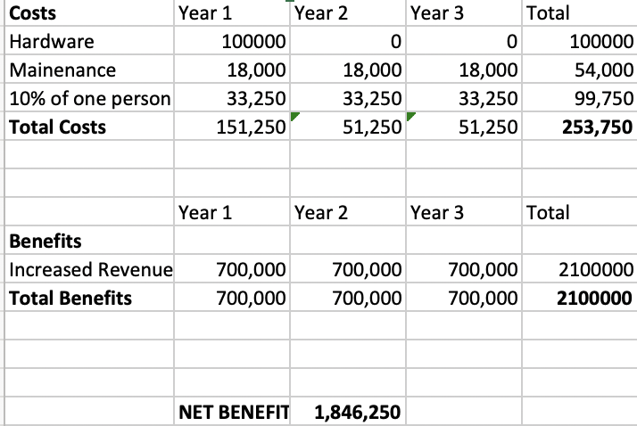

Works Cited

“Microsoft SharePoint: What It Is and Why It Matters.” *R & G Technologies*, rgtechnologies.com.au/resources/microsoft-sharepoint/.

Niaulin, Benjamin. “Why Use SharePoint - Between Two Farms.” *Sharegate*, en.share-gate.com/blog/why-use-sharepoint-its-benefits-between-two-farms.

MikePlumleyMSFT. “External Sharing Overview.” *Microsoft Docs*, docs.microsoft.com/en-us/sharepoint/external-sharing-overview.