  - Marketing Strategy Consulting Report

MKT 2101 – Spring 2012
by Alexander Patterson
Ayana Pendergrass
Laura Peppler
Samantha Sitarski
INTRODUCTION
Thirty years ago, no one would imagine the necessity for handheld cellular phones, let alone wireless cellular phones. Now, we cannot imagine going about our everyday lives without one. Many cellular companies continue to cater to this necessity, such as T-Mobile. T-Mobile is considered the world’s seventh largest wireless provider, and the world’s third largest multi-national provider with over 42,000 employees. T-Mobile continues to take advantage of global opportunities and expansion of the company in order to connect to consumers all around the world. The company states their value of plans as “the breadth of [their] coverage, the reliability of [their] network, and the quality of [their] service which are meant to do one thing: help you stick together with the people who make your life come alive” (T-Mobile.com). Our group has prepared a report analyzing T-Mobiles, strengths, weaknesses, opportunities, and threats, as well as its microenvironment, market segmentation, market targeting, and brand positioning.

CURRENT STATE OF THE FIRM PORTFOLIO ANALYSIS
T-Mobile USA is part of a large multi-national corporation Deutsche Telekon AG. T-Mobile has a presence in ten European countries: Austria, Croatia, Czech Republic, Hungary, Macedonia, Montenegro, the Netherlands, Poland, Slovakia and the United Kingdom, as well as the United States, Puerto Rico and the U.S. Virgin Islands. T-Mobile has either the first or second largest market share in the European countries. In America, T-Mobile has the fourth largest market share, behind AT&T, Verizon, and Sprint.
Overall, the wireless phone service market is a high growth market. Despite this, the market is already very saturated with dealers and subscribers. According to Experian Marketing Services, 98% of adults 22-24 own a cell phone, and this strong status holds over most adults. Ownership decreases among the elderly and young. The highest growth opportunity for mobile phone services lie within upgrading to smart phones and capturing the rest of the market.
Most of the countries in which T-Mobile has a presence are already developed. This gives them a disadvantage because the countries that are currently developed, present the highest opportunity to capture the customers who are currently entering the market.
Because of their lack of offering to developing countries and very small market share in America, T-Mobile has a small market share of a rapidly growing market. This position makes T-Mobile a “question mark” which means that they have a low-share of a high growth market.
(Percent of Americans that own a cell phone (according to age)
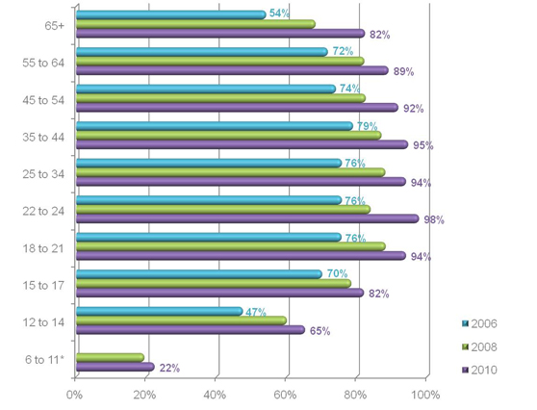
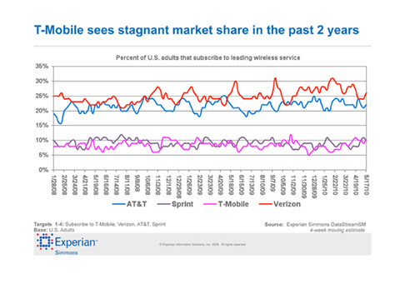
SWOT ANALYSIS FOR T-MOBILE
STRENGTHS
The strengths of a flourishing company are very important in maintaining and preserving the company’s assets. T-Mobile stands at being the world’s seventh largest wireless provider, and the world’s third largest multi-national provider. T-Mobile also has a very strong brand equity and recognition in the United Kingdom and the United States, making it a key player in the world economy.

WEAKNESSES
Many customers of T-Mobile have complained about poor wireless service and many dropped calls while using the service. Customers have also complained about poor customer service such as through delayed refunds, etc. Another concern with T-Mobile is that they have no presence in emerging markets; they only have customers in developed countries.

OPPORTUNITIES
There are many different opportunities for T-Mobile. T-Mobile is leading the upgrade from 3G to 4G service throughout the United States. Because the iPhone and Apple products have been sweeping the nation with enormous sales, the acquisition of the iPhone to T-Mobile will improve their presence within the industry. The addition and growth of Wi-Fi-enabled tablets will also increase subscriptions in the company.

THREATS
Possible threats are always a part and concern to every company that wants to become or sustain its success. With new rises in technology and rising competition within other companies, T-Mobile faces a very strong competitive market including AT&T and Verizon. Another threat that has affected many of other companies is the economic recession in the United States and Europe. Because of the recession, T-Mobile’s business has slowed down. T-Mobile also has a reputation for being slow to adapt to market changes and advances in technology.

ANALYSIS OF THE MICROENVIRONMENT
SUPPLIERS
T-Mobile’s main suppliers are its cell phone manufacturers. T-Mobile sells BlackBerry, HTC, LG, MyTouch, Nokia, Samsung, and T-Mobile in its stores. Worldwide, Nokia is the top manufacturer of mobile devices while Samsung is the top manufacturer of smart phones. T-Mobile sells wireless phones, smart phones, tablets, and internet devices.
There is fierce competition to contract the latest devices from the suppliers. For example, T-Mobile had a competitive advantage over its competitors because it was the first wireless provider to sell an Android based phone. On the contrary, T-Mobile is the last major wireless provider to acquire the iPhone and for that reason, T-Mobile has lost many customers.

INTERMEDIARIES
The intermediaries at T-Mobile include their own retail stores, franchise retail stores, and leased cell sites. They run 2,000 company-run stores and 1,100 branded partner stores throughout the country. T-Mobile told the Wall Street Journal in June that they are still expanding and plan on adding 200 more independently run retail stores throughout the nation this year.
Despite these ambitious plans, the retailers also told the journal that they are slowing down their expansion plans because of the uncertainty about T-Mobile’s future. This past summer T-Mobile and AT&T announce plans for a merger, which ultimately collapsed. Currently, the media is discussing T-Mobile mergers with other smaller competitors such as Sprint/Nextel. This uncertainty is disconcerting to customers, retailers, and employees.

COMPETITORS
T-Mobile’s greatest weakness is its strong competitors. Verizon and AT&T currently have the largest market share of the industry. Also, the Wall Street Journal says that AT&T operates about twice as many stores as T-Mobile: they run about 2,300 company run stores and 3,800 franchises.
All of T-Mobile’s competitors have acquired the iPhone. This is bad news for T-Mobile, as iPhone sales have skyrocketed. According to CNN Money, the iPhone’s market share of all mobile phones increased almost 6% the last quarter of 2011; from 3% to 8.7%. This is a lot of lost business for T-Mobile!

PUBLICS
The publics have recently had a huge impact on T-Mobile’s business. According to T-Mobile’s website, they announced their plans to be bought by AT&T last March. They reported that, with all government approval, the merger should be complete in twelve months.
AT&T planned to purchase T-Mobile and consolidate to become the largest wireless provider in America, beating Verizon. The FCC in Washington fought this merger and denied its passage until AT&T was forced to abandon all negotiations in December. This is not good news for the operators of T-Mobile USA, Deutsche Telekom who, according to the Washington Post, has expressed interest in abandoning business in the states.

CUSTOMERS
There are roughly 59 billion mobile phone subscribers worldwide, or 87 percent of the population. Of these, India and China have the largest amount of subscriptions; accounting for about 30 percent of the total subscriptions.
Despite the fact that T-Mobile does not have a stake in any of the developing countries, they have about 10 percent of the market share in America. They have many average American subscribers, but in recent times they have been targeting the developing Latino-American community. The Economist reported that T-Mobile has started to strategically open stores in up-and-coming neighborhoods that are run by Spanish speaking owners. This type of familiarity is unknown in their competitor’s stores, and is very attractive to these new customers.

THE MARKETING STRATEGY
SEGMENTATION OF T-MOBILE’S MARKET
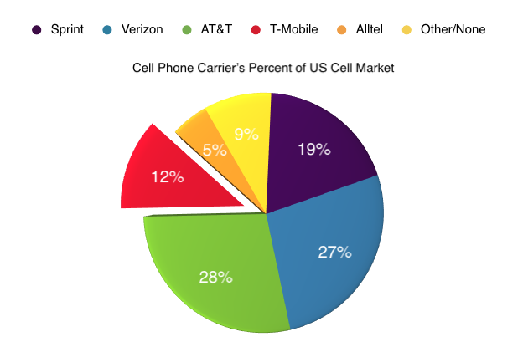
When researching online, it was found that little information could be discovered on the demographics of T-Mobile customers. The information listed above shows that T-Mobile only serves 12 percent of the United States population with cell phones, while nearly the entire remainder of the market is monopolized by the companies AT&T and Verizon (phone statistics). Of such a profitable market in the United States, and the world for that matter, it would be in the companies’ best interest to expand their coverage range as the customer’s demand gets higher. This will be discussed in more depth later. Location is key for a companies’ success, so T-Mobile would benefit from moving into more rural areas, which would allow them the opportunity to take over the Alltel market share, which caters to rural areas, as well as the other nine percent, giving them the prospect of gaining a larger percentage of cell phone customers.

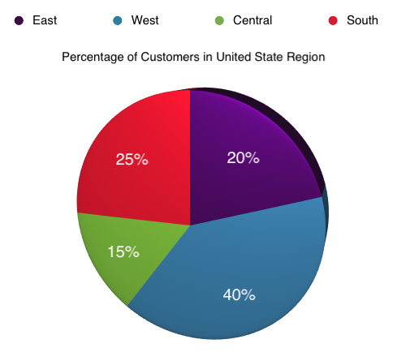

The chart above shows the percentage of T-Mobile customers by region in the United States. As stated before, there was trouble finding demographics on T-Mobile customers, so in lieu of gaining that information the percentages listed were found and averaged from My3cents.com. The cities and states listed in the 50 randomly selected comments were then placed into regions of the country and made into the above graph. Of the regions, the South and West were the most common in their market share which is unsurprising based on an article published back in 2009. Written by Denis Romero, he talks about the growing popularity of T-Mobile amongst the Latino demographic and seeing as how there is a high concentration of Latin Americans in the South and West, it is only natural that those regions would be their highest segmentations.

TARGETING
CURRENT CUSTOMERS
- Based on the ratings, found at my3cents.com, the average customers for T-Mobile are families and single phone carriers.
- Families: With T-Mobile’s many bundle packages, and well-known low prices, T-Mobile naturally attracts families who are looking for multiple lines at the cheapest prices. Especially with all the new technology today, T-Mobile offers unlimited family plans that provide affordable rates to target and market a large share of the cell phone service consumers.
- Single Phone Carriers: Based on the customer reviews, another current customer of T-Mobile is the single phone holder. It could also be coined the “independent young adult” category for the reason that many of these clients are either college or recently graduated students and are looking for the cheapest plans available. With new rising bills and tuition, this age group tends to lean towards any offer that can save them a few dollars. Fortunately, T-Mobile offers them the services that they ask for at a low price that accommodates to their financial needs.

POTENTIAL CUSTOMERS
- Business Men and Women: While gathering research for the demographics, there were many comments from parents as well as students, but there was a large lack of comments from business men and women. Although T-Mobile is known for their low prices and bundles, they are not, however, known for their new phone technology or data plans that the average business consumer is looking for. It would be in T-Mobile’s best interest to try and break into this market since this group makes up a considerable proportion of the cell phone usage in America. They could do so by acquiring and offering new models of phones and more data plans as well.

POSITIONING
Information gathered and formulated using customer reviews also showed that customers were very unhappy with the overall reception of the phone that they had paid for. Most customers barely received service in their own homes or work places, while others could only get quality reception when they were in a major city. Also, when commenting on the overall phone models, most were very unhappy with the lack of options as well as the outdated types. When compared to companies such as Verizon and AT&T whose customers are much happier with their service and phones, T-Mobile really needs to make some adjustments. It would be most advantageous for T-Mobile if they were to increase the quality of their reception service to top their competitors and to make them stand out, as well as to improve the quality of the phones and make more updated versions available more quickly.

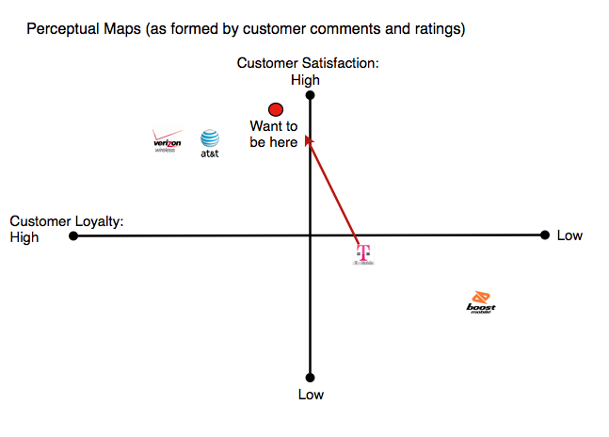
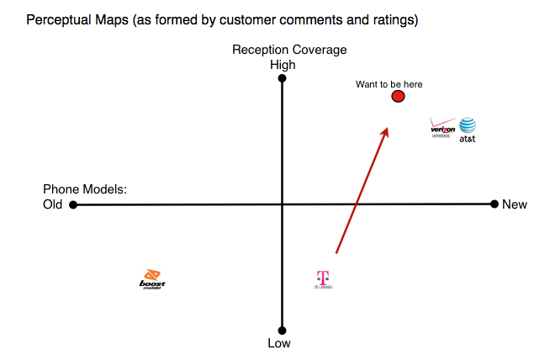
In the perceptual maps above, customer loyalty and customer satisfaction are judged. Based on the research gained from customer reviews, T-Mobile has much that is left to be desired. Out of the fifty comments polled, almost everyone gave a negative comment on either the customer service or the reception. From those comments, many stated that they were leaving T-Mobile to go to another company since they felt ignored, cheated and lied to about their services. Losing customers for poor service is unacceptable for any company. By improving their quality and becoming the leading standard in this field for customer service, they could gain a great deal of customers who would be willing to leave a service provider that they are tired of fighting with.

Works Cited
"Company Information." T-Mobile. T-Mobile USA, 2012. Web. 14 Mar. 2012. <http://www.t- mobile.com/Company/CompanyInfo.aspx?tp=Abt_Tab_CompanyOverview>.
"ComScore Reports March 2010 U.S. Mobile Subscriber Market Share - ComScore, Inc." ComScore, Inc. ComScore, Inc., Mar. 2010. Web. 14 Mar. 2012. <http://www.comscore.com/Press_Events/Press_Releases/2010/5/comScore_Reports_Ma rch_2010_U.S._Mobile_Subscriber_Market_Share>.
Elmer-DeWitt, Philip. "With 8.7% Market Share, Apple Has 75% of Cell Phone Profits." CNN Money. Cable News Network. A Time Warner Company, 3 Feb. 2012. Web. 15 Mar. 2012. <http://tech.fortune.cnn.com/2012/02/03/with-8-7-market-share-apple-has-75-of- cell-phone-profits/>.
Fetto, John. "Mobile Market Overview." Experian Marketing Services. Experian Information Solutions, Inc., 22 Apr. 2011. Web. 15 Mar. 2012. <http://www.experian.com/blogs/marketing-forward/2011/08/22/mobile-market- overview/>.
Fetto, John. "Mobile Providers Grapple for Market Share." Experian Marketing Services. Experian Information Solutions, Inc., 29 Jan. 2010. Web. 15 Mar. 2012. <http://www.experian.com/blogs/marketing-forward/2010/06/29/mobile-providers- grapple-for-market-share/>.
"Global Mobile Statistics 2012: All Quality Mobile Marketing Research, Mobile Web Stats, Subscribers, Ad Revenue, Usage, Trends... | MobiThinking." Home. DotMobi, 2012. Web. 14 Mar. 2012. <http://mobithinking.com/mobile-marketing-tools/latest-mobile- stats>.
Kang, Cecilia. "AT&T Gives up on T-Mobile Merger." Washington Post. The Washington Post, 20 Dec. 2011. Web. 15 Mar. 2012. <http://www.washingtonpost.com/business/technology/atandt-gives-up-on-t-mobile- merger/2011/12/19/gIQAapQP5O_story.html>.
Romero, Dennis. "T-Mobile Shakes Up Owner-Operator Model." Entrepreneur. Fox Business, 30 Mar. 2009. Web. 16 Mar. 2012. <http://www.entrepreneur.com/article/200982>.
"SWOT ANALYSIS ON T-MOBILE - ManagementParadise.com - Worlds Leading Management Portal. Online MBA | Classroom to Boardroom and Beyond." Management Paradise. 24 Nov. 2010. Web. 14 Mar. 2012. <http://www.managementparadise.com/forums/principles-management-p-o-m/208027- swot-analysis-t-mobile.html>.
T-Mobile. Web. 16 Mar. 2012. <http://www.t-mobile.com/>.
"T-Mobile Consumer Reviews." Reviews and Complaints. Web. 16 Mar. 2012. <http://www.my3cents.com/reviews/tmobile>.
"T-Mobile Release." Latest News. T-Mobile USA, 20 Mar. 2011. Web. 15 Mar. 2012. <http://newsroom.t-mobile.com/articles/more-information-att-acquires-tmobile>.

TROIANOVSKI, ANTON. "T-Mobile Dealers Start to Hang Up." Wall Street Journal. Dow Jones & Company, Inc., 23 June 2011. Web. 15 Mar. 2012. <http://online.wsj.com/article/SB10001424052702303970604576402021687133238.html >.

