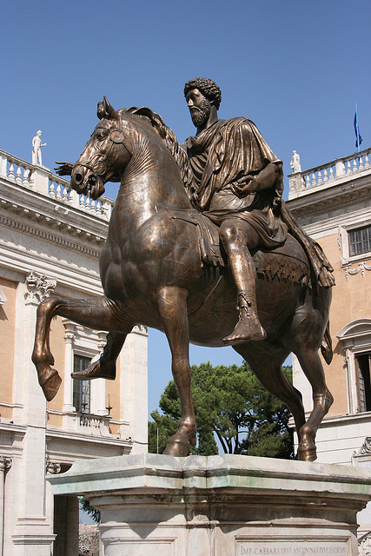
Experience Rome like you never have before
By Ayana Pendergrass
The Thrill-seeker’s Guide

to Rome
Rome: “The Eternal City”. The city of beauty, historical landmarks and remarkable art draws people from all around the world. But within the historical realm of Rome lie secrets, adventure, and excitement for the biggest thrill-seekers.
Take a ride on the wild side with five amazing attractions. Make all of your friends jealous when you tell them that you’ve sky-dived, went biking on Rome’s first consular road aligning ancient tombs, explored the largest and most extensive catacomb, climbed St. Peter’s Basilica and then cooled off by going to a club made purely of ice.
- Sky-diving in Rome: Reaching 4,000 meters in a mere 15 minutes, experience Rome from a view like no other, dropping from a prime spot on a high-power turbine aircraft.
- Biking down the Appian Way: This is no ordinary bike ride in the park. With a bumpy structured road, this trail is not for the faint at heart. If you’re ready for the challenge, conquer the winding roads and see some amazing sights along the way!
- Exploring Catacomb Domitilla: What’s a better thrill than going through an ancient underground burial place? See ancient tombs and bone remains and appreciate the history behind it all.
- Climbing the Cupola of St. Peter’s Basilica: Let the inner mountaineer in you come out by walking up this famous dome to see a breath-taking view from above.
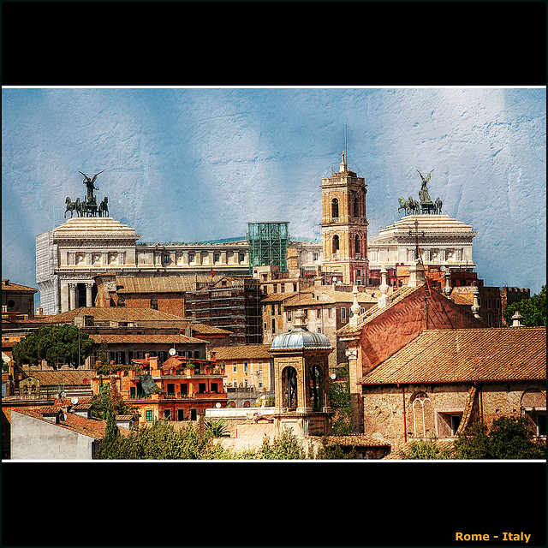
- Chillin’ in the Ice Club: After being fired up from a week full of adventurous activities, take a chill down at a bar made of nothing but ice. The experience will blow your mind!
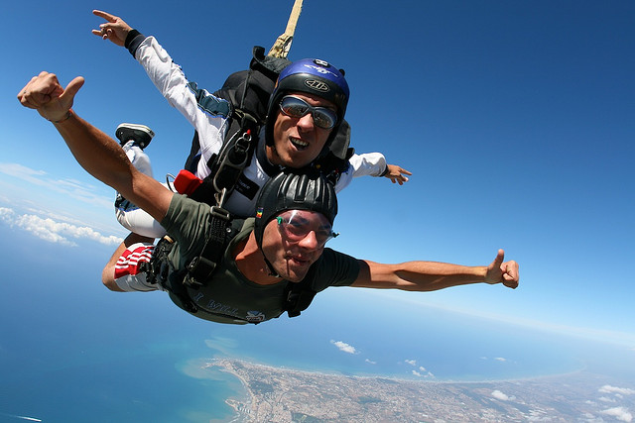
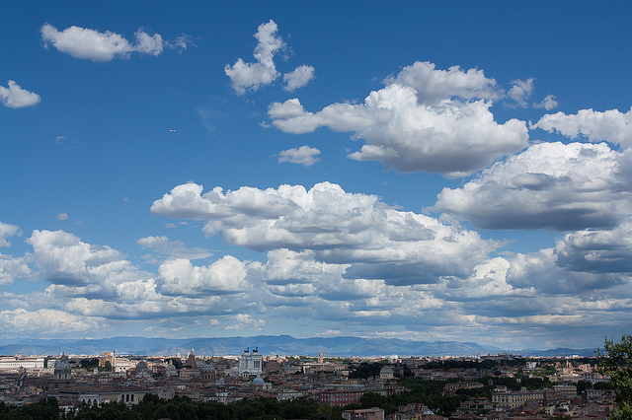
Roma Skydive, Rome’s most popular skydiving destination, fulfills any thrill-seeker’s dream. Become a certified skydiver or just do it for the experience! The amazing high-powered aircraft “The Pilatus Porter PC-6” ascends to about 13,000 in 15 minutes. From there you will jump out, descending 200km/hr with some of the best skydiving instructors there are! At 4,000 ft. your instructor will open your parachute and from there, a slow 5 minute fall to take in the breath-taking view. Experience all of this for 230-260 euro. If you’re really adventurous and want to be become an AFF (accelerate free fall) certified skydiver, pay 1700 euro and
The Drop Zone, located near the famous “"Torre Astura" or "Parco Nazionale del Circeo", offers great services:
- A great restaurant
- Playful kids area
- Rooms with private toilette, air conditioned, shower and TV

Rooms with private toilette, air conditioned, shower and TV

THE SKY IS THE LIMIT
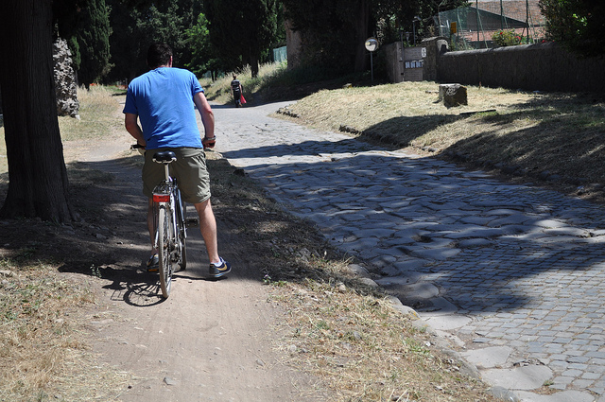
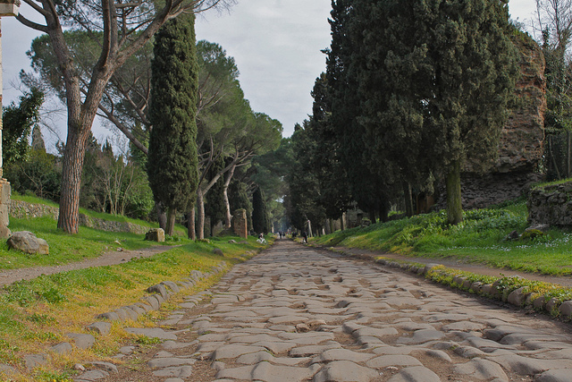
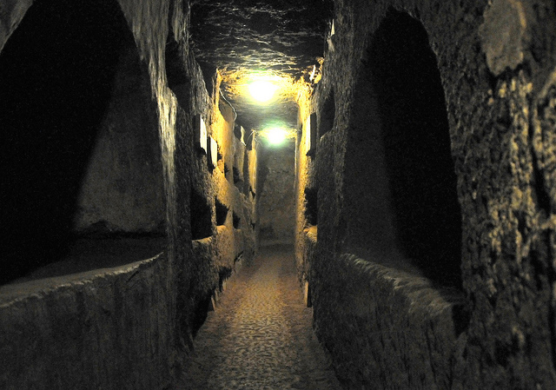
Preferably on Sundays, take a thrilling ride on the bumpy roads of Via Appia Antica. As you ride along the road, you will see an alignment of ancient tombs of Roman families.
After your adventure on the Appian Way, wind down at the Appia Antica caffe just a little down the road from your starting position.
Getting there:
- Take bus 218 that leaves from the San Giovanni Metro stop (line B)
- Save with a discount pass—Roma Pass allows free admission to certain sights around the Appian Way.

Originally, Via Appia Antica, one of the original seven roads that lead to Rome, served as a Sunday picnic destination for many Roman families. However, fumes from ongoing cars disturbed the tradition. Since the 1990’s, an initiative closed Via Appia Antica to traffic allowing for the tradition to stay alive. Now, biking along the Appian Way has become a very popular activity. For as little as 3 euro per hour or 10 euro per day, you can take part in the tradition.
Biking the Appian Way

Opening Hours:
From 9:00a.m-12:00p.m and from 2:00p.m-5:00p.m. TUESDAYS ARE CLOSED
Cost: 8 euro for adults and 5 euro for children ages 6-15.
How to get there
From Rome’s Termini station, take bus 714 from Palazzo Sport to Piazza del Navigatori then from there, take bus 282.

The catacombs of Rome are intense, and impressive. The largest and most extensive catacomb, the catacomb of Domitilla features 15 km of breath-taking subterranean galleries and offers insight into the necropolis of the early-Christians. Any thrill-seeker should make a stop here as it provides mystery through each passage way.
Another fact that makes Catacomb Domitilla unique is that it is the only catacomb that has bones.
THE MYSTERIES OF THE CATACOMBS
For all the thrill-seekers, this destination is a treat. At the entrance to St. Peter’s basilica is the option to climb the 320 steps to the top of the dome or take an elevator.

St. Peter’s Basilica attracts people from all around the world for its beautiful mosaics and ornamental designs. But for the thrill-seeker, climbing the dome is an added bonus as you get a thrilling downward view of the dome

The Cupola of St. Peter’s Basilica
Some things to remember:
- Dress Code: Make sure that you cover your arms as well as your knees. A modest dress is required
- Operating Hours: St. Peter's Basilica is open daily, Apr-Sep 7:00-19:00; Oct-Mar 7:00-18:00. The Cupola is open 8:00 - 18:00 (Apr - Sep) 8:00 - 16:45 (Oct - Mar)
- Cost: To climb the Cupola, it is 6 euros to take the stairs and 7 euros to the take the elevator
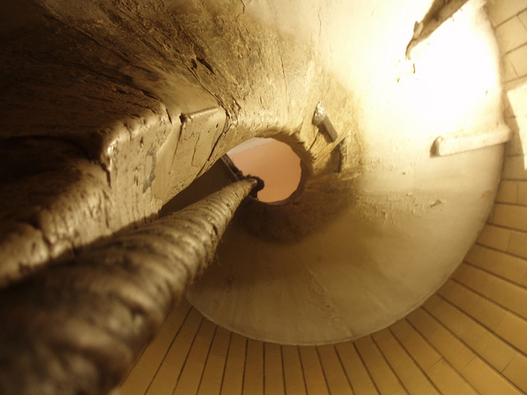
- After your amazing trip up the Cupola, enjoy a cappuccino at the coffee bar or even stop at the gift shop.

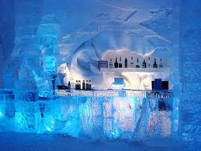
Rome is known for many things, but not everyone would expect for there to be a club completely made of ice in this hot city.
After your adventurous week, cool down in a thrilling way.

COOL OFF AT THE ICE CLUB
The Ice Club is the first known club of Rome to be built completely of ice. With a temperature of -5 degrees Celsius inside, you’ll surely wish you were back out in the heat. “Harmony between light and sound brings to the Ice Club a magic atmosphere with a unique and unforgettable experience to [top off your trip to Rome].”

- Location: Via della Madonna dei Monti which is one of the oldest blocks of Rome, near Piazza Venezia. Metro stops near this destination are Colosseo and Cavour
- Opening Hours: from 6 in the evening until 2 in the morning
- This club is a convenient walking distance from Basilica di San Pietro and from many pizzerias and restaurants.
