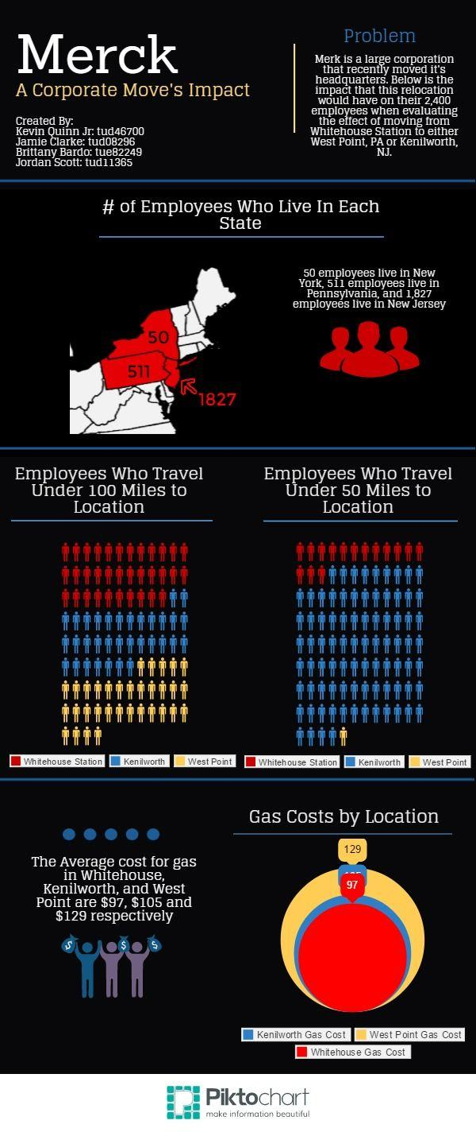
Merck: Temple Analytics Challenge 2014

Infographic Write-up

Infographic Description 1

The first infographic was more of a large scale effort to break down the Merck challenge and their recent decision of moving their corporate headquarters from Whitehouse, New Jersey to Kenilworth, New Jersey, and also if they were to move their headquarters to West Point, Pennsylvania. We highlighted New Jersey on the map of the United States to pinpoint the actual location of where Merck is headquartered. From there we made a small pictograph displaying the number of employees who travel under 100 miles to each possible location where Merck could be headquartered. Each location had a different color association such as Whitehouse Station was represented through using Red, Kenilworth used Blue, and West Point used yellow. The largest group of employees that traveled under 100 miles in order to get to work was those who were stationed at the Whitehouse Station. The Kenilworth and West Point stations both had an equal number of employees who traveled under 100 miles to get to these two locations. Lastly, we constructed a bar graph that represents employee average gas cost per week. Those who had to travel from White House Station, New Jersey to West Point, Pennsylvania had the most expensive trip accumulating around $129 as a their gas expense. The cheapest gas location for employees was the Whitehouse which the totaled $97

Infographic Description 2

This second infographic was much more descriptive than the first infographic. First, we stated the problem from the challenge and how Merck decided recently to move its headquarters from White House Station, New Jersey to either Kenilworth, New Jersey, or even West Point, Pennsylvania. Next we made a state by state graph of the Northeast focusing on three states in which Merck employees reside within. The state with largest number of Merck employees was New Jersey with 1,827, in the middle was Pennsylvania with 511, and last was New York with 50. In addition to providing the chart about employees who travel under 100 miles in order to get to either the Kenilworth or West Point location we also added in a new chart titling it “Employees Who Travel under 50 miles To Location”. It was discovered that those who were traveling to Kenilworth location were the highest number who traveled under 50 miles to get to that location. There was only one Merck employee that traveled under 50 miles in order to get to work at the West Point Location. Lastly we made a pie chart displaying gas costs by location. Not surprising was discovering that West Point PA had the highest total gas cost at $129. The cheapest gas cost was for employees who were traveling to the Whitehouse location which totaled $97. In the middle was the Kenilworth location with a gas cost of $105.

