Philly Challenge: Moneyballing Economic Development

2007 - 2012 Shift Comparison

Average Number of Employees vs. Average Annual Wage
 | $100,000
 | Highest Wage Industry |  |  |  |  |  | Highest Growth
 | $90,000 |  |  |  |  |  | & Wage Industry
Wage* | $80,000
 | $70,000
 | $60,000
Annual
 | $50,000
Average | $40,000
 | $30,000
 | $20,000
 | $10,000
 |  | 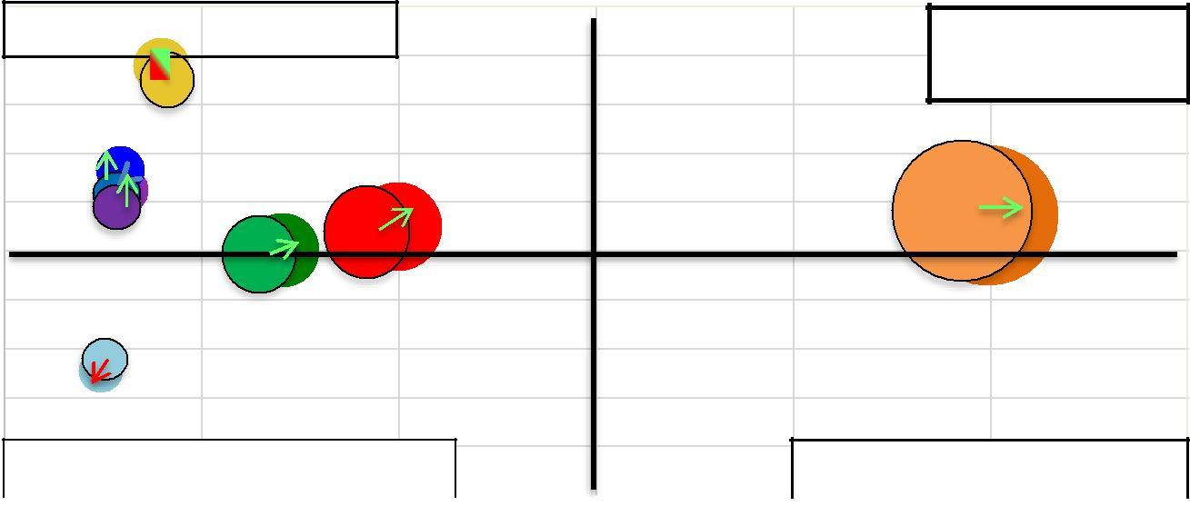$- |  | Lowest Growth & Wage Industry |  |  |  |  |  | Highest Growth Industry
 |  | 0 |  | 100,000 | 200,000 | 300,000 |  | 400,000 |  | 500,000 | 600,000

Number of Employees

*Adjusted for inflation
LEGEND
- Service-Providing

- Education and Health Services

- Health Care and Social Assistance

- Professional and Business Services
▪ | Hospitals
▪ | Educational Services
▪ | Retail Trade
 | Increase in Wages/Employees
 | Decrease in Wages/Employees

Temple Analytics Challenge 2013
Moneyballing Economic Development: Philly Challenge
Data Visualization Write-Up

On the Y axis, this graph is showing the average annual wage for each industry in Philadelphia. On the X axis, it shows the number of employees for each industry. The relation of these together shows how an industry that has the most employees might also have the highest average annual wage. We compared this data of 2007 and 2012 to see which industries seem to be growing the most based on an increase in employees. We decided to also compare their average annual pay because a company may increase its annual pay to attract some of the top talent because that industry may be growing so much that they need only the top talent to keep up with its growth. The sizes of the circles exemplify how large the industry is in comparison with Philadelphia’s total based on the number of employees. The graph is divided into 4 sections to show which industries are the best in which sections. For example, the top left area shows the highest wage industries, while the top right shows the highest growth and wage industry and then the bottom right shows the highest growth industry. Then the bottom left shows industry’s that are not doing well in either area and possibly not even growing at all.

This graph is effective because it shows the top industry in Philadelphia based on the average annual wage and the number of employees in that industry. The number of employees is important because the largest industry will need the most employees. The average annual wage is important because usually an industry will increase its annual wage to attract the top talent. The sizes of the circles are important because it shows each industry’s size compared to the total employees in Philadelphia. As you can see from the graph, the service providing industry is the largest and is still growing. However, we would suggest that investors invest in the education and health service industry because it grew in both the average annual wage and the number of employees, even during the recession in 2008.

