Brendon Lee

MIS 2501:  Enterprise IT Architecture

Mart Doyle

Flash Research Assignment #2:  REVISED

Virtualization and Cloud Computing

Our company will realize a net benefit of $9.2 million over three years when we convert our physical servers to virtual machines using VMware.  The advantage of switching from physical servers to virtual machines is server consolidation.  This allows us to reduce our total amount of servers from 1,000 to 280 servers.

Server consolidation is combining servers or replacing legacy servers with virtual systems, the cloud, or SaaS products.  A virtual machine is a computer file that acts like a computer.  It is a computer running on a computer.  The biggest benefit of server consolidation is that it allows us to convert 800 of our physical servers to 80 virtual machines.  Fewer servers mean we pay less in maintenance costs.

Converting our physical servers to virtual machines will cost us $4.8 million dollars.  Our company will be receiving a benefit of $14 million in costs over a three-year period.  The net benefit will be $9.2 million over a three-year period.

Calculations

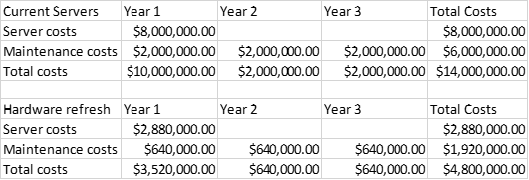

Works Cited

Rouse, Margaret.  “What is Server Consolidation? Why  
Should You Do It?” *SmartFile*, 14 July 2016, [www.smartfile.com/blog/what-is-server-consolidation-and-why-should-you-do-it/](http://www.smartfile.com/blog/what-is-server-consolidation-and-why-should-you-do-it/).

Peterson, Curtis.  “What is server consolidation? -  
Definition from WhatIs.Com.” *SearchDataCenter*,  
searchdatacenter.techtarget.com/definition/server-consolidation.

Kupfer, Michael.  
“Top 5 benefits of server virtualization for your business.” *Black Diamond Solutions Top 5 benefits of server  
virtualization for your business Comments*, 21 June 2012,  
blackdiamondsolutions.com/top-5-benefits-of-server-virtualization-for-your-business/.