Bridgette Brodnyan
Professor Doyle
Flash Research Assignment #3
SharePoint
Investing in Microsoft SharePoint will allow billable hours for PMPs to increase by approximately 3810 hours per year, through reducing the time related to the management of documents. SharePoint is a web-based application integrated with Microsoft Office that is used to organize, share, and store information in a secure, central location. The integration of this application will produce a three-year net benefit to our company of over $1.84 billion.
Microsoft SharePoint is a highly configurable web-based application, primarily sold as a document management and storage system. The key capability of this application is that it allows for a more efficient collaboration of documents, both internally and externally. SharePoint’s collaboration features increase the ability and the capacity of an organization to manage and store documents; which, in our case, will allow for a 20% decrease in the amount of time PMPs spend working on documents, and an increase in total billable hours of 3810 hours per year.
Microsoft SharePoint will cost our company $151,250 in the first year and $51,250 in each of the following two years, for a total cost of $253,750 over a three-year period. That being said, SharePoint will produce $2.1 million in revenue from increased PMP billing hours in that same three-year period. Investing in Microsoft SharePoint will produce a three-year net benefit of $1,846,250 for our company.

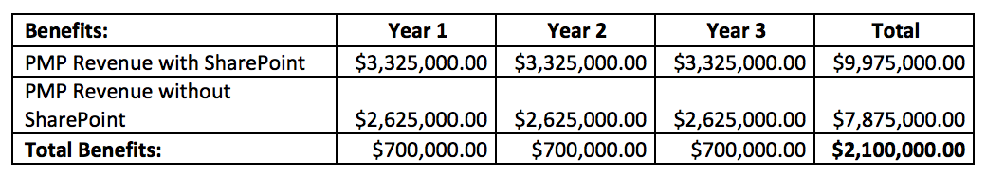
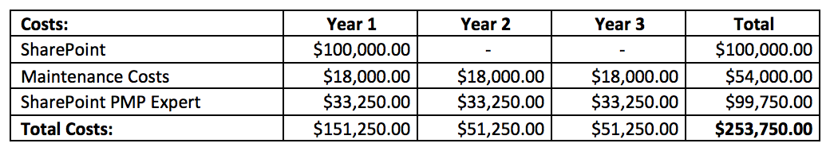
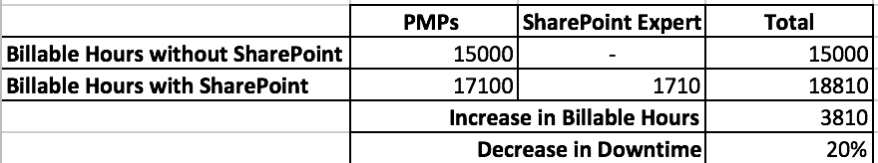

Works Cited
"SharePoint Server 2016." What Is SharePoint – Overview of Features. N.p., n.d. Web. 03 Apr. 2017.
"The Top 10 Advantages of SharePoint Online." Total Solutions, Inc. N.p., 08 Sept. 2016. Web. 03 Apr. 2017.
"The Top 10 Advantages of SharePoint Online." Total Solutions, Inc. N.p., 08 Sept. 2016. Web. 03 Apr. 2017.
"Why SharePoint? SharePoint Benefits and Advantages." Total Solutions, Inc. N.p., n.d. Web. 03 Apr. 2017.

