Bridgette Brodnyan
Professor Doyle
Enterprise IT Architecture
Flash Research Assignment #2
February 28, 2017

Virtualization and Cloud Computing
Through utilizing virtualization to consolidate server workloads, our company can reduce its operating costs by nearly 66%. Virtualization refers to creating a software-based, or “virtual,” representation of something, rather than a physical representation. This reduction in costs translates to a net benefit of $9.2 million to our company over a three-year period.
Virtual machines allow for faster deployment of workloads, and an increase in performance and availability, for they allow multiple operating systems to run on a single machine. Because operations become automated with the introduction of virtual machines, IT is therefore less costly to operate and simpler to manage. On average, 10 physical servers can be consolidated into just one single virtual machine server, and 80% of our servers can run as virtual machines under VMware. This will result in the company utilizing 80 virtual servers and only 200 physical servers.
Implementing virtualization provides our company the opportunity to reduce its costs by 65.71%. This implementation would cost our company $4.8 million for a three-year period, which is a significant decrease from the $14 million the traditional machines would cost. Overall, implementing visualization will result in a $9.2 million net benefit to our company.
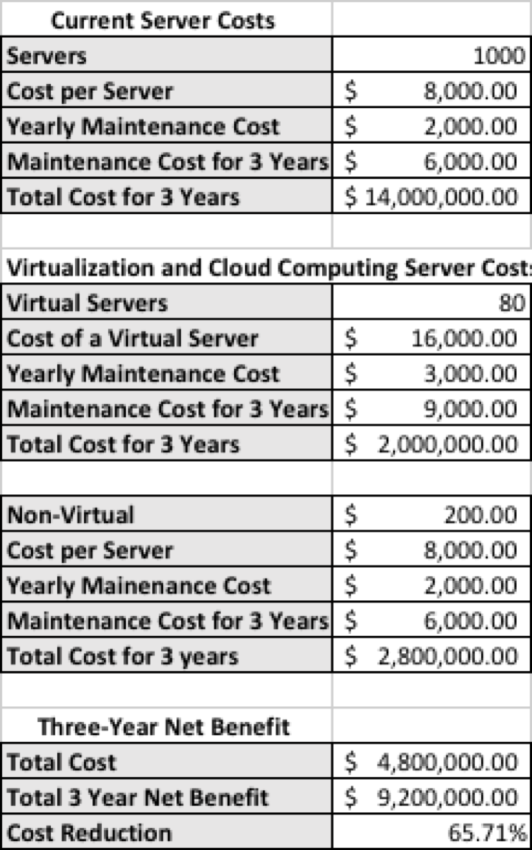

Works Cited
Rouse, Margaret, and Brian Kirsch. "What Is Virtualization? - Definition from WhatIs.com." SearchServerVirtualization. TechTarget, n.d. Web. 26 Feb. 2017. <http://searchservervirtualization.techtarget.com/definition/virtualization>.
"Virtualization Technology & Virtual Machine Software." Virtualization Technology & Virtual Machine Software. VMware, Inc., 24 Feb. 2017. Web. 26 Feb. 2017. <http://www.vmware.com/solutions/virtualization.html>.
"What Is Virtualization? - Definition from Techopedia." Techopedia.com. Techopedia Inc., n.d. Web. 26 Feb. 2017. <https://www.techopedia.com/definition/719/virtualization>.

