Mesh Networking
Change Management Plan
Purpose
The purpose of the Change Management Plan for the Mesh Networking Project is to set expectations on how the approaches to changes will be managed, what defines a change, and to ensure a consistent and repeatable process for change requests. This document should be referred to by the project sponsor, project manager, and engineers when making or considering any changes that would have an affect on the project’s schedule, scope, and or budget. By adhering to this change management plan, the project team will prevent unnecessary change from occurring and focus its resources only on beneficial changes within the project scope.

Change Management Process
All change requests will require filling out the change request form below and submitted to the project managers, Thompson Nguyen (Thompson.Nguyen@temple.edu), Stanley Okoro (tue85789@temple.edu) and Connor Gawlik (Connor.Gawlik@temple.edu). Thompson, Stanley, and Connor will log the change requests and evaluate its impact on the project schedule, budget, and or scope by discussing the changes with the project sponsor and engineers. The proposed change along with the impact evaluation will then be discussed during the next scheduled meeting with the final decision made at the conclusion of this meeting on whether or not the change is approved or rejected. If a change is urgent, a special meeting with the project managers and engineers will take place before the next weekly scheduled meeting to discuss the change. A decision will then be made on whether to approve or reject the change. If a change is approved, the project managers will adjust the project baseline accordingly.

Change Request Form
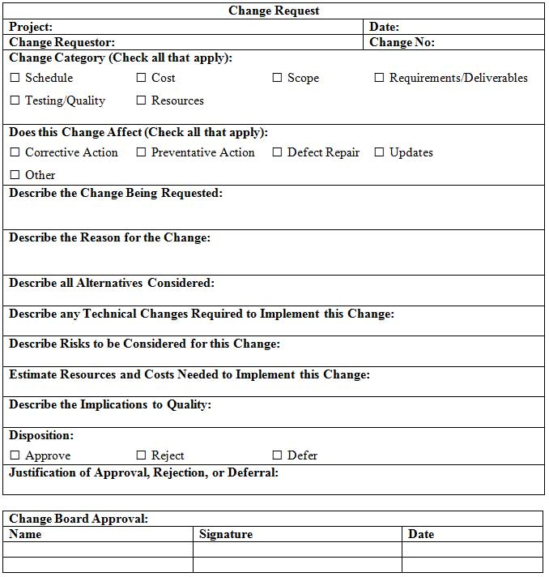

Change Request Log

Change Log
Project: |  |  |  |  |  | Date:
Change No. | Change Type | Description of Change | Requestor | Date Submitted | Date Approved | Status | Comments
Each change request is assigned a reference number. | This may be a design, scope, schedule or other type of change. | The change request should be described in detail. | Who initiated the change request? | When was the request submitted? | When was the request approved? | Is the change request open, closed or pending? Has it been approved, denied or deferred? | This section may describe why the change request was rejected, deferred or provide any other useful information.

