Fatai Saka
Flash Research Paper #3
Professor Mart Doyle
MIS 3406 Enterprise IT Architecture

SharePoint
Our company will have a benefit of $2,100,100 by switching to SharePoint. SharePoint is a collaborative platform for creating, managing and sharing documents, which will increase efficiency and result in more billable hours
SharePoint is a platform that has the capacity to synchronize people, processes and productivity. SharePoint allows users to work-together while creating, sharing, and managing documents. Therefore, our PMPs can create documents, and integrate our clients, which will promote a central place for seamless collaboration.
The total cost of implementing SharePoint is $253,750, which includes hardware and system software, maintenance, and administration over three years. By implementing SharePoint, it will increase the efficiency of our PMPs in managing documents, which will increase our billable hours. Therefore, our company will have a benefit of $2,100,000 and a net benefit of $1,900,000 over three years.

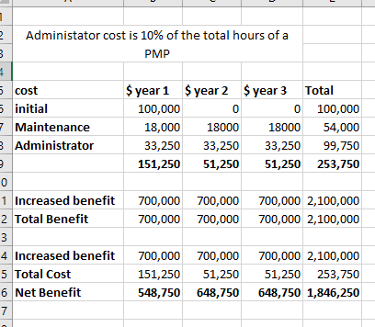

Work Cited

Microsoft. “SharePoint, Your mobile, intelligent intranet,”
https://products.office.com/en-us/sharepoint/collaboration. Accessed 2 Nov. 2018.

R & G Technologies. “Microsoft SharePoint, What it is and Why it matters., “September 2014. https://rgtechnologies.com.au/resources/microsoft-sharepoint/ Accessed 2 Nov. 2018.

Study.com. “What is SharePoint? – Basic, Features and Examples: https://study.com/academy/lesson/what-is-sharepoint-basics-features- examples.html.
Accessed 2 Nov..2018.
What it is and why it matters

