Fatai Saka
Enterprise IT Architecture
Mart Doyle
Flash research Paper #2

Virtualization and cloud Computing

Our Company could have a benefit of $14,000,000 by switching to virtualization. It has the capability to consolidate multiple physical servers into fewer virtual machine servers, which lowers the costs of server ownership.
Virtualization allows a physical server to run multiple servers virtually, which lowers hardware, software, space, and cooling costs. Therefore, we can consolidate 800 physical servers into 80 virtual servers. Virtualization will provide a platform for automated resource management and offer faster backup and recovery of key application workloads and data, compared to our current servers.
The total cost of consolidating the physical servers and maintaining the virtual servers will be $4,800,000 over a three-year period, which will provide a benefit of $14,000,000 to our company. Due to a reduction from the current cost for physical servers, our company will have a net benefit of $9,200,000 at the end of the third year of implementation.

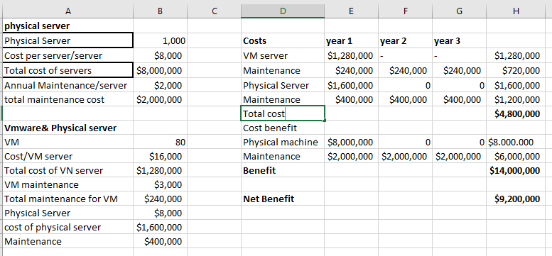

Work Cited
Marshal David. NetworkWorld. “Top 10 ways Server Virtualization changed the Data Center,” 2 Nov. 2011, https://www.networkworld.com/article/3263399/virtualization/top-10-ways-server- virtualization-improves-the-data-center.html.Accessed. Accessed 7 Oct. 2018.

VMware. Virtualization Overview: How Virtualization Works| Type of Virtualization| Resources,” (n.d). n.p, https://www.vmware.com/solutions/virtualization.html#overview. Accessed 7 Oct. 2018.
White Paper. “Making Business case for Virtualization: A guide for business leadership on how to reduce
costs, improve business continuity and increase IT efficiency.” (n.d.), pp 1-6, https://www.vmware.com/content/dam/digitalmarketing/vmware/en/pdf/whitepaper/solutions/business-case-for-virtualization-white-paper.pdf. Accessed 7 Oct. 2018.

