NOTE:

Anytime that you see “##”, you are to enter YOUR unique FS-##. Never enter “00”.

Exercise Introduction

In this exercise, you will be processing a customer order for the fictitious Fitter Snacker company—a manufacturer of snack bars. Fitter Snacker has two products, the NRG-A and NRG-B bars. The NRG-A bar touts “Advanced Energy,” while the NRG-B bar touts “Body Building Proteins.”

Within each client of this R/3 system, there are 100 copies of the Fitter Snacker Company data. You have been assigned to one of these sets of data, defined by your Data Set Number, which tells you which set of data you should be using within our client (702).

IT IS CRITICAL THAT YOU USE ONLY YOUR DATA SET. FAILURE TO DO SO WILL CAUSE YOU PROBLEMS AS WELL AS OTHERS IN YOUR CLASS.

All of the data in the Fitter Snacker database begins with a Data Set Number. For example, the NRG-A bars are entered as 00 NRG-A, 01 NRG-A, 02 NRG-A, etc. This will allow you to use the search function in SAP to find your particular snack bar. In the instructions that follow, the pound symbol (##) will be used to represent the Data Set Number. For example, in creating an inquiry for West Hills Athletic Club, the instructions will refer to ## West Hills Athletic Club. You will need to replace the ## with your Data Set Number. For example, if you are data set number 09, then you will be searching for 09 West Hills Athletic Club. The screen shots in the instructions were created using Data Set Number 00, which is reserved for the instructor. Do not use Data Set Number 00 in any transactions.

If your default home screen is the “USER –Menu” (Seen Below), please switch to the “SAP Menu” by navigating to Menu→SAP Menu:

USER Menu:

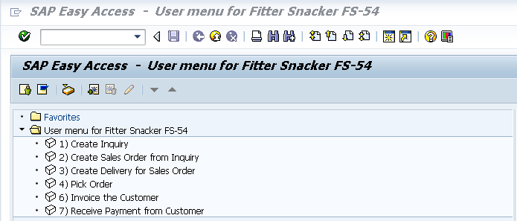

SAP Menu:

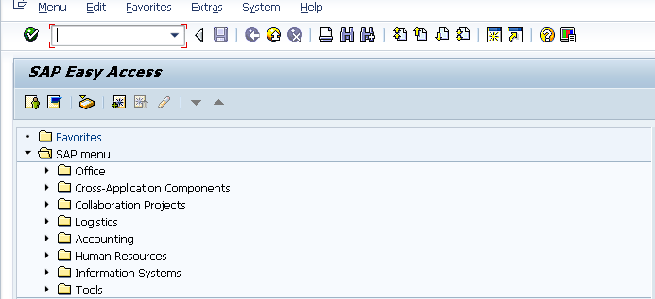
1. Create an Inquiry

An inquiry is a non-binding price quotation to a customer that tells them the price of a specific quantity of your product. We will create an inquiry for ## West Hills Athletic Club. To do this, follow the menu path:

Logistics Sales and Distribution Sales Inquiry Create

which will bring up the following screen:
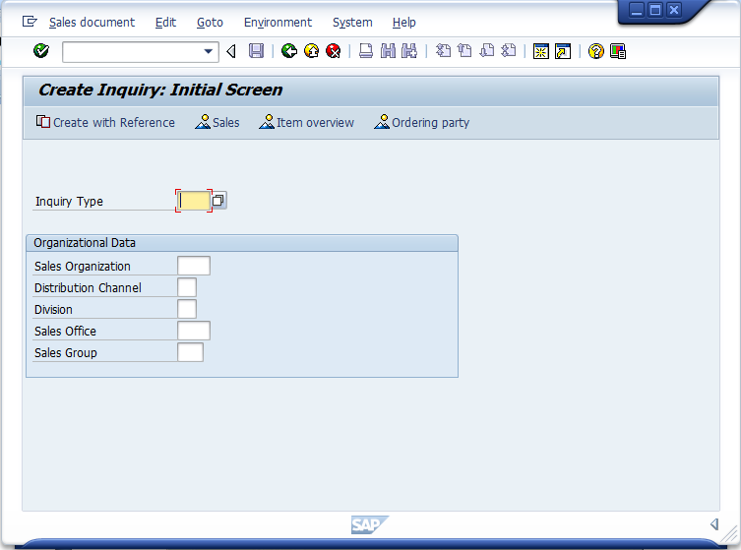
Enter IN for Inquiry Type
Enter ##FS for Sales organization
Enter DI for Distribution Channel
Enter SB for Division
Then click on the enter icon

Enter the information shown above, click the enter icon () and the following screen will appear:

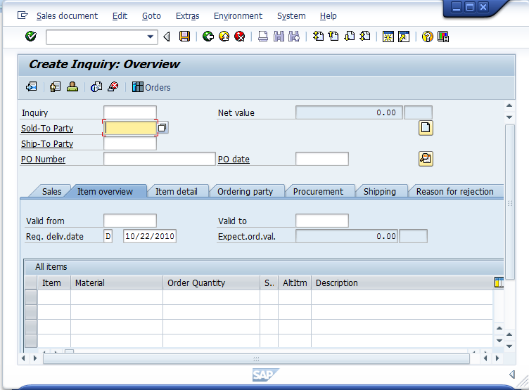
Your cursor should be in the Sold-to party field, and the search icon () should be visible. If not, click on the Sold-to party field.

The screen should have the cursor already in the Sold-to party field. If you knew the customer number of the company requesting the inquiry, you could type it in directly. Usually, people can’t remember arbitrary customer numbers. Fortunately, the SAP R/3 system has a comprehensive search function that will allow us to find the Sold-to party easily. Click on the search icon () and the following pop-up menu will appear:

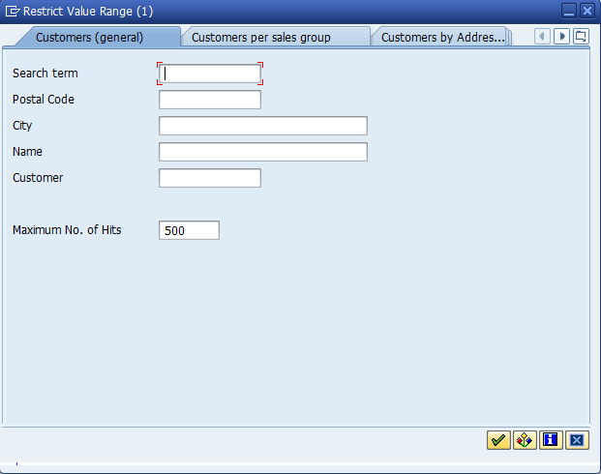
Enter ## for your search term,
then click on the enter icon ()

Enter your Data Set Number (##) for the search term and click on the enter icon () and a list like the following will appear:

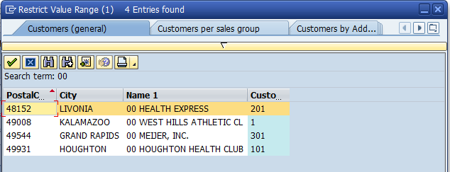
Double-click on ## West Hills Athletic Club

Select on the entry ## West Hills Athletic Club to select it. When you do, the customer number will be entered automatically:

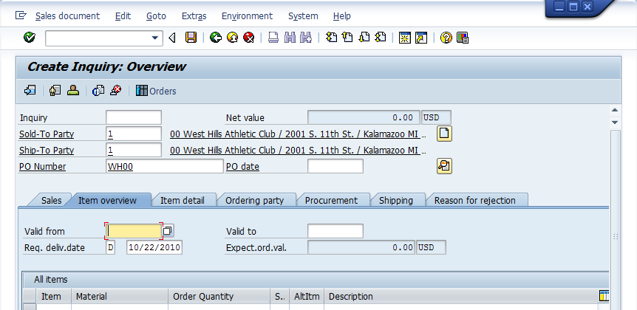
The customer number for ## West Hills Athletic Club is displayed.
Enter WH1## in the Purch. Order no. field, then click on the Valid from field to display the search icon, then click on the search icon ().

Next, click on the Purch.order no. field and type WH1##. Then, click on the Valid from field so that the search icon is again displayed. Click on the search icon, and a calendar will be displayed:

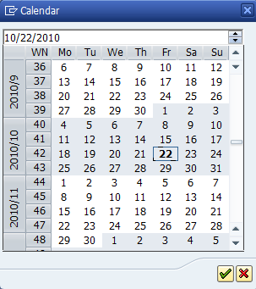
Double-click on today’s date (which is highlighted) to enter it

Today’s date is highlighted. Select on it to enter today’s date in the Valid from field. Click on the Valid to field, then click on the search icon () to call up the calendar again, then Select on a weekday approximately one month from today. When you are done, the customer order screen should look like the following:

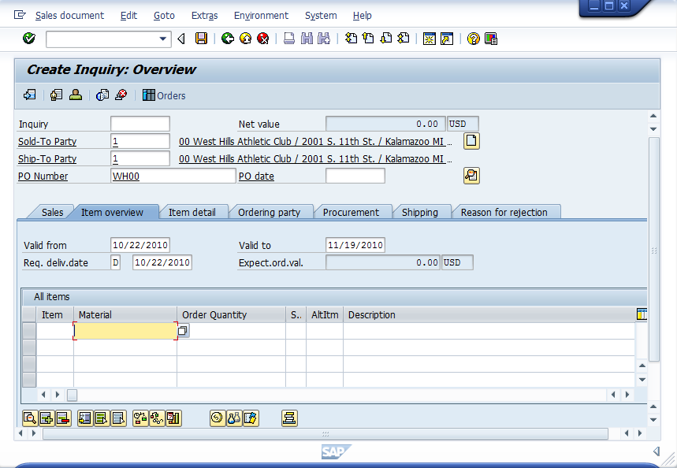
Check data, and then click on the first material field

Click on the first material field, and then click on the search icon to call up the following search pop-up window:

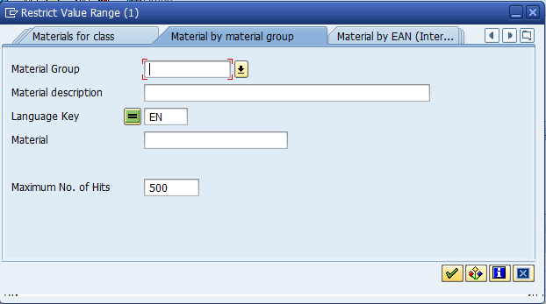
Select the tab Material by Material Group
Click on the arrow next to the material group field to find the tab

Find the tab with Material by Material Group, and then click on the arrow () next to the Material group field, which will call up a second pop-up window:

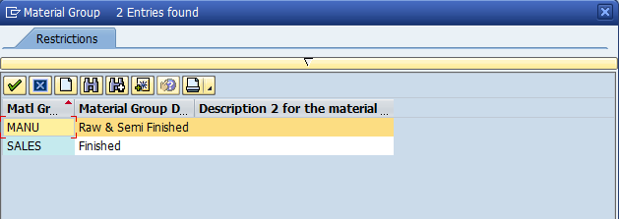
Select Sales.

We will select the material group of Sales since the material is a finished product suitable for sale. If this was a manufacturing department which was using other materials to create a product, one of the other material groups would have been appropriate. Select on the SALES group to select it, then enter ##* for Material description:

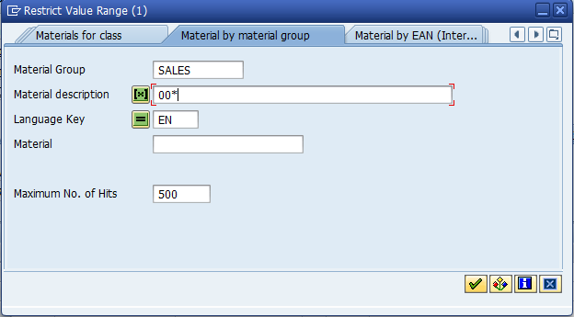
Enter ##*for Material description

There are many ways to search for material in the SAP R/3 system. One of the more useful is to search by old material number, as most companies change their material numbering systems after installing the SAP R/3 system while many customers will still be using the old material numbers. Unfortunately, the SAP R/3 system does not provide for user-defined search terms for materials like it does for customers. However, with the addition of an asterisk, we can take care of that problem. Because this database has all materials defined with the Data Set Number first, you can screen out materials for other Data Set Numbers by entering ##* for the material description. This tells the search tool to only display those materials beginning with your Data Set Number. After selecting the SALES Material group and entering ##* for material description, click on the enter icon () and a list like the following will be displayed:

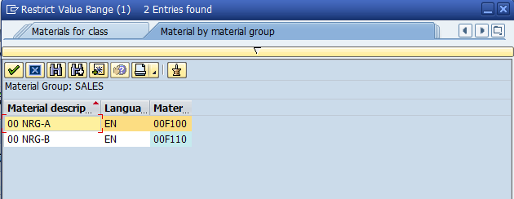
Double-click on ## NRG-B to select it

Select on the ## NRG-B snack bar to select it, and the material number will be entered automatically:

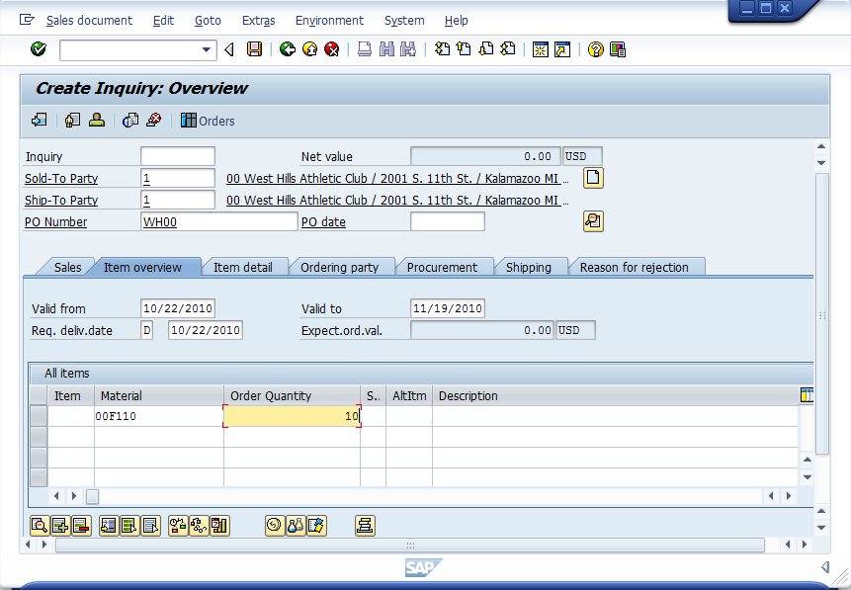
Material number is automatically entered. Enter 10 for Order quantity, then click on the enter icon ().

With the material number entered automatically, enter 10 for Order quantity, then click on the enter icon ():

If any informational messages appear, just click on the enter icon () to clear them.

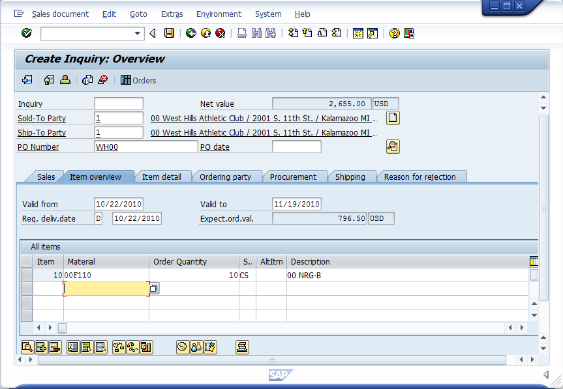
Notice that SAP has called up information about the Sold-to party and Material from the database.
Select the first line by clicking on the square next to it (),
then click on the item conditions icon ()

Click on the square () next to the first line to select it, and then click on the item conditions icon () and the following screen will appear:

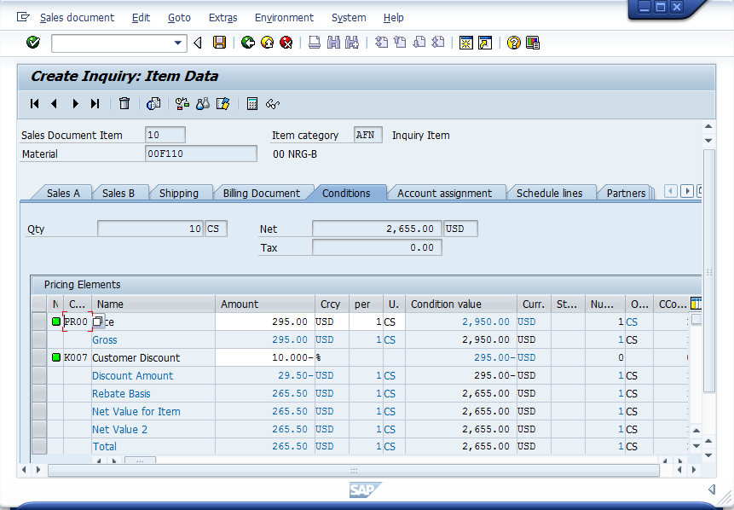
Note discount, then click on the back icon

The Item Data screen provides the user important information pertaining to the price of the specific item desired by the customer. In addition, any quantity discounts which might be available when the product is sold and any special customer discounts offered previously arranged with this particular customer. Because the standard price for 10 cases is $2,950 and ## West Hills Athletic Club receives a 5% price discount for any line item over $1,000 and a 10% discount for any line item over $1,500, this inquiry includes a discount of $295. Click on the back icon () to return to the Create Inquiry: Overview screen:

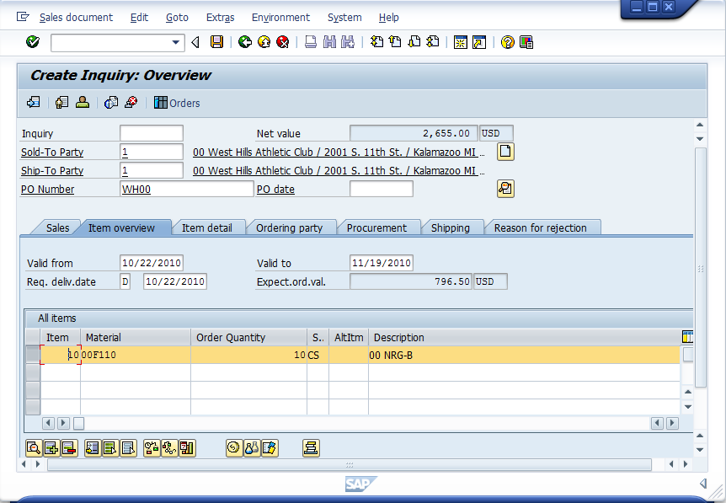
Select the first line, then click on the Display availability icon

Select the line item again, and then click on the Display availability icon () which will produce the following screen:
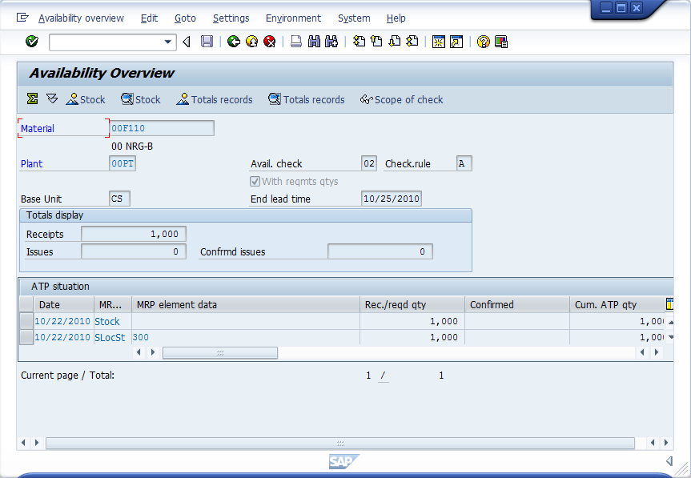
This screen shows that number of cases that are currently available to sell and where they are located (storage location 300)

The Availability Overview displays the amount of stock availability for sale. Note the quantity of ## NRG-A bars available and the storage location where they are currently located. Click on the back icon (), then click on the save icon () to save the inquiry. Click on the exit icon () to return to the SAP Easy Access screen.

2. Create a Sales Order from an Inquiry

If the customer wants to place an order after receiving the inquiry, we can create a sales order from the inquiry so that we don’t have to reenter the basic data (and, potentially, make a mistake in doing so). To create a sales order from the inquiry, follow the menu path:

Logistics Sales and Distribution Sales Order Create (Create Sales Order from Inquiry)

which will bring up the following screen:

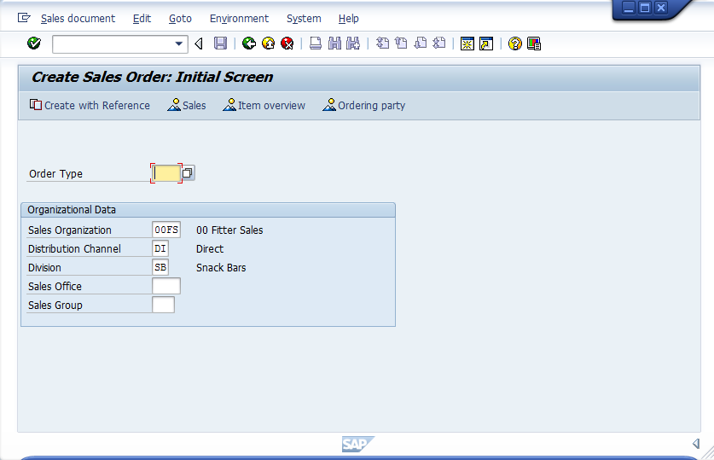
Enter OR for Order Type
Enter ##FS for Sales organization
Enter DI for Distribution channel
Enter SB for Division
Then click on the Create with reference icon

Enter the information shown above, then click on the Create with reference (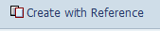) icon and the following screen will appear:

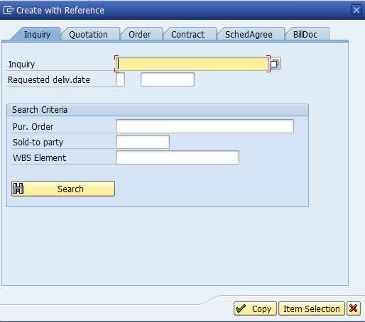
Click on the Inquiry tab, then click on the search icon to search for your customer.

Make sure you have selected the inquiry tab, and then click on the search icon () to bring up the following pop-up window:

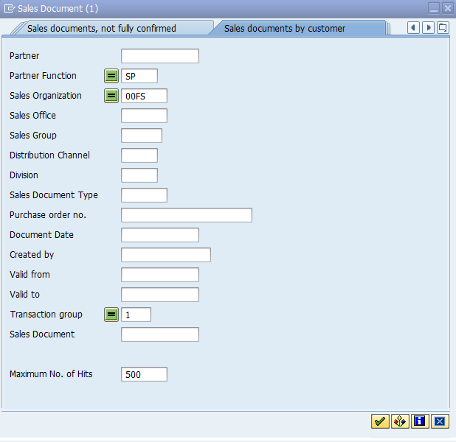
Select the Sales documents by customer tab
Make sure SP (sold-to party) is entered under the Partner function, ##FS is entered for the Sales organization and 1 is entered for Transaction group, then click on the enter icon

To search for the inquiry, make sure SP is entered for the Partner function (sold-to party) and ##FS is entered for the Sales organization, then click on the enter icon () and search results similar to the following should appear:

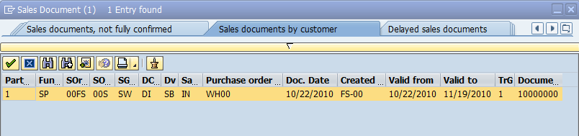
If more than one inquiry appears, find the one created by you by looking for your user id.
Select the line to select your inquiry.

Select on your inquiry, and the inquiry number will automatically be entered:

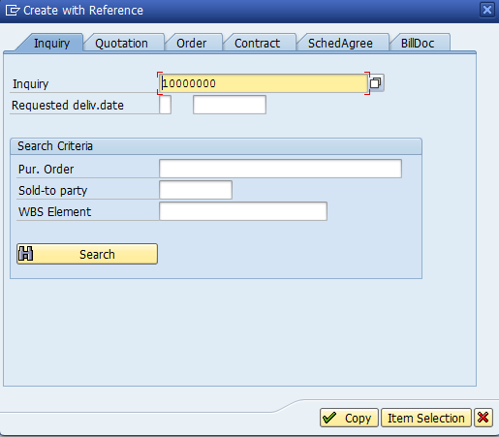
Inquiry number automatically entered

With the inquiry number entered, click on the copy icon () and the following screen will appear:

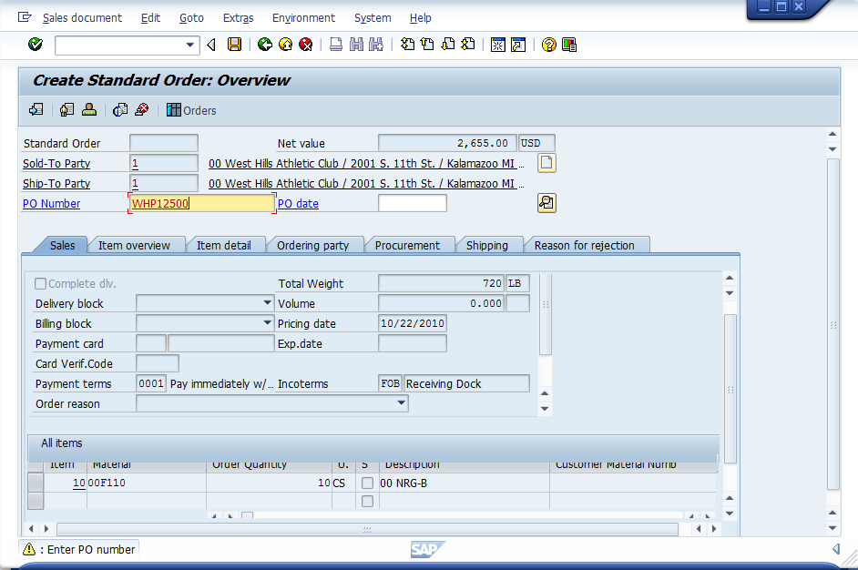
Enter WHP125## for Purch. order no., click on the enter icon and then click on the save icon

Information from the Inquiry has been entered automatically—sold-to and ship-to party information, material and quantity. Purchase Order Numbers are typically internal numbers issued by the customer so it can track all of the purchases it has made. Accordingly, this number will not be generated by SAP. Rather, it will be issued by the customer and will need to be manually entered into the SAP system. This will allow the customer ease in tracking its orders by having one consistent number.

Enter WHP125## for purchase order number, click on the enter icon (), then click on the save icon () to save the order. Click on the exit icon () to return to the SAP Easy Access screen.

3. Create a Delivery for the Sales Order

In the SAP R/3 system, a delivery is a status that allows the warehouse to pick, pack and ship the order. To create a delivery, follow the menu path:

Logistics Sales and Distribution Shipping and Transportation Outbound Delivery Create Single Document With reference to Sales Order (Create Delivery for Sales Order)

which will bring up the following screen:

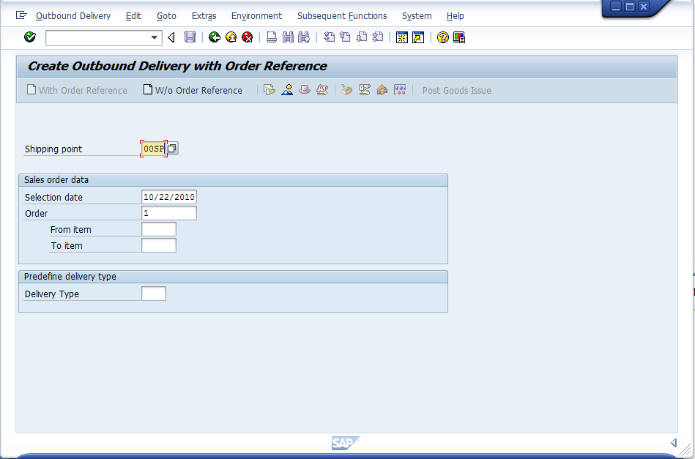
Enter ##SP for Shipping Point
Order number should be entered automatically.
Click on the enter icon

The order number should be entered automatically. Enter ##SP for shipping point, then click on the enter icon () to bring up the following screen:

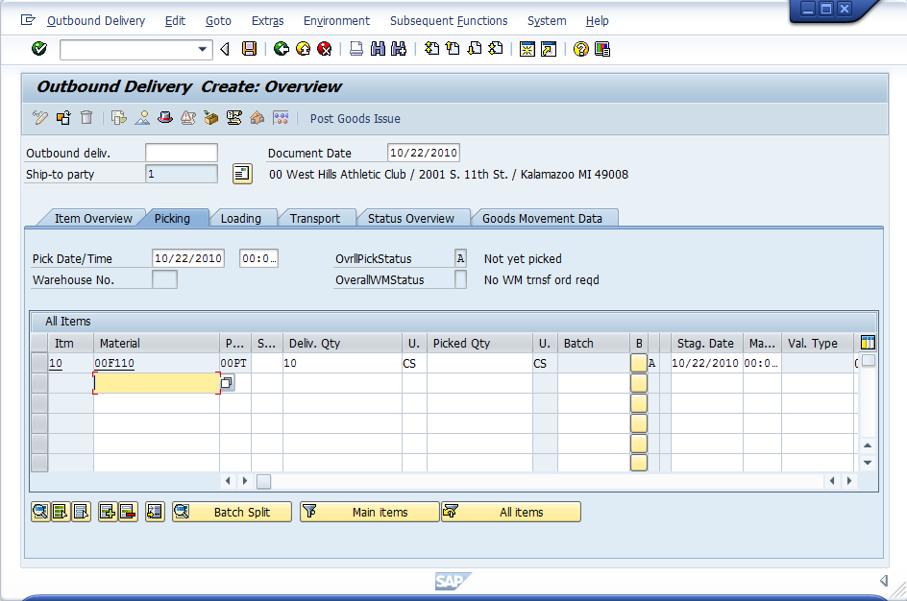
Click on the save icon to create the delivery

we are happy with all of the default values, we can click on the save icon () to create the delivery. You should get a message at the bottom of the screen like the following:

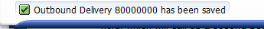

Click on the back icon () to return to the SAP Easy Access screen.

Stock/Requirements List

To see the current inventory position for our snack bars, we can use the Stock/Requirements list. The stock requirements list shows the current inventory level, any outstanding sales orders as well as any planned production orders. The stock/requirements list is very handy, and it is usually a good idea to keep a session open so that you can easily view the Stock/Requirements list without having to leave a session.

First, we need to create another session for the Stock/requirements list. To do this, follow the pull-down menu path:

SystemCreate Session

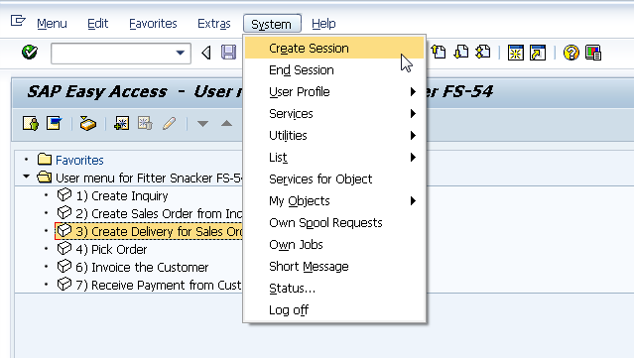

This will create a new session. To view the new session, look for it on the task bar at the bottom of the screen and click on it.

When you are in the new session, you need to find the Stock/Requirements list. There are many different menu paths that will get you there. One of the menu paths is:

Logistics Production MRP Evaluations Stock/Requirements List

which will bring up the following screen:

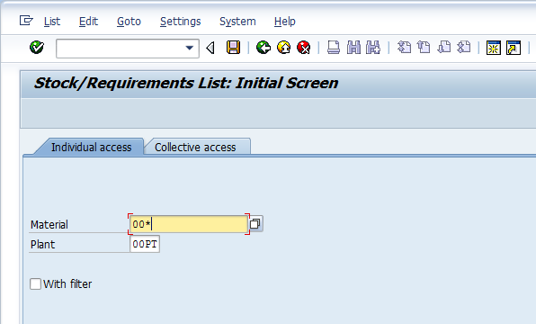
Use the search function to find ## NRG-B, by entering ## * in Material and ##PT in Plant, and then click on the search icon

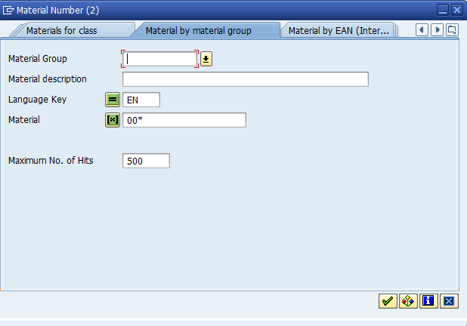
Select the tab Material by Material Group
Click on the arrow next to the material group field to find the tab

Find the tab with Material by Material Group, and then click on the arrow () next to the Material group field, which will call up a second pop-up window:

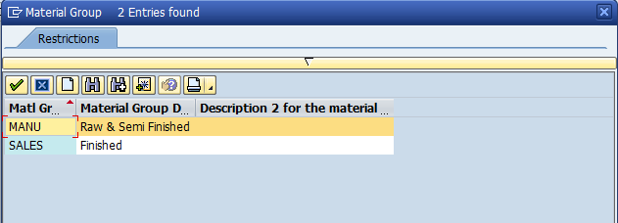
Select Sales.

Select on the SALES group to select it, then enter ##* for Material description:

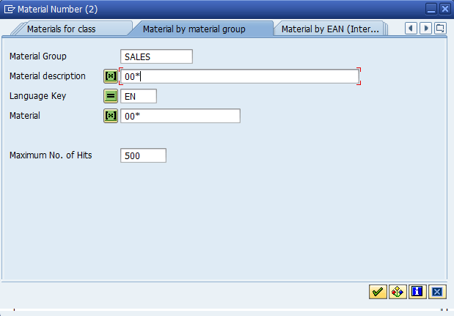
Enter ##*for Material description and then click the select icon

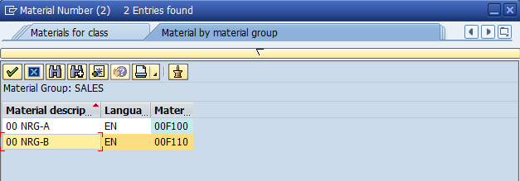
Double-click on ## NRG-B to select it from the list of materials.and the material number will be populated in the material field in the Stock Requirements List Initial Screen

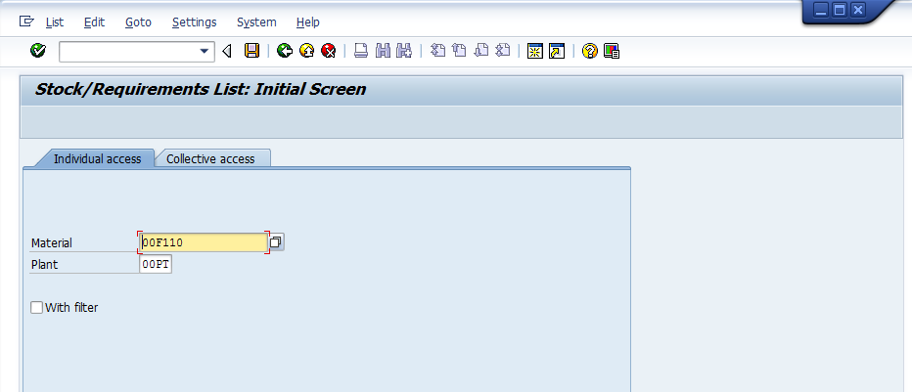
Verify ##PT is in the Plant field and the material information is in the material field. Click on the enter icon. which will bring up the Stock/Requirements list:

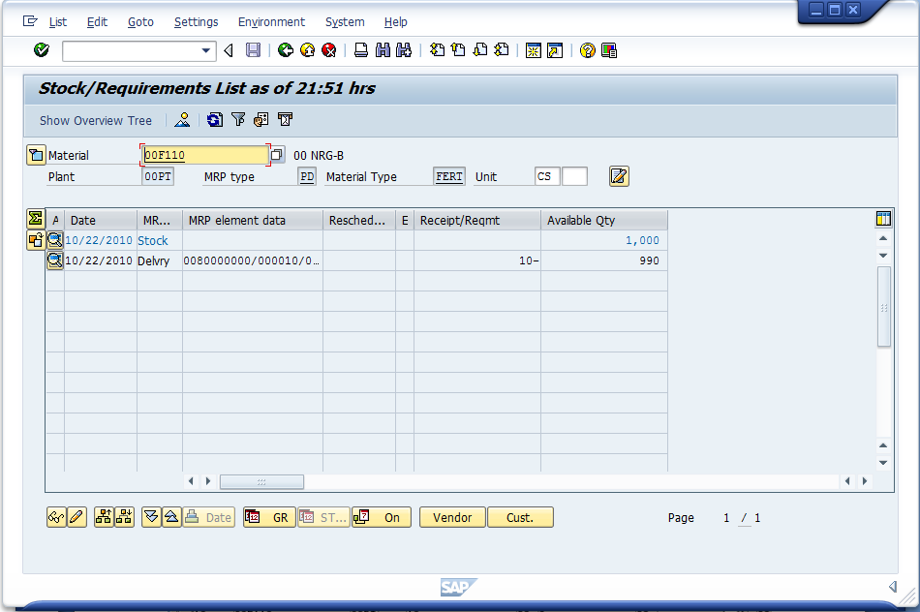
Note the current level of on-hand material and your delivery (Delvry). Select the delivery line. By clicking on the icon next to Delvry

You should see enough material on hand to complete your order and your delivery should be listed. Note that the Delivery amount is negative as there will be 10 units decremented from stock once the delivery is processed. You may also see deliveries from other students. You can see more details about the delivery by select on the line with your Delivery. When you do, you will get the following pop-up window:

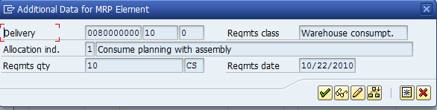
Click on the details icon

Click on the details icon, and the R/3 system will display the details of the delivery you just created:

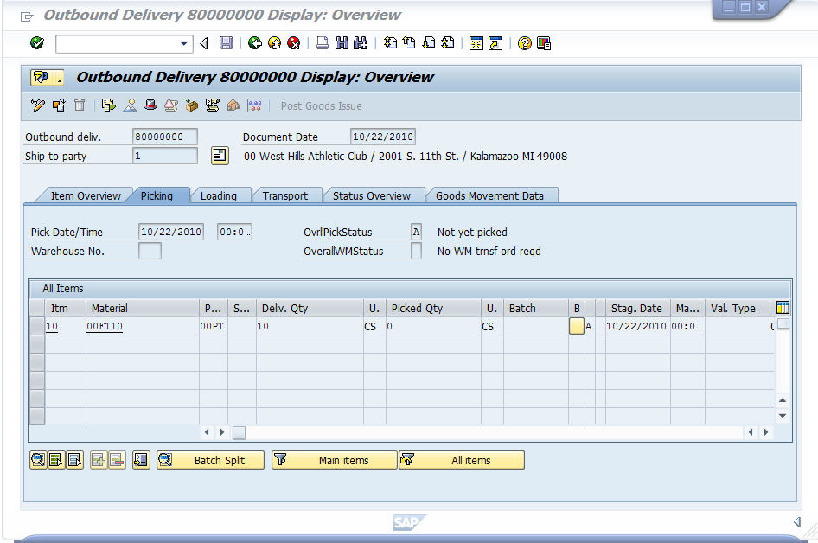
Make sure Picking Tab is selected

Verify the Picking tab is selected. From this delivery, we can see the documents that resulted in this delivery (inquiry and sales order). In SAP, the Document Flow links all of the documents related to a particular sales order. The document flow can be accessed by following the pull-down menu path:

EnvironmentDocument Flow
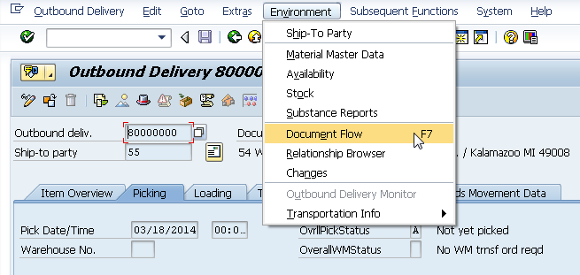
which will produce the following screen:

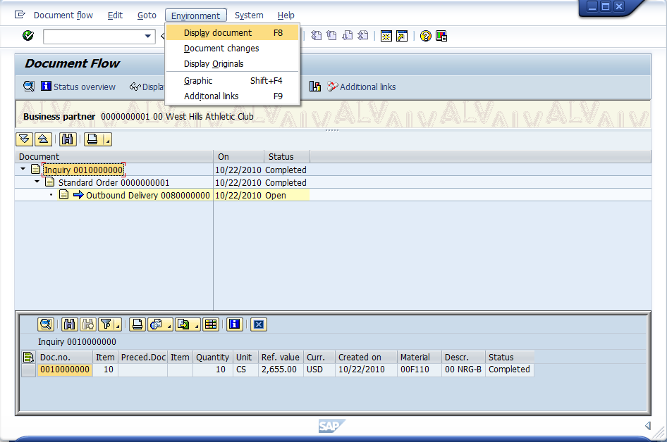
Click on the inquiry line and select Evironment-> Display documents.
The Document Flow shows the trail of documents for the sales cycle. For the ## West Hills order, the cycle started with an inquiry which was used to create a sales order. The processing status of the Inquiry and Standard order are shown as completed. The Outbound Delivery, which encompasses the pick, pack and ship tasks, is shown as open.

From the Document flow, you can display any of the documents shown. For example, click on the inquiry and select Evironment-> Display documents to display the original inquiry that started the sales-order process:

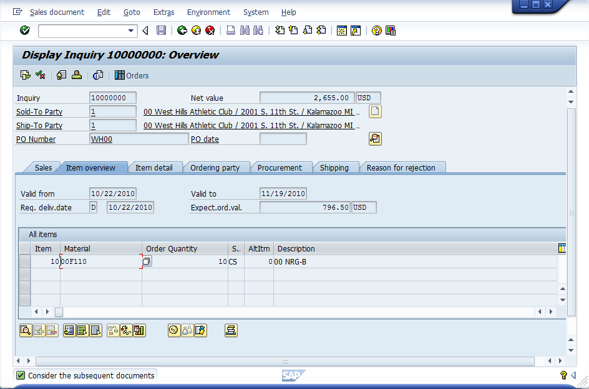

The ability to link to any document in the sales process via the document flow is a powerful tool. If a customer calls with a question regarding their sales order, the customer service representative can quickly find any document related to the sales order once they have found one document.

Use the back icon () repeatedly to return to the Easy Access screen.

4. Picking the order

With the delivery created, the order can be picked, packed and shipped. The SAP R/3 system has many capabilities to schedule these processes, however, we will not consider those in this exercise. In a highly automated warehouse, the picking of the order may be recorded in the SAP system using bar code scanning. For our exercise, we will manually enter the quantity picked. To do this, follow the menu path:

Logistics Sales and Distribution Shipping and Transportation Outbound Delivery Change Single Document

which will bring up the following screen:

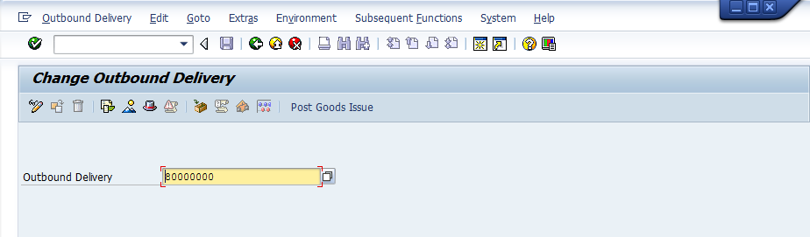

Your delivery number should automatically be entered. Click on the enter icon () to bring up the following screen:

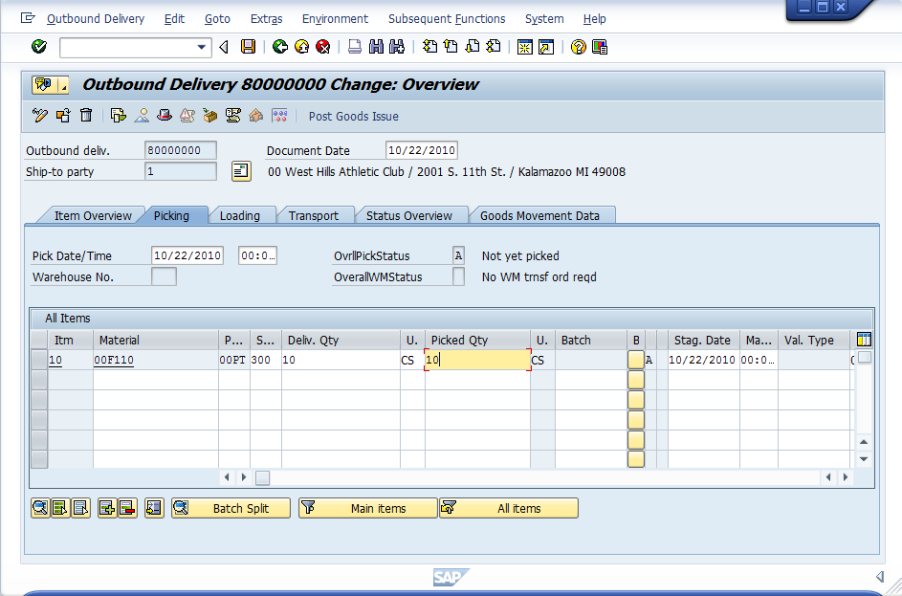
Click on the Picking tab, then
Enter 300 for SLoc (Storage location) and 10 for Pick quantity, then click on the save icon .

This screen allows you to enter a different pick quantity than what was in the order in case the inventory in the warehouse does not match the inventory level shown in the system. Of course, the idea with an integrated information system like SAP is to have 100% accurate, real-time inventory information, but mistakes in entering and recording inventory transactions do occur.

We will assume that the inventory is accurate and the order can be completed, so enter 10 for Pick quantity and 300 for SLoc (Storage location), then click on the save icon (). You should get a message like the following at the bottom of the page:

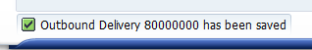

Switch to the other session, which should still be showing the Stock/Requirements list.

If the Stock/Requirements list is not on the screen, follow the menu path:

Logistics Production MRP Evaluations Stock/Requirements List you will see:

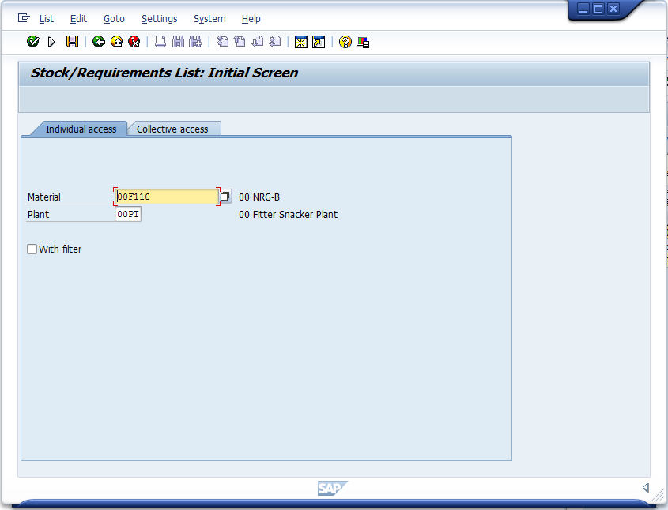

then click on the click on the enter icon ().

Click on the refresh icon () to see if picking the order has changed anything:

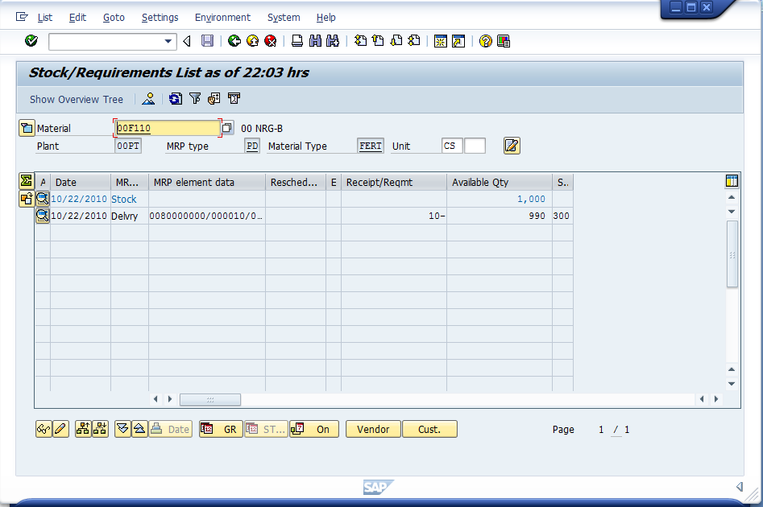

In case you haven’t noticed, the Stock/Requirements list is unchanged. While we have picked the cases of snack bars off of the warehouse shelf in preparation for shipping, according to the SAP system they are still Fitter Snacker’s snack bars. In the next section, we will post the goods issue, which will signify that the snack bars have left the building.

Return to the easy access main menu by clicking the exit button ().

5. Post Goods Issue

In the SAP logistics terminology, we receive goods into inventory and issue goods from inventory to the production floor or to the customer. In the accounting world, we record business transactions by posting them to an account. Thus, when we post the goods issue, we record the change in stock level and financial position of the company as a result of sending the goods on their way. To post the goods issue, follow the menu path:

Logistics Sales and Distribution Shipping and Transportation Outbound Delivery Change Single Document

which will bring up the following screen:

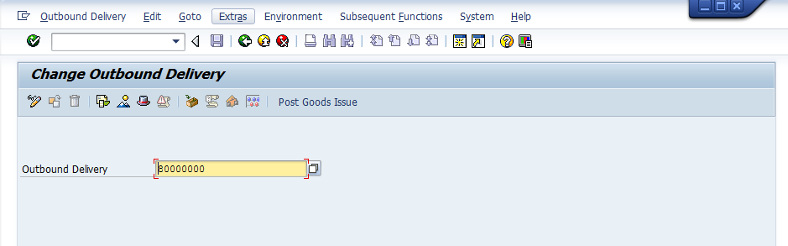
The document number should be entered automatically. Click on the Post goods issue icon.

After clicking on the Post goods issue icon, the following message should appear at the bottom of the screen:

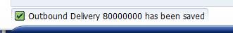

Return to the easy access main menu by clicking the exit button ().

Navigate to the Stock/Requirements list by following the menu path:

Logistics Production MRP Evaluation Stock/Requirements list
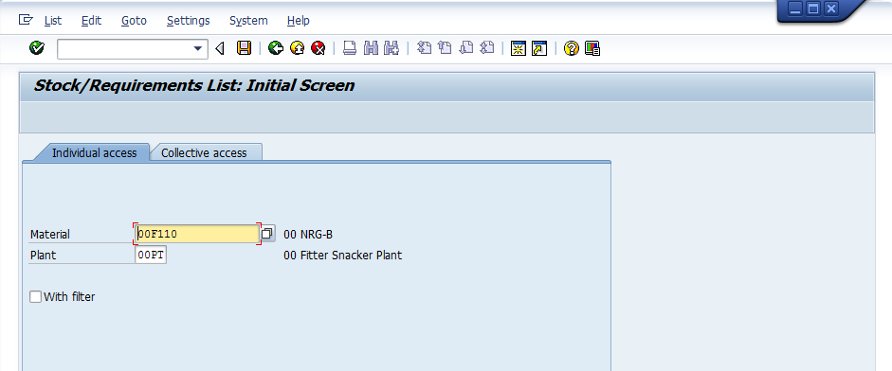

click on the enter icon () which will bring you to:

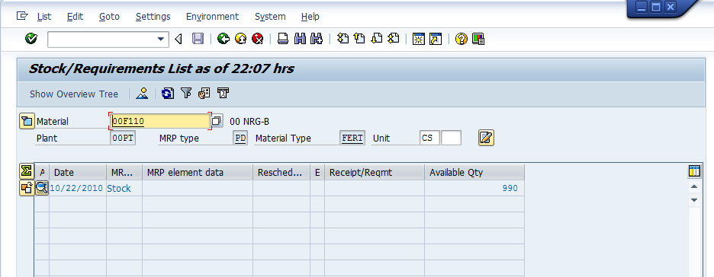
Delivery is gone, and the inventory level is reduced by 10 cases

Posting the goods issue has removed the Delivery from the Stock/Requirements list and reduced the available inventory level by 10.

Switch to the other session. You should be at the Change Outbound Delivery screen. If not, follow the menu path:

Logistics Sales and Distribution Shipping and Transportation Outbound Delivery Change Single Document

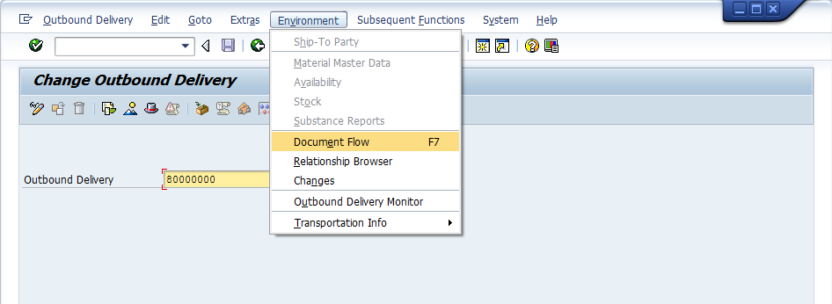

Your delivery document number should be entered automatically. Follow the pull-down menu path:

EnvironmentDocument Flow

which will produce the following screen:

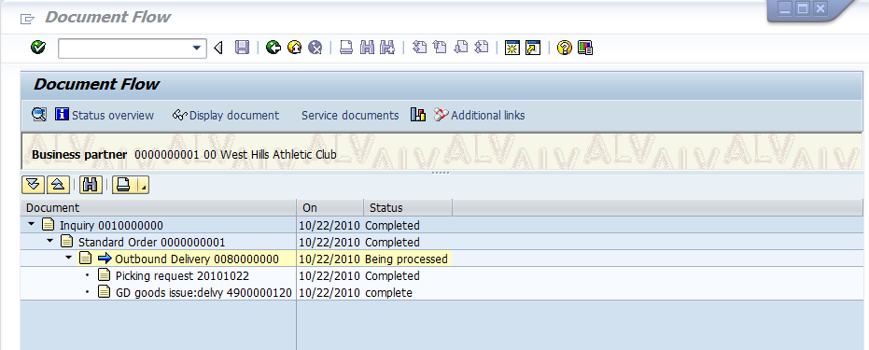

Compare this document flow to the previous status. The outbound delivery status is now Being processed, and the picking request and goods issue are both complete. Click on the back icon () until you are back at the SAP Easy Access screen. By now, your menus are probably pretty unwieldy because of the number of paths that have been expanded. To make the menus easier to use, click on the SAP Menu icon () to restore you menus to their original configuration.

6. Invoice the Customer

Perhaps as important as delivering the customer’s order on time an in good condition is properly billing the customer for their purchase. If we don’t invoice the customer, we aren’t likely to be paid. Thus, it is important to be able to determine which customers still need to be billed. WE can use the Billing Due List to see all of the customers that need to be invoiced. To create the Billing Due List, follow the menu path:

Logistics Sales and Distribution Billing Billing Document Process Billing Due List

which will produce the following screen:

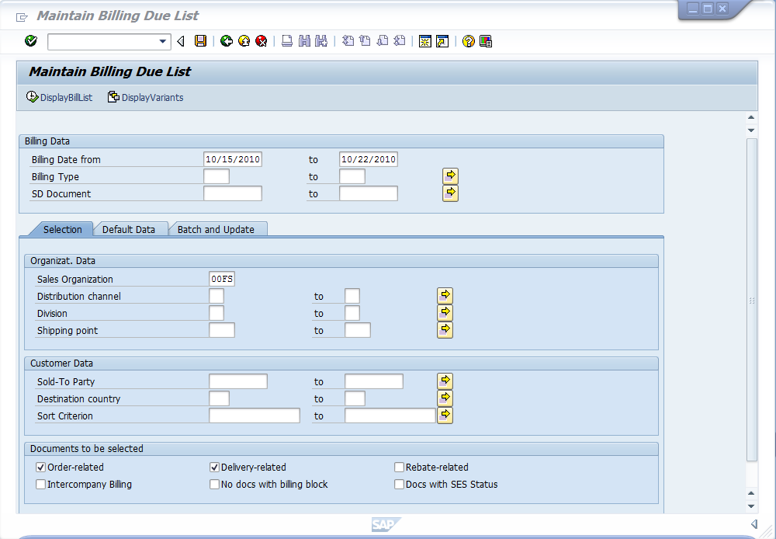
Today’s date will show up automatically in the to field. Enter a date a week in the past in the Billing date from field.
Enter ##FS for Sales organization
Check both Order-related and Delivery-related check boxes.

Enter the information shown above, then click on DisplayBillList icon (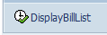), which will produce the following screen:

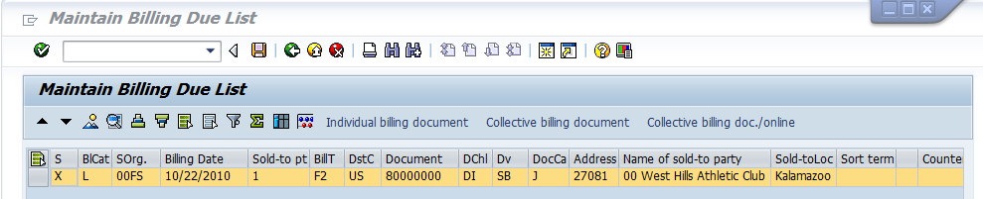
Click on block at end of line to select, and then click on Collective billing document

There should only be one item on the list. Select it, and then click on the icon Collective billing document (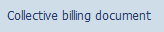). It won’t appear that much has happened, but an invoice will be created. Use the exit icon () to confirm and return to the SAP Easy Access screen. Follow the menu path:

Logistics Sales and Distribution Shipping and Transportation Outbound Delivery Display

which will produce the following screen:

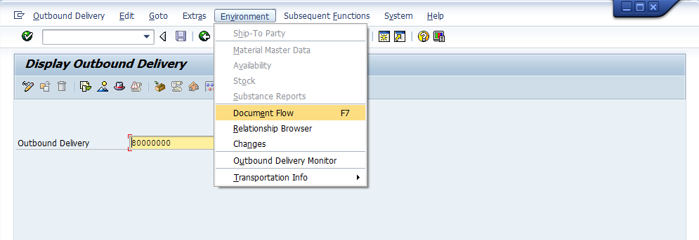

Your delivery document number should be entered automatically. Follow the pull-down menu path:

EnvironmentDocument Flow

which will produce the updated Document Flow:

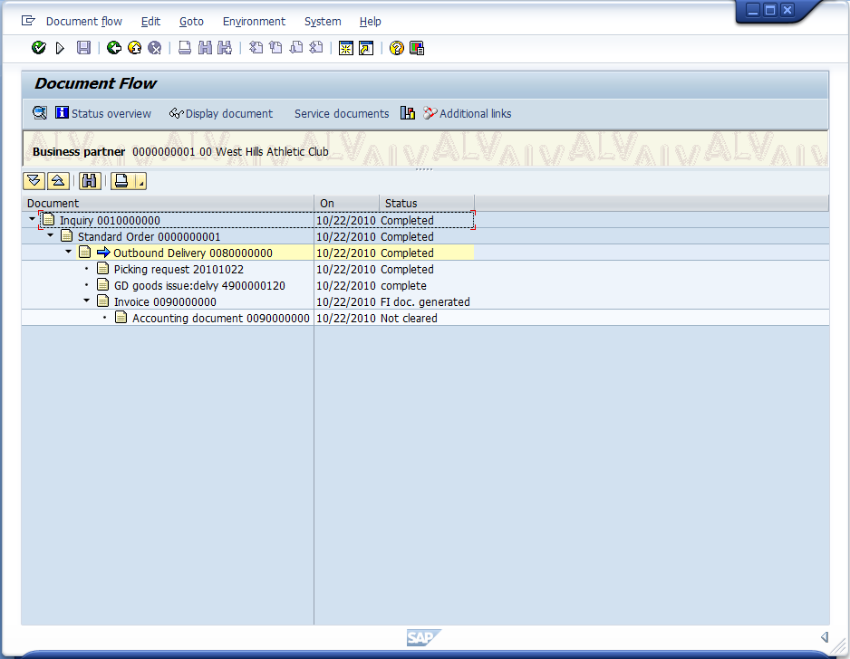
Click on the Accounting document line, then click on Environment → Display document

Notice that the status of the Outbound delivery is now completed. That is because the creation of the invoice completes the Outbound delivery process. Notice also that an accounting document has been created. Click on the Accounting document line, then follow the pull-down menu path:

Environment -> Display document

Which will display:
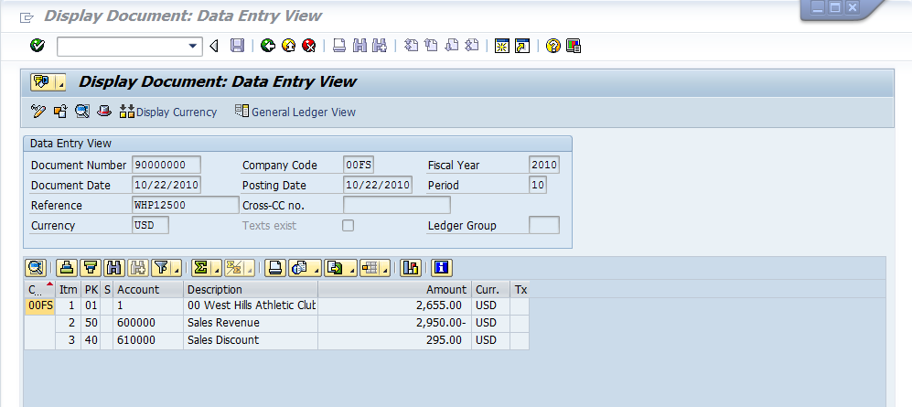

Notice that three accounts have been affected by the invoice—## West Hills Athletic Club’s account, the Sales Revenue account and the Sales Discount account. Click on the back icon () until you have returned to the SAP Easy Access screen.

7. Receive payment from the Customer

Hopefully the invoice has prompted the customer to send in a payment for the snack bars they have received. The billing folks must post the payment received to the customer’s account or the customer will receive subsequent notices indicating delinquent payment. (This does not produce good feelings from customers!!!) To post the customer payment, follow the menu path:

Accounting Financial Accounting Accounts Receivable Document Entry Incoming Payments

which will bring up the following screen:

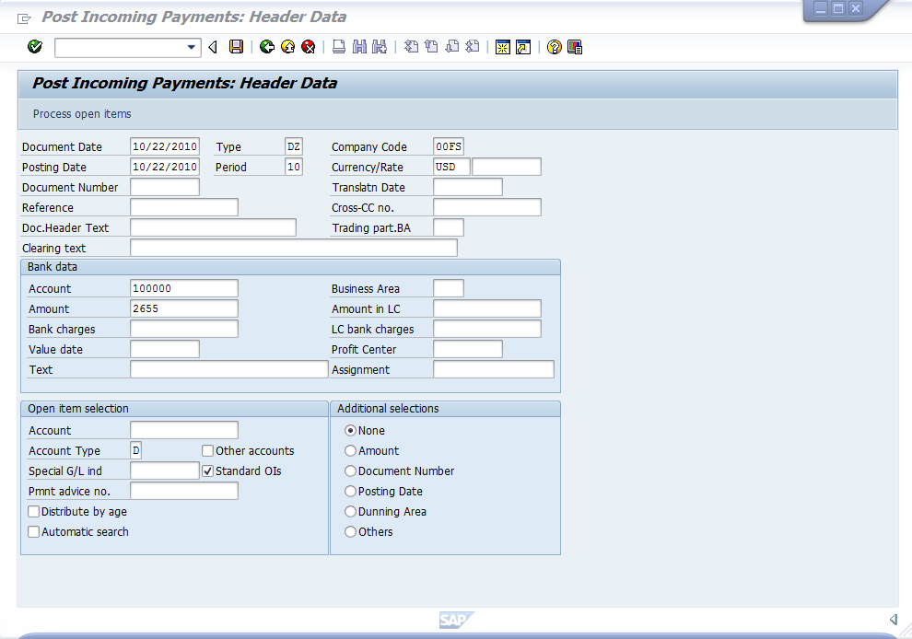
Enter today’s date for document date
Make sure ##FS is entered for company code and USD is entered for Currency/rate
Enter 100000 for Account under bank data
Enter 2655 for Amount
Click on the Account field in Open item selection, and then click on the search icon
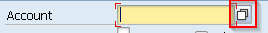

Make sure the information shown above is entered, then click on the search icon for Account under Open item selection:

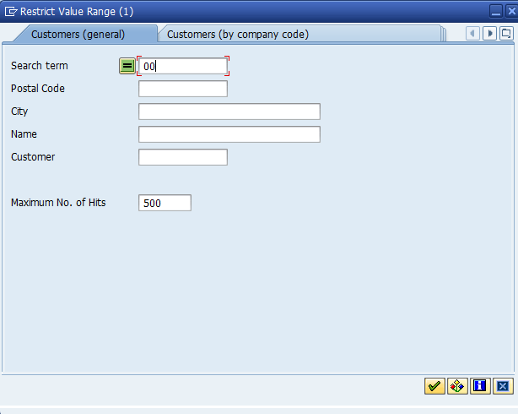
Enter ## for Search term, then click on the enter icon

Enter ## for search term, then click on the enter icon (), which will bring up a list of your customers:

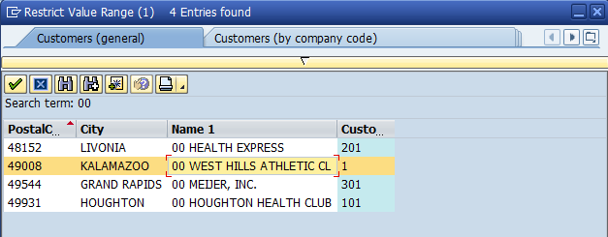
Double-click on West Hills Athletic Club line to select it

After selecting ## West Hills Athletic Club, click on the Process open items icon ():
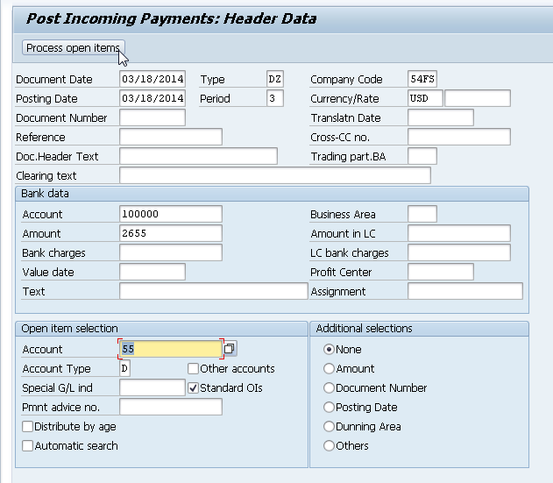

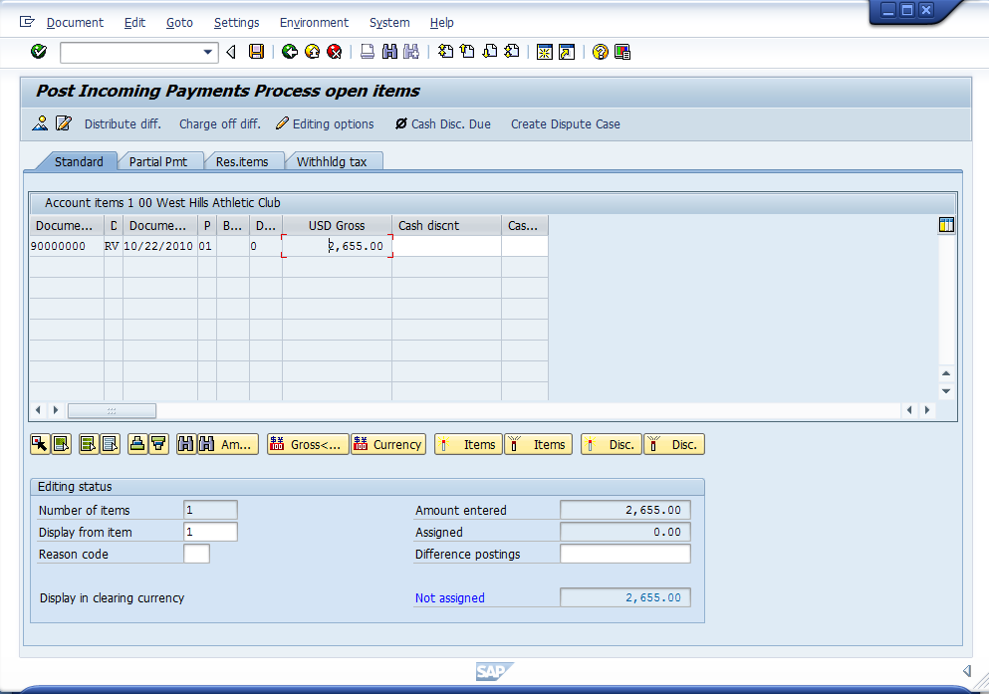
Double-click on the USD Gross amount

Select on the USD Gross amount, and the system will assign the entire payment to the invoice:

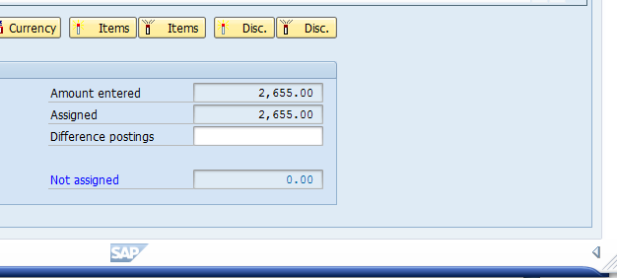

Click on the save icon () to post the payment. You will see this message:

Click on the exit icon () to return to the SAP Easy Access screen. A data lost dialog box may appear. If so, click yes.

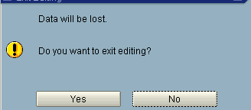
To view the document flow, follow the menu path:

Logistics Sales and Distribution Shipping and Transportation Outbound Delivery Display

which will again produce the following screen:

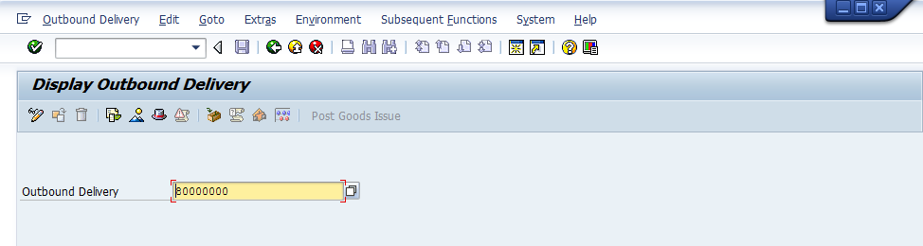

Your delivery document number should be entered automatically. Follow the pull-down menu path:

EnvironmentDocument Flow

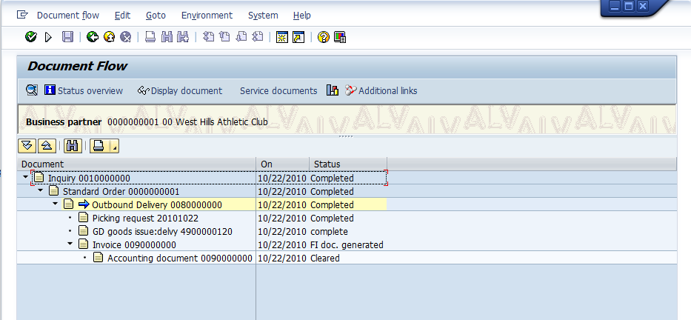

The document flow shows that the sales order process is complete.

Create a screen shot of the Document Flow Screen.

To make a screen shot, verify the screen you need to make an image of is on the screen. Hit the Ctrl and Prt Screen (next to the Num Lock key) keys at the same time. Open the Word document with the Overview of the SAP Exercise. Place the cursor in correct position in the document for the Sales Order Screen Shot. Hit Ctrl and V keys (or Edit -> Paste from the Menu on the top of the Word Document). This will paste the screen shot into the Word document you are preparing for this assignment.

You are now ready to proceed with the next exercise. Be happy – this is the longer exercise so you are more than a half of the way there!!!

