Setting Up Azure Accounts

1. Go to www.microsoftazurepass.com. This should be the page you get to:

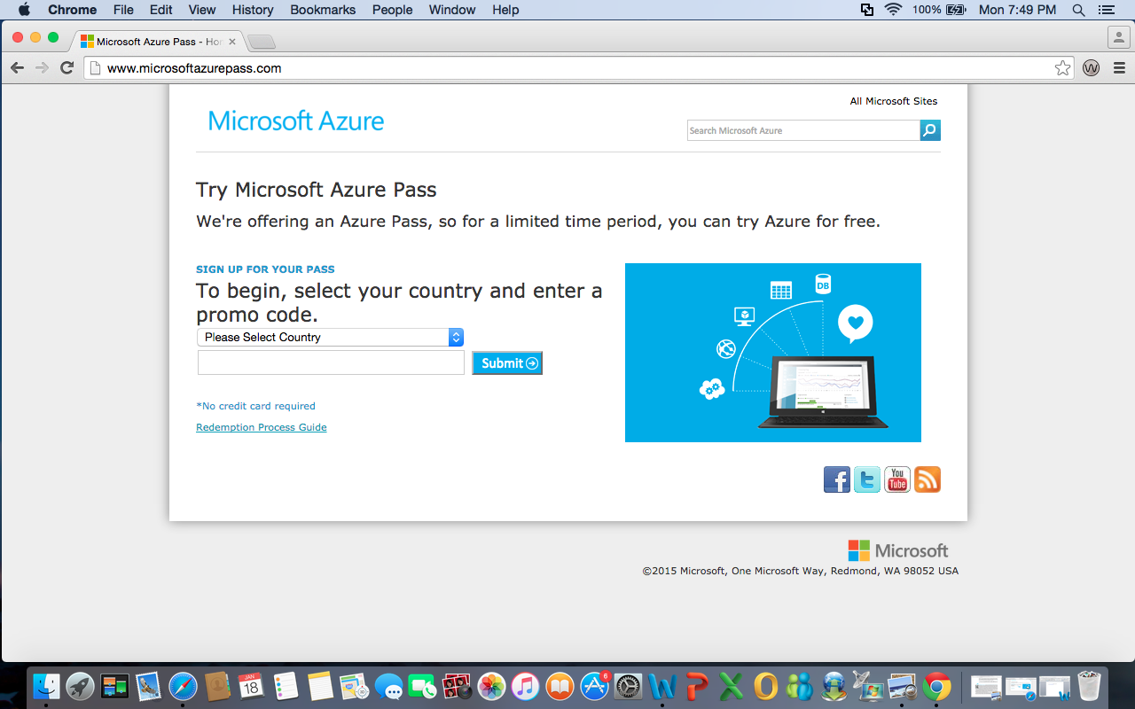

2. Select United States for country and enter the promo code that was given to you (This code can be found In Gradebook). Then click submit.

3. You will be redirected to a sign in page:
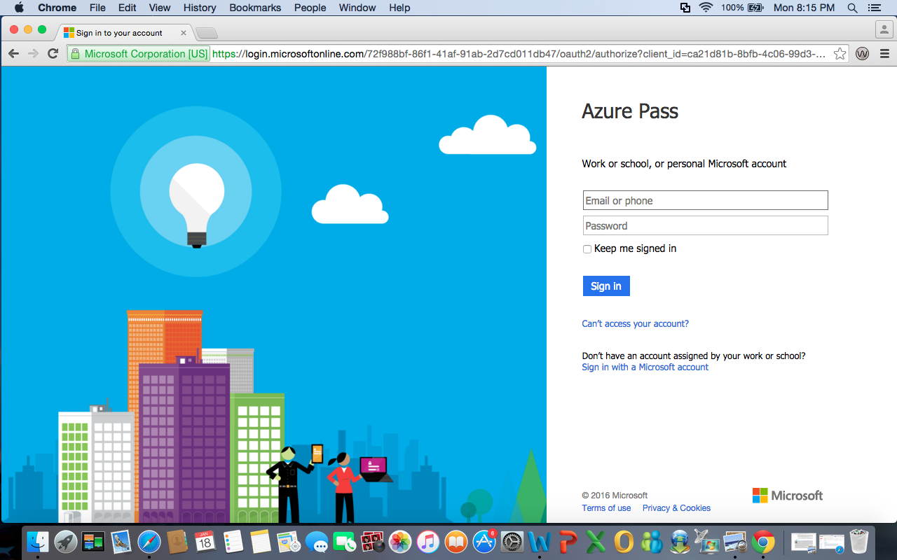
4. Enter your temple email and you will be redirected again to a temple sign in page:

5. Enter your temple accessnet username and password to log in.

6. You will be sent to a page to confirm your information. Make sure it is correct and click submit.

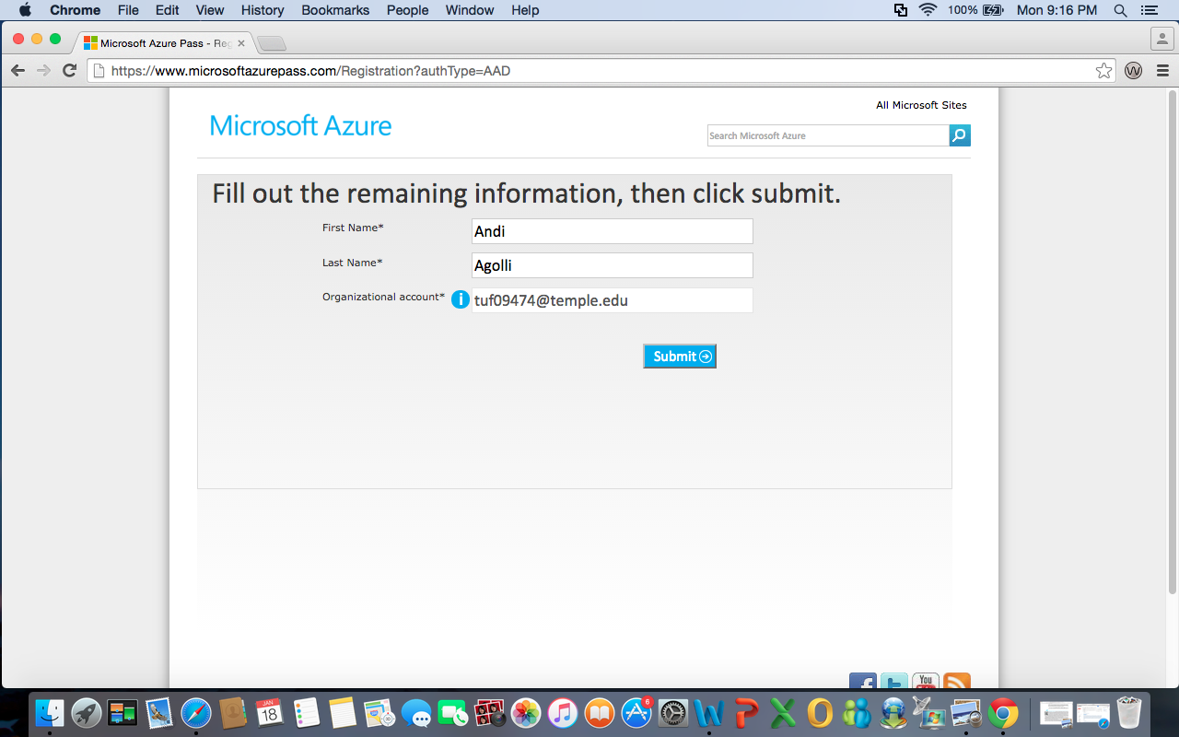
7. You should then see your Azure Pass offer and an option to activate it. Click Activate.

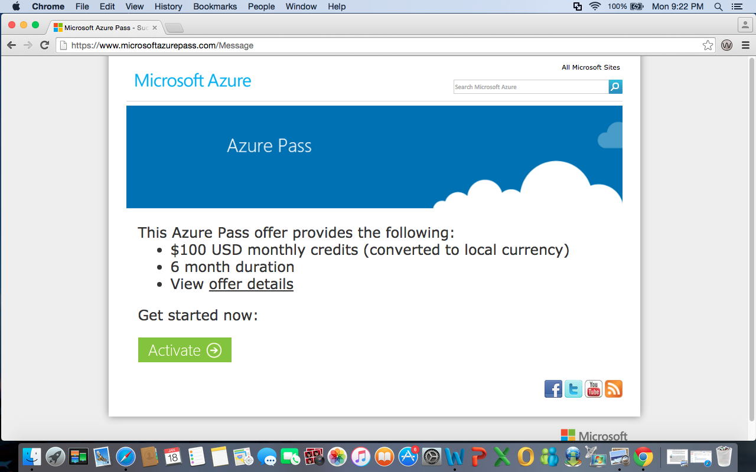

8. Azure will then ask you to enter some more information. Fill in the necessary info, check the agreement box, and click Sign Up.
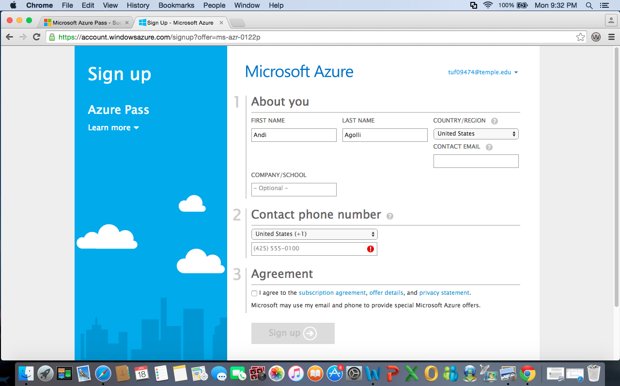

9. You will be asked to agree to their terms one more time. Make sure the box is checked and click Purchase. It may take some time to process.

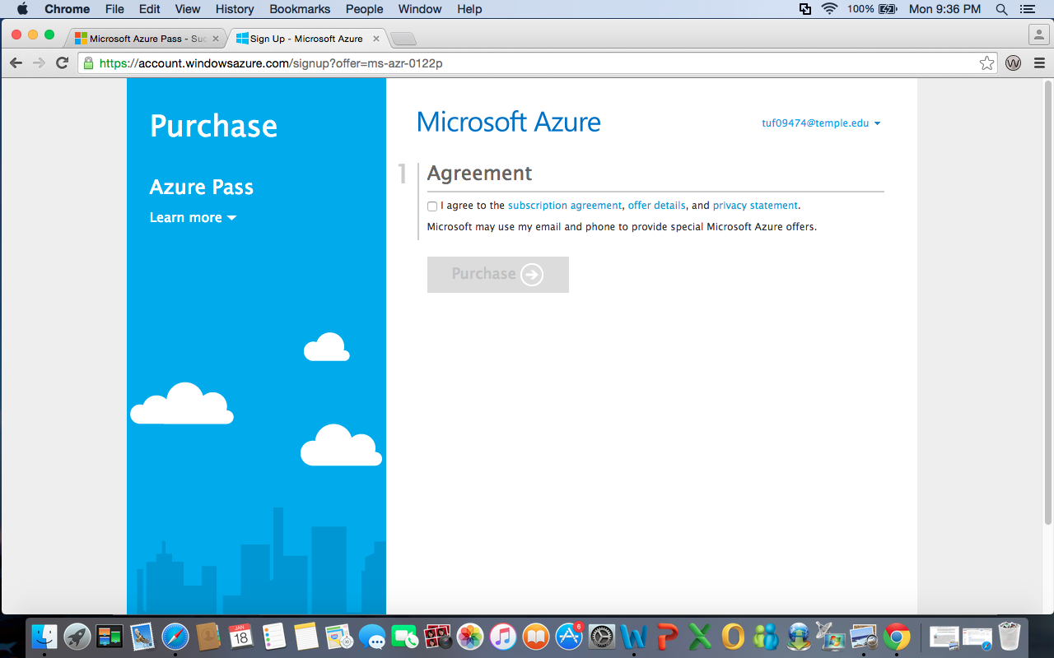

10. Finally, you will be redirected to a page that will ask you to wait for your subscription to be applied. After a short wait, your subscription will be ready. Click Start managing my service to begin using Microsoft Azure!
