Summary of Findings:
On 9/21/2016, Silas Adams (SA) intended to perform a reconnaissance exercise on Dow Chemical in order to attain information on the company to create a profile that would be used for vulnerability scanning, and ultimately a penetration test. However, SA identified a softer target via investigation into Dow Chemical, as such the exercise analysis was carried out on AgroFresh Holdings Berhad. SA executed an nslookup command within Linux to retrieve the internet protocol (IP) address and re-performed the process to retrieve sites related to the dow.com address (refer to Appendix A). An anomaly was returned, one of the addresses listed was deathtothequeen.com, SA re-performed the nslookup to see if the addresses associated with deathtothequeen.com would be the same addresses associated with Dow Chemical. Again the results contained a single anomaly, smartfresh.com appeared this time, however, it did not appear during the initial nslookup (refer to Appendix B). Additionally a whois command was ran to see the details on the owner of the domain and the results indicated that Dow Chemical was the named server for the site. After further investigation, it was determined that smartfresh.com was an R&D project for a new type of agricultural technology for preserving fruit and vegetables. It was divested to Avenue Capital Group for $860 million. The Capital Group then restructured the business and sold it off to a holdings group in Southeast Asia and was renamed AgroFresh Holding Berhad (AHB). In addition to the findings below, it was noted that AHB was disallowed trade with the U.S. after failing to pay taxes several years in a row, further its Tax Identification Number (TIN) was divulged in the same document, which subjects their TIN to inappropriate and illegal usage. AHB is considered a soft target and needs to re-assess its IS risks associated with its continued operations.
Key Findings:
- Organizational Structure:
  - Findings: Through the use of structured search queries in Google’s search engine, the key executives of AgroFresh Holdings Berhad (AHB) and its board members were disclosed as well as their relationships to other board member and key executives in industry. Using a normal Google search it was disclosed that the two of the key executives serve on the board of directors and are family of the Executive Chairman (refer to Appendix D).
  - Potential Impact: Nepotism in the upper echelon of organizations can cause principal-agency issues and disrupt the operational efficiency of the organization, threatening the long-term viability of the firm and puts the family at higher risk of ransom, hacking and kidnapping.
- Key Buyers / Suppliers Database:
  - Findings: Using a Google structured search, the database containing all of AHB’s buyers and sellers information including phone, address, names, emails and websites.
  - Potential Impact: This information easily allows for social engineering and phishing attacks to be carried out against AHB (refer to Appendix E). In addition to exposing AHB to additional supply chain risk.
- Enterprise Partners:
  - Findings: In the same Google query, we found an excel file entreprises_partenaires and after further investigations it was found that one of AHB’s subsidiaries was identified as a enterprise partner for Tunisia’s PMN program; which was an economic development plan intended at enabling Tunisian companies to begin competing globally.
  - Potential Impact: Emerging markets have a lot of economic profit potential due limited competition and above average growth trajectories. This information is critical as this makes some subsidiaries and other firms within the listing a prime acquisition target for one of AHB’s competitors, thus eliminating any competitive advantage AHB might have had in the market.

Appendix A:
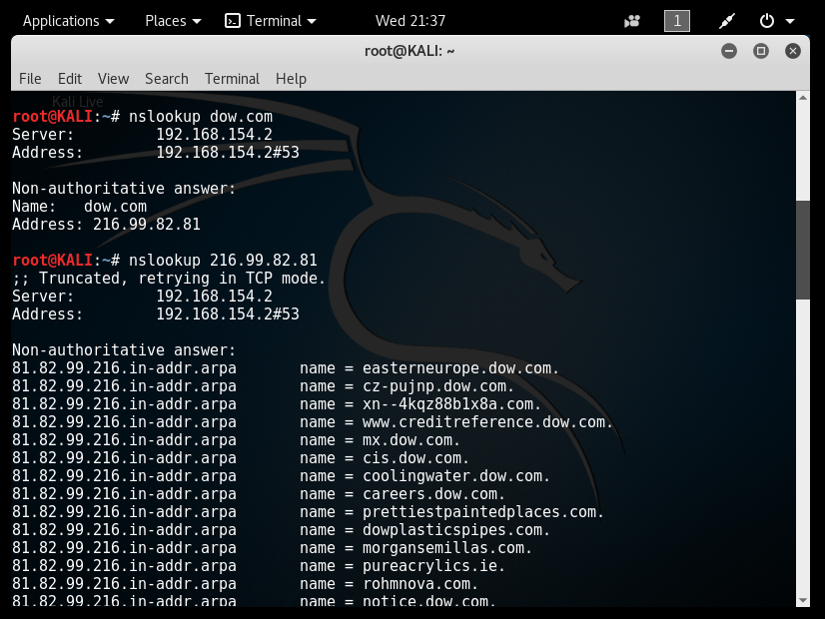

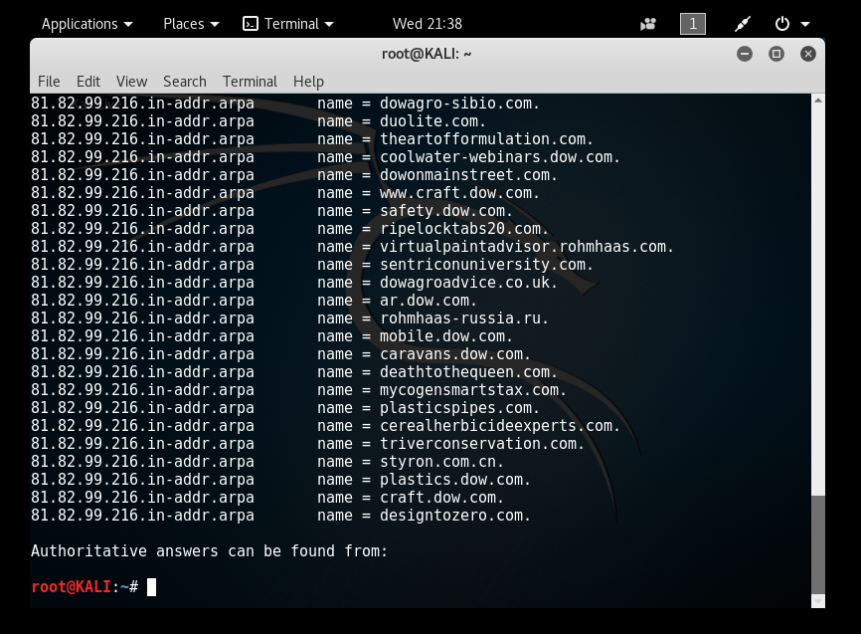
Appendix B:

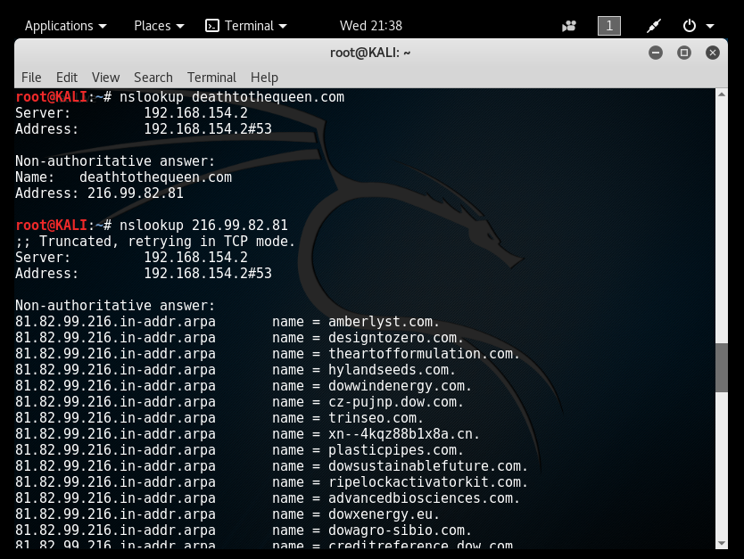

Appendix B (con’t):
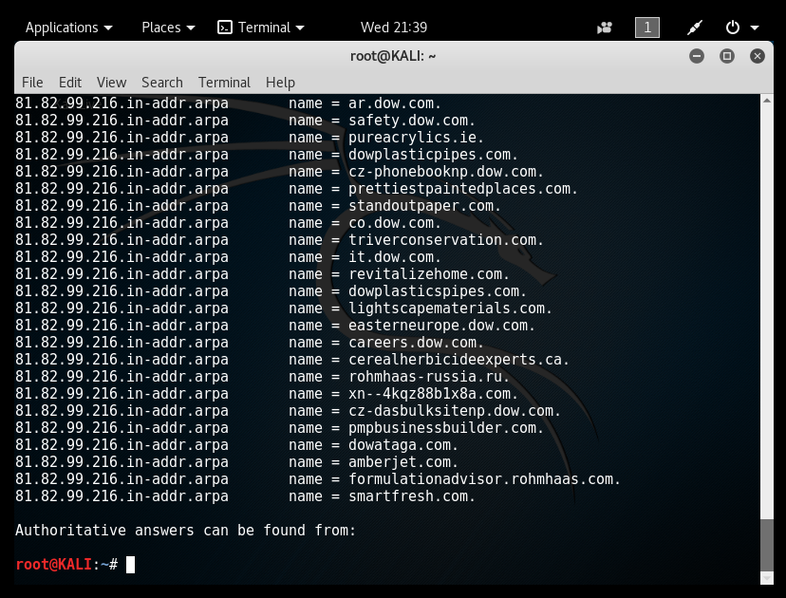

Appendix C:
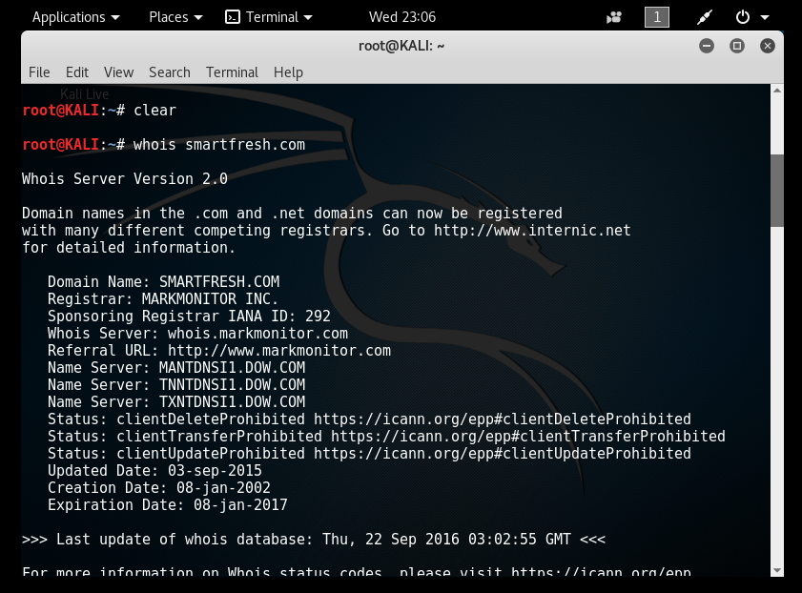

Appendix: D
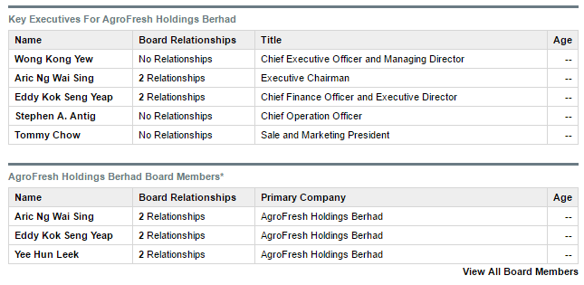

Appendix E:
