Flash Research Assignment #2: Servers & Storage Technologies – Thin Provisioning
Dear CIO,
I am proposing that we invest in thin provisioning technology, which will allow us to use our storage more efficiently and help us save money on unnecessary server costs. We spend a considerable amount of money on storage, but still a majority of the space becomes stranded and unused. This requires us to purchase more storage and data centers, which are unnecessary costs. With thin provisioning we will increase storage utilization rates by 75%-80%, require less physical space for our storage, and reduce our energy costs (Gartner). Investing in thin provisioning will help us save a lot of money that is wasted with our current storage costs.
Our current provisioning strategy involves allocating large amounts of storage in anticipation of our future storage needs and increased data complexity. This results in much of the storage going unused and becoming stranded, thus increasing our storage costs (SearchStorage). With thin provisioning however, we would instead allocate physical capacity from a virtualized pool of storage to logical volumes on a just-in-time basis. This will increase our storage utilization rates by as much as 75%-80% (Gartner). The diagram on the next page shows how thin provisioning works. In figure 1, nearly half of the storage is allocated and unused. This is how we operate right now. In figure 2, however, the storage is more efficiently utilized, which allows for the allocated and unused storage from figure 1 to be available storage instead (Wikibon). All of our current storage will be used to its full potential if we invest in thin provisioning.
Investing in thin provisioning will yield great cost savings. By using thin provisioning, we will require less hardware space for storage, reduce our consumption of electrical energy, and reduce heat generation compared to our current system (SearchStorage). Less hardware space means less money spent on data centers, and with the ever increasing price of energy, the reduced consumption of energy and heat generation will significantly cut back on our expensive energy costs. The benefits of investing in thin provisioning will greatly outweigh the costs, so we would be foolish not to invest in this.

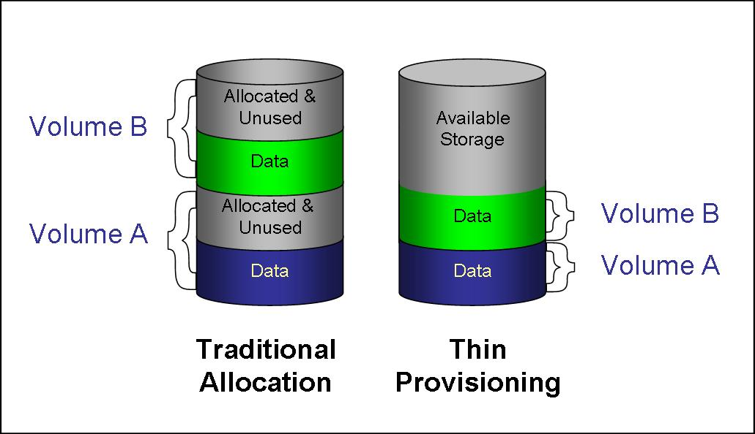
-Wikibon

References
Rinnen, Pushan. "Hype Cycle for Storage Technologies, 2013." Gartner.com. Gartner, 24 July 2013. Web. 18 Sept. 2013. <http://my.gartner.com/portal/server.pt?showOriginalFeature=y&open=512&objI D=260&mode=2&PageID=3460702&id=2557319&ref=>.
Rouse, Margaret. "Thin Provisioning (TP)." Searchstorage.techtarget.com. N.p., Nov. 2006. Web. 18 Sept. 2013. <http://searchstorage.techtarget.com/definition/thin- provisioning>.
Floyer, David. "Thin Provisioning." Wikibon.org. Wikibon, 9 Oct. 2009. Web. 18 Sept. 2013. <http://wikibon.org/wiki/v/Thin_provisioning>.

