Datacenters and Networking-Our Path to a Higher Competitive Advantage

Over the period of the last 3 years, our company has lost $77 million due to 30 unplanned network and power outages due to our data center being obsolete our firm currently loses $14,800 per minute because of our Tier I Data Center. If we implement a Tier III data center we will save $13,229,056 over 3 years. A Tier III data center is a very fault and risk tolerant system that can save our company precious downtime.
Currently, our Tier I data center allows us to have 99.67% availability as a Tier III data center will provide our company with a 99.98% availability. Our current firm’s Tier I system is outdated, and we are losing revenue daily by not upgrading to a Tier III system. A Tier I system is vulnerable to many power failures, data network failures/vulnerability, and the capacity components are non redundant. The Tier III system provides multiple capacity components and distribution routes, allowing our network to have multiple routes to increase efficiency. This will negate risks of sole channel reliance, expelling our vulnerability. Our company will have a premier fault tolerance level as it will be dually powered with at least 12 hours of onsite fuel storage, and multiple added solutions of action for power failure, negating power loss risks. A Tier III system will allow us to remove any capacity components on demand. We can run updates, system tests, and switch components in milliseconds without shutting down the companies network and servers.
The overall investment in a Tier III system appears to be a short-term cost of $35 Million. We are losing $25,670,304 per year, which equates to $77,010,912 in 3 years. Implementing the $35,000,000 system will increase our benefits by $24,114,528 yearly. Conservatively estimating a year of adaptation time for a Tier III system, our benefit will be $48,229,056 a year and our total savings will be $13,229,056 after 3 years.

Cost of Company Downtime In One Year
Tier Level | System Availability | Minutes in One Year | Amount of Downtime (Minutes/Year) | Cost of Downtime In One Year
Tier I | 99.67% | 525600 | 1734.48 | $25,670,304.00
Tier III | 99.98% | 525600 | 105.12 | $1,555,776.00
 |  |  | Net Yearly Savings | $24,114,528.00
Cost/Benefit Analysis of Tier III
Year | Cost | Benefit
1 | 35,000,000 | 0
2 | 0 | $24,114,528.00
3 | 0 | $24,114,528.00
Totals | $35,000,000 | $48,229,056.00
 | Total Net Savings | $13,229,056.00

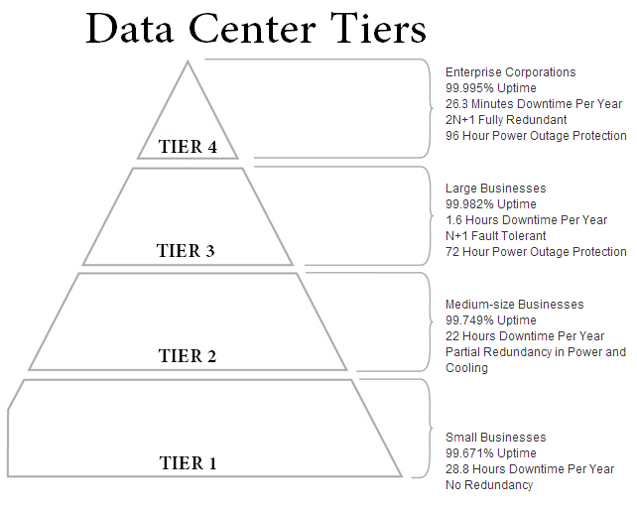
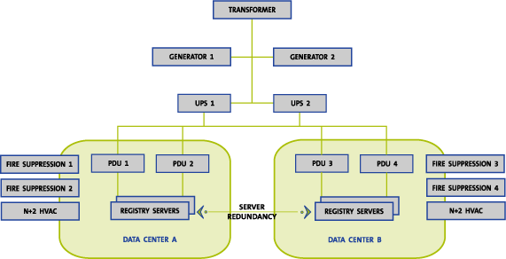

Works Cited
Institute, Uptime. UPTIME INSTITUTE Data Center Site Infrastructure Tier Standard: Topology (n.d.): n. pag. Web.
"Section III." Section III. N.p., n.d. Web. 29 Jan. 2015.
"Tier Standards Overview | Data Centers | Colocation America." Colocation America. N.p., n.d. Web. 28 Jan. 2015.

