Maria Boggi

Magento Flash Research Exam

Our company will earn a three year net benefit of $9,039,000 through implementing Magento. Magento is a free e-commerce platform that would give our developers the ability to publish customizable e-commerce websites more efficiently, resulting in a 20% developer headcount reduction.
Magento is an e-commerce platform built on open source technology that enables developers to create and customize web content for e-commerce companies more efficiently. It offers our developers the flexibility of utilizing a large selection of themes and third-party extensions in which they can modify to their own discretion to limit the amount of unnecessary code writing. Because of Magento’s efficiency and flexibility, we will be able to function with 64 developers instead of our current 80 developers.
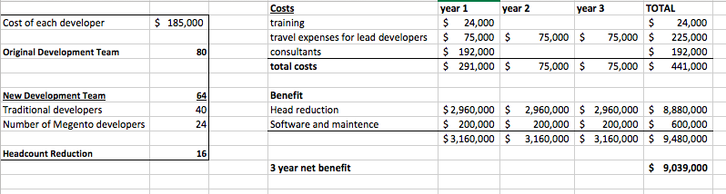
The three year total cost of implementing Magento will be $441,000 which includes the cost of training, annual conference travel expenses, and Magento consultants. The benefit will total $9,480,000 in a three year period, resulting in a three year net benefit of $9,039,000.

Works Cited
Interactive, CommonPlaces. “Blog.” What is Magento?, CommonPlaces Inc., 2017, www.commonplaces.com/blog/what-is-magento/.
“Magento eCommerce - What is Magento?” The Pixel, TVG Media Ltd, 2016, www.thepixel.com/magento-ecommerce/.
“What is Magento? Learn All About It Here.” Magenticians, 16 Oct. 2017, magenticians.com/what-is-magento/.

