Learning by Doing: Studio Classes in MIS Education

|  |  |
| --- | --- |
| **Mart Doyle**  Department of Management Information Systems  Fox School of Business  Temple University  mdoyle@temple.edu | **Richard Flanagan**  Department of Management Information Systems  Fox School of Business  Temple University  ryflanag@temple.edu |
|  |  |

**James Moustafellos**

Department of Management Information Systems

Fox School of Business

Temple University

jamescm@temple.edu

# ABSTRACT

The idea of a “studio class” is a foreign concept in traditional business schools. In a school of Art or Architecture, studio classes are the norm. In a studio class much less time is devoted to traditional lecture, instead students focus on doing their own projects, is essence, “learning by doing”.

Even a more foreign concept than a studio class is the concept of a “vertical studio”. In a vertical studio, students of varying levels of advancement work together as a unified team on a single project. As with a traditional studio course, the emphasis is on learning by doing but with a vertical studio format, students at different points in their education can make different contributions to the team based on their skills and ability.

In this paper we will discuss an innovative approach to basic MIS education that we modeled on design studio formats and introduced at the Fox School at Temple University. We will discuss MIS3504 – Digital Design and Innovation and MIS3535 – Change Leadership. Each of these courses is a studio course where the emphasis is on learning by doing. These two courses are linked together to form a vertical studio helping students to not only master the content from their respective courses but also to learn to work together as a cohesive team.

## Keywords

Studio, Vertical Studio, Business Analysis, Systems Analysis, Design, Design Theory, Project Management, Change Management, MIS Education

# INTRODUCTION

Business process analysis and project management are two of the staple courses of MIS departments everywhere. Over our collective years of teaching these subjects, we noticed a pattern of students knowing the concepts, but being unable to apply them to even rudimentary business problems. After exploring this further, we discovered we were not alone in this observation. A quick literature review showed similar concerns in fields as diverse as organic chemistry and political science.

“The average student was able to mimic simple problems but did not have the ability to apply the ideas to new problems or situations” (Jones-Wilson, 2005)

“Students were not yet able to be either analytical or creative in their thinking about the materials I presented, and I did not know to do about developing their thinking.” (Moreland-Young, 1983)

These authors’ experiences resonated with us very clearly, it seemed we were facing the same problem.

Designers seem to instinctively know that the best way to perfect their design skills is through practice. Design schools have always spent less time on traditional lectures and textbooks. The way they teach students to design is by having them work on projects with coaching and criticism along the way. Can you learn to play a musical instrument by sitting through Powerpoint lectures and by reading a textbook? You can learn about Music Theory and analyze the relationships between Mathematics, Music and Art. At the end of the day, however, none of this brings a student any closer to actually playing a musical instrument. While you can learn about music this way, you simply cannot learn how to play a musical instrument without practicing the required skills.

In an applied field like MIS, we must not assume that our students will learn how to perform a skill as a result of us teaching them about a skill. The only way to learn a skill is to learn by doing it over and over, with coaching. Studio classes are founded upon this type of iterative learning process. Students practice skills in class by applying what they learn to case studies or a project. By doing this, students develop a deeper and much more genuine understanding of material. Not only can the average student explain what they have learned in the classroom, they can also apply it in real life situations.

Teaching a studio class is much more demanding than teaching a traditional class. Today, publishers will provide a “course in a box” with slide decks, assignments, answer keys and question banks for assessment. This approach ensures that the major topics of the course are well explained and that students are assessed appropriately. From our point of view, it does not prepare students to apply the skills they learned in the real world.

Finding the right instructors for studio classes can be a challenge. Instructors in a studio class must be more of a coach than in a traditional classroom setting. They need to be very good at thinking on their feet.

“In the active problem-centered model the instructor becomes actively involved in the problem-solving process, allowing the students to see prototype problem solving and thus learn to develop a model for problem solving and independent thinking” (Jones-Wilson, 2005)

They must have both an intimate understanding of the material and how that material is used. They must be good at encouraging students to jump in and give it a try and be skillful at providing situational feedback. Given that they frequently have no idea how a discussion will play out, they, most of all, must be confident in their personal skills and ability to navigate ambiguity.

One of the biggest challenges in creating studio classes is to decide what not to cover. In a studio class, “studio work” takes time and reducing the course content is the most common criticism of this approach. (Crow 1986) Our design goal was to have students in our studio classes spent at least 50% of our class time working on assigned cases or their semester long project. For all of us who have taught these classes using the traditional approach for years, deciding what content is really important and which is marginal was difficult. We spent several semesters removing content until we got to a comfortable balance of content and studio time. All marginal content had to be eliminated to make time for studio work so that students could develop a deeper, more genuine understanding of the content that remained.

# THE VALUE OF LEARNING BY DOING: LEARNING FROM DESIGN STUDIOS

The design studio is the primary instructional format for design disciplines. Typically, these studios are small and more intimate teaching environments with a low student/instructor ratio. Class time is often more informally structured and there are few lectures and limited readings. Instead, the emphasis is on experiential learning. Design studios use a “learning by doing” approach in which students engage in project-based work and are guided through the problem solving process by their studio instructor. Design concepts are learned and skills are developed through the process of working through the project. This type of learning mainly takes place at the student’s desk, reviewing their individual or team work. As described by Mewburn,

“The pedagogical core of the design studio is the ‘desk crit’, a collaborative activity where the teacher and the student do design work together, discussing and sketching possibilities and imagining the consequences of design choices. During desk crit interactions the design teacher works to understand what the student is trying to do with his or her design work, provides feedback on these ideas and works with the student to further develop them.” (Mewburn, 2010)

This high-touch format necessitates a shift in course structure away from student dependence on the instructor and instead emphasizes self discovery through active engagement in the project as well as peer-to-peer learning. In addition, this also shifts instruction to smaller localized discussions rather than collective course instruction. As a result, this change in instructional format also changes the role of the instructor. The instructor takes on an active and more engaged role in student projects, serving as a “coach”, as described by Schon, or an actor/choreographer whose role fluctuates between leading and supporting, as described by Mewburn.

“This performative take on the pedagogical practices of the design studio suggests that the desiggn teacher is not always a coach as Schon claimed, but one of the actors. In fact, the teacher will not always be the lead actor. . . .Some of the time, the role of the all-seeing, all-knowing coach might be appropriate, or sometimes it might be best to step back from the performance. . . .As choreographers, or as actors, teachers are never going to be entirely in control of any performance.” (Mewburn, 2010)

In addition to the ‘desk crit’, the presentation format of the ‘critique’, where students publicly present their work, is the primary feedback mechanism in studios. The ‘critique’ may be conducted informally within the studio as a presentation to one’s peers or may be a more formal ‘design jury’ in which the presentation is made to external invited critics. Feedback, ideally constructive, is the primary purpose of this process. Dannels’ and Martin’s research on the critique format identifies nine different types of feedback that differ depending on the different levels of the studio participants, ranging from novice to expert.(Dannels & Martin, 2008) Feedback in novice studios tends to be more directive and evaluative, whereas for more advanced students it is less directive and more collaborative, allowing the student to be more of an independent thinker. (Dannels & Martin, 2008)

A particular form of studio utilized in design education is the ‘vertical studio’ which combines students with less advanced skills with those who are more advanced. Working together on the same projects, their collaboration becomes a mutually beneficial learning experience.

“Although senior students have more fully developed technical skills and a broader knowledge of professional design issues, their younger colleagues have an enthusiasm and fresher outlook that is continually stimulating and challenging. The combination of these two peer groups creates a very meaningful and interactive experience.” (Barnes, 1993)

The purpose of combining these students of varying levels of advancement is to provide a more reality-based experience that replicates the hierarchical and collaborative structures of working in a design firm. Students learn how to lead and how to be led and transfer knowledge from the more experienced to the less experienced.

“Most basically, the vertical or elective studio system mirrors the reality of practice, which is a nonlinear, iterative, and unpredictable process for finding solutions to design problems within a very complex cultural setting. The vertical studio mandates personal responsibility at multiple levels, requires independence of thought and action, and generates mature thinking, all essential attributes of the successful professional designer.” (Barnes, 1993)

Ultimately, the goal of studio format teaching is to develop a student’s design experience and skills by actually engaging a project, experiencing the process as it unfolds and replicating the social and cultural interactions of design practice.

In recent years, business schools have discovered the value of design methods to enable students to be come more critical thinkers who can deal with complexity, uncertainty and ambiguity. The logic of combining the strengths of these two disciplines is becoming increasingly apparent.

“The imperative now is for business schools and design schools alike to open new paths for students to acquire design skills that allow them to think through design. This involves the ability to quickly visualize problems and concepts, the development of people-based scenarios and the design of business strategies based on design research methods.” (Cooper, Junginger,, Lockwood, 2009)

Applying these methodologies to Business Analysis makes sense given the problem-solving nature of the role. Using design pedagogy as a model for MIS education is the logical next step.

# 

# MIS3504 – DIGITAL DESIGN AND INNOVATION

In MIS3504, students learn to work as Business Analysts. We actively try to balance traditional systems analysis with design thinking. We cover the major topics of:

* Project Scoping
* Stakeholder Analysis
* Requirements Elicitation (Especially interviewing)
* Requirements Analysis (Process, Data, Business Rules)
* Design Thinking and Creativity
* Personas and Scenarios
* Prototyping (As a way to specify requirements)
* Selling the Client

Our normal week involves using half of the contact time covering the material in traditional lecture including many short (10 minute max) exercises to illuminate key points and then the other half with students actively working to solve a made up case or working on their semester project.

The semester long project is a key part of our studio classes. Each semester we arrange to work with a local organization on a business problem they are facing. These organizations ask to be involved and we have consulted with local businesses, local non-profits and Temple departments that need a hand. Projects have ranged from optimizing operations at a local airport parking company to streamlining the process the library uses to upload images in their Urban Archive.

Each week, students learn about a particular skill, practice it in class on an exercise with the instructor coaching them, then they use it on their own with their project team. Interviewing is an excellent example. By the third week of class, students are interviewing an executive from the project organization. For the first interview, we ask that they prepare 10 questions that we critique. By the second interview (mid-level manager) the students are writing their own questions and by the third (worker), they are pinpointing areas about which they are confused. It is one thing to understand open vs closed ended questions but another to experience an executive respond with a Yes or a No. We encourage the interviewees to treat the students as if they were consultants, such that they call the students on not listening to previous answers or asking stupid questions. Another key learning from these interviews is that the students are shocked to realize that the three interviewees always contradict each other on some important point and that the boss doesn’t know everything.

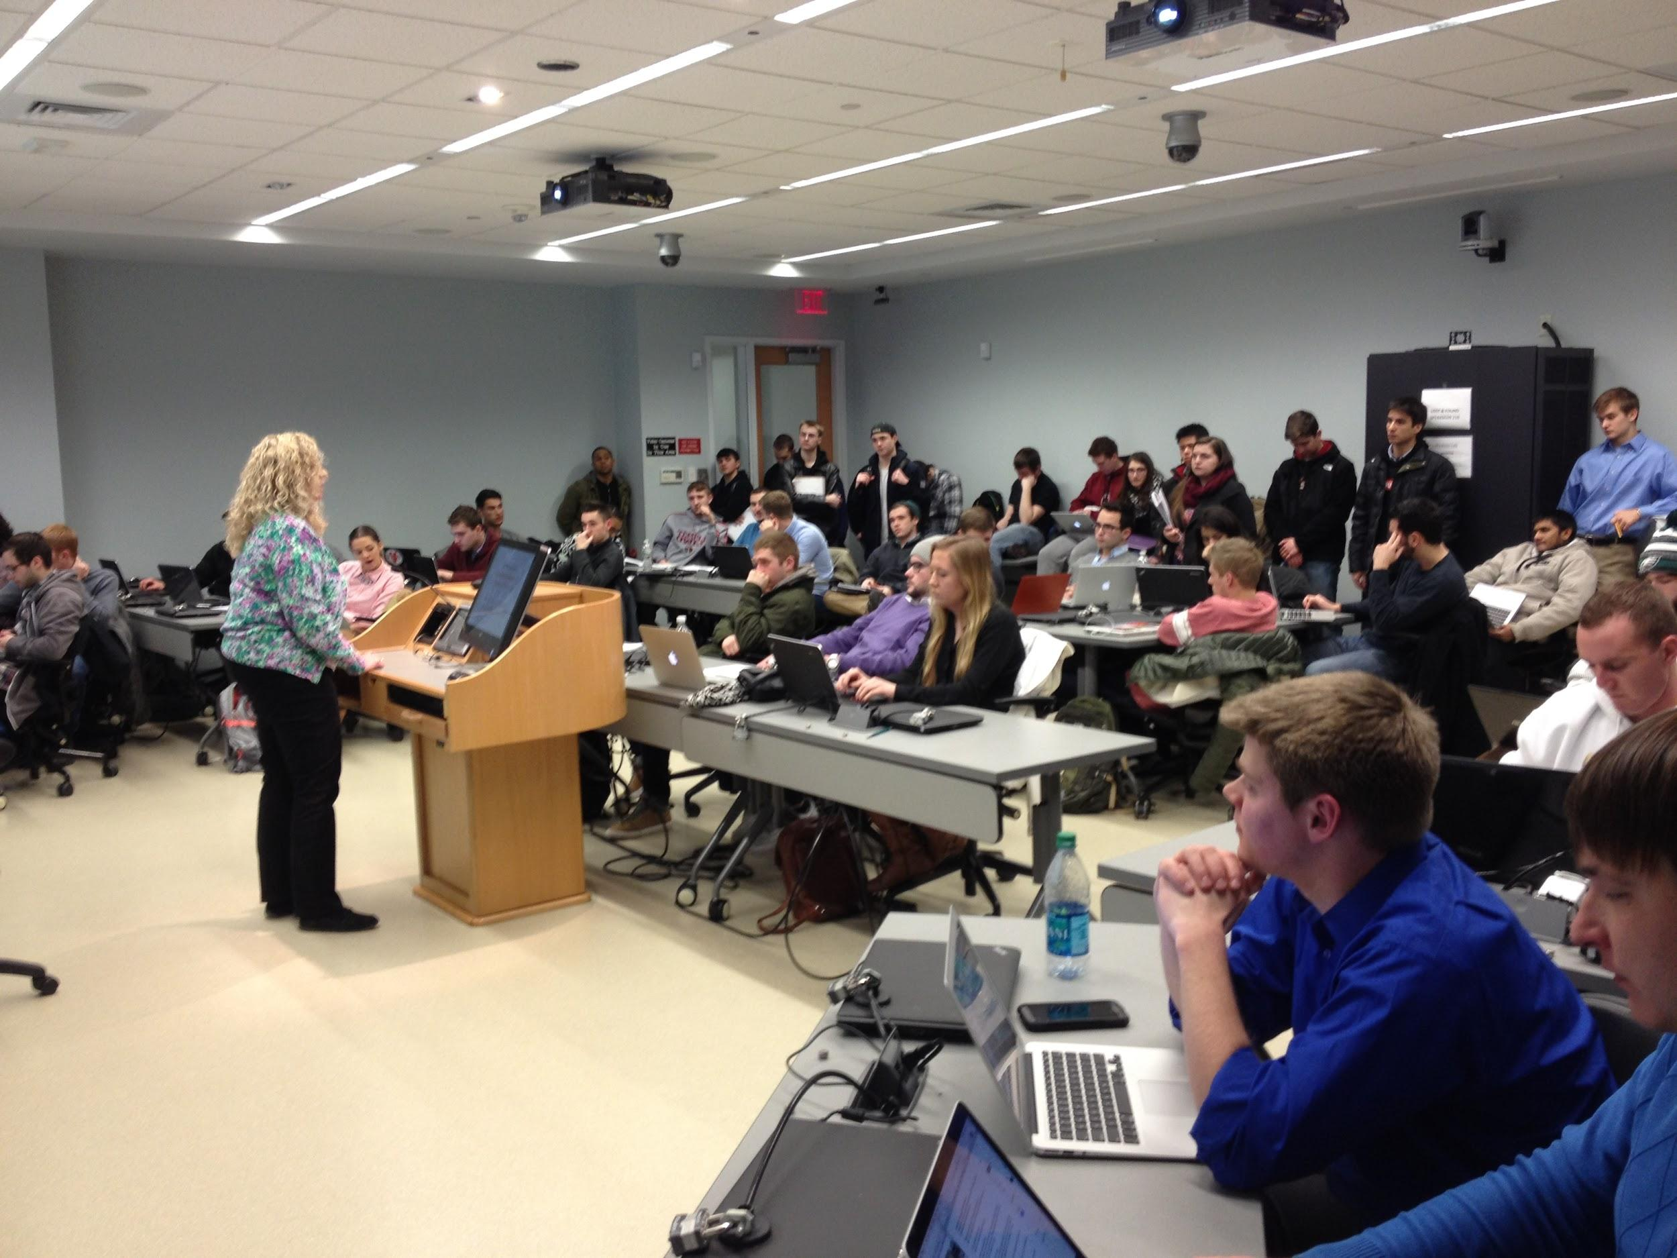

After developing a thorough understanding of the problem and uncovering the requirements during the first half of the semester, students learn about a variety of design frameworks and techniques and use them to design possible solutions. Student teams use the prototyping tool Justinmind to create a prototype solution for the client that meets the client’s requirements. We stress iteration, forcing students to have a working prototype of a solution each week. Each week, student teams review each other’s work and provide constructive criticism along with one or two teams presenting to the entire class. Teams also meet with the instructors frequently to get feedback on their project. Finally, the semester wraps up with students pitching their proposals to the client for their consideration.

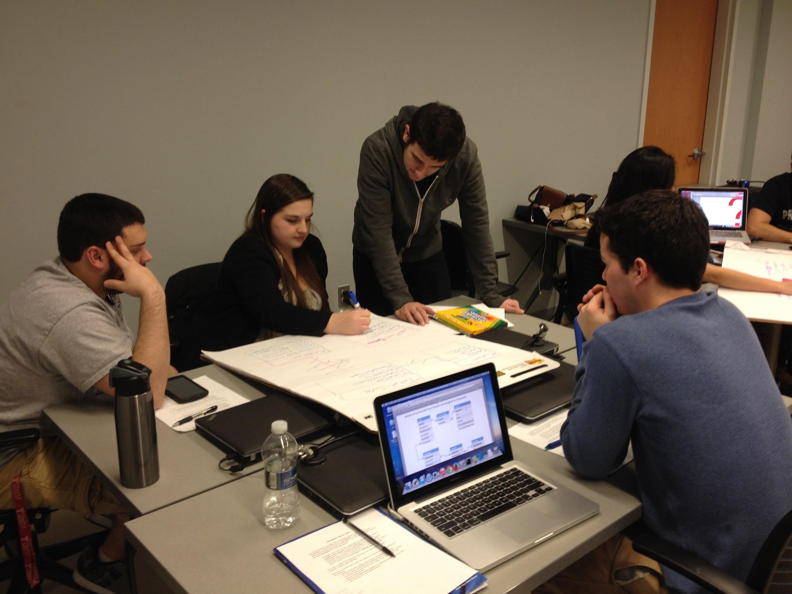

# MIS3535 – CHANGE LEADERSHIP

In MIS3535 students learn to work as Project Managers. One thing to note is that MIS3535 is a prerequisite for MIS3504 so all of the students who are learning to work as Project Managers have already learned how to work as a Business Analyst, typically during the previous semester. In this vertical studio project teams are comprised of a number of students from MIS3504 who are learning to work as Business Analysts along with a number of students from MIS3535 who are learning to work as Project Managers. In MIS3535 we cover the major topics of:

* Traditional Project Management
  + Scope, Time, Cost, Quality, Human Resource, Communications, Risk, Procurement and Integration Management
* Change Leadership

Our normal week involves using one third of our contact time covering materials in traditional lecture, one third with students actively working on their semester project and one third with students leading class discussions on change leadership, typically attempting to apply lessons on change leadership to their semester project.

Each week students learn about one of the core knowledge areas of project management, practice it in class on an exercise with the instructor coaching them, then they use it on their own with their team project. Towards the beginning of the semester the MIS3535 students learn about scope management while the entire team is working on defining the scope of the project. After the first round of interviews with the client each MIS3504 student drafts their proposal for a scope document. With the coaching of instructors and their project managers from 3535, the team consolidates the best work from each team member into a single scope document which is used by the team for the rest of the project. In addition, the project managers develop a framework and utilize that framework for managing changes to scope which are frequently proposed by team members throughout the semester.

On Change Leadership days the students run the classroom. Each student must prepare to lead a class discussion on a collection of cases where organizations have struggled with making large scale institutional change. Students are called on at random to lead the class discussion. For each of these cases students discuss how these lessons in Change Leadership can be applied in the workplace and how these lessons in Change Leadership can be applied to their semester project.

While the MIS3535 students are learning to work as project managers, this role goes beyond the basics of managing the work breakdown structure and the schedule. Since the MIS3535 students have already successfully completed MIS3504, they also play the role of coaches and mentors to the analysts on their team. Not only are the MIS3504 students receiving coaching from their instructors but they are also receiving coaching from their Project Managers. A significant amount of studio time in MIS3535 is dedicated to discussing the challenges the Project Managers are experiencing leading their team and sharing ideas how to deal with these issues.

As the semester wraps up with our 3504 students pitching their proposals to the client for their consideration, the Project Managers are closing out the project and delivering a portfolio of project management artifacts that document how they managed their project throughout the semester as their final deliverable.

# 

# VERTICAL STUDIOS – MORE THAN TWO STUDIO COURSES

The vertical studio concept compounds the benefits of the individual studio courses. MIS3504 and MIS3535 make up a two course sequence that is required for all MIS majors. All students in MIS3535 have already successfully completed MIS3504. While the MIS3535 students are learning basic project management skills they bring their experience working as a business analyst to the novice analysts. From writing scope documents to soliciting requirements to developing prototypes, the project managers have been through this before. Their experience put them in a position to be another coach or mentor. An experienced student working on a team project can connect with a more junior student in a way that a faculty member can’t and can help them learn what they need to do and to help them be successful. Working as a coach and a mentor provides MIS3535 students with valuable lessons and experience that simply cannot be learned from books or lectures. This symbiotic relationship between the business analysts and the project managers working on the project together create more value than if the two studio courses stood alone.

# STUDENT TEAMS – NOT EXACTLY RANDOM

Teams in both MIS3504 and MIS3535 are assigned. Students do not get to pick who is on their team. Teams are not created randomly; the technique is not exactly traditional as described by Moreland-Young:

Placing students in groups serves three purposes: It makes the exercise more manageable, it gives the weak and moderate students a chance to observe the thought processes of stronger peers in a nonthreatening context, and it helps build the academic confidence of the weak student… (Moreland-Young, 1983)

This is not our approach. When we used this approach we felt the high-performers stole opportunities for growth and learning from both the average and the poorer performing students. The average students were completely overshadowed by the high performers and many poorer students were content to just ride along.

Instead, when forming our teams in MIS3504 and MIS3535, students are sorted by GPA (by an administrator). The highest performers are together, the average students are together and the weaker students are together. To level the playing field, we assign the project managers with the highest GPA’s to the analyst team with the lowest GPA’s and vice versa. This inverse relationship causes some interesting things to happen.

First, with a mix of strengths and abilities, all teams have an opportunity to succeed. On a team with strong project managers and weak analysts, the project managers assume more of a role of coaches and mentors and can push and inspire the team of analysts towards success. On a team with weaker project managers and strong analysts, the team of analysts continues to plow forward towards a solution to the problem even in the absence of strong leadership.

# WHAT WE HAVE SEEN

To date, we are very pleased with the changes we have made to these two courses. The courses have become more academically challenging (exams are primarily case based). Students enjoy the classes more as they are constantly working on skills that they know they will need in the next week. We are most pleased with the way the courses have opened up new learning opportunities for students.

* Each semester, the average competence of our students appears to be going up. We never anticipated it, but the feedback cycle of senior project managers coaching junior analysts is strengthening the program. We find ourselves adding some material because the students have institutionally learned much of what we were teaching 3 years ago. We especially see this in the use of Justinmind (which we don’t teach). Ever semester, we see the prototypes becoming more sophisticated and more engaging.
* Challenges exist for students of all levels. Highest GPA project managers usually observe the following at their first studio day., “Where the heck did you come up with my team! They don’t respond to e-Mail messages! They don’t communicate their status! I don’t know where they stand and what we need to do next!” As a class we brainstorm ideas for how to deal with issues and keep the project moving forward. Good preparation for what they will face when they graduate.
* Initially we were worried that the high GPA analyst teams had too much of an advantage. We were wrong. Frequently the high GPA teams have trouble working together and, with the poorest project managers, they need to learn much on their own. We have noticed that each semester teams 3-5 (out of 7 or 8) produce the best project proposals.
* To reinforce that doing is different than reading, we have noticed that students react very differently to the “doing” part of the course, regardless of their GPA. Its not unusual to have several student who get all the book questions on the first exam right and all the applied questions wrong. One such case was a student named John who was on Team 1 (highest GPA) who failed the first test in just this manor. John had trouble deciphering the important details in a case in order to solve the applied questions. We started him analyzing things in his world and reviewing them during office hours every week. By the final exam, John was back to his usual high standards. While it was probably the lowest grade he ever got, John came back to say that he learned more in this class than any other.
* Finally, what about the poorer students? Certainly many continue to do poorly but each semester, one or two students on each of the lower rated teams accepts the challenge and does well. With the coaching from their project managers and the faculty, they see what needs to be done and get help doing it. Before long, their confidence grows and they are off and running. Another anecdote is Adnette, a marginal student on a lower level team. While book learning wasn’t her thing, doing analysis and project management were. Adnette excelled in both classes and when SAP interviewed her on the phone they immediately offered at job because she was so good at explaining what it actually meant to do analysis and project management.

# CONCLUSION

Schools of Art and Architecture have known for years that studio classes and learning by doing is much more effective for teaching applied skills. Based on the results we are seeing after three years of teaching MIS studio courses we agree. The practical skills and insights that students are learning seem to be paying off while they complete their studies and after they graduate. We have a steady stream of students who attribute receiving offers for internships and full-time employment to their experiences in these two courses. Furthermore, many of our alumni come back and relay how these skills have helped differentiate them in their first jobs.

# REFERENCES

1. Barnes, J., (1993) A Case for the Vertical Studio, *Journal of Interior Design* 19(1): 34-38
2. Cooper, R., Junginger, S., Lockwood, T. (2009) Design Thinking and Design Management: A Research and Practice Perspective, *Design Management Review* 20(2): 46-55
3. Dannels, D., Martin, K.,(2008) Critiquing Critiques: A Genre Analysis of Feedback Across Novice to Expert Design Studios, *Journal of Business and Technical Communication* 22(2): 135-159
4. Jones-Wilson, M., (September, 2005) ”Teaching Problem-Solving Skills without Sacrificing Course Content” *Journal of College Science Teaching 35 1*
5. Mewburn, I., (2010) *Lost in translation*: Reconsidering reflective practice and design studio pedagogy, *Arts & Humanities in Higher Education* 11(4): 363-379
6. Meyers, C.M., (1986) *Teaching Students to Think Critically,* San Francisco: Josseey-Bass
7. Moreland-Young, C., (September, 1983) “Teaching Analytical and Thinking Skills in a Content Course”, *New Directions for Teaching and Learning* 15: 41-47
8. Wang, T., (2010) A New Paradigm for Design Studio Education, *International Journal of Art and Design Education* 29(2): 173-183