Mike McAleer
12/4/13
MIS 3538: Term Paper

Section 1
Google analytics was an exceptional tool to analyze the web site traffic to my personal course blog. Analytics gave me insight into how many people visited my blog, how many pages they visited, the duration of time spent exploring the blog, the devices used to access my blog, and the sources of my web traffic. Examining the information that Google analytics provides allowed for me to understand how my blog was being perceived, and what changes I could make to improve my blogging experience. One segment of analytics that I found particularly interesting was the devices that web visitors were using to access my blog. Before viewing the information, I had assumed that all web site traffic was through traditional desktop computer. It was exciting for me to realize that, although not many, a number of people accessed my blog through portable devices like tablets and mobile phones. As a new blogger, it was surprising to see how my information could be found using mobile devices at the visitor’s convenience. 4 people used tablets or mobile devices to view my blog, which encourages me to seek more ways to appeal to mobile users. My blog received 47 total visitors and 88 page views, meaning that on average there were 2 pages explored per visit. Overall, my blog was successful in attracting some website traffic, however, analytics provided information that can be used to further grow my blog in the future.
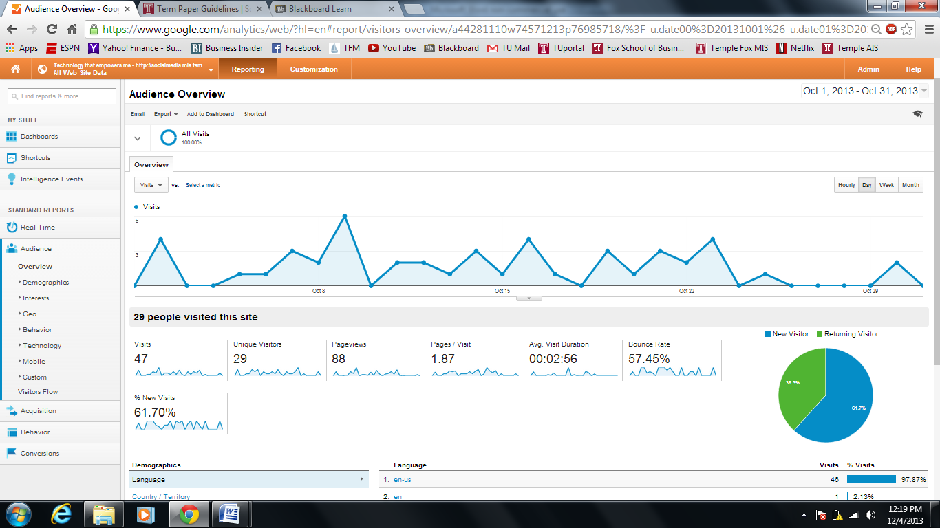
Section 2
Class preparation and participation:
The topics that were covered in class preparation and participation throughout the semester enhanced my ability to analyze social media. Data visualization, blogging, social media as a marketing source, and search engine optimization are all interesting and thought provoking subjects. Although there were many other subjects covered in class throughout the semester, because my attention was captured, my social media use improved, and my understanding of social media innovation increased, the topics of data visualization, blogging, social media marketing, and search engine optimization were the most beneficial topics involved in class preparation and participation.
Data visualization was a topic that I was not very familiar with prior to this semester; and now that I understand its use and importance its effectiveness is clear. Whether in the form of pictures, videos, or infographics, data visualization is a tool that can be used by individuals and companies to attract and appeal to their target audiences. The article “The Power of Infographics: Using Pictures to Communicate and Connect With Your Audiences”, written by Mark Smiciklas, displayed the advantages that data visualization provides. It was interesting to read how infographics can be beneficial in areas of business such as marketing, content strategy, and communications. The most useful tool from this article was being to visualize how things work and are connected.
Blogging was a practice that I had not previously taken part in, and the opportunity to make my own blog and engage an online audience was exciting. I appreciated that everyone was able to select their own blog topic, and that we were provided with information throughout the semester to assist us in our blogging development. The article “Why Even the Worst Bloggers Are Making Us Smarter”, written by Clive Thompson, discusses how blogging provides online users with a wider perspective on numerous topics. Prior to the start of this class, and reading this article, I had very little interest in starting a blog or reading the blogs of others. It makes a great deal of sense to me now as I see the value that blogs can deliver to end readers. Because anyone is able to relay their thoughts through a blog, readers are subject to different perspectives, ideas, and thought processes they otherwise may not have been. The concept of thinking publicly is accurate, and is absolutely changing the way society thinks in today’s age.
Perhaps the topic that encouraged the most class discussion, social media as a marketing platform related to my prior work experience and other course work. I was very interested in exploring the different strategies that companies are using to reach consumer bases through social media. The article “What Is Your 2013 Content Marketing Strategy?”, written by Michael Brito, discussed many different marketing strategies and the reasons why companies are successful or unsuccessful in using social media marketing. The article suggests that whether in the form of a blog, Instagram post, Facebook status, tweet, etc., the content presented will ultimately decide how consumers find you and evaluate you. This article reminded me a lot of the points that our guest speaker, Melinda Emerson, made when she spoke to our class. There needs to be a strategic foundation behind the content implemented in posts if the goal is to attract consumers, followers, and fans.
Search engine optimization exposed me to current innovative ideas in social media and related to all other topics that we discussed in class. One reading that we covered in class preparation was “Why Google’s New Hummingbird Algorithm is Good News for Serious Content Creators”, which discussed the transition of search engine optimization. Content marketing and the strategy behind attracting online users, consumers, and readers is clearly going to revolutionize. Rather than focusing on traditional methods such as keyword use to summarize content, there needs to be a transition to a conversational context in search optimization. Adopting this changing trend will differentiate users online and result in a greater level of online exposure.
The overall takeaway from class preparation and participation is the importance of content. This is perhaps the most important theme we’ve discussed in class this semester. Not only have our weekly readings and numerous guest speakers put emphases on this topic, but members of our class have as well. It’s important for social media users to understand what they want to accomplish through social media, and then choose their content appropriately. Content seems to be the most effective factor in attracting and retaining followers, as well as making money through the use of social media.
Community Hub contributions:
The community hub contributions furthered my understanding of social media’s uses, practices, issues, and future plans; also the community hub contributions fit in nicely with our class preparation and discussion. The posts on the community hub provided insightful and helpful discussion of many topics related to social media. One post I thought was exceptionally interesting was “Buying fake followers or fans”, posted by William Trost. I had never considered this as a practice until this post put it in perspective. Because many consumers and online users look to reviews, followers, or other online reputation factors, companies are looking to differentiate themselves from their competition. Although clearly unethical and immoral, the practice of buying followers, fans, and reviews is clearly evident and understandable from an organizational perspective.
Social Media Activities:
The social media activities covered in class allowed me to become more familiar with social media sited I had previously participated in, and gave me the opportunity to explore other platforms. This portion of the course presented how each different social media site has unique features that can be used by individuals and organizations to achieve online goals. I enjoyed experimenting with different social media sites and was able to determine how each is beneficial in presenting, sharing, and gathering information.
Group Assignment:
I genuinely enjoyed working with Pat and Noah on our group assignment. The technology that we explored, Simplewash, exposed us to innovative thinking and how it can be applied to social media. Simplewash is an extremely easy, effective, and valuable application that a large demographic of users can find useful. Because of this group assignment I was exposed to the Simplewash application, and have sense used it to clean up my online presence.
Section 3
3 Things I would do that same while blogging:
When evaluating lessons I learned from Social Media Activities, particularly my personal course blog, there are three practices that I would do the same again in creating another blog in the future. When creating a future blog, I would continue to select the same blog topic, include visuals/graphics with each blog post, and share information regarding my blog on other social media platforms. The topic of Empowering Technology is one that I find very interesting, and is a topic I believe others find interesting as well. The goal of my blog was to provide insight into different technologies that I have found useful and advantageous to explore; by posting about these technologies others would be able to gain an understanding of them and potentially use them to their benefit also. Another practice I would continue to do while blogging in the future is including visuals/ graphics with every blog post. At the top of each blog post of mine, was a picture of the subject technology. This was placed to engage the reader immediately, allow the reader to paint a picture of how the technology could be used, and further the readers understanding of the technology’s benefits. The last practice that I would continue in future blogging is sharing information about my blog on other social media platforms. Using Twitter, Facebook, Instagram, Google+, etc, to share information about personal blogs is very beneficial. By sharing information on other online platforms, it increases the number of people that may see your blog; this increases blog exposure which is ultimately a blogging goal.
3 things I would do differently in creating another blog in the future:
When evaluating lessons I learned from Social Media Activities, particularly my personal course blog, there are three practices that I would do differently in creating another blog in the future. When creating a future blog, I would post more frequently, consider trending, popular, and innovative technology in addition to technology that has empowered me personally, and add features to my blog to further engage the reader. The reason that I would blog more frequently in the future is based on the web traffic that my blog has received thus far. It is clear that as the rate of my posts increased so did website traffic. In order to gain and retain an online following, it is essential to be consistent and frequent in blog posts; In the future I would consider posting five days a week as opposed to two. The second practice that I would adopt in creating a blog in the future is considering popular, innovative, and trending technologies in addition technologies that I have found useful in my own experiences. By posting about current and popular technologies, readers could find interest in topics that I have had no experience using; generating a larger demographic that my blog could relate to. I would still post about technologies that I have experienced and found empowering, however, I would also begin posting about new and exciting technologies as well. The last thing that I would do differently when blogging in the future is implementing a feature t0 further engage the reader. I could get more engagement by implementing an approval system. A simple “yes or no” button would allow readers to express their opinion about the topic. The reader would feel engaged, and I could improve the material posted on my blog.

