Creating Organizational Structures

If you find yourself entering the same parameter value over and over again and want to set up a default Parameter ID value, you can determine the parameter fairly easily. For example, suppose we are frequently entering purchase orders. If you follow the menu path:

Human Resources Organizational Management Organizational plan Organization and Staffing Create
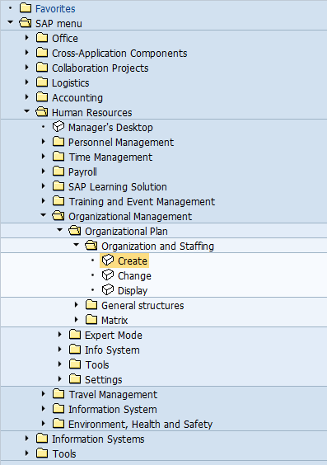

This will produce the following pop-up window:
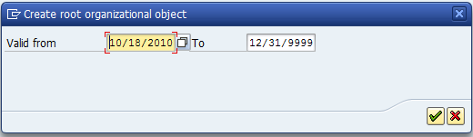

This window allows you to set the validity period for the organizational structure you are about to create. The SAP R/3 system will provide default values of the current date for the start date and the end of the year 9999 as the end date. Note that there will be a Y10K problem with the SAP R/3 system!

Accept the default values by clicking on the green checkbox, and you will get the following screen:
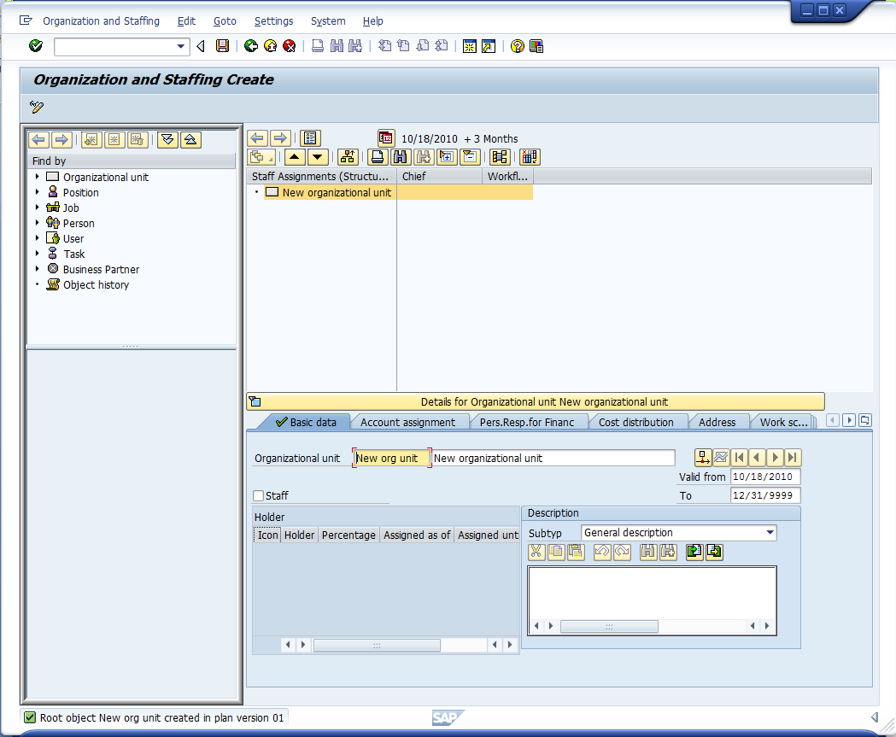
Organizational hierarchy
Organizational unit details
Enter ## FSHR and ## Fitter Snacker for the new organizational unit name and description.
Note – these fields will have text such as New Organizational Unit. Clear these fields before typing.
After the previous step, click on the Account assignment tab

This screen allows the user to build the organizational structure. The screen starts with a blank organizational unit to be defined. Enter ## FSHR and ## Fitter Snacker Organization under the basic data tab, then click on the Account assignment tab:

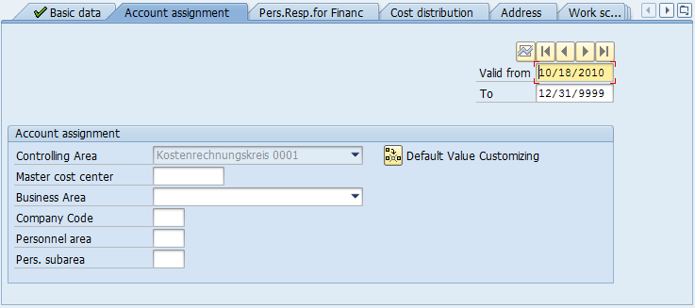
Make sure Account assignment tab is highlighted
Then click on Default Value Customizing

The default Controlling area Kostenrechnungskreis 0001 is not the correct one for our Fitter Snacker company, so we need to click on the Customizing default value icon () to change this. Clicking on the icon allows the controlling area to be changed. Enter the following data:
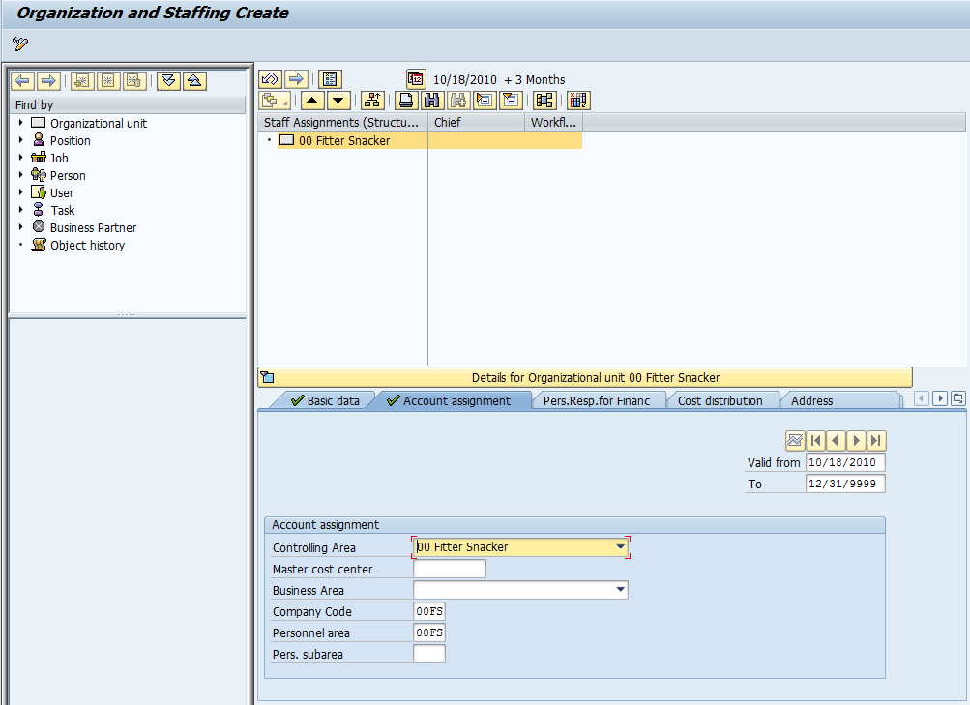
- Select ## Fitter Snacker for the Controlling Area from the pull-down list
- Enter ##FS for company code
- Enter ##FS for Personnel area
Note – enter your ## NOT 00

then click on the save icon () or the save button to save the current structure.

After saving, right click on ## Fitter Snacker, then hover over Goto then click on Organization Structure:

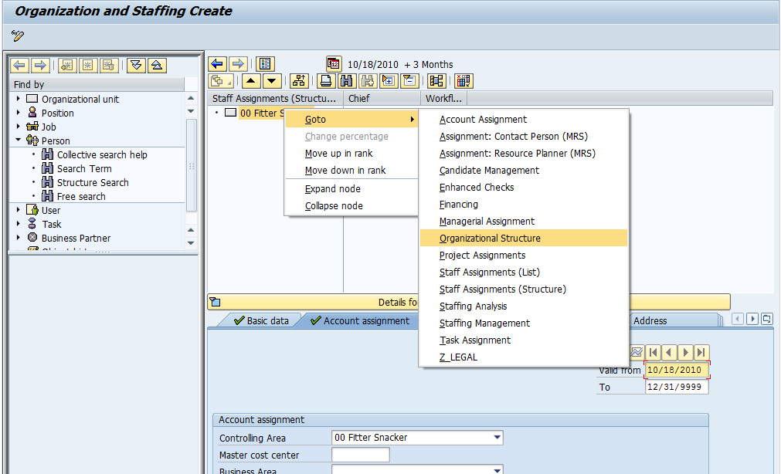

The Fitter Snacker organization is broken down into two areas: a manufacturing group and a headquarters group. To create the manufacturing group, click on the ## Fitter Snacker in the top-right window, then click on the create icon:
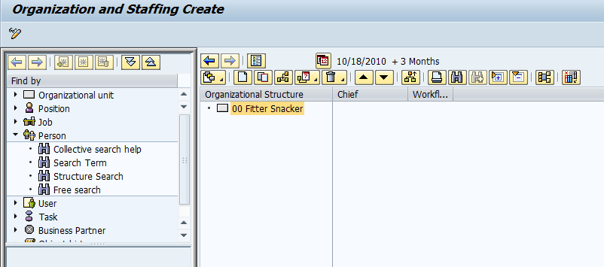
- Click on ## Fitter Snacker
- Then click on the create icon

Click on ## Fitter Snacker, then click on the create icon to produce the following screen:

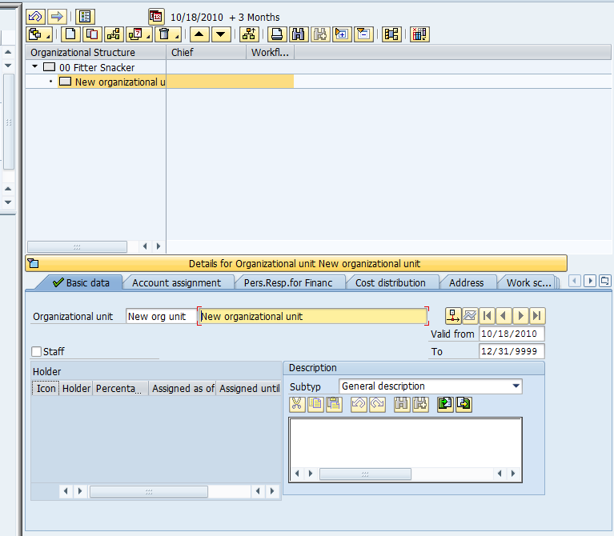
New organizational unit added under ## Fitter Snacker

The SAP R/3 system has added a new organizational unit. Enter the following basic data:
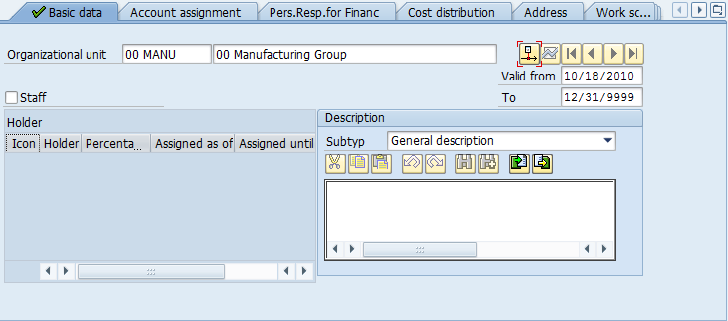
- Enter ## MANU
- Enter ## Manufacturing Group
Note – these fields will have text such as New Organizational Unit. Clear these fields before typing.
Note – enter your ## NOT 00
Click on the save icon () or the save button to save the current structure.

The Fitter Snacker Manufacturing Group has three personnel areas: Receiving, Warehouse and Production. We will create the Production personnel area first. Make sure that the ## Manufacturing Group is selected, then click on the Create icon:
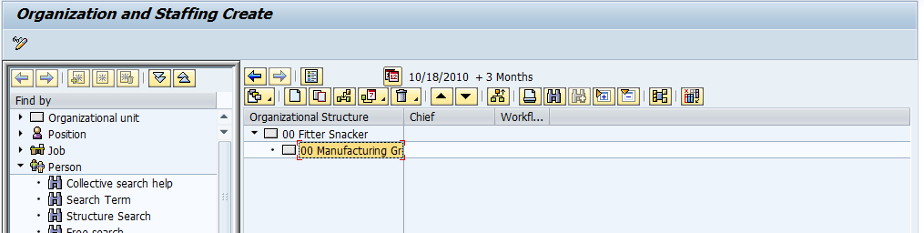
- Make sure ## Manufacturing Group is selected
- Then click on the Create icon

Following screen will be produced:

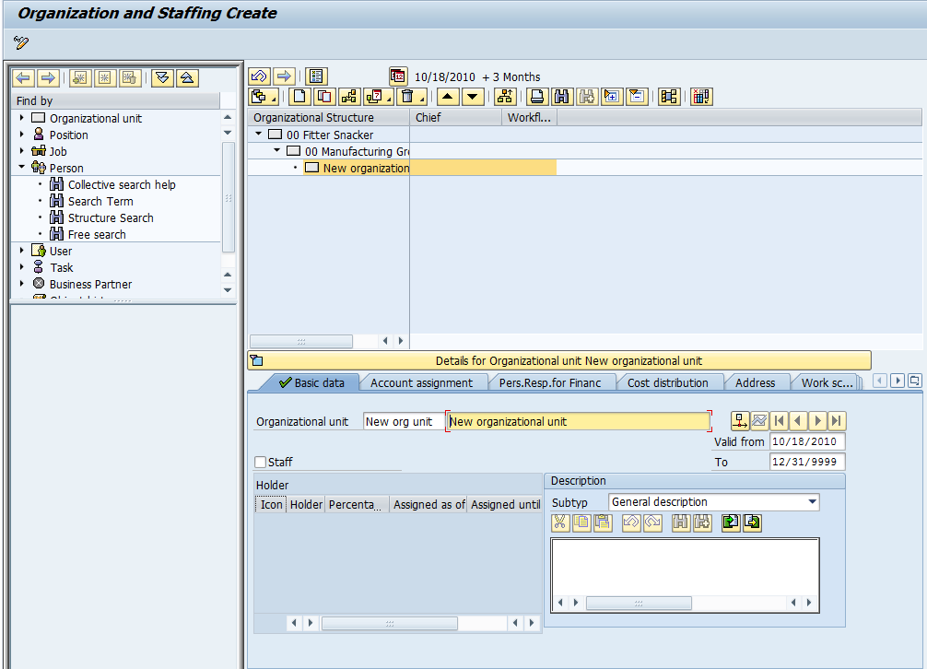

Double-click on the newly created New Organizational unit. Enter the following basic data:

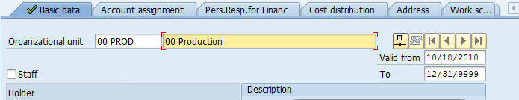

Click on the Account assignment tab, and then click on the Master cost center field to call up the search icon:

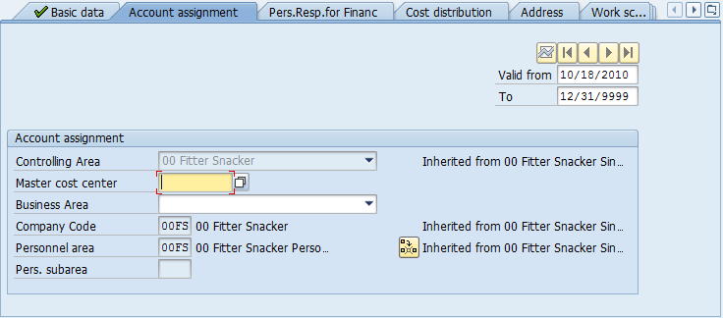
Click on the Master cost center field to call up the search icon (
)

Click on the search icon () to call up the following search window:
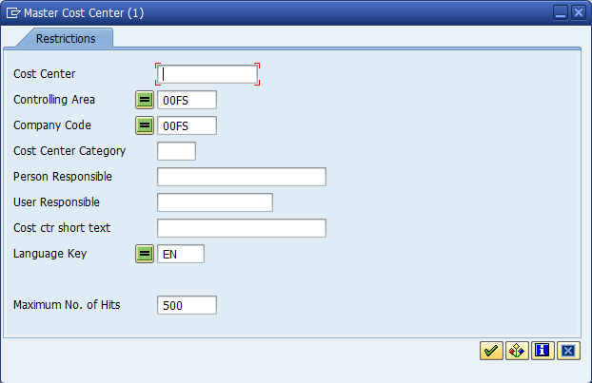
Make sure ##FS is entered for the Controlling area and Company code
Note – It must be your ## NOT 00
then click on the Start Search icon or place your cursor in the Cost Center field and hit the enter key

- Enter ##FS for Controlling area and Company code so that the system finds your controlling areas, then click on the enter icon or place your cursor in the Cost Center field and hit the enter key
to produce the following pop-up window:

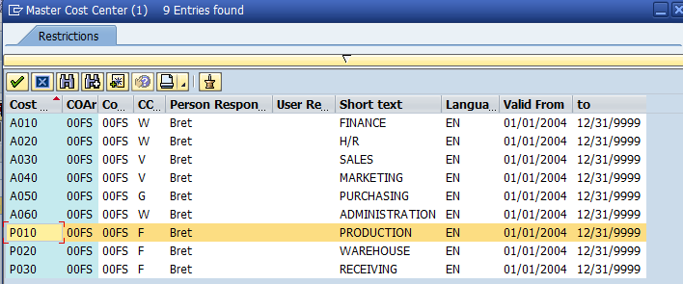
Double click on P010, the Production cost center

Double-click on P010 to select the Production cost center.
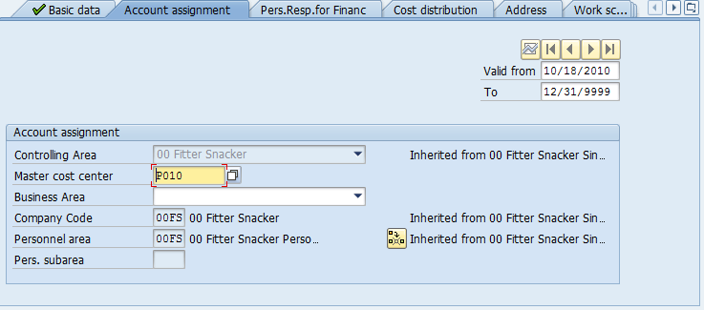
Make sure ##FS is entered for the Personnel area

Make sure ##FS is entered for the Personnel area, then click on the save () icon or hit the save button.

Next, we want to create the position of manager for this personnel area. Right-Click on ## Fitter Snacker, then click on Goto and then click on Account Assignment:

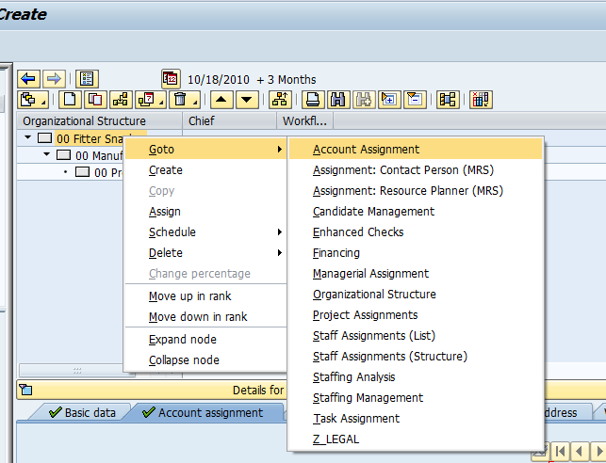

Following screen will be produced then, click on ## Fitter Snacker and click on Expand ().:
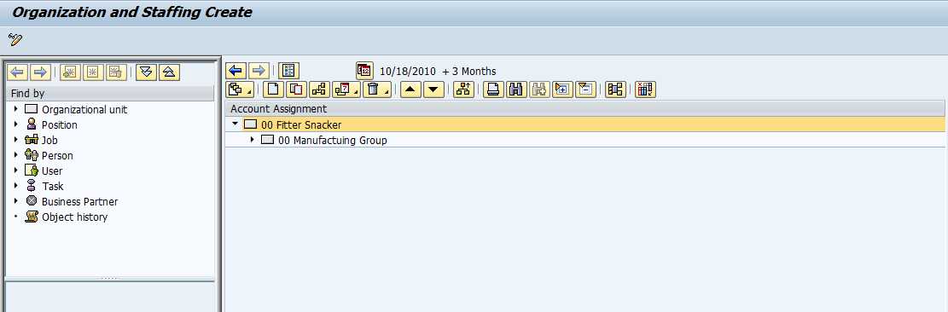
- Make sure ## Fitter Snacker is selected
- then click on the Expand

Next, Click on ## Production and click on Create.

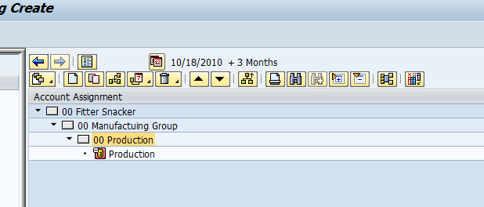
- Make sure ## Production is selected
- then click on the Create icon

Following screen will pop-up:
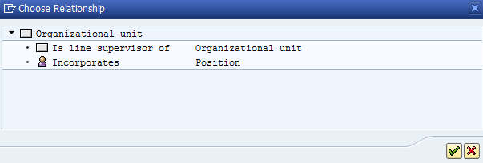
Double-click on Position
Double-click on Position, then enter the following description:

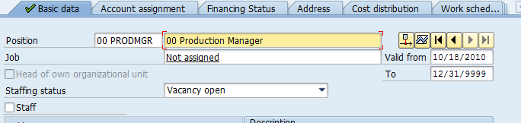

After entering the description for the production manager description, click on the Account assignment tab, then enter the following information:

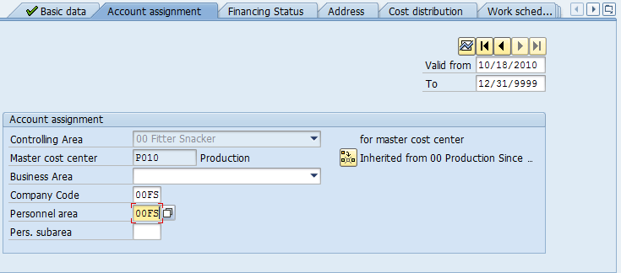
Enter ##FS for Company code and Personnel area

Enter ##FS for Company code and Personnel area, then click on the save icon () or hit the save button to save the current structure.

We would like to designate this position as the head of the production area. In SAP, the head of an organizational unit is called the Chief. To designate the position ## Production Manager as the head of the ## Production organizational unit, click back on the basic data tab, then click on the Display key date icon ():
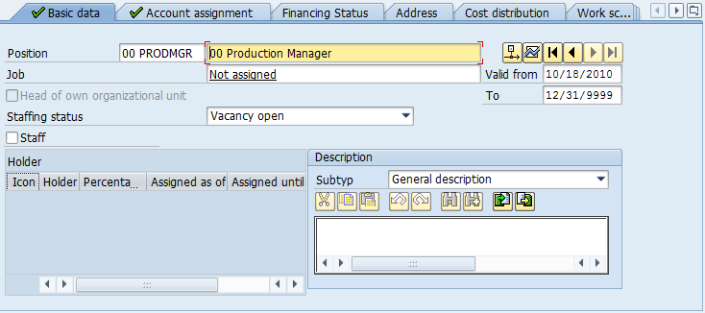
Make sure you are on Basic data tab
then click on the Display key date icon
Cannot designate as head of Production

This will allow you to designate this position as the head (Chief) of the production area:
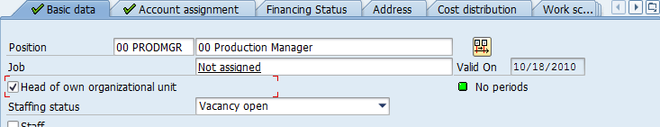
Click on the check mark to designate this position as head (Chief) of Production

Check the box Head of own organizational unit, the click on the save icon () or hit the save button. Note that the icon for the position is now indicated in red, and the position name shows up in the Chief column:

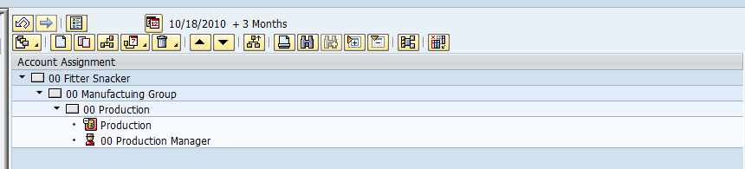
Icon is red

To see the difference, create the position production scheduler under ## Production. Use ## SCHED and ## Scheduler for the position. After entering the Basic and Account assignment data, (note: do not make this person the chief!) click on the save icon () and note that in the SAP system, the Chief is red and wears a hat while subordinates are blue and are hatless

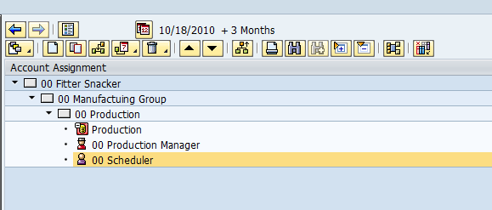

Although this might seem silly, the different icons make it easy to see who is responsible for an organizational unit. This makes a number of tasks easier in a complex organization.

Displaying the Organizational Structure
To display the organizational structure, make sure it is completely expanded. To do this, click on ## Fitter Snacker, then click on the expand node icon ().

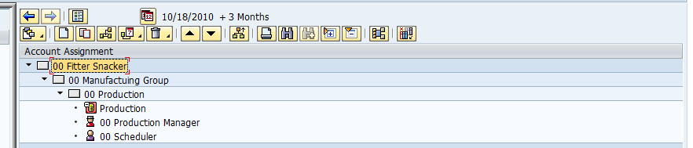
Click on ## Fitter Snacker
Then, click on the expand node icon.

The organizational structure will be displayed:

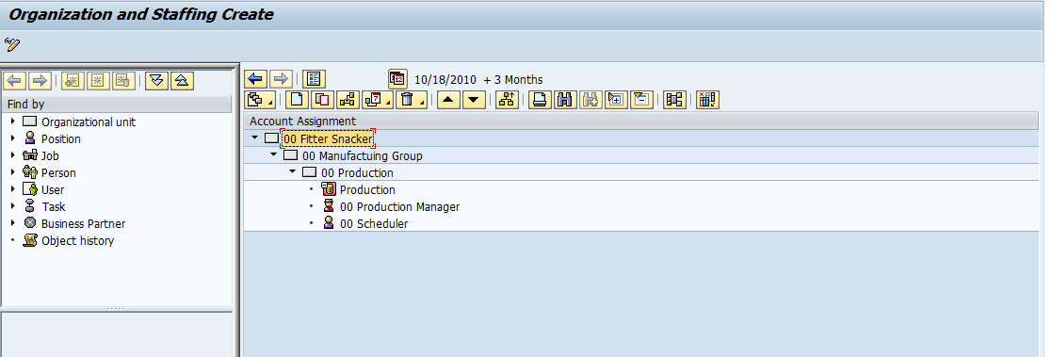

Create a screen shot of this screen shot with your data set number. Paste it to the Word document you are preparing for this assignment.

CONGRATULATIONS - you are on your way to becoming an SAP PRO!!! ☺

