SalesForce common questions

You log back into SF, and don’t see your project. Where did your work go? Click on Object Manager and select Pitch.

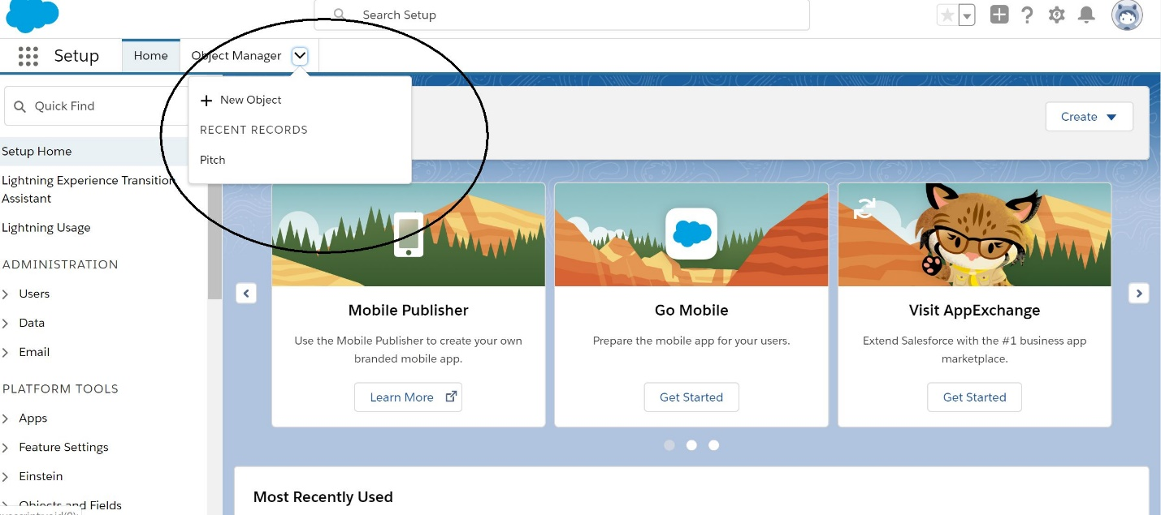

You are logged in to Sal esForce, but can’t find the setup option?
Click on the gear (Max calls this the “Big Gear”) that is in the top right corner of the screen. Select Setup
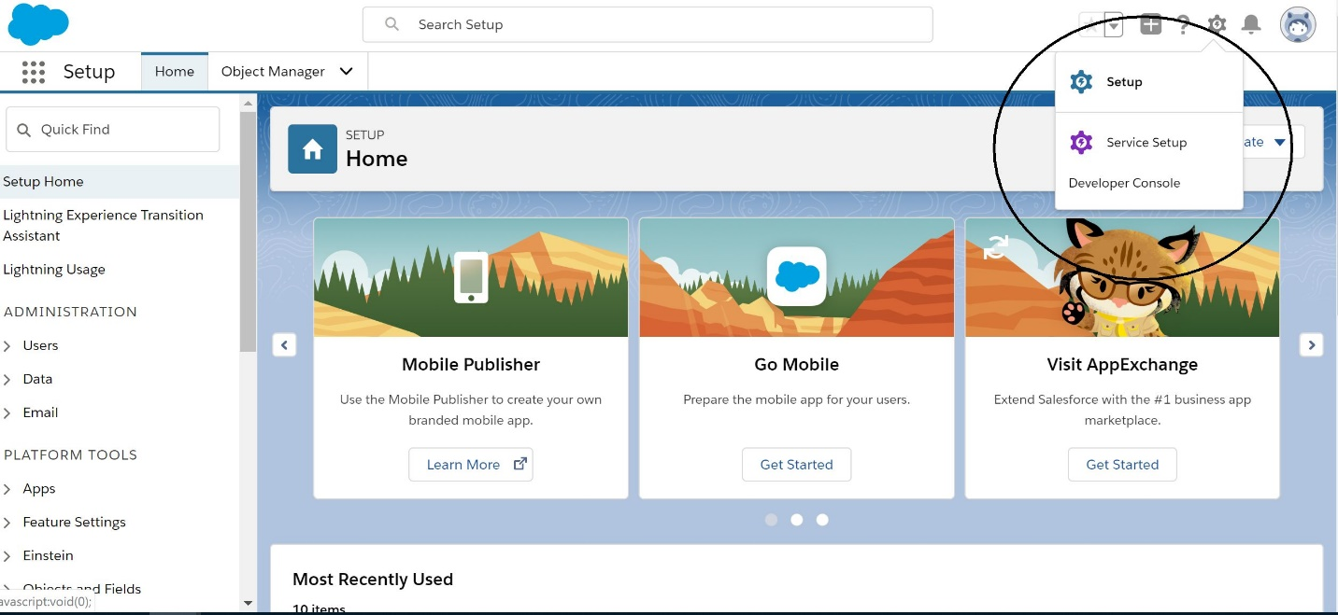

When you try to change the Page Layouts, you may be tempted to try to move around the buttons in the upper part of the screen. However, the fields are hidden in the lower part, where you least expect them... So, for instance, I can move “Investment Amount $ 123.45” to below “Contact Name Sample Text”.
