Name: ____________________________ Date: __________________________

TUid: ______________

# Max Labs Pre-flight

Paste within text box (remove this text)

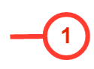

# Max Labs 1B