**LEARN IT – 1**

**Digital Identity Management**

**Community Platform**

*Note: This document is for Fox BBA in MIS majors (only). The instructions and software described below will not work for others. Please contact your instructor if you received this document by mistake.*

Digital identity is what uniquely describes a person and their relationships online. Most students are experts in *social* identity management (e.g., a change in status on Facebook). The goal of this assignment is *professional* digital identity management - learning how to actively shape professional reputation and manage networks:

* Professional reputation: In your next team project, do you want to work with individuals who are comparable in skill and career interests, or with a friend who will free ride? In this assignment, learn how to develop a professional reputation and build a professional network – a ‘digital brand.’
* Digital identity: When you apply for a job, employers will search for you online. Do you want them to find your Facebook page or a carefully curated digital identity that highlights your professional achievements? In this assignment, create a curated digital identity and apply analytics to analyze the impact.
* Social and knowledge systems: Organizations understand that innovation is accelerated by digital systems that connect individuals to enable communities of practice[1]. In this assignment, learn to use digital systems to identify and connect to individuals with relevant skills, share knowledge in virtual teams, and manage professional relationships.

Achieve the above goals by creating a digital identity and e-portfolio. An e-portfolio is a web site that displays professional achievements that highlight your skills and body of work. The e-portfolio is dynamic, updated frequently, and pushed to search engines. It is a type of resume, that is more formal and professional than Facebook, but it is more creative and open than LinkedIn; it is your digital brand. This digital brand enables others to find and connect with you and for you to find and connect with others.

**Part 1 – Digital Identity**

Establish a digital identity on the Community platform.

1. Visit <http://community.mis.temple.edu/> and *login* using your Temple AccessNet ID and password. If the password does not work, refer to <http://accounts.temple.edu>.
2. Hover on *Hello, …* (on the top right) and hover on *Profile*, and thenclick *Edit* to access your Community profile.
   1. 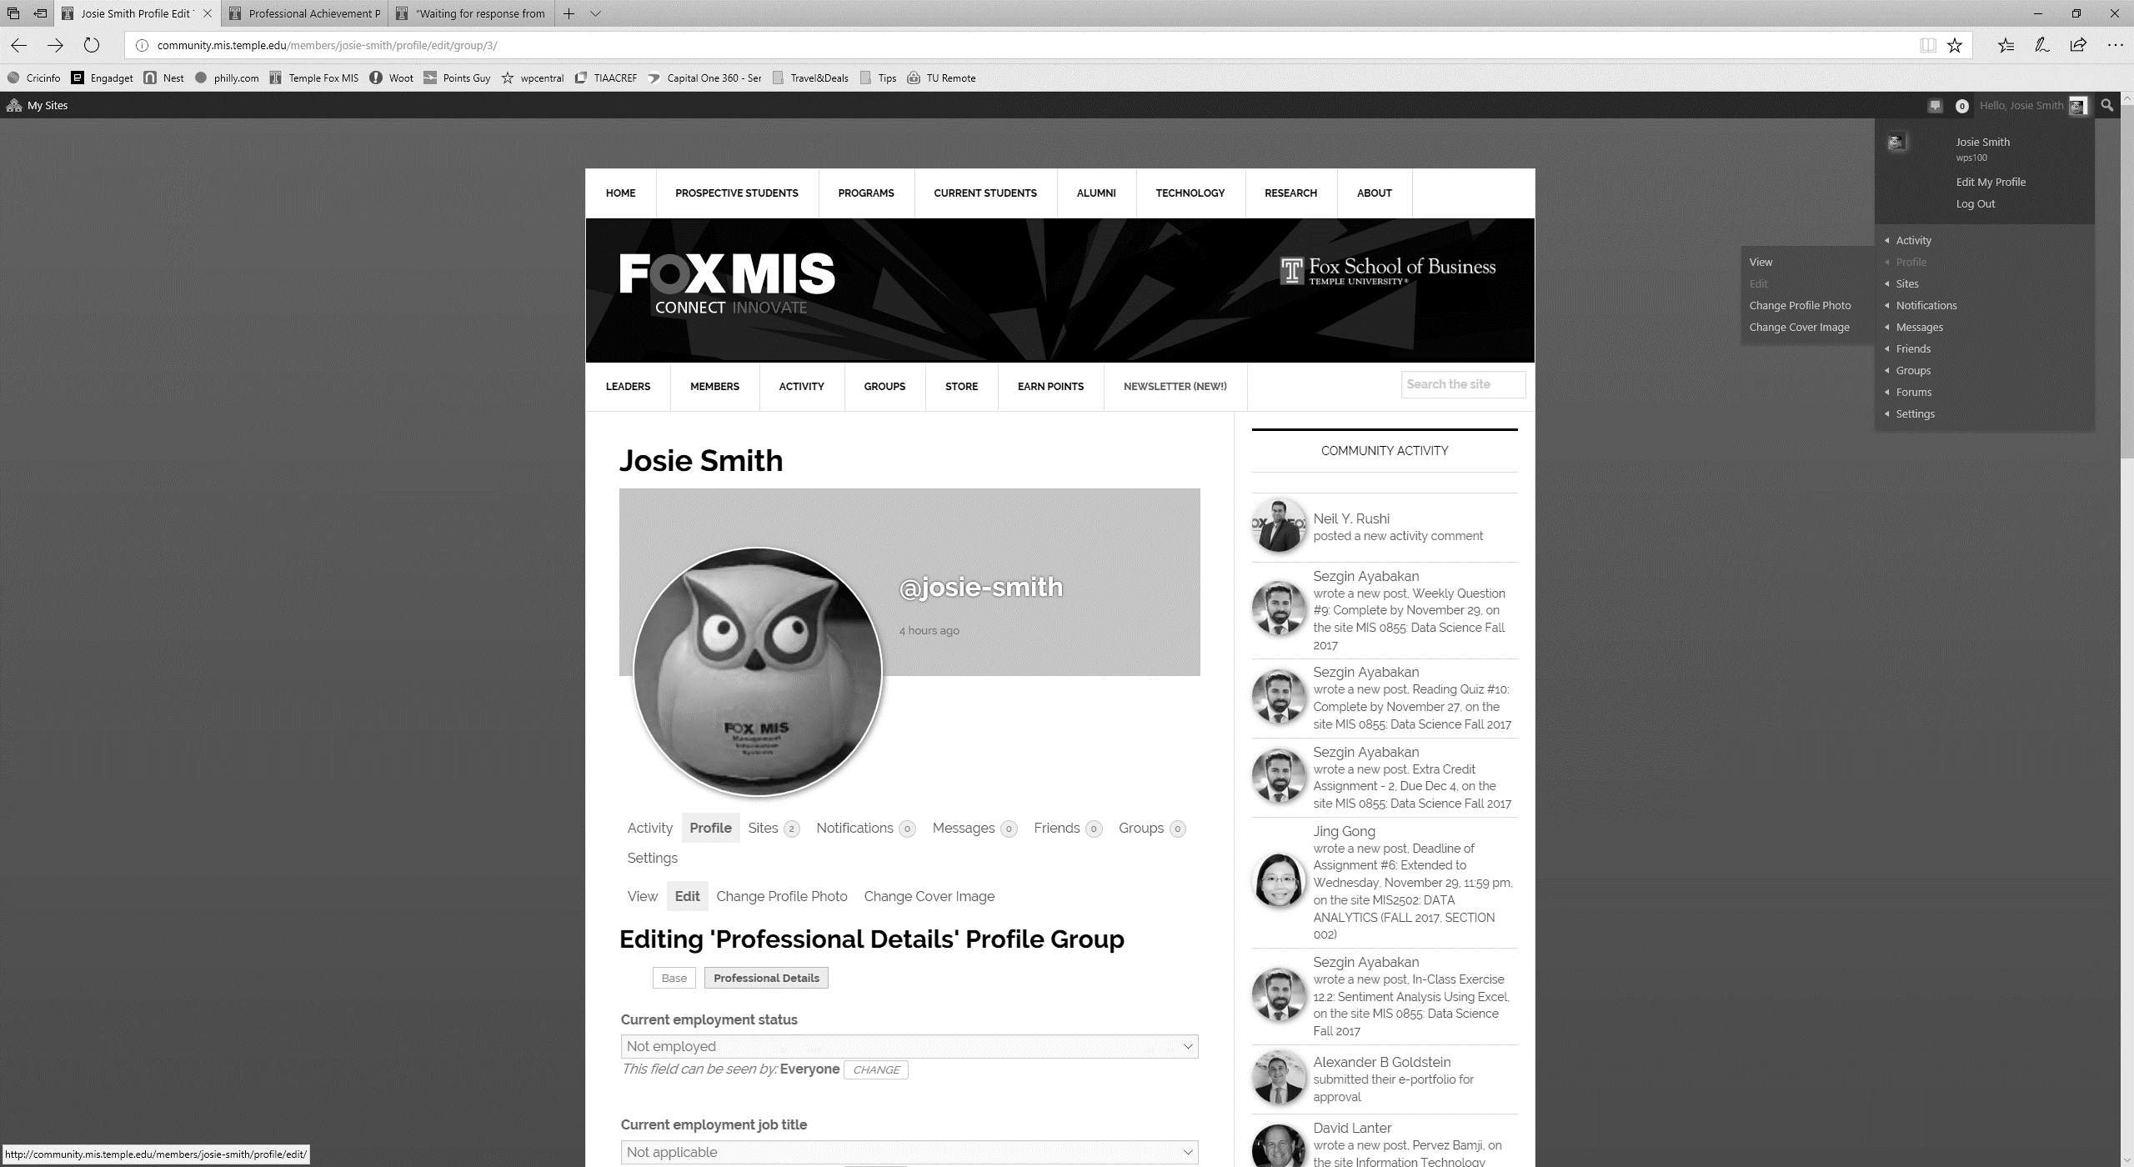Complete the fields listed. *Major, University affiliation*, and *Hometown* are required. Note the visibility setting for each field. For example, *Hometown* is by default only visible to your friends (on this site). You could change it to be visible to *All Members* (authenticated users of the university community). Change visibility by clicking *Change* next to the current setting. **Make an informed choice: balance the need for privacy with the need to engage with others.** Click *Save Changes* at the bottom.
   2. Complete the following professional details. Look under ‘Editing Base Profile’, and to the right of the ‘Base’ tab, locate and click on the *Professional Details* tab. *Skills* *and* *Interests, Job Interest, Graduation date – Month, and Graduation date – Year* are required*.* Select at least two items each for *Skills* *and* *Interests* and *Job Interest*. Hold the control key to select multiple items. **These fields are important because they signal who you are to employers, alums, professors, and prospective team members.** Note the *E-portfolio* field, we’ll come back to it later, For now, Click *Save Changes* at the bottom.
3. Add or update an avatar by clicking *Change Profile Photo*. Next, click *SELECT YOUR FILE* to upload a professional high-resolution picture (which is usually larger than 1 MB). Next, crop the image using the cropping handles. A typical avatar shows the face, collar, and top of the shoulders. Click *CROP IMAGE* to complete. Note: To access all features of the platform **you must add an avatar now**. For example, the e-portfolio search function for employers will only display students who have avatars.
4. Go back to your profile (*Hello,..., Profile, View*) and click the previously chosen *Skills and Interests*. You will see others who have similar interests, click through to check out their profiles. (Note: you must first select your own Skills and Interests before you can see other’s.)
5. Review the COMMUNITY ACTIVITY sidebar on the right of the main screen to review the activity of other students. If you see an interesting activity, click the *student’s name*, and then click *Profile* to learn more about them.
6. Click the *LEADERS* near the top left of the home page to locate high achieving students. Click the *student’s name* to view their e-portfolios. Note: These students will provide the inspiration for your own e-portfolio so it is in your interest to locate the best examples.

**Part 1 - Deliverables**

1. Take a screen shot of your complete *Base* AND *Professional Details* profile (Hello,…, Profile, View).
2. Locate the profiles of **two** different people. These people should share at least one of your of your selected *Skills and Interests*. Take a screen shot of each of their respective profiles. Circle or highlight the common *Skills and Interests*.
3. Locate the e-portfolios of **two** other people (who are different from the above) whose sites you admire. Take a screen shot of each of their respective sites. Circle or highlight what you like about their sites.
4. Paste all of the above items into a Word document and save.

To take a screen shot, press *Alt* or *Fn* (hold it down) and then press *PrtScn* on any Windows computer. On a MAC, press *control* (hold it down) and *Shift* (hold it down) and then press *3*. Open up Word, and click *paste*. If the image is too big to fit on the page, double click the image and use the Crop tool to cut out the non-relevant parts. To circle an item on an image in Word, click *Insert*, *Shapes*, and choose a shape.

**Part 2 – Digital Portfolio**

Create an e-portfolio to highlight professional details and accomplishments, including:

* professional profile photo (e.g., a headshot in formal attire)
* academic information (e.g., major, year of graduation)
* career interests and aspirations (e.g., industry and careers you are interested in)
* personal interests and volunteer work (e.g., relevant personal details that will help a professional colleague see you as a well-rounded person)
* descriptions of current or past work experience (e.g., a brief description of what you learned or did in a particular job)
* pictures that highlight the above activities (e.g., a picture at work)
* samples of work (e.g., a PowerPoint of a project)
* classes taken and results (e.g., list and describe what you learned from a favorite class)
* current resume (PDF version of your resume; in Word, select File, Save As Type: pdf)

***See Appendix A for tips on do’s and don’ts***

1. Create a new e-portfolio site by hovering on *Hello,…, Sites,* and click *Create a Site.*
2. 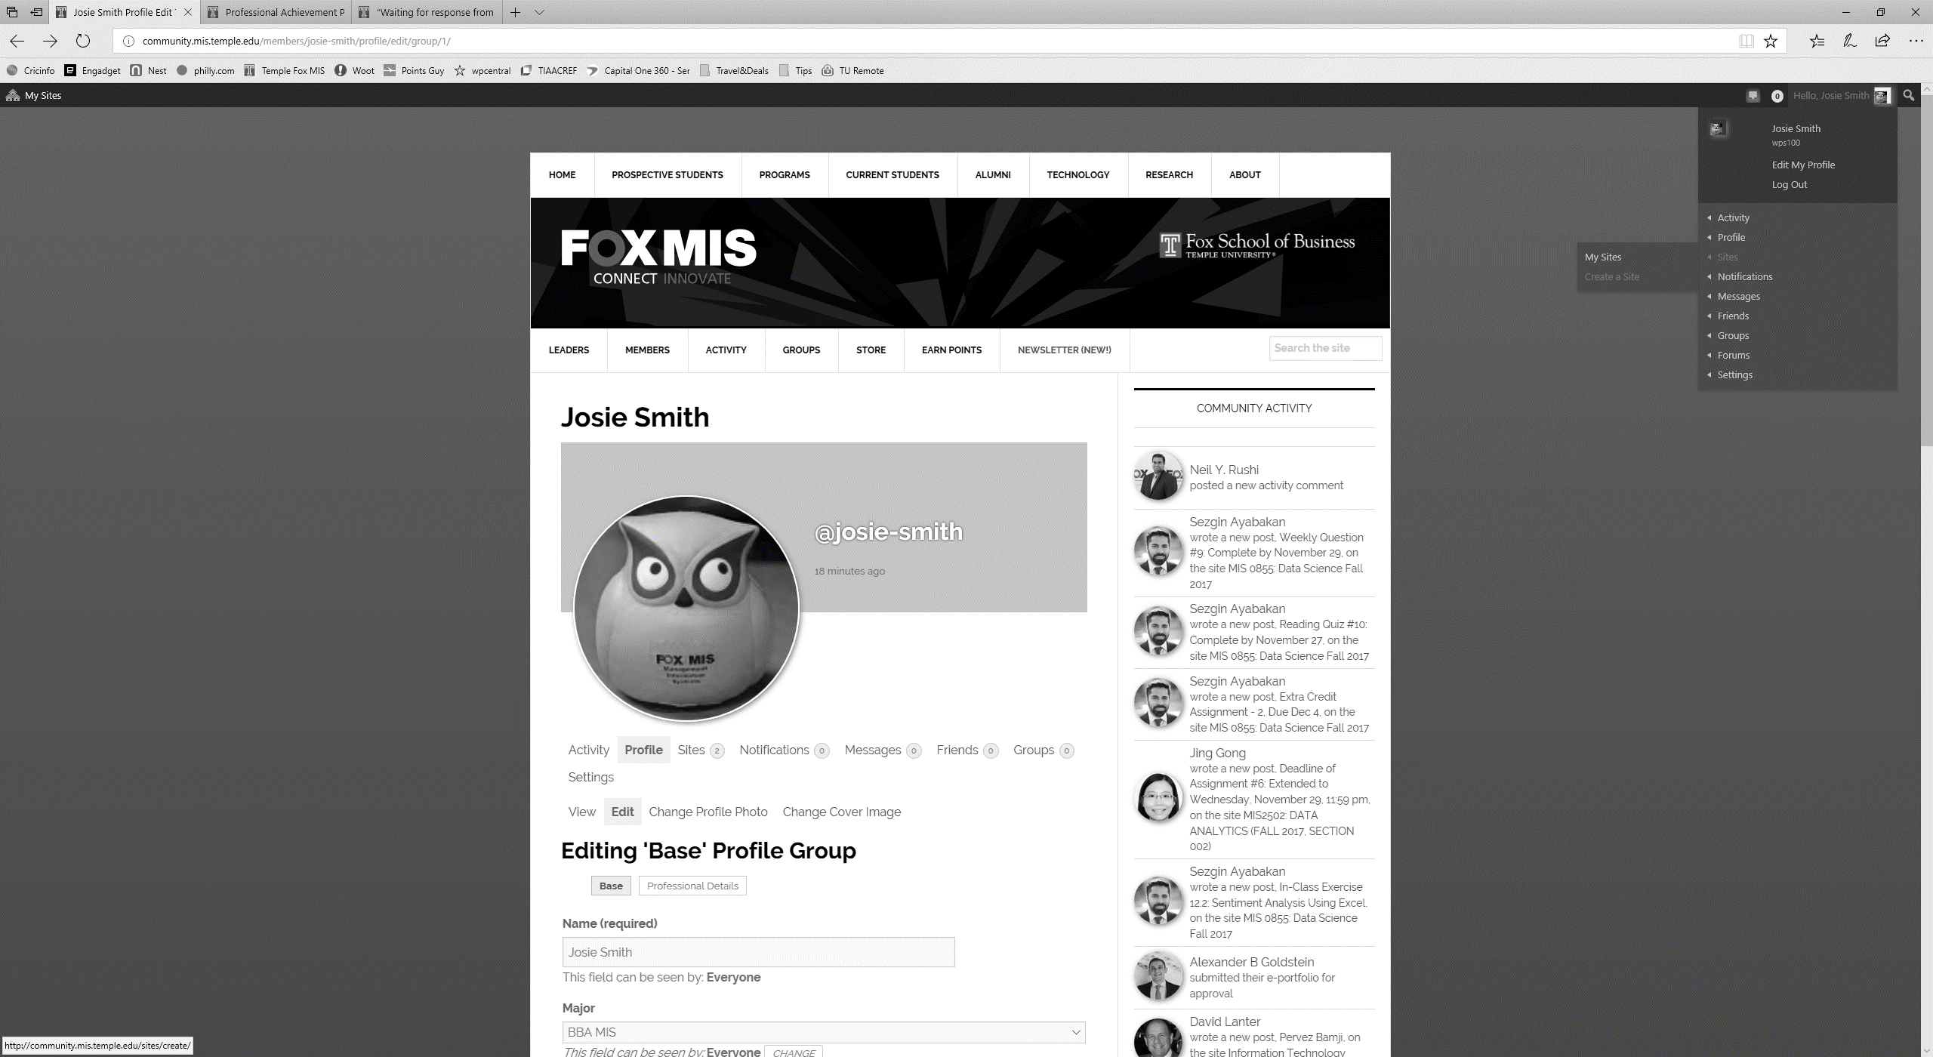The site name is the URL (uniform resource locator) also known as Internet address - so it should be easy to remember. Only lower case letters are allowed, do not use punctuation such as dashes or underline. Use the following convention for the *Site Name*:

* First initial followed by last name (e.g., jsmith for Josie Smith)
* If that does not work, then full first name followed by last name (e.g., josiesmith)
* If that does not work, then full first name, middle initial and last name (e.g., josiemsmith).

1. You must use your full name (e.g., Josie Fox) for the *Site Title*. **The site title is important, as that is how Google and other search engines will locate you.**
2. Select *Yes* for “I would like my site to appear in search engines, and in public listings around this network.” This will allow Google to index your site. Ignore the other choices for visibility.
3. Select *Student e-portf*olio for the *Site Categories*.
4. Finally, click *Create Site*. When you see the confirmation message, congratulations! You have created a site on the Internet with a permanent address. The address will look like http://community.mis.temple.edu/jsmith. Google will immediately start indexing the e-portfolio. You are now taking control of your digital identity! In about a week, try searching for your name. Note: Google likes content, the more posts your site contains; the higher the page ranking.
5. 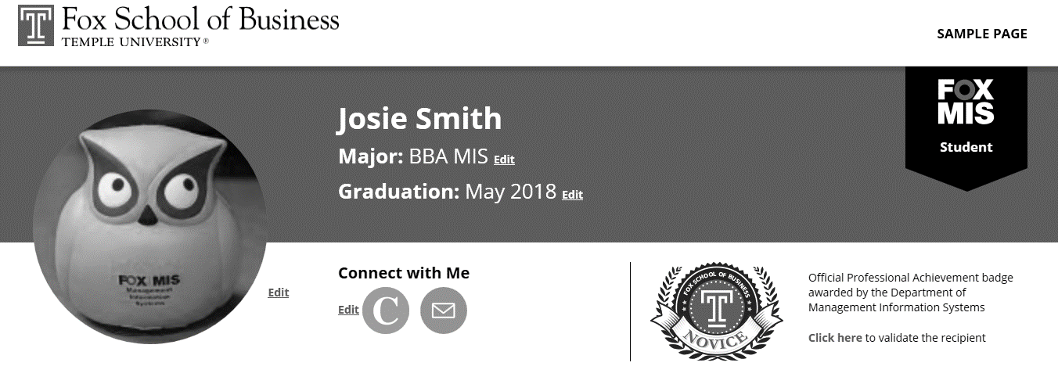Click on the URL of the new site to visit it. The site should look similar to the below.
6. If the site looks different, hover over *the name of your site* at the top, and click on *Themes*. Hover on the *Student e-portfolio* themeand click *Activate.* Click on *visit site* at the top to confirm that the new theme was activated.
7. Next, hover on *the name of your site* at the top and click *Dashboard*. Check out the items in the Dashboard.
8. Add a new page. Hover over *Pages* on the left and click *Add New*.
9. Title this new page ‘About Me’ and type in a paragraph about your background and interests. Do not add a picture in the About Me page; the e-portfolio will already display your picture on the top left. If you need ideas for content, review the e-portfolios of other students. **Important formatting tips:**
   1. Before pasting from Microsoft Word, click  on the editor toolbar to ‘turn on’ conversion of content to plain text. This step will avoid messing up the look of your site.
   2. Avoid using underlines, since underlines usually denote a hyperlink on the internet.
   3. Do use the provided styles in the editor under *Paragraph* (Heading 1, Heading 2, etc.) as paragraph headings. There are two benefits: first the theme will automatically adjust for mobile, and second Google uses the heading style as part of its indexing.
10. Click *Publish* on the right to publish the above page. You have now created a page on the Internet! (Titled ‘About Me’), click on *View Page* at the top to see this page.
11. Add at least two more pages:
    1. ‘Coursework’ page: List selected courses taken followed by what you learned from each course in one or two sentences. You can also list current courses and what you expect to learn. Optional: Include a picture or downloadable file of an interesting project.
    2. 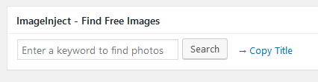‘Experience’ page: List each professional position including internships and part-time jobs. Describe your roles in each position. Optional: Include a company picture and description.  
       AND/OR  
       ‘Interests’ page: Describe your professional and personal interests. Include a picture or other visual elements that highlight your interests.   
       Tip: In the editor, scroll to the bottom to use the ‘ImageInject’ tool to easily locate and insert legal free images (e.g., picture of a technology, sport, or building).
12. Remove the sample content. First, delete the Sample Page by clicking on *Pages* in the Dashboard to access the sample content. Hover on the sample content and click *Trash* to delete it. Second, repeat the process to delete the Sample Post by clicking on *Posts* in the Dashboard.
13. Add a menu to display the new content you just created:
    1. 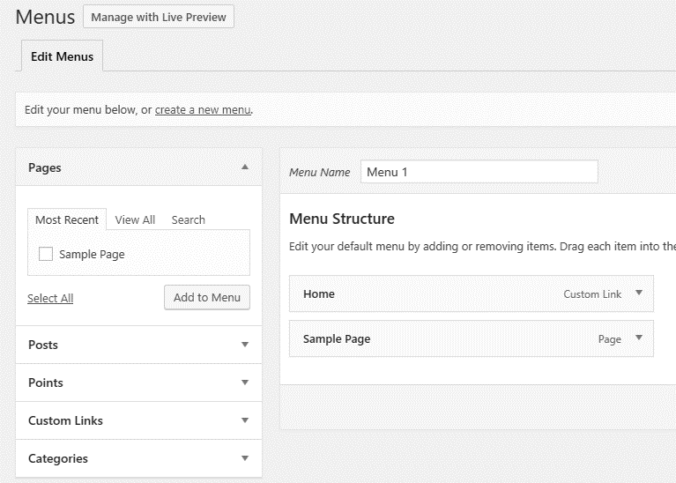On the sidebar, click on *Appearance,* then *Menus*.
    2. Remove the default items (typically Home and Sample Page). Access the Remove option by clicking the little down arrow next to each item.
    3. If not already there, add the three new pages to the menu by using the *Pages* option available on the left. Tip: Plan on 5-7 main menu items. More than 5-7 items will wrap to the next line, which will look ugly and make your side hard to navigate. If you need more menus, create sub-menu items under the main menu items. To do that, drag the desired sub-menu item to the right in the *Menu Structure* screen.
    4. Click *Create Menu* to complete the process.
14. Make the ‘About Me’ page your landing (home) page:
    1. 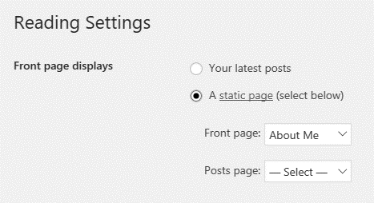In the Dashboard, hover on *Settings* and click on *Reading*.
    2. Select *A static page* on the right, and choose the ‘About Me’ page as the *Front page*.
    3. Click *Save Changes*.
15. Personalize the site by changing the tagline. The tagline is displayed by search engines and is visible on the right side of your site name in the browser tab.
    1. In the Dashboard, hover on *Settings* (if needed) and click on *General*.
    2. Change the default tagline by either removing it or by adding something more relevant (e.g., ‘Fox BBA in MIS student’)
    3. Click *Save Changes*.
    4. To view your site, on the top left corner, click *My Sites, (Your Site Name), Visit Site.* Copy the URL of your site as you will need it for the next step.
16. Finally, add the e-portfolio to your profile.
    1. Hover on *Hello, …* (on the top right) and hover on *Profile*, and then click *Edit* to access your community profile.
    2. Click *Professional Details*. Paste in the URL of your new site in the E-portfolio field (e.g., http://community.mis.temple.edu/jsmith)
    3. Click *Save Changes* at the bottom.

**Part 2 - Deliverables**

1. Take a screen shot of the e-portfolio home page that shows the About Me page as the home page and the links to the additional pages.
2. Take screenshots that display the content of the two other pages (Coursework, Experience/Interests).
3. Paste all of the above items into a Word document and save. Tip: To avoid losing points, check that you deleted all the extra posts and pages automatically added by the system.

**Part 3 - Analytics**

Connect your e-portfolio to Google Analytics to analyze the impact of your digital identity. Creating a site on the Internet is like hosting a party; it is no fun if nobody visits! Google Analytics will provide detailed data on the impact of your new digital identity.

1. Login to your new site (e.g., http://community.mis.temple.edu/jsmith)
2. Hover on the site name (at the top of the screen near the left) and click *Dashboard*. Next, click on *Settings* (near the bottom on the left) and then *Google Analytics*.
3. Enter the Site Tracking Code into the box. (see the detailed instructions in Appendix B on how to get the site tracking code from Google)

In about a week after initial creation, your site should list some traffic on Google Analytics.

**Part 3 - Deliverables**

1. Login to Google Analytics and click on your site. On the bottom right corner of *Google Analytics Home,* click *Audience Overview.* Take a screenshot of the overview and paste it into the Word document. (Note: you will need to wait a week before you see any data on this screen).

**Part 4 – Build Your Professional Network**

Start building your professional network. To achieve this goal, locate and interact with people with whom you share an interest or you admire.

1. Go to http://community.mis.temple.edu and click on *MEMBERS,* or *ACTIVITY,* or click onspecific *Skills and* *Interests* in your profile to find **two** students who share similar interests, or who you admire.
2. Select one of the two individuals and send them a public message. Click on *Public Message* on the selected person’s profile*.* Note: The software will automatically insert the selected person’s handle (looks like @ followed by userid) into the textbox. This is similar to publicly communicating on Twitter. Click *ACTIVITY* near the top of the screen in the second menu bar to see your public comment.
   * Optional: Send a *Private Message* to somebody you know.
   * Optional: Send a friend request by clicking on *Add Friend*.
3. Create OR join a ‘community of practice.’ A community of practice focuses on a specific professional interest (e.g., careers in analytics). To create or join a group, click on *GROUPS* on the menu bar. This feature provides a platform for people with similar interests to network and share information. Group members can message the group, share updates, and documents.
   * If you create a group, you should get at least one other person to join the group.
   * To join an existing group, review the list and click *Join Group* to join the group.
4. Post a message about your interest in the above community of practice (group). To post, click to enter the selected group, and type your message in the textbox below *What’s new in ….* Click on *Post Update* when you are done.

**Part 4 - Deliverables**

1. Click *Hello,…* then *Activity*, and then *Personal*. Use the *Show* filter to focus on the activities that you just completed. Take a screen shot and paste into your Word document.
2. Create a table in the Word document with three columns: Public Message, Comment, and Community of Practice (Group). Under each column, explain in one or two sentences the differences between the three forms of professional networking and communication.

**Submit the Assignment**

Congratulations! You now have the concepts and tools needed to manage your professional digital identity.

1. Confirm that you have completed all the parts above integrated into one Word document:
   * Part 1: Screenshots of your profile, the annotated profiles of two others, and the e-portfolios of two others.
   * Part 2: Screenshot of your e-portfolio’s home page plus the two other pages.
   * Part 3: Screenshot of the Google Analytics Overview page for your site
   * Part 4: Screenshot that shows activity, plus the table that compares the three different forms of professional networking and communication.
2. Save the Word document as a PDF (click *File Save As ..PDF* in Word) using the following convention: LastName_FirstName_LearnIT1. The instructor will provide directions on how to email the document.

**Appendix A – E-portfolio Do’s and Don’ts**

**DO’S**

1. Include your full name in the e-portfolio site title. This is the most important way you can influence Google’s page ranking algorithm so that it displays the e-portfolio. On your homepage, include descriptive and contact information (e.g., email address).
2. Include sample work. If you are proud of work you did for a class (e.g., class project) or outside school, then show case it! After all, this is your digital portfolio.
3. Include a description of your work experience. Describe your role. What did you accomplish? Include a hyperlink.
4. Highlight involvement in non-profit organizations. Describe your role. What did you accomplish? Include a hyperlink for each activity with a picture.
5. Add pictures. Pictures that highlight your professional experience and/or achievements will make your site more attractive.
6. Proofread your e-portfolio. This is your public digital identity. Typos, spelling mistakes, or poor formatting will negatively affect your professional image.
7. Use Google and Mobile friendly formatting: The use of pre-defined styles such as Heading 1, Heading 2, etc., makes it easier for Google to index your site. These styles are available in the editor in the *Paragraph* menu. Moreover, pre-defined styles will automatically adjust to look good on mobile devices.

**DONT’S**

1. Avoid inappropriate photos. A typical headshot displays your face and shoulders with a neutral background such as a wall or building.
2. Don’t post normally private information such as home phone, home address, and anything else that does not belong on a public forum. Remember, e-portfolios are your *public* digital identity.
3. Fix broken links. Make sure all hyperlinks work.
4. Don’t post word documents. Word documents might contain viruses and often don’t work across platforms. Use PDF instead.
5. Don’t post inappropriate content. This is not Facebook. YouTube videos of the greatest song ever… and things of that nature do not belong on the e-portfolio.
6. Don’t password protect or close the site. This defeats the purpose of having a public digital identity.
7. Don’t use custom formatting or CSS: The underlying theme and software is designed to professionally display content on both desktop and mobile devices. The use of different fonts, font colors, custom font sizes, or CSS code may break your site on desktop or mobile or both.

**Appendix B – Google Analytics**

1. Login to your site (e.g., http://community.mis.temple.edu/jsmith)
2. Navigate to the *Dashboard* and click *Settings* and then *Google Analytics*.

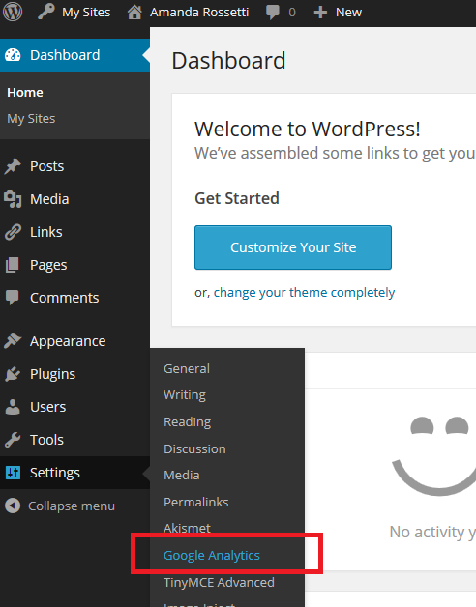

1. Note the *Site Tracking Code* box below. You will need to setup a Google Analytics account to obtain this site code. See next.

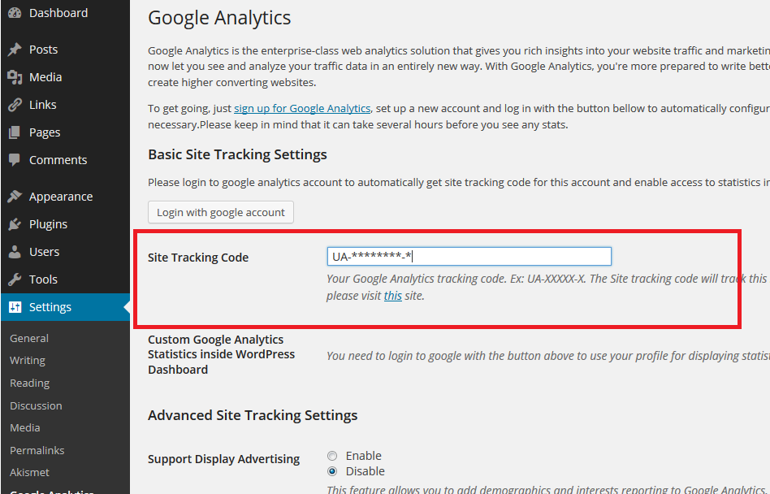

1. To use Google Analytics (GA), you will need to use your Temple email-address (e.g. tueXXXXX@temple.edu). If you do not have a Temple e-mail, you cannot proceed further. Please contact your instructor.
2. Go to [www.google.com/analytics](http://www.google.com/analytics).
   1. 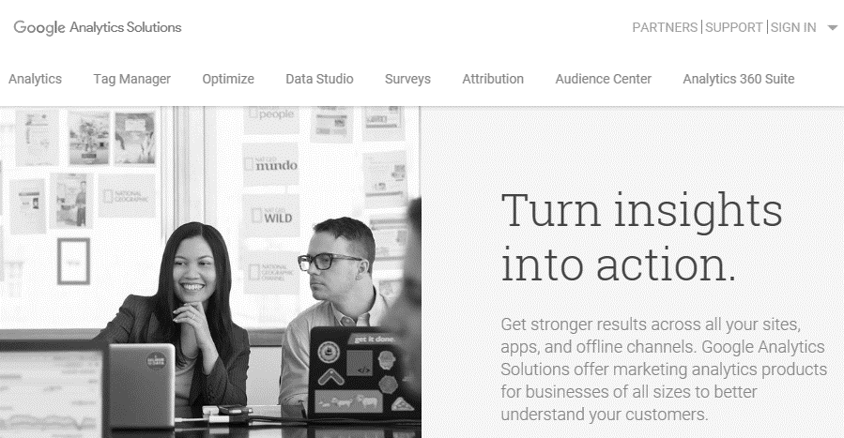Click *Sign in,* then click *Analytics*.
   2. Sign in with your Temple email address and password.
   3. 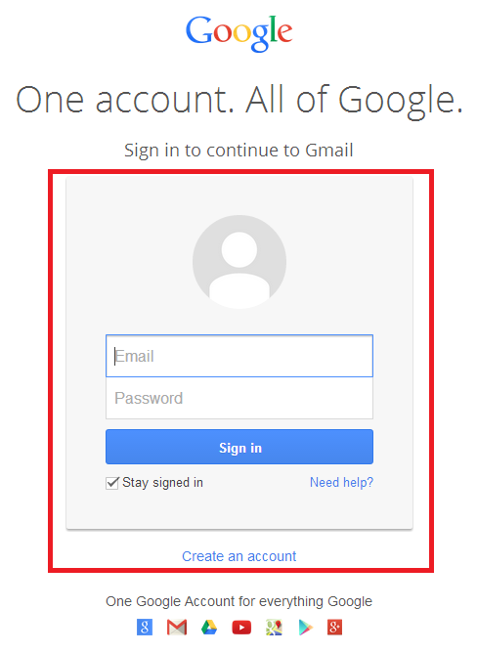Click the big, grey *Sign up* button on the right.

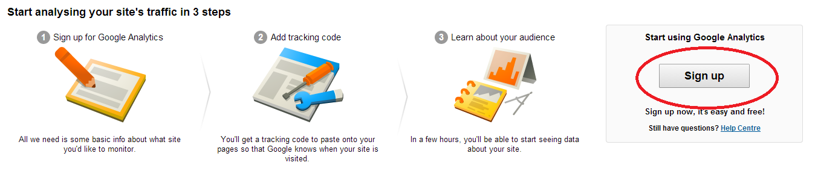

1. You will be directed to the *Create New Account* screen.
   1. Fill in:
      * *Account Name* (e.g. ‘John Smith Analytics’).
      * *Website Name* (e.g. ‘John Smith E-portfolio’).
   2. For *Website URL*, select *http://* from the drop down menu.
   3. Copy your e-portfolio URL and paste it into the *Website URL* field (exclude the http://). For example: community.mis.temple.edu/jsmith.
   4. Select *Industry Category* > *Jobs and Education.*
   5. Select *Reporting* *Time Zone* > *United States > (GMT – 05:00) Eastern Time*

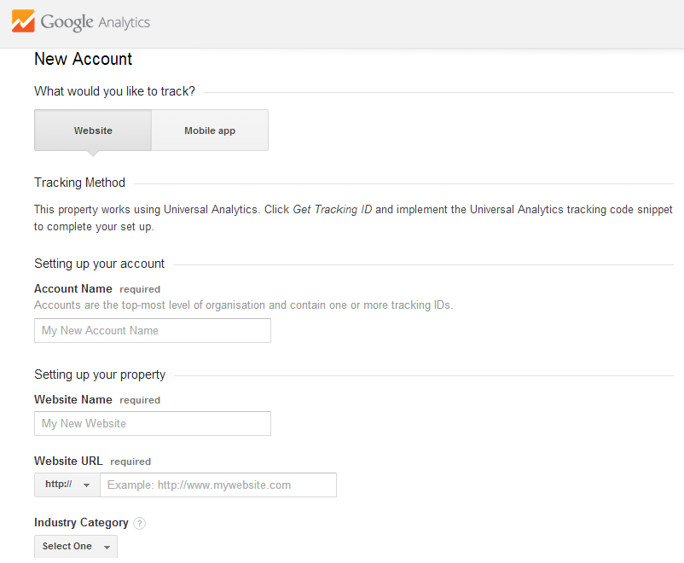

1. Choose whatever Data Sharing Settings you wish. Click *Get Tracking ID*

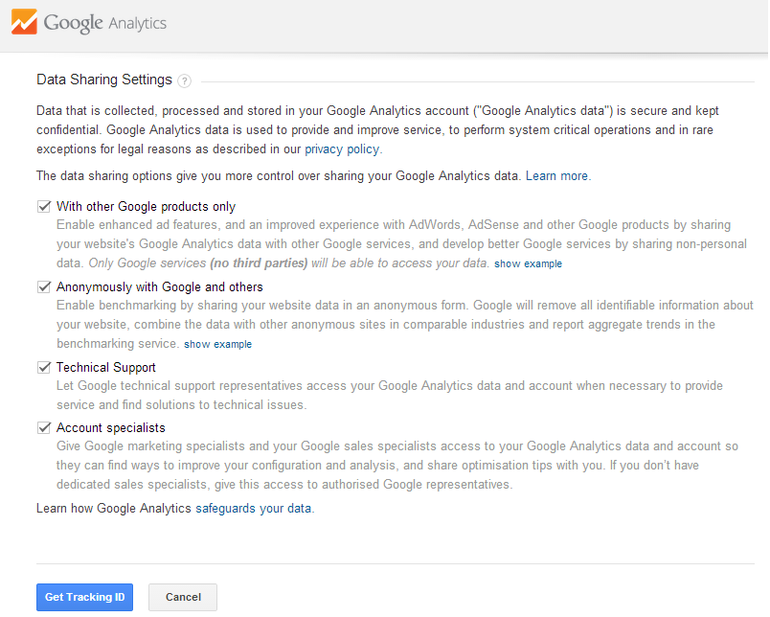

1. Select *United States* and then click *I Accept* 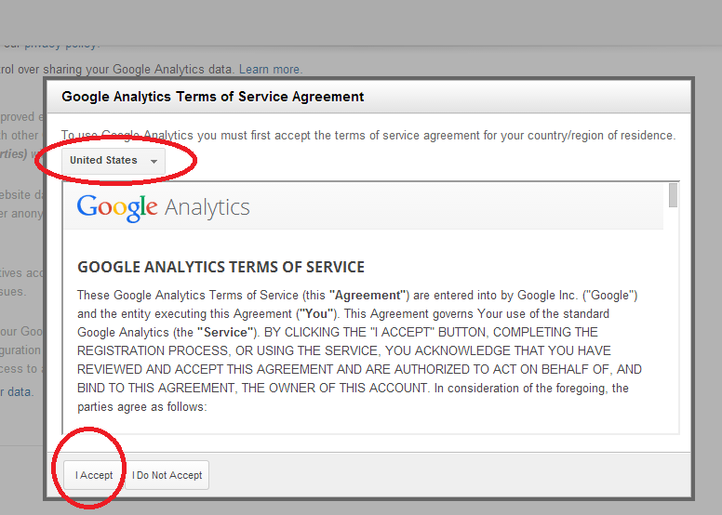
2. Scroll down and you should see the Tracking ID. This is the ‘UID’ that you need to connect to your e-portfolio.
3. Copy the Site Tracking ID including “UA” and save it.
4. Go back to step 3 (above) and paste it into the screen from step 3. (note: the ‘Tracking ID’ is equal to the ‘UID’ which is the same as ‘site tracking code’). Click *Save Changes*. 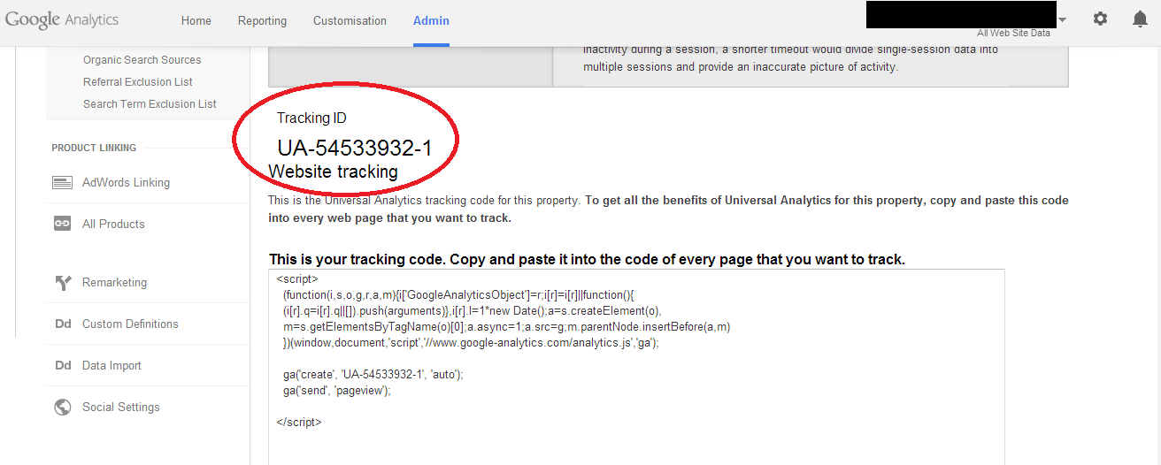
5. Wait for a week. Ask your friends to look at your e-portfolio to generate traffic. Log back into Google Analytics, go to *Reports > Audience > Overview* to see the results!

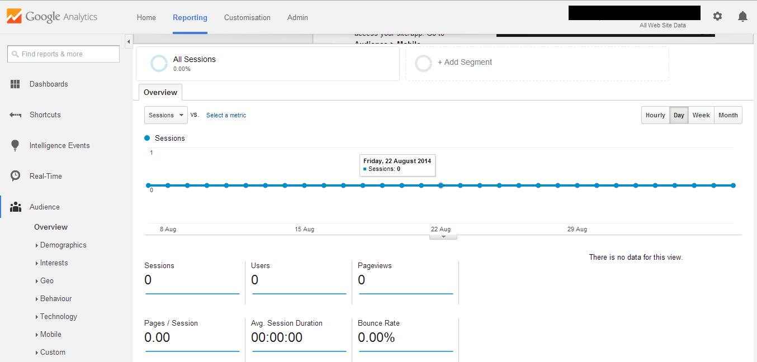

1. http://en.wikipedia.org/wiki/Communities_of_practice