Debugging your code in VS Code

You have written your code, opened it in the browser, and you get an error message, or -even worse- a blank screen. This means that there is an error somewhere in your code.

Common issues:
1. Did you save your file before opening it in the browser?
2. Are all the brackets and parentheses matched? { } ( )
3. Are all the variable names exactly right? Click on them to make sure they match. CaSe mAtTeRs!
4. Do the variables you added have truly new names, or do they repeat variable names or function names elsewhere in the program?

VS Code has some tools to help you with the debugging. In the menu, select View, and then Problems. This will open the Debug Console on the lower right of your screen. The interface looks slightly different for a Mac, but works the same.

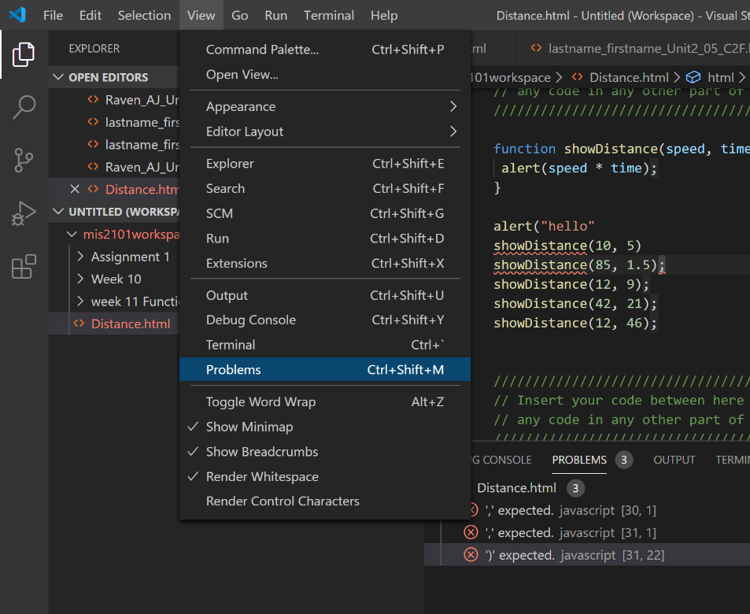

When you click on one of the problems, it will show where in your code the bug is located. In some cases the bug will be in an earlier line. For instance, a variable name that was mistyped on line 35 may not cause any issues until it needs to be used in line 46.

