Logging into SAP

The first challenge to completing the SAP assignment is simply logging into the SAP system. This may sound simple but you have a few choices to make and your need a few pieces of information, not just an account and password. This document will help you understand how to get logged into the SAP system. Other documents on the assignment blog will help walk you through the assignment after you get logged in.

The first choice you have to make is how you will access the SAP system. You have three options:

- Using the SAP GUI that is already installed on the machines in the labs in Alter and Speakman Halls is the recommended way to access the SAP system. The students who are providing support for this assignment will only provide support if you use this approach. Using the SAP GUI (vs. a web browser) is the easiest way to complete the assignment because the screen shots in the assignment will most closely match what you will see when using the SAP GUI. The directions below assume that this is how you will be accessing SAP.
- If you have trouble getting to the labs in Alter and Speakman Halls, installing and using the SAP GUI on your own personal machine is another option. Both Mac and PC versions of the SAP GUI are available for download from our class blog. Directions for installing this software on your own personal machine are included with the software. This option is not supported by the students who are providing support for this assignment but it is another option. Like accessing the SAP system using the SAP GUI in Alter and Speakman Halls, the screen shots in the assignment will more closely match what you will see when completing the assignment compared to accessing the system via a web browser.
- The third option, and one that I would highly discourage, is accessing the SAP system from a web browser. No support will be provided for this approach and the screens you see will not match the screens in the assignment but if you can’t make it to the labs in Alter and Speakman Halls and if you don’t want to install the SAP GUI on your personal machine, this is the only remaining option. Directions are provided in the class blog.

Before you try to login to SAP you will need four pieces of information which will be provided by your instructor. These four things are:

- The System Name
- The Client Number
- Your Userid
- Your Password

To launch the SAP GUI, look on the desktop for the SAP Logon icon that looks like :

Click on this icon to launch the SAP GUI. If you have trouble finding the SAP Logon icon, you can launch the application by going to “Start…All Programs…Fox Business Applications…SAP…SAP Front End…SAP Logon” You should see a screen that looks like this:

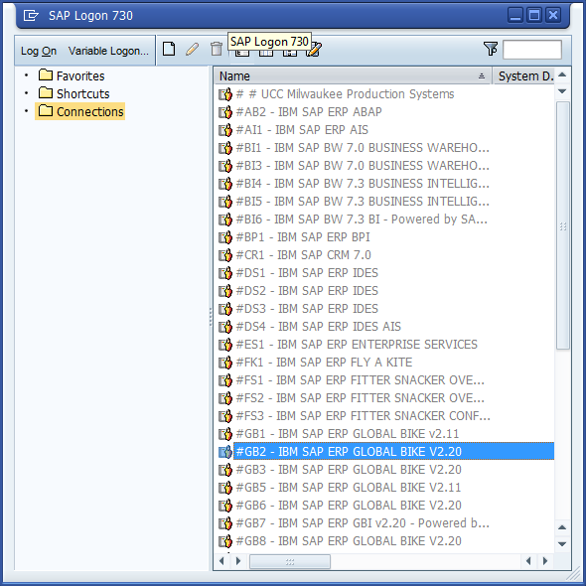

Your instructor should have provided you with the name of the SAP system that you will be using. Please select that system by double clicking on it. In this example I am selecting the system GB2 but your system name may be different.

You should then be presented with a screen that allows you to enter the three remaining pieces of information, your client number, your userid and your password. Please note that the default client number is 000 and this is most likely not your assigned client number. Please enter your client number, your userid and your password and click on the green circle with the check mark in the upper left corner.

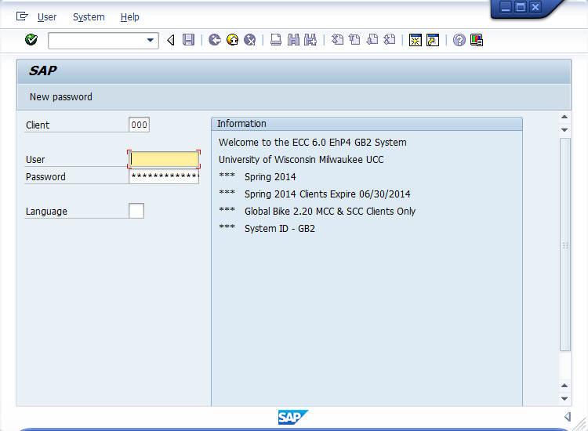

You should now be logged into the SAP system and you can start to work through the tutorial and complete the assignment. If this is the first time you’ve logged into the SAP system you will be required to supply a new password that only you will know. Please do not forget your new password because it is extremely difficult to get this password reset.

