Organizational Systems: IT income statement impacts
After completing this activity you will be able to:
- Map IT impacts to a corporate income statement.
- Differentiate between hard and soft costs (and benefits).

Step 1: Form Small Groups (3-4)
In this activity your team will focus on the offerings of a software vendor and consider how it could be used by a professional services company.

Groups | Vendor / Product | URL
1, 4 | Sage Timeslips | http://na.sage.com/us/sage-timeslips
2, 5 | Basecamp (Project Management) | https://basecamp.com/
3, 6 | Salesforce (CRM) | https://www.salesforce.com/

Step 2: As a Class
Review the income statement for a professional services company (Razorfish).

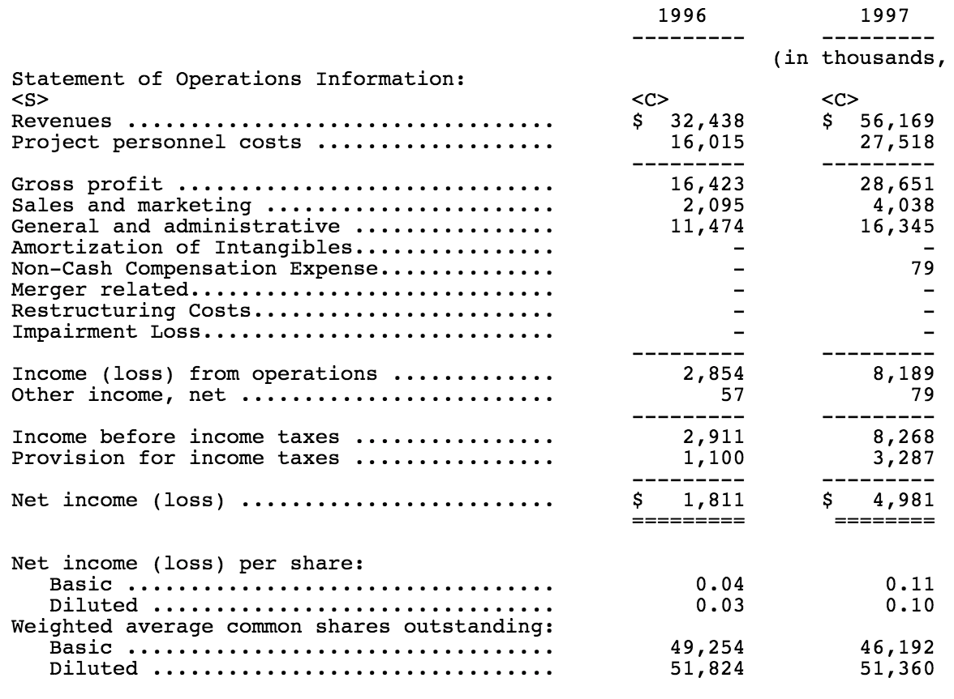

Step 3: Individually
Review product websites:
- Identify any stated or implied costs of implementation and usage.
- Identify 3-5 stated or implied product benefits.
- How do the product benefits map to operations of a professional services company?

Step 4: As groups
- Compare your answers.
- Identify two key benefits.
- Identify one-time and recurring costs.

Step 5: In larger groups
Groups 1, 2, and 3 meet together on one side of room; groups 4, 5, and 6 on other side of room.
- Each group makes a short report of their findings.
- Other teams ask clarifying questions.

Step 6: Answer these short-answer questions (individually)
1. Are most vendor claims hard benefits or soft benefits?

2. Is it easier to identify costs or benefits? Why?

3. If you ran a small, growing professional services firm, which of the three solutions would you pursue first? Why?

Step 7: Rate this activity (individually)

Ratings | 1 Completely Disagree | 2 Somewhat Disagree | 3 Neutral | 4 Somewhat Agree | 5 Completely Agree

Statement | Rating (1 to 5)
This is an engaging activity.
I learned a lot completing this activity.
This activity should be included in future classes.
Anything else you want the instructor to know?

Submit this activity to OWLbox from your Temple email account to upload.Unit_3_.3pfwo5q00k@u.box.com

