MIS 2101 - Project 1
Business Applications

Name

Instructions

This assignment has three major parts. Each part involves reading, interacting with some software, copying computer screen images into your assignment to demonstrate your work, and responding to questions.

Grading Criteria

This assignment will be graded using a total numeric score based on the accuracy of your answers.

Submission of Deliverable

Add your answers to this document and submit this document as a file. Answers to questions should not be longer than two to three sentences. Credit will be deducted for answers that are too long.

Additionally, in an effort to save paper, please do not include the directions in your final submission.

Submit your final project via hardcopy only, due by the end of class on the assigned date. NO late submissions will be accepted. The assignment is posted on the class MIS Community site. Please use the assignment template for your answers, and provide screen shots for all of the assignments when directed.

To copy a screen image on your computer, press the Alt+PrtSc keys on your computer. This copies the screen to the Windows clipboard. Then go to the assignment Word document,
- place the mouse cursor at the point where you want to insert the screen image
- press and release the left mouse key
- select Edit/Paste

PART A – Customer Relationship Management

Introduction

The purpose of this assignment is to learn how businesses manage relationships with existing and potential customers through a Customer Relationship Management (CRM) system. You will explore a demo of Microsoft’s CRM. Make sure you are using a computer with the volume up so you can hear what the presenter is describing.

Steps
- Watch and listen to the Microsoft Dynamics CRM Demo:
http://www.youtube.com/watch?v=rKiHKzyd_xw

- You will also need to refer to chapter 8 of the Valacich book, Improving Supply Chains and Strengthening Customer Relationships, to answer some of the questions.

- Please use the following site for the Questions referring to the CRM functions in the last 3 boxes below. Go to Solutions sub-menu and use the Sales, Marketing, and Customer Care links respectively.
http://www.microsoft.com/en-us/dynamics/default.aspx

Answer the Questions for Part A Here

QUESTIONS | YOUR ANSWERS
Developing a CRM strategy is discussed in chapter 8 of the Valacich book.
- What changes are necessary for an organization to successfully implement a CRM?
In chapter 8 of the Valacich book, the terms analytical CRM, collaborative CRM and operational CRM are introduced. According to the book,  What is an analytical CRM?  What is a collaborative CRM?  What is an operational CRM? | Analytical CRM:  Collaborative CRM:  Operational CRM:
List one function that a CRM performs for the sales organization (from the Microsoft site).
List one function that a CRM performs for marketing organizations (from the Microsoft site).
List one function that a CRM performs for customer service organizations (from the Microsoft site).

PART B – DECISION SUPPORT SYTEMS

Introduction

The purpose of this exercise is to gain hands on experience with a Decision Support System (DSS). According to whatis.com a “DSS is a computer program application that analyzes business data and presents it so that users can make business decisions more easily. A DSS may present information graphically and may include an expert system or artificial intelligence (artificial intelligence). It may be aimed at business executives or some other group of knowledge workers.”

Due to increases in processing capabilities and analytical developments, coupled with decreases in the cost of storage mediums, DSS has become increasingly popular and widely used in the past couple of years. As a result, DSS today are used in almost every discipline imaginable, such as: business, agriculture, and personal use.

In this DSS simulation, you are a Product Manager for a large mobile Phone and Service provider. You have been asked to develop a pricing strategy for a new line of phones and the service needed to operate them. You know that the phone market is very competitive, and that there are very different strategies for how to price both the phones and the service. One method is to sell phones with a price markup that allows the manufacturer to make money on the phone, and sell the service at a lower price with a small profit margin. Another method on the other end sells phones at a fairly significant loss, but charge higher prices on the service. In this scenario, the idea is to sell more phones, and make profit on the service. Both strategies have pro’s and con’s, and you need to decide how your company will price their phones and service to maximize profit.

Various groups in Sales & Marketing have submitted four (4) different recommendations on pricing the phones and services. Using the DSS software application in this exercise, you need to evaluate each proposal and the assumptions provided, to determine which scenario makes the most sense for your company. Your assignment will require you to answer some questions about the overall DSS evaluation, and provide screen shots of your DSS analysis screen shots. .

Getting Started

- Go To this URL: http://forio.com/simulation/aftermarket/casestudies.htm

- Select the “Mobile Phones and Mobile Service” simulation from the Drop Down

- Select “Select Simulation”

This will bring you to a screen titles: “Review Phone and Service Assumptions”

- Using this screen calculator, you will enter the data from the four (4) Sales Plan scenarios, one plan at a time (which are found in Table A below). Enter the data accurately from each Sales Plan into the individual fields, and check to make sure they are correct.

For each individual sales plan, you then:

Click: “Go to Step 2: Review Phone Sales Estimates”. This will bring you to a screen labeled “Review Phone Sales Estimates”, which shows you the expected phone sales estimates by units over the course of the product life.

- Click: “Submit Sales Estimates and Run Simulation.”

- This Aftermarket Analysis screen gives you all of the data you need to analyze each Sales Plan. There are menu tabs to give you specific information for metrics like: Revenue (for phone sales, service sales, and total sales), Units Sold, Number of Customers, Market Share, and Profit (by phone, service, and total profit).

- Take a snap shot of your screen shot of the “Yearly Revenue”
- To capture, use the PrtSc key on your keyboard.
- Open a Word document and press Control +Alt + “V”
- Paste the screen in the space below the questions, or on a separate Word Document to attach with the answers.

- Then click “Spreadsheet.” This now totals sales and profit, by product category, by year. Take a snap shot and paste a copy of the Spreadsheet next to the “Yearly Revenue” screen.

- Click: “Export Spreadsheet to Excel, and you now have a working spreadsheet to help you answer the questions related to this exercise. (Hint: You can use AutoSum to quickly add up the sales and profit figures, using these spread sheets.) You will run this simulation for each Sales Plan, to develop the data to answer the questions below. When you have totaled all of the data rows on the spread sheet, label each sheet by Sales Plan # and print a copy of the spreadsheet for each plan. You will need these spreadsheets to answer the questions below.

Answer the Questions for Part B Here

QUESTIONS | YOUR ANSWERS
Which Sales Plan scenario provides the highest total revenue (phones & service) over the life of the product?
Which Sales Plan scenario provides the highest level of total profit (phones & service) over the life of the product?
Can it make sense to sell phones at a loss, in order to maximize revenue and profit?

Why?
As a manager using this DSS application, which Sales Plan would you choose?

Why?

Table A
Sales & Marketing Scenarios: To be used for your DSS evaluations.

Sales Plan 1:
Phone Assumptions
Phone Price: $35
Average Phone Life (years): 2
Phone Profit Margin: -75%
Highest Expected Yearly Sales: 5,000,000
Service Assumptions
Service Price: $50
Frequency of Service Purchase: Once a Month
Service Profit Margin: 5%

Sales Plan 2:
Phone Assumptions
Phone Price: $70
Average Phone Life (years): 2
Phone Profit Margin: 15%
Highest Expected Yearly Sales: 4,000,000
Service Assumptions
Service Price: $40
Frequency of Service Purchase: Once a Month
Service Profit Margin: 3%

Sales Plan 3:
Phone Assumptions
Phone Price: $60
Average Phone Life (years): 2
Phone Profit Margin: 5%
Highest Expected Yearly Sales: 4,500,000
Service Assumptions
Service Price: $45
Frequency of Service Purchase: Once a Month
Service Profit Margin: 4%

Sales Plan 4:
Phone Assumptions
Phone Price: $25
Average Phone Life (years): 2
Phone Profit Margin: -105%
Highest Expected Yearly Sales: 6,000,000
Service Assumptions
Service Price: $65
Frequency of Service Purchase: Once a Month
Service Profit Margin: 8%

Paste screen shots here:

PART C: Business Intelligence

The primary purpose of an information system is to process information to produce reports to facilitate decision making. Reports may appear in various formats and be used to support a diverse range of organizational decisions. Reports provide a mechanism for organizing, analyzing, presenting and delivering information to end users. A common classification of reports is based on the types of systems on which they are built from. On-Line Transaction Processing (OLTP) systems as the name suggests are optimized for transaction processing. They process real time information and are accessed by many users. The reports are derived from the various business transactions and predominately support tactical decision making. An alternative information system is On-Line Analytical Processing (OLAP). This type of processing allows users to analyze information by creating multidimensional reports. They deal with large volumes of aggregated historical data. OLAP based reports are more flexible than the more traditional reports produced by an OLTP system.

OLTP reports provide information about particular transactions. The type of reports an OLTP system produces include:

- Who purchased a particular product?
- How much did an employee get paid?
- How many of a product was manufactured?

The flexibility of OLAP reporting assists end users in understanding why particular business events have occurred and or forecast what may occur in the future. The types of questions an OLAP system can assist with could include:

- What are the total sales for each product?
- What are the total sales for each department?
- Which salesperson has sold the most?
- Which products does each salesperson sell the most of?
- In which month did most of the sales occur?

OLAP systems and their ability for multidimensional reporting are considered important component of Business Intelligence. OLTP systems often provide the transactional data which is used as an input for OLAP system’s multidimensional reports.

To gain a better understanding of multidimensional reporting and related concepts we have created an exercise using Microsoft Excel’s PivotTable. The purpose of this exercise is to create a PivotTable in Microsoft Excel to analyse the data using multi-dimensional reporting.

Scenario
You are a manger of a department store and one of your responsibilities is to make decisions related to product ordering, promotions, customer discounts as well as monitoring and managing the daily operations of the store. You have a number of OLTP systems to assist with the recording of day to day transactions. At the end of each month you are provided with a report which displays each sale (see Excel file retail_sales_feb08.xlsx for February 2008 report). Although this report provides a lot of information, the information is not in a format which can easily assist in the type of decisions you are required to make.

Some of the questions that you are required to answer at the end of each month include:
Q_a) Which customer spent the least amount of money in February?
Q_b) Which customer spent the most in February and which sales person was responsible for the majority of these sales?
Q_c) Which product provided the most revenue?
Q_d) Which salesperson provided the most sales revenue?

PivotTables
An example of a multidimensional reporting tool is Microsoft Excel’s PivotTable function. A PivotTable is a tool which assists users with summarising large amounts of data into useful reports. The PivotTable’s flexibility enables you to re-arrange the table’s structure (columns and rows) until you get the required information.

Here are the instructions to create pivot tables. Follow these steps (1- 7) to create a pivot table to find out which product provided the most revenue (Q_a). Next follow step 8 to modify this Pivot Table to create a two dimensional pivot table to answer Q_b. Creating Pivot Tables to answer Q_c and Q_d are left as an exercise for the students.

Steps

1. Open the file retail_sales_feb_Fall14.xlsx

2. Click Insert -> Pivot Table at the top left of the screen
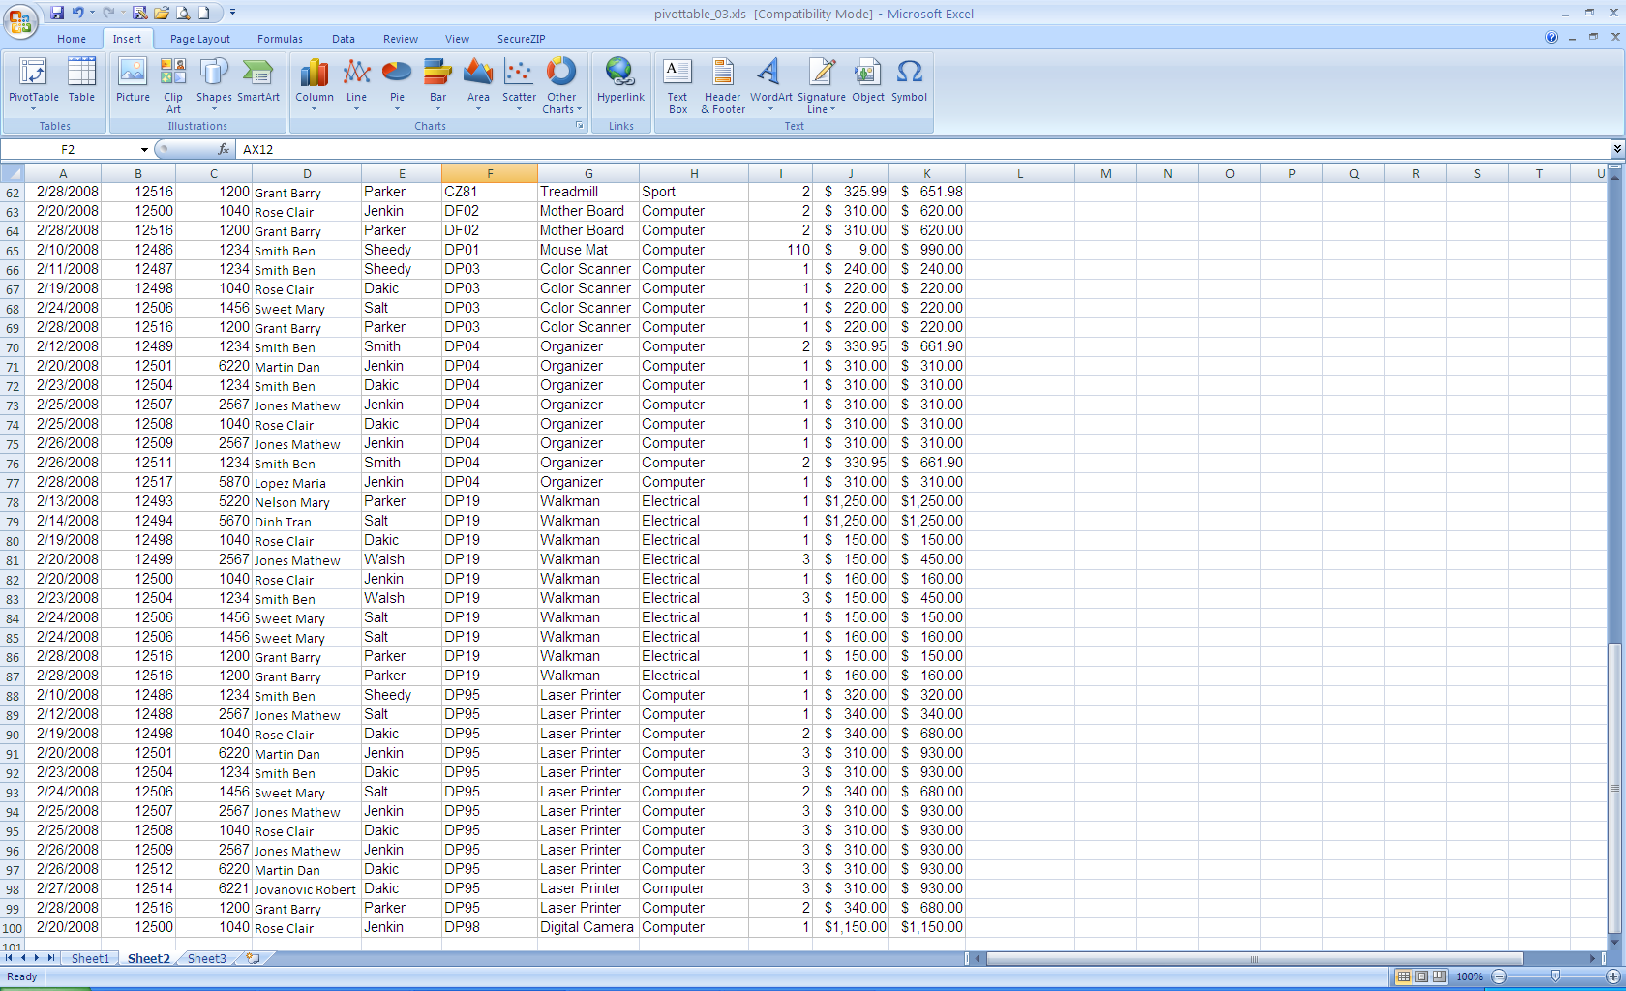

3. Select Pivot Table from the drop down menu
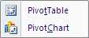

4. The next screen requires you to identify the data range to be analysed by the PivotTable. You will notice that Excel has automatically detected the data range. Also indicate where the PivotTable will be created.
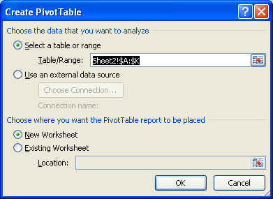

Click OK to continue

5. A new worksheet appears similar to below. The screen is divided into two sections. On the left is the Design Area where you define the structure of your PivotTable. On the right, is the Field List which corresponds with the column headings of your data.
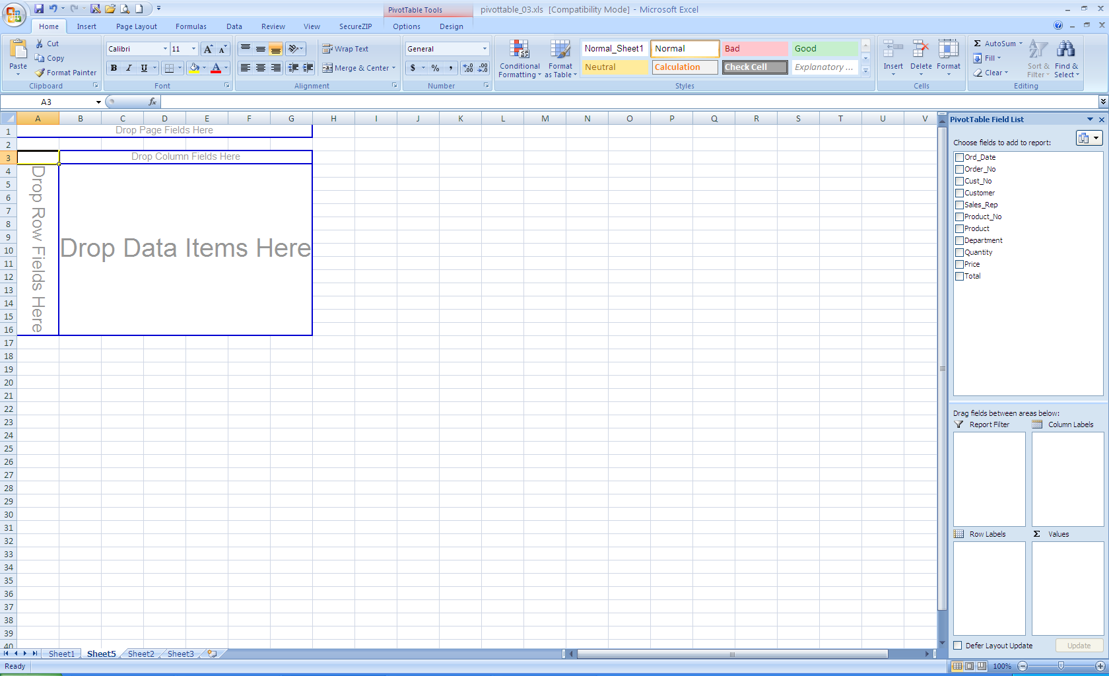

6. Click the checkbox Customer field from the list on the right to display the list of customers. This is the same as dropping the Customer field in the Row Labels box on the lower right side of the screen. Your screen will look like this:

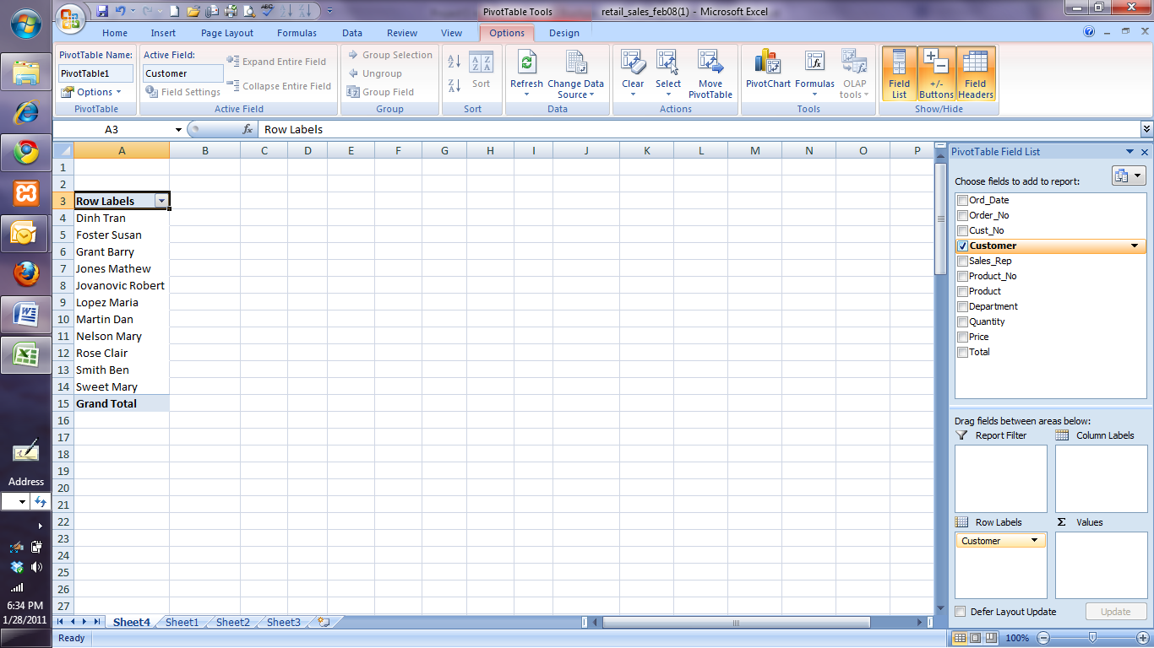

7. Drag & drop the Total field to the ∑ Values field in the lower right corner of the screen. Notice the order total next to each customer and a Grand total in your pivot table.
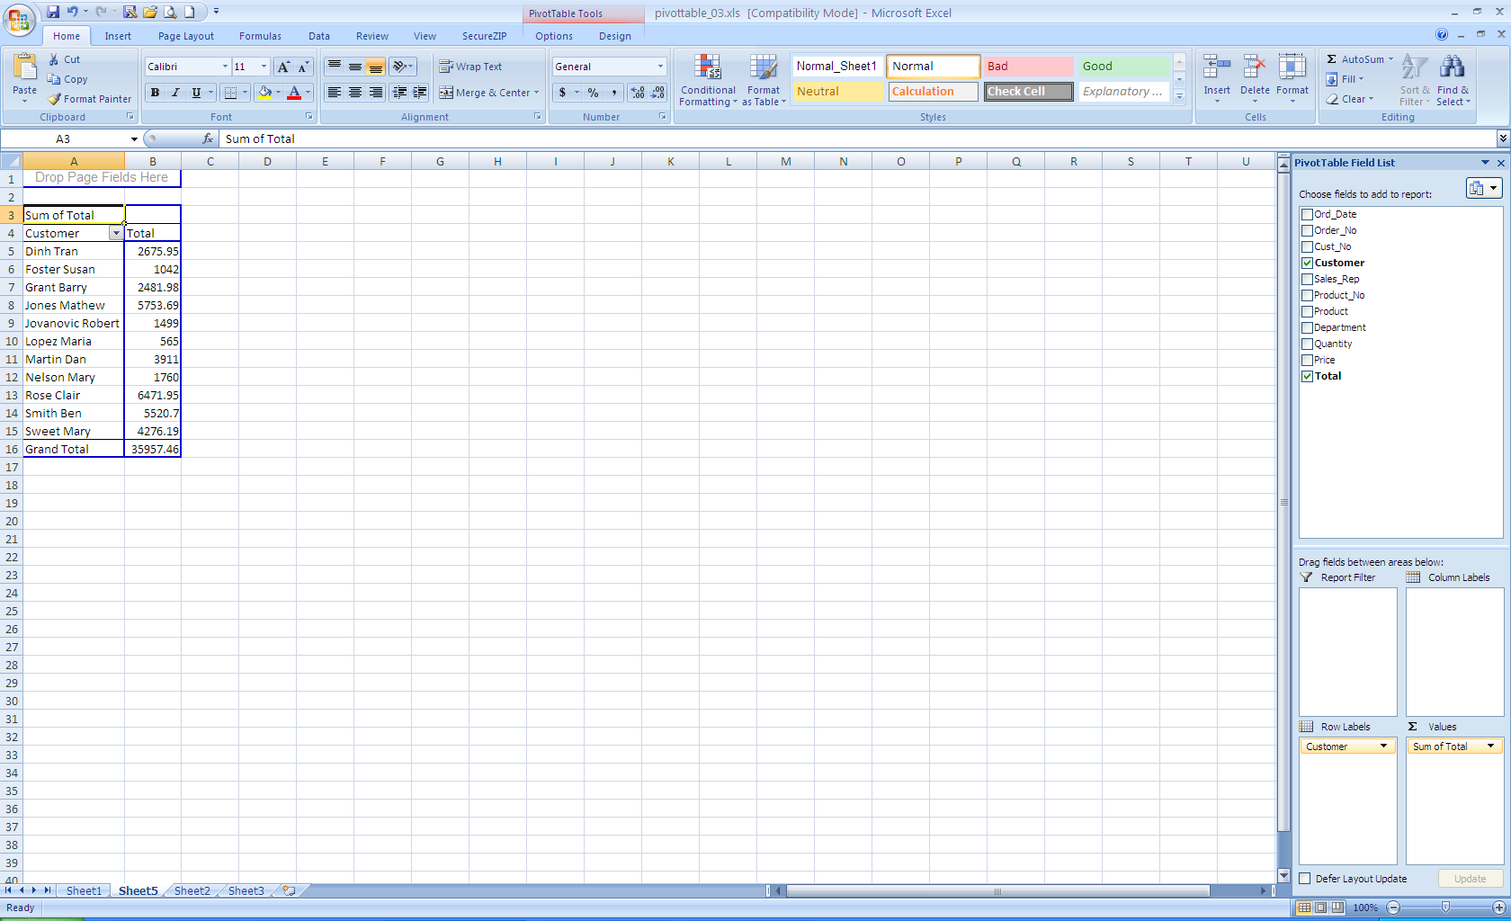

Notice the answer to Q_a: which customer spent the least amount of money in February?

Multidimensional Pivot Table

A multi-dimensional structure has been designed to enable a user to report on multiple dimensions at the same time – for example, Department sales by Customer and Product. This would display all records.

Department
Customer
Product
It is possible to navigate through the structure to view a subset of the data. For example a report which displays all sales for Products in all Departments for a particular Customer

Department
Customer
Product

Alternatively a user could “slice” the data to view all Customers and Products they purchased for a particular Department.
Department
Customer
Product
Through “dicing” more granularity can be achieved. For example:

Department
Customer
Product
Customer = Lopez Maria
Product = Hub Caps
Department = Auto
Total Sales = $35.50

To answer Q_b – “which customer spent the most in February and which sales person was responsible for the majority of these sales?” we need to create a two dimensional pivot table which includes information by customer and by salesperson.

7. In the Pivot Table created in Step 7, drag &drop the Sales_Rep field from the list on the right to the Row Labels box on the lower right side of the screen (can be done by clicking the checkbox). Make sure that the Sales_Rep field appears below the Customer field. You can drag and drop fields in this box to rearrange the order, if needed.

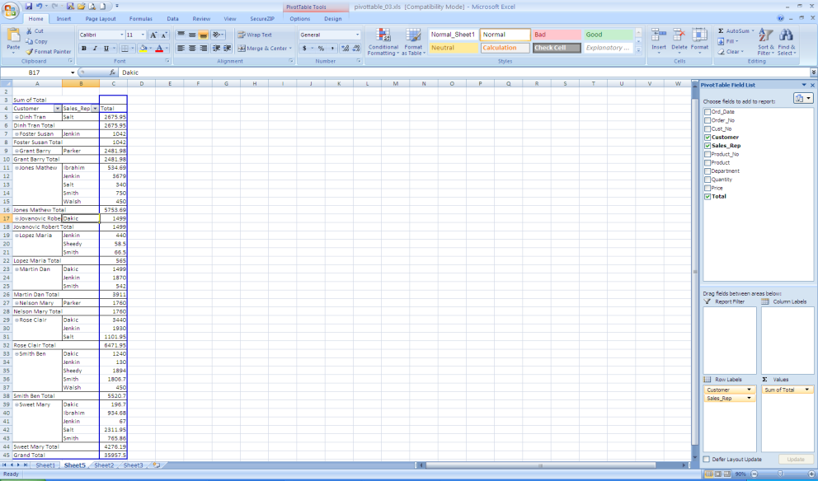

To answer Q_b, think about the following: which customer has the highest order Total? For this customer, which sales person was responsible for majority of the sales?

Questions for BI Assignment:

QUESTIONS | YOUR ANSWERS
Which customer spent the least amount of money in February?

Which customer spent the most in February and which sales person was responsible for the majority of these sales?

Which product provided the most revenue?

Which salesperson provided the most sales revenue?

