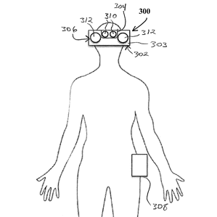

Beyond Reality, Web 3.0,
and Applications We Can barely Imagine

Included below is an interesting TED Talk from 2007 that describes a program named Photosynth, which can crowd-source passively shared photos online, and use them to render composite navigable models of 3-D landscapes, that can potentially be embedded with enriched semantic information. Essentially this program has the capacity to map the earth virtually (and historically). I believe this is part of the technology that will be used in the bridge between Web 2.0 and Web 3.0, in that intelligence and inert data are being connected in a new and usable fashion. Programs such as Photosynth will be necessary building blocks in the foundation of technologies such as those mentioned in the following article.

Follow this link for TED Talk on Photosynth:
http://www.ted.com/talks/blaise_aguera_y_arcas_demos_photosynth?language=en

Secondly, included is the article “How Magic Leap’s Augmented Reality Works.” Magic Leap was recently invested in by Google, and has filed patents for augmented reality technology, wearable technology that allows the user to see 3D images overlaying what is in the field of vision. These types of technology combined with programs like Photosynth have enormous potential as far as what they can be used for; such as information embedded in the world around us. We could virtually explore place we have never been, or enrich the places we physically inhabit, we could intuitively manipulate things that are a continent away, we could face time without the screen, we could virtually walk into a store and browse a virtual representations of actual saleable items. What if “auto-fill” could recognize your true size and match clothing to you, streamlining the virtual browsing, shopping, and transactional processes, while improving your overall satisfaction as a customer. Perhaps you are purchasing a living room set, and you could see them in your home before you purchased. These are very limited applications, and realizations of all things sci-fi; however as businesses traverses the tech-landscape searching for improvements in the way we do business and consume, incredible leaps will be made, but what will be the net effect to consumers?

Can you imagine looking in your own mirror to see how a shirt or dress you hadn’t purchased looked on you?
Can you imagine seeing the inside of a car around you that you aren’t inside?
Can you imagine road signs, and directions illuminated in your own field of vision without referencing a hand-held device?
Can you imagine vision impairment being solved?

1. Beyond the sales and income generated by the actual product, what applications can you think of in which these technologies might be applied to create economic benefit?

2. Do you think there are dangers associated with augmented reality, and our increased dependence on technology?

3. Do you think augmented reality will become unavoidable, like the ubiquity of electricity, TV, cell phones, home computing and the Internet? Will you adopt early, or late?

