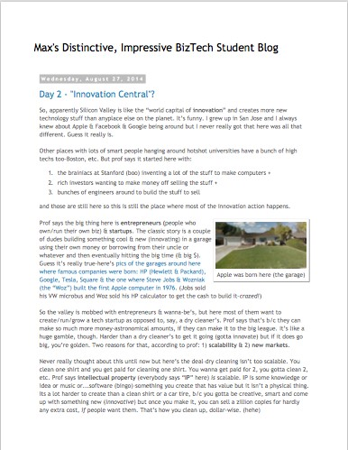
Business Systems Innovation Labs
Lab 1a Pre-flight Checklist
“I did it! Check this OUT!”
Today you’ll pick up where you left off with the story of Max, the
SJSU student blogger. Just follow along as she describes what she did in her new job with a startup company.

Prep: What do you need to start?
- Be sure you’ve read the Pre-lab backstory so you know what’s going on.
- Be sure you know how to do a screenshot so you can show your progress. (For instructions, see http://tiny.cc/screencapMac for Macs or http://tiny.cc/screencapWindows for Windows.)
- When you get to the point of creating your Salesforce account be sure you:
  - Get the free Developer Edition (DE) account, NOT the “Free Trial” account with a 30-day expiration.
  - Use your TUmail account to sign up
- Note: you can click on any image in the lab to see a larger version (easier to read).

Learning Objectives: What to “get”
- What is data, really? What are databases, at their core? What good are they, in real life & in business?
- What’s the big idea of “the cloud?” Why use it for apps & data we work with?
- Get how the Silicon Valley startup culture works & drives the world’s innovation.
- See for yourself how tools, like Salesforce, let you do a lot, without a lot of effort/skill/knowledge.
- This stuff’s not nerdy. It’s cool, it’s tech-boosted business and women belong.
Deliverables: Get your points

This time there are two(2) points marked for you to stop and take a screen capture to submit for credit. Match the numbers below with the annotations in the blog:
When you reach this point (after Step 80), you should be on a pitch record details screen showing all the fake field values you entered for one Pitch record. If not, click your Pitches tab and then click on the Pitch ID to open that record’s details. Take a screenshot and paste the screenshot into the correct text box on the answer sheet for credit.

At this point (after Step 99), assuming that you correctly updated your Pitch layouts, you should see a table of at least four (4) rows of fake data (2 VCs + 2 Angels) that you made up in five (5) columns: Pitch ID, Business Name, Type, Investment Amount and Equity Percentage. Do a screenshot and paste it into the correct text box on the answer sheet for credit.
Tips: Get more
The big idea is the “why” & “how” of tech supporting/enabling business. If you zoom through the steps to just get to the end, you’ll miss out! The steps are just the “what.” The “how” & “why” are in the story. You have to read & think…
experience it.

