Hello World – Assignment03

This is a simple “hello world” assignment. Even though the tasks to be accomplished are very simple, students will be exposed to some basic jQuery commands that they will need throughout the semester.

Getting the project files
- Using Windows File Explorer, open this folder: C:\mis2402workspace
(This folder will be already created on the computers in the classroom. However, if you are following along on your own computer, you will need to create this folder! See the “Introduction to VS Code” document for Windows or Mac OS.)
- Your instructor will provide you with a zip files named: assignment03_01.zip, assignment03_02.zip and assignment03_03.zip
- Download these zip files and put them on your desktop.
- Double click on each zip file. Drag each assignment03 folder in to C:\mis2402workspace
- Now, open VS Code. Open the assignment03_01 folder in VS Code. Edit index.html.
- Notice that there are some new tags found in the <head>. Those tags bring in external resources that allow you to perform common actions more simply. The external resources are:
  - Bootstrap. Bootstrap is a collection of CSS rules that are professionally developed and free for use. You’ll see that the button on this page looks nice because it has some bootstrap classes applied to it.
  - jQuery. The jQuery library is a collection of JavaScript functions that are professionally developed and free for use. They are meant to help you do common tasks more simply.
- Look in the <body> tag. Notice the HTML comments here. Edit the HTML in the body so that page looks like this:
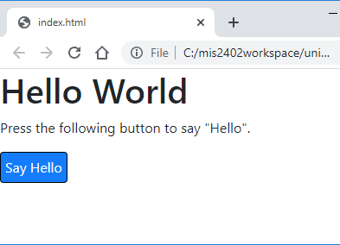
- Look in the <script> tag where our JavaScript commands will go. Discuss:
  - What event is defined here? What user action are we waiting for?
  - Where do the JavaScript commands go that will specify the response to the event?
- Add this line of code so in response to the event:
$("#textDisplayed1").html("Hello Stranger");
  - Discuss: what is the significance of the “#” in the line above?
  - Discuss: does it matter if you use single or double quotes in the line above?
  - Test your work. Refresh (or reopen) the index.html file in Chrome. Click the button. What happens?
- Even though what happened here seems simple, it is an important step forward. We used a special function named “$” to find a tag. Then we were able to manipulate the inner html of that tag. Note that the $ function is a significant part of the jQuery library mentioned earlier. We have the $ function because we included a reference to the jQuery library back in the <head>.
  - Discuss: would you be able to manipulate the inner html of the <h1> tag with this same technique? How about the <p> tag that holds the directions?
  - What about the <input> tag? Can you manipulate the inner html of that? Why / Why not?

- Upload your work. Be sure that you can find your work on the class server by typing in its URL in the browser.
For example: http://misdemo.temple.edu/tux99999/assignment03_01
- Open the assignment03_02 folder in VS code. The task to be performed here is slightly more complicated. We will use a jQuery command similar to the first one to obtain a piece of text typed by the user.
- Inspect index.html as found in the assignment03_02 index.html file. What tag will hold the user provided text? How will we uniquely identify that tag?
- Find the click event handler in the <script> tag and add this line of code inside its code block:
let your_name = $("#textEntered1").val();

With this line of code, we are creating a JavaScript variable called your_name. The variable your_name will be used to hold whatever the user types into the input tag with the id textEntered1.
Discuss: why did we use .val() here and not .html()?
Discuss: What is the significance of the # in front of textEntered1?
- Add another line of code to the click event handler:
$("#textDisplayed1").html("Hello " + your_name);

Discuss: Compare this to the line of code you typed in step nine. What is the plus sign doing here?

Continued

- Test it out.
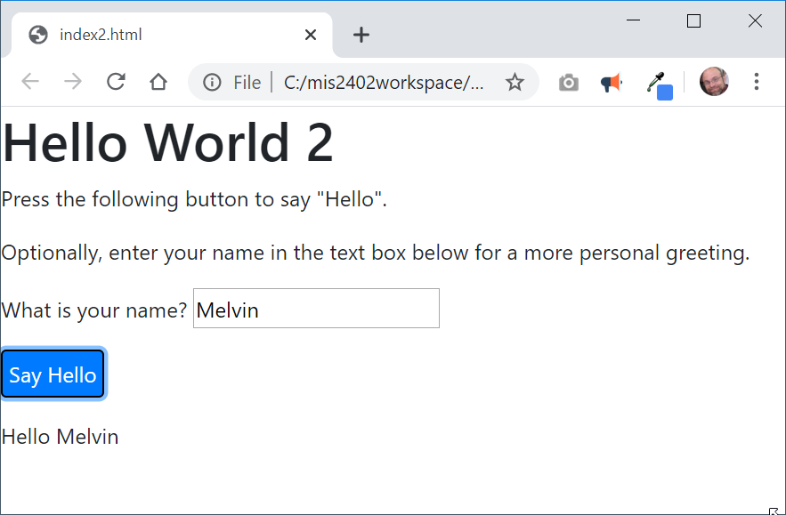
Results of the button click.
What you typed.
Discuss: What would you need to do in your JavaScript code if you wanted the user name to be in bold?
- Upload your work. Be sure that you can find your work on the class server by typing in its URL in the browser.
For example: http://misdemo.temple.edu/tux99999/assignment03_02

On your own

- Open the assignment03_03 folder. Complete the code so that you can get results that vary with the input provided by the user. A sample is shown below.
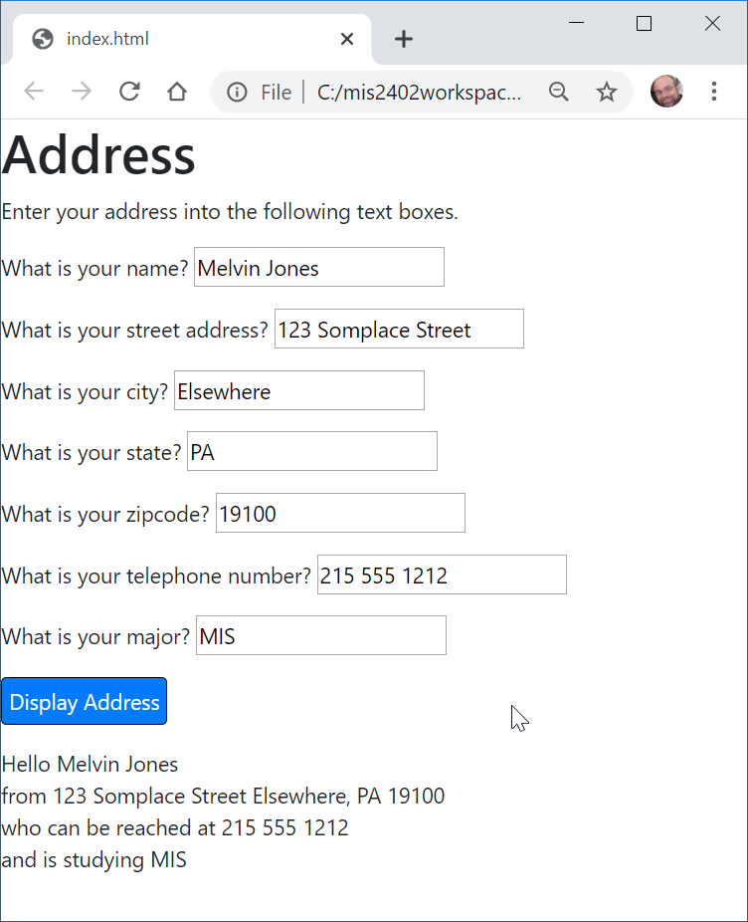
Results
What you typed.
HINT: To make a line break appear in the results, you will need to use the HTML <br> tag
- Test and upload your work. Be sure that you can find your work on the class server by typing in its URL in the browser.
For example: http://misdemo.temple.edu/tux99999/assignment03_03

How will this assignment be graded?
Item | Point Value
All three folders uploaded OK?  (solution must be exactly where requested!) | 30
Assignment03_01 works as expected | 20
Assignment03_02 works as expected | 20
Assignment03_03 works as expected | 20
Break tag used correctly | 10

