# Assignment09 – distance traveled ( JavaScript loops )

THE PROBLEM: The distance a vehicle travels can be calculated as follows:

distance=speed X time

For example, if a car travels at the speed of 40 miles per hour for three hours, the distance traveled is 120 miles. Write a program that asks the user for the speed of a vehicle (in miles per hour) and the time it has travelled. The program should then express the distance travelled in hourly increments as a list of comma-separated values.

For example:

40,80,120,

Define a function that uses a loop to produce the output as shown above. The function should take two parameters as input, a variable named **speed** and a variable named **miles.** The function should return a string of comma separated values, with no extra spaces, ***exactly as shown.***

Notice that in the example given there a comma at the end of the list. ***This is expected in this assignment***.

If a user provides any input that is not a natural number, then the function should return the error message:   
"Bad data. Try again."

**HOT TIP:** You can reuse your isNaturalNumber() function from a prior assignment to help you with your error trapping.

## Getting started (Together as a class)

1. Retrieve unit4_04_distancetravelled.zip provided by your instructor.
2. Extract the code into your mis2402workspace and open the index.html file in Visual Studio Code.
3. Bring in the isNaturalNumber() function from a previous assignment. Put it in portion of your code designated for “supporting functions”.
4. Use the web developer tools in Chrome to test your isNaturalNumber() function.

## On your own

1. Complete the distanceTravelled () function. If the input into the function is bad, then the function should return the text: “Bad data. Try again”.

Otherwise, the function should return the miles travelled at hourly intervals. An example of good output is shown below.

1. When you are done, clicking the button should generate output as shown below.

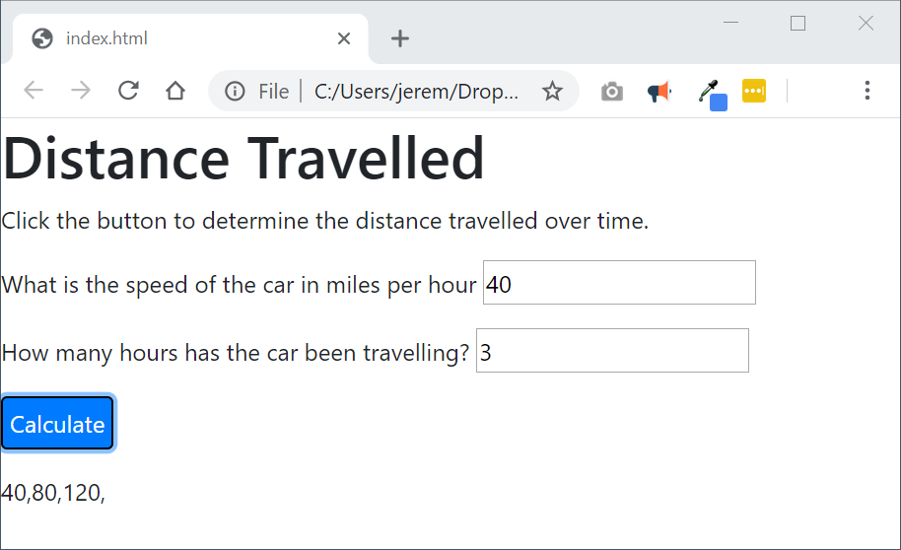

1. Test your work using the web developer console. Changing the input to the distanceTravelled() function should change its output. An example follows:

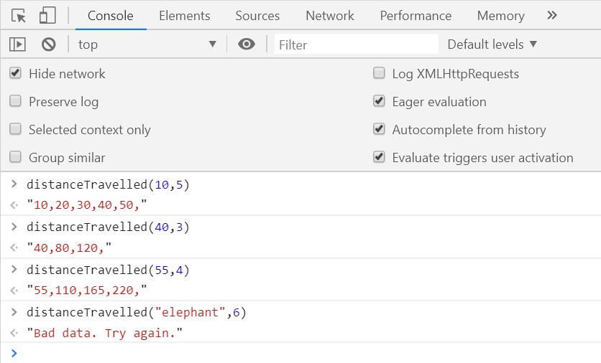

1. Upload your work. Be sure that you can find your work on the class server by typing in its URL in the browser. Test your work *again* on the class server.  
     
   For example:   
   http://misdemo.temple.edu/tux99999/unit4_04_distancetravelled

How will this assignment be graded?

This assignment will be evaluated by an automated process.

* If your work is not found at the expected location on misdemo, you will get a score of **zero**.
* If your work generates **all output** correctly, you will get a score of 100%.
* If your work generates **almost all output** correctly (**only one** bad output), you will get a score of 80%
* If your work generates **some output** correctly (some right output, some wrong output), you will get a score of 60%
* If your work generates **only one output** correctly, you will get a score of 40%
* If your work does not generate any correct output, you will get a score of **zero**.