JavaScript String Assignment

Sum of digits in a string

Write a program that asks the user to enter a series of single-digit numbers with nothing separating them. The program should call a function that returns the sum of all the single digit numbers in the string.
For example, if the user enters 2514, the method should return 12, which is the sum of 2, 5, 1, and 4.
Hint: Use the parseInt() method.
Another Hint: You do not need to use indexOf() to solve this problem.
Yet Another Hint: Use the isNaturalNumber function provided in this start file to perform your error trapping.
Steps:
- Create a variable called digitSum and initialize it to 0;
- Create a for loop that starts at zero and loops once for each character in the number using the .length property.
- Remember that you can parse a string is an array and that you can access any individual character in an array (i.e. numberPassed[2] is the third element/third character in the string. Add this digit to the digitSum after using parseInt() to convert it to an actual number.)
- Return digitSum.
- If the user enters anything that is not a Natural Number, return "Bad data. Try again."

Getting started (Together as a class)
- Retrieve assignment13_sumofdigits.zip provided by your instructor.
- Extract the code into your mis2402workspace and open the index.html file in Visual Studio Code.
- Write the code in sumOfDigits that will test to see if the parameter numberPassed is a natural number. If it is not a natural number, then return “Bad data. Try again.”
- If numberPassed is a natural number then declare a variable called digitSum and initialize it to zero.
- Put in a comment “//come back later. loop will go here.”
- End the function with “return digitSum”
On your own
- Test your work so far using the Web Developer Console.
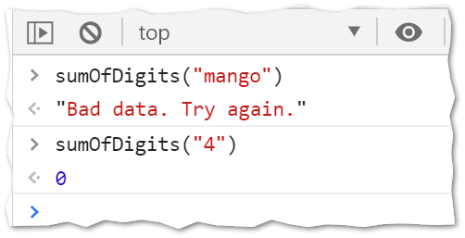
- Complete code you started in sumOfDigits.
- Test your work. Sample screenshots are shown below.
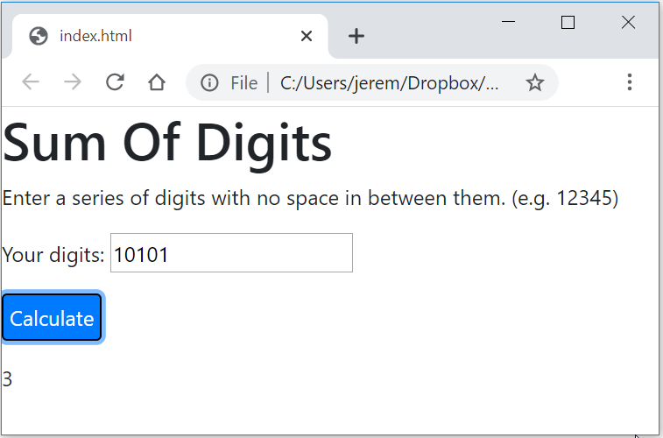
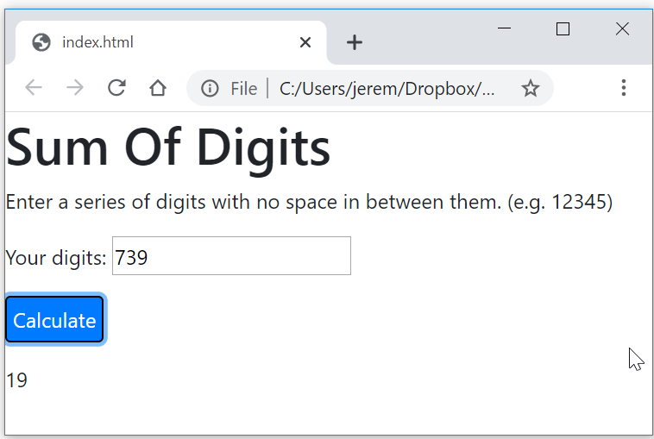
- Test your work. Don’t forget to test your error trapping as well.
- Upload your work. Be sure that you can find your work on the class server by typing in its URL in the browser. Test your work *again* on the class server.
For example:
http://misdemo.temple.edu/tux99999/assignment13_sumofdigits

How will this assignment be graded?
This assignment will be evaluated by an automated process.
- If your work is not found at the expected location on misdemo, you will get a score of zero.
- If your work generates all output correctly, you will get a score of 100%.
- If your work generates almost all output correctly (only one bad output), you will get a score of 80%
- If your work generates some output correctly (some right output, some wrong output), you will get a score of 60%
- If your work generates only one output correctly, you will get a score of 40%
- If your work does not generate any correct output, you will get a score of zero.

