Peekaboo Puppy (jQuery and HTML)

In this assignment you will write JavaScript and jQuery that changes the appearance an HTML web page.

Getting started (Together as a class)
- Retrieve assignment17_puppy.zip provided by your instructor.
- Extract the code into your mis2402workspace and open the index.html file in Visual Studio Code.
- Preview index.html in Chrome. You will notice that the page has nicer margins than previous assignments. It also appears to have two columns.
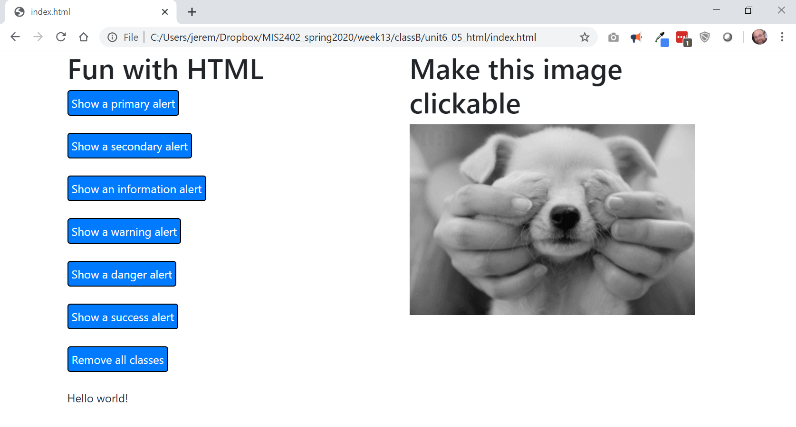
Better margin
2 columns

- The reason for this improvement is that the HTML is now inside a <div> with a class of “container”… and the container then holds div tags of class row and col-md-6.
All those are classes are defined by Bootstrap. Recall that Bootstrap is a library of pre-defined CSS classes. So, what we have, is a combination of those tags to create this effect:
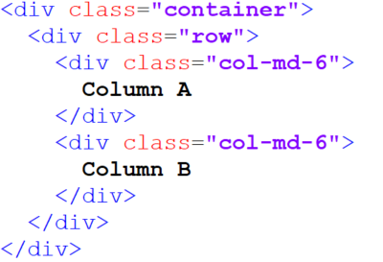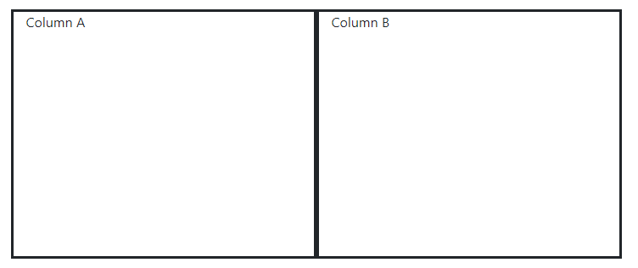
You can get a good review of Bootstrap here: https://www.w3schools.com/bootstrap4/

- Notice the click event handler for button 1. It adds two Bootstrap classes to the <div> identified by #sometag. Those classes are “alert” and “alert-primary”. The jQuery addClass method allows us to add one or more CSS classes, separated by spaces.
Also, in this click event handler we remove any previously existing classes. We do that with the jQuery removeClass method. The removeClass method, with no arguments, removes all the classes from the selected tag.
- Amazingly, Bootstrap has a variety of classes used for styling tags. The Bootstrap class names follow a pattern – primary, secondary, info, warning, danger and success. So, an “alert” can be styled with “alert-primary”, “alert-secondary”, “alert-info”, “alert-warning”, “alert-danger” and “alert-success”. There are similar patterns for “text” (e.g. “text-success”) and buttons (e.g. “button-success”)
- Create a click event handler for button 2. It should style the tag as “alert alert-secondary”.
- Create click event handlers for the remaining buttons.

On your own
- Create a click event handler for the image puppy1.
- Create a click event handler for the image puppy2.
- Use the show() and hide() methods discussed in class so that the images appear and disappear with each mouse click.
HINT: Here is an animated example that illustrates the effect you want to achieve:
http://misdemo.temple.edu/gifs/peekaboo-gif.gif
- Upload your work. Be sure that you can find your work on the class server by typing in its URL in the browser. Test your work *again* on the class server.
For example:
http://misdemo.temple.edu/tux99999/assignment17_puppy

How will this assignment be graded?
- All or nothing. Either the code works or it doesn’t.

