File System Basics

In this assignment you will explore two software titles installed on the classroom computers: Visual Studio Code and Bitvise. Visual Studio Code (VS Code, for short) is used to edit HTML, CSS, JavaScript and other kinds of files. Bitvise is used to transfer those files from one computer to another.

Bitvise does not run on the Mac platform. Consequently, Mac users have another software title to become familiar with: FileZilla. FileZilla does the same thing that Bitvise does.

Regardless of your preferred platform (Mac or PC) you will be expected to use Bitvise on exam days later in the semester.

Some terminology
Files – Computer operating systems of all sorts (Windows PCs, Macs, Linux machines, Android phones, etc.) store data in files. Some files are made up of sequences of a simple finite set of characters. These files are called text files. All the files you edit this semester are text files. The files you create and work with will have names that end in .html, .css, or .js. This last part of the file name is called the file extension. It indicates the type of file, and gives the operating system a hint as to how the file should be treated. This “file extension” idea is a basic convention in all operating systems, although many try to hide this important information from the user.

Folders – All computer systems store their files in folders, also called directories. Folders can hold other folders. A collection of folders that holds other files and folders is called a hierarchy. Tools like Windows File Explorer and the Apple Finder are used to navigate this hierarchy of folders and files. Operating systems usually give you two ways of navigating the hierarchy. You can use a graphic user interface (like Windows File Explorer) or commands that you type in to a command prompt, shell, or terminal.

Root – The top of a folder hierarchy is called “the root”. The root of the file system on a windows PC is usually C:\. That is, there is a disk, represented by the drive letter “C” and it has a starting point “\”. The root of a file system on a Mac or Linux server is represented by a “/” (yes, the slashes go in the opposite direction… that’s just life in the big city, kids.)

A system can have different kinds of roots. A document root would be the highest level in a collection of folders that hold documents. A web root would be the highest level in a collection of folders that hold .html, .css and other kinds of web pages. The file system root is the highest level in a collection of files and folders used by the computer’s operating system.

Zip files – Sometimes it is handy to put a collection of files and folders together into a single file. Those files commonly end with the extension .zip. Mac and PC operating systems usually have special software already installed that will allow you to unzip a file and get the files and folders out of it.

Workspace – A workspace is a folder that is set up to hold your coding work. That’s it, nothing special. It’s just a place to hold your work. Sometimes VS Code will create a .json file to hold extra information about the workspace … things like when files were last modified and so on. That’s nice to know, but not essential for this course.

Instructions
- Downloading a folder – Visit the class site on the MIS community system and download assignment01.zip. Open the zip file. Click and drag the assignment01 folder in to your mis2402workspace.
- Start VS Code – Start VS Code and open the assignment01 folder found inside the mis2402workspace folder.
- Delete a file – In the assignment01 folder there is a file named deleteme.html. In Visual Studio Code, notice that you can right click on that file and copy, delete, rename and/or take other actions on that file.
- Make a file – With the assignment01 folder open in VS Code, click the “New File” option from the “File” menu in the upper left-hand corner of the Visual Studio Code window. This will create a new file with the name Untitled-1. Click “File” and “Save As” and give your file the name index.html. Take care to type index.html in all lower-case letters. The file and folder names given to you in all assignments are case sensitive and should not be changed.
- Edit the file – Using VS Code, type the following text in to index.html. Save your work.
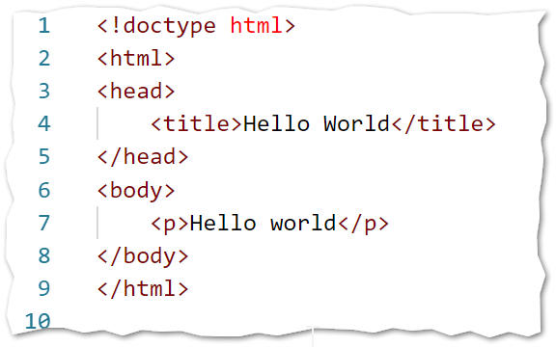
- Preview your work -- Right click index.html in VS Code and choose “Open In Browser”. You should see a page similar to what is shown below. Note the difference between the title of this page, and the content of this page.
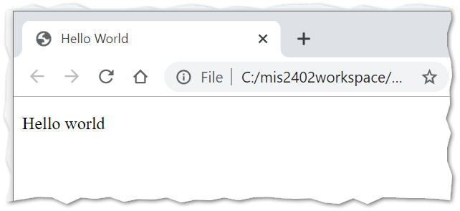
- Upload it –
  - Open Bitvise. The Bitvise icon looks like this:
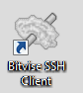
  - The following window will appear. This window is prompting you for the information you will need to connect to the remote system.
- Enter in the host name of the class server: misdemo.temple.edu
- Enter in your Accessnet Username.
- Click Login
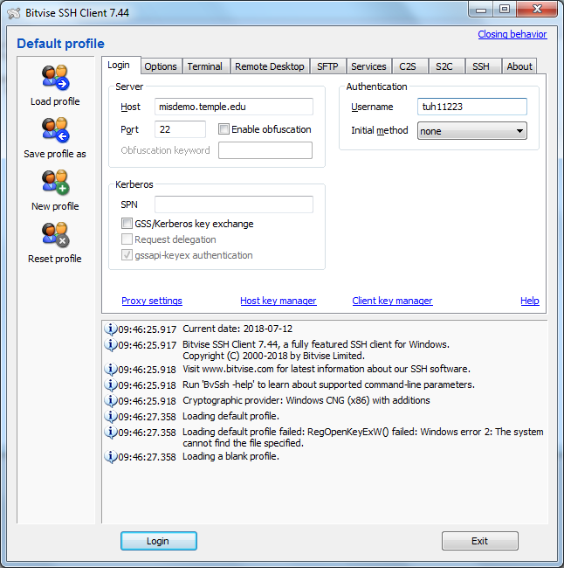

  - The first time you connect to a remote server, you may see a prompt like the one below. This prompt is asking you to trust the remote system. Click Accept and Save to continue.
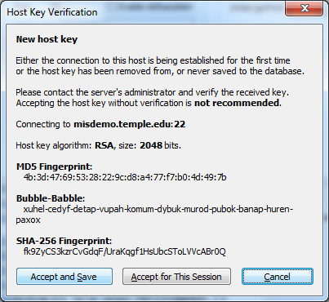
  - Next you will be prompted for your password. This password is assigned to you by your instructor and can be found on the MIS Community Gradebook. Type it in and click OK.
Do not attempt to change your password. Use only the password assigned to you by your instructor.
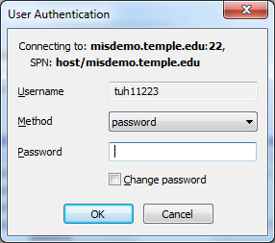

  - When you connect successfully, two windows will appear. The window with the black background is the terminal interface, and the window with two panels (“Local Files” on the left, and “Remote Files” on the right) is the file transfer interface.
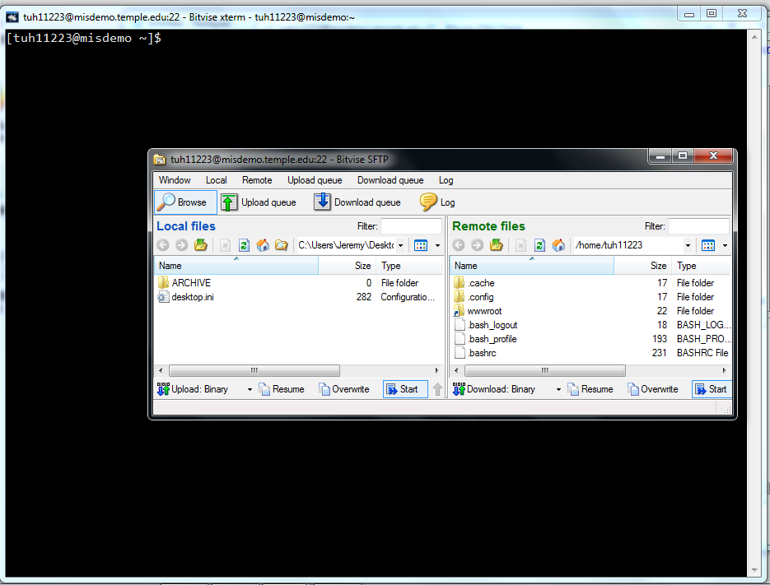

  - Close the terminal interface (the black window) by clicking on the X in the upper right corner of the window.
  - Now, on the file transfer window, double click on the “wwwroot” folder on the right panel.
  - Next, find your work on the left (local) panel. Students may find it easiest to click the “up” button repeatedly (see below) until they reach their disk root (C:\) and then navigate down into their c:\mis2402workspace folder.
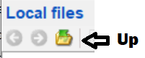
  - Click and drag the assignment01 folder holding your local work from the left panel and drop it in the right panel.
  - Check your work. By placing your folder in your wwwroot folder, you have published a web page. You should be able to visit this URL in a browser and see your “Hello World” page.
http://misdemo.temple.edu/tux99999/assignment01
(Here “tux99999” is a placeholder for your own AccessNet Id.)

- Delete the local file – Back in VS code, right click on index.html and delete it.
- Download it – Woah, check it out, you can drag and drop in the opposite direction! Using the file transfer window in Bitvise drag index.html back down from the server and put it in your local assignment01 folder.
- Edit it again – Back in VS Code, edit the text so that instead of “Hello World” it says “Hello Fred” (You should probably use your own name, instead of “Fred”.)
- Upload it to misdemo.temple.edu again. You will be prompted to overwrite the file that is already there. Click the “Overwrite” button when prompted.
- Check your work – Again, visit your assignment01 URL in the browser. You should see your change.

What we’ve seen so far
So far, we have seen that Visual Studio Code can be used to delete, create and edit html files. We’ve seen that content uploaded to the class server (misdemo.temple.edu) can be downloaded again for additional editing. We’ve also seen the relationship between the folders/files we upload, and the web URLs that consequently become available.

What this means to you…
As you do work in class this semester, you will want a way to save your work, so that you can easily pick up where you left off sometime later. You don’t need to upload your work to Owlbox, Google drive, or a USB drive. Just put your work on the class server and pull it back down again when you need to edit it.

You have also seen that you can overwrite files that were previously uploaded to misdemo.temple.edu. If you need to fix a mistake, or complete your work, you should not rename your assignment file or folder names without checking with your instructor. If your instructor doesn’t find your assignment work in the expected location, with the expected name, you will get a zero on the assignment.

Finally, you have seen that you can check your work by visiting a URL of this pattern:

http://misdemo.temple.edu/tux99999/assignment01

Students should always check their work when turning in an assignment. If your work does not appear at the expected URL, or suddenly stops working when uploaded to the class server, then you have probably done something wrong. Each student is responsible for uploading, checking and correcting his/her own work *before* the assignment is due.

On your own
Consult the HTML Essentials Reference and the assigned videos there. Use them to create a table as shown on the following page.

Upload to your misdemo web root
Change the title

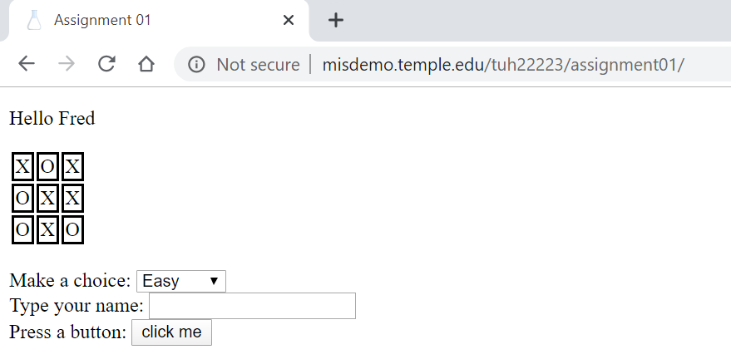
Change “Fred” to your name.

More instructions:
- The tic tac toe board should be recreated as shown. It is an HTML table.
- To make the table border appear as shown, you will need a little CSS. Put this CSS in the HTML style tag:
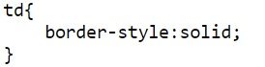
- The selection list next to “Make a choice” should show three options when clicked: Easy, Medium and Hard.
- Use the <br> tag to add line breaks where needed.
- The box next to “Type your name” is an input of type text.
- The button next to “press a button” is an input tag of type button. (The button does not need to do anything in this assignment … it is just for show.)

Upload your work when done, replacing the index.html file you created in class.

CONTINUED

How will this be graded?
Task | Weight
Uploaded to misdemo OK | 10
Solution shows appropriate use of:
<table> <tr> and <td> | 10
<br> | 10
<style> | 10
<title> | 10
<form> | 10
<input> of type text | 10
<select> | 10
<option> | 10
<input> of type button | 10

Total score possible: 100

