JavaScript Math – Assignment08

Sum of cubes difference
THE PROBLEM: The sum of the cubes of the first ten natural numbers is,
1³+2³+...+10³=3025
The cube of the sum of the first ten natural numbers is,
(1+2+...+10)³=166375
Hence the difference between the sum of the cubes of the first ten natural numbers and the cube of the sum is 166375−3025=163350.
Write a program to find the difference between these two numbers for any natural number provided by the user.
If the user enters a decimal number, convert it to an integer using the parseInt() function.
If the user enters zero or a negative number, then your function should return the message “Bad data. Try again.”
If the user enters a non-numeric value, your function should return the message “Bad data. Try again.”
HOT TIP: You can’t reuse your isNaturalNumber() function from a prior assignment to help you with your error trapping on this assignment. The error trapping rules are a little different. (See above.) But, you might want to look back at that earlier code.

Getting started (Together as a class)
- Retrieve unit4_13_cubes.zip provided by your instructor.
- Extract the code into your mis2402workspace and open the index.html file in Visual Studio Code.
On your own
- Complete the three functions set up for you there:
  - sumOfCubes()
  - cubeOfSum()
  - calculateSumCubesDifference()
  - Do not create any additional functions!
HINT: Both sumOfCubes and cubeOfSum require you to write a loop, and use the Math.pow() function.

- Test your work using the web developer console. An example follows:
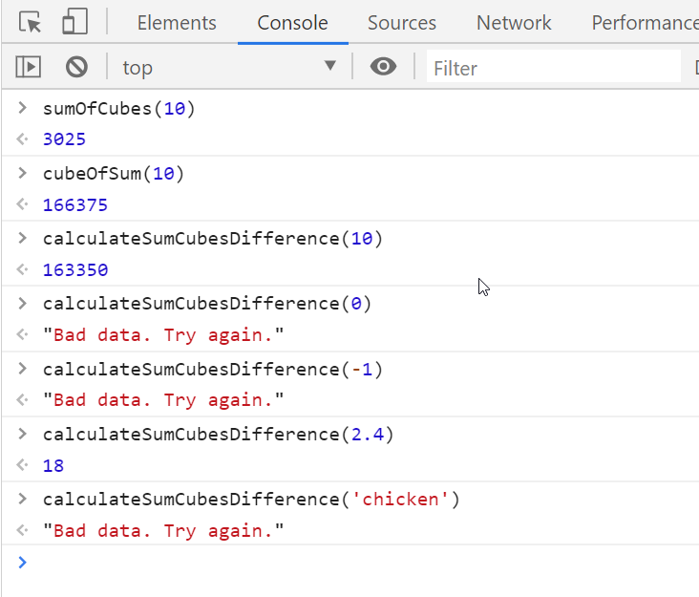

- Test your work. A sample screenshot is shown below.
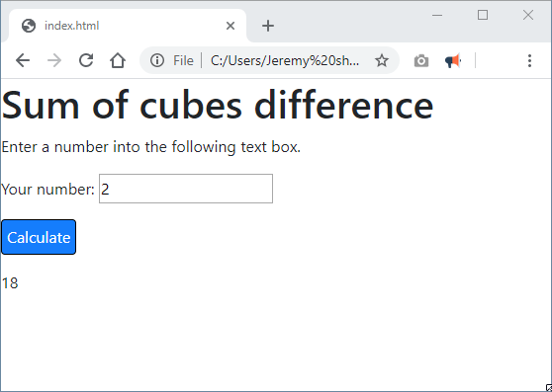
- Test your work. Don’t forget to test your error trapping as well.
- Upload your work. Be sure that you can find your work on the class server by typing in its URL in the browser. Test your work *again* on the class server.
For example:
http://misdemo.temple.edu/tux99999/unit4_13_cubes

How will this assignment be graded?
- If your work is not found at the expected location on misdemo, you will get a score of zero.
- If your work generates all output correctly, you will get a score of 100%.
- If your work generates some, but not all, of the output messages correctly, you will get a score of 80%
- If your work is found, but does not generates any of the output correctly, you will get a score of zero.

