More HTML – Assignment02

In this assignment, we will put into practice some of the ideas presented in the assigned viewing.

At the end of the activity, you will upload your work to the class server, the same way you did previously.

The text used in this exercise originated here: http://www.catb.org/~esr/faqs/hacker-howto.html

By the next time we meet as a class, you are expected to have completed the assigned videos described in Reference-HTML-Essentials.pdf. That material will help you with this assignment as well.

Getting the project file
- Using Windows File Explorer, open this folder: C:\mis2402workspace
(This folder will be already created on the computers in the classroom. However, if you are following along on your own computer, you will need to create this folder! See the “Introduction to VS Code” document for Windows or Mac OS.)
- Your instructor will provide you with a zip file named: assignment02.zip
- Download this zip file and put it on your desktop.
- Double click on the assignment02.zip file. Drag the assignment02 folder in to C:\mis2402workspace
- Now, open VS Code. Navigate to the assignment02 folder using the VS Code Explorer panel. You should find a file named index.html inside the assignment02 project folder.
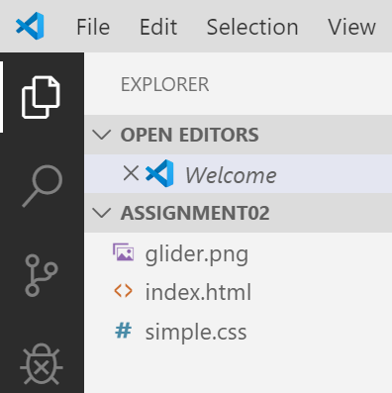
- Click on the index.html file. Notice the code editor panel that appears on the right. It holds only a tiny bit of HTML. If you use Visual Studio’s “Open in Browser” feature, the results will look like this:
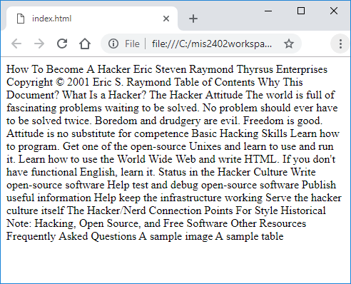
Not very impressive! We are going to add HTML tags to improve the structure of this content

- Work on the HTML and CSS fixes as described in the following table.
Task | Comments
Add a doc type declaration. | Here we are letting the browser know what version of HTML we are using. Insert a new line above the <html> tag and add the following:  <!doctype html>  This is a best practice! It informs the browser that we are using HTML5.
Give the page a title. | Inside the <head> tag add a title tag as follows:  <title>How To Become A Hacker</title>  Type it in! Get out of the habit now of copy / pasting text from Microsoft Word and other Microsoft products.  Save your work. Preview your work in the browser to see the change.
Add in heading tags. | In the body, put an <h1> tag around “How To Become a Hacker”  Put <h2> tags around “Eric Steven Raymond” and “Table of Contents”  Put a paragraph tag <p> tag around the copyright notice.
Add an anchor tag. | Put an anchor tag <a> around “Thyrsus Enterprises”. When you click it, it should go to http://www.catb.org/esr/
Check your work.
More heading tags | Add <h3> tags around: “Why This Document?”, “What Is a Hacker?”, “The Hacker Attitude”, “Basic Hacking Skills”, “Status in the Hacker Culture”, “The Hacker/Nerd Connection”, “Points For Style”, “Historical Note: Hacking, Open Source, and Free Software”, “Other Resources”, “Frequently Asked Questions”, “A sample image”, “A sample table”
Add in ordered list tags. | Add in <ol> and <li> tags to make lists as shown below.  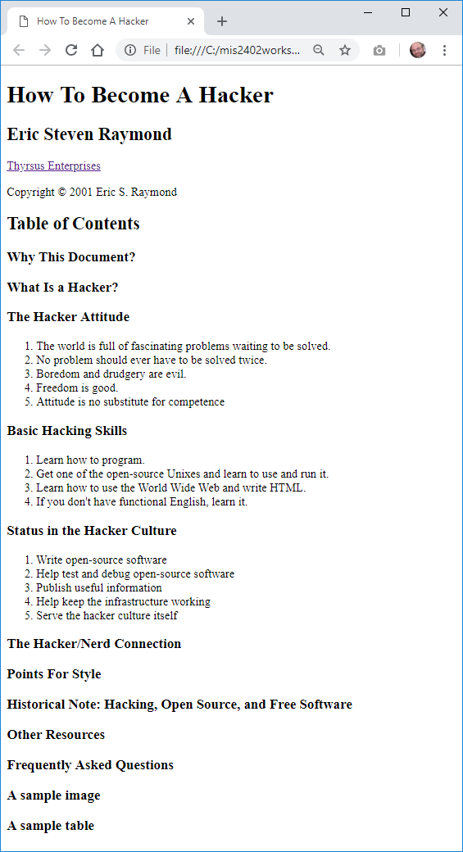
Add an image. | Use the following to add an image to the page under “A sample image”  <img src="glider.png" alt="The Glider Emblem">
Go back to the <head> tag. Add a <link> to the simple.css style page. | The css style page can be used to control the appearance of the page.  <link rel="stylesheet" href="simple.css">
In the <body> tag, create a <div> tag that will encapsulate all the content.  Give the <div> tag a class attribute of “content”. | Your HTML code should look like this:  <body>  <div id="content">  …  </div>  </body>  <html>
Now that you have this div tag, and a linked style sheet, we can add a style to simple.css | This is the new and improved code for simple.css  table, th, td, form {  border: 1px solid black;  }  #content{  background-color: white;  width: 600px;  padding: 10px;  }  body{  background-color: gray;  }  Your instructor will review this in class!
Finally, add an HTML table. | Use the <table> <tr> and <td> tags to add an HTML table under “A sample table”. The resulting table should look like this:

Check your work
The next page contains a screenshot of what your work should look like if everything has been done correctly.

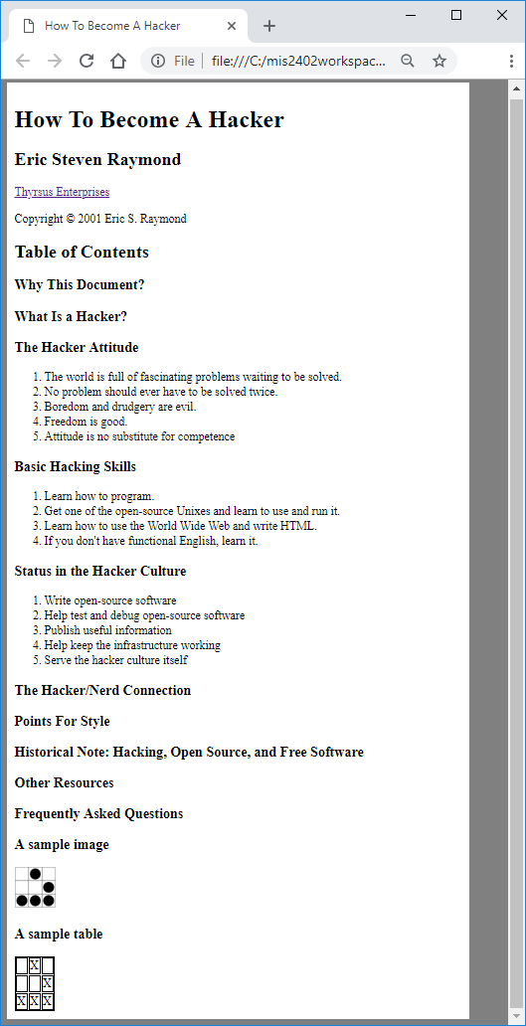

Upload your work
Now use Bitvise to upload your work to the class server. Use the same process that we covered in class.
Be sure that you can find your work on the class server by typing in its URL in the browser. For example: http://misdemo.temple.edu/tux99999/assignment02

On your own

- Add a table under “Other Resources”.
  - The first row of the table should use the <th> tag to create table heading cells that contain the words “Resource” and “Link”
  - The next two rows contain data. Use the <td> tag for those.
  - To create the “click me!” links you should use an HTML anchor tag: <a>. Clicking on the first “click me!” link should take you to this page: https://tinyurl.com/homesteadingmis2402
  - Clicking on the second “click me!” link should take you to this page: https://tinyurl.com/cauldronmis2402

- At the bottom of the page, add an HTML form. Specifically:
  - Create an <h3> tag to hold the “Leave a comment” text.
  - After the <h3> tag, create one form tag, and put three input tags inside it.
  - The first two tags are inputs of type “text” and the last input tag is an input of type “button”
  - Use the <br> tag to create line breaks as needed.
CONTINUED…
  - The border around the form will appear automatically. There is already a CSS style rule for the form created in simple.css.
  - Note that the form doesn’t need to do anything. For now, it is enough to just create the form as shown.
- Upload your work. Be sure that you can find your work on the class server by typing in its URL in the browser.
For example: http://misdemo.temple.edu/tux99999/assignment02

How will this assignment be graded?
Item | Point Value
Uploaded OK?  (solution must be exactly where requested!) | 10
Does all the “in class” material appear to be correct? | 30
Did you create the HTML table under “Other resources?” | 10
Did you use <th> and <td> appropriately? | 10
Do both the links in the table work? | 10
Was the HTML form created correctly? (Again, there should be one form that holds two input tags of type text, and one input of type button.) | 30

