-Where in the html files should the link to a CSS file go? (e.g., head, body, etc.)
-What is the correct syntax to put a comment that says “the html code for the form” in an html document?
-How is linking to an image different from linking to a url? Write the html syntax to each:
-How is an Id different from a class attribute in a <P> tag? Show it in an example:
-What does &nbsp do in an html document? (try it before showing up to exam) what if you type it in 10 different lines in a row, say, between two p tags like: <p>a</p> and <p>b</p>
-How do you wrap an ordered list tag in a div tag? Write the correct syntax (your list can include 2 items: item1 and item 2). Try doing the same with an unordered list.
-What is the difference between “value” and “name” attributes in “input” tags? Write examples.
-What does the “type” attribute in an input tag signify? Write examples of input tags with different type values.
-Add a label tag before each input tag created above. What should be the value of attribute “for” in the label?
-in an html tag such as <input name=”something”>, what is the technical term when referring to ‘name’.
-What is the difference between padding, margin, border, and width? Create a simple html form, with only one button input tag in it. Then, try and change the padding, margin, border, and width attributed to the button, one at a time, and see the impact.
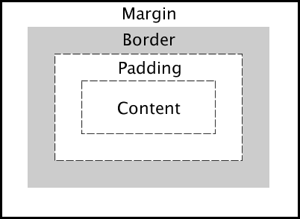
-Write an html table that has 4 rows and five columns. Make sure the content in the first row is bolded (you have to wrap the content in those cells in a tag that bolds the content). The content in each cell can be something like: R1C1, R1C2, R1C3…R2C1,…, R4C5.
Practice creating forms. Visit the following and make sure you know various elements that can be contained in a <form> tag:
https://www.w3schools.com/tags/tag_form.asp (see especially under Definition and Usage in that page; pay special attention to input, option, select, and label tags under that section)

