# Hello World - How to download and upload your work

## Instructions for Windows

In this exercise you will be provided with a zip file containing a small HTML “Hello World” project. You will unzip the file, and put the project folder into your MIS2402 workspace. After you edit the file, you will upload it to the class server (misdemo.temple.edu).

## Getting the project file

1. Using Windows File Explorer, open this folder: C:\mis2402workspace

(This folder will be already created on the computers in the classroom. However, if you are following along on your own computer, you will need to create this folder! See the “Introduction to VS Code” document for Windows or Mac OS.)

1. Your instructor will provide you with a zip file named: demo_hello.zip
2. Download this zip file and put it on your desktop.
3. Double click on the demo_hello.zip file. Drag the demo_hello folder in to C:\mis2402workspace
4. Now, open VS Code. Navigate to the demo_help folder using the VS Code Explorer panel. You should find a file named index.html inside the demo_help project folder.

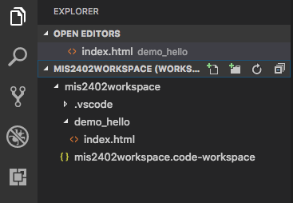

1. Click on the index.html file. Notice the code editor panel that appears on the right. It holds a combination of HTML and CSS code.
2. Scroll down through the HTML/CSS code and find the text “Hello Terry Pratchett” and edit it. Replace the name Terry Pratchett with your own name. Then click **File** and **Save** on the VS Code menu.
3. Let’s see what your edit looks like in a browser. Right click on index.html and choose “Open in Browser” You should get something that looks something like this:

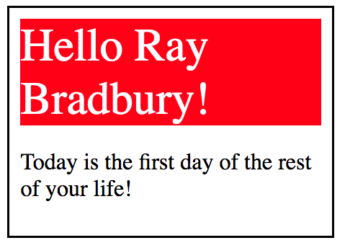

(Note that the “Open in Browser” option only appears if you are working on the classroom computers or have installed Live HTML Previewer as previously instructed.)

1. Now let’s upload your work to the class server using the Bitvise SSH client. Find the Bitvise client on your desktop (or in the “All Apps” menu). Start it.

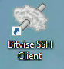

Provide the name of the class server as the **Host** and your Accessnet Username as the Username. Click **Login.**

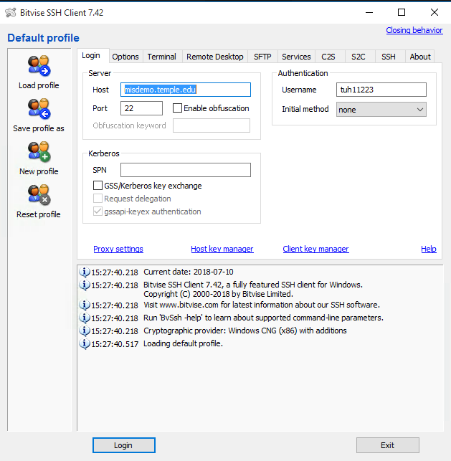

1. Provide your password. Your password is assigned to you in the MIS Community Gradebook. Click **OK.**

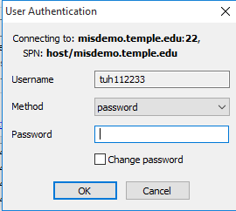

1. A window will open with two panels. The left panel represents your local file system. The right panel represents your remote file system on the class server. On the left panel’s address bar, type in c:\mis2402workspace as shown below:

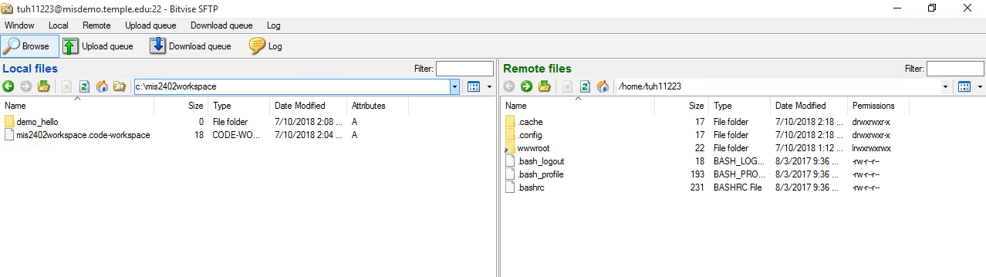

1. In the right panel, double click on the wwwroot folder so that you are *inside* the wwwroot folder. The result is shown below.

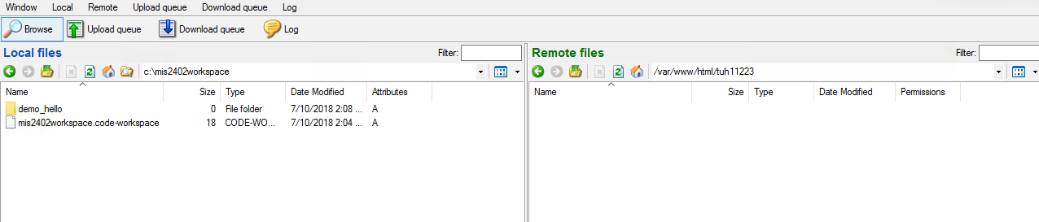

1. Now click and drag the demo_hello folder from the left panel to the right panel. This uploads the folder to your wwwroot folder assigned to you on misdemo.temple.edu.

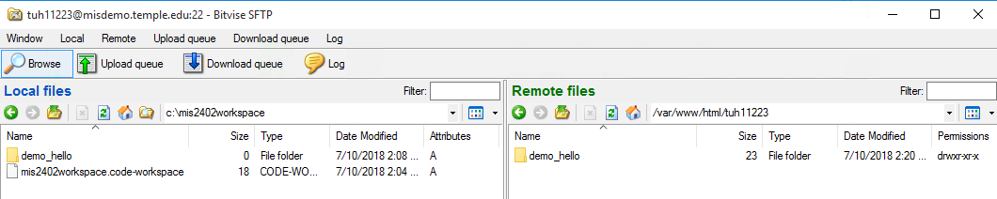

1. You did it! You used an SSH client to copy a folder from your PC to a web server on the internet. Check your work. Open up a browser (e.g. Chrome) and type in the following address: http://misdemo.temple.edu/tuh11223/demo_hello

(When you type the URL, be sure to replace tuh11223 with your Accessnet id!)

The results should be similar to the following:

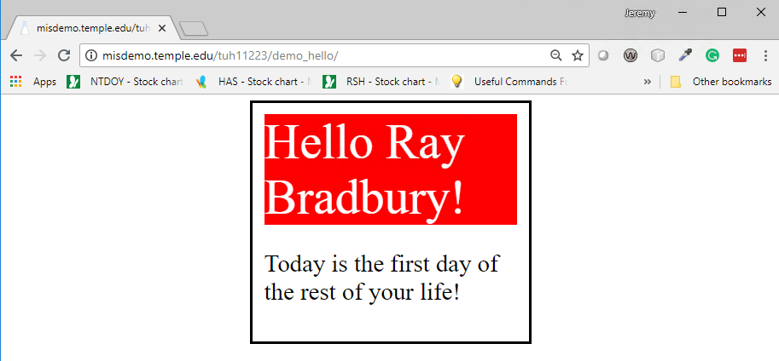

*Fun Fact:* There are (of course) multiple ways to do this. There are VS Code Extensions that can be set up to do the same thing that Bitvise is doing for us here. But, for the purposes of instruction, this is the upload technique we will use in the course. Feel free to try other mechanisms.