# Exercise: Ice Cream

Work through the following steps and upload your work when done.

## Getting the project file

1. Using file explorer/finder Open your mis2402workspace
2. Your instructor will provide you with a zip file named: ice_cream.zip
3. Open the zip file. Drag the ice_cream folder in to the mis2402workspace folder.
4. Now, open VS Code. Navigate to the ice_cream folder using the VS Code Explorer panel.
5. Right click on index.html and choose “Open in browser”

## Add CSS

1. You’ll notice that the HTML form looks very plain. Its appearance can be improved a great deal if you add in some CSS. Go back to VS Code and do the following steps.
   1. Add CSS to the existing <style> tag. The selector should be: .container
   2. Add rules to be applied to the .container selector as follows:

border: solid;

border-width: 3px;

margin: 0 auto;

width: 33%;

font-size: 2em;

padding: 15px;

Notice that .container starts with a dot “.” - that is because “container” is a CSS class.

* 1. Add another CSS selector: header
  2. Add rules to go with the header selector as follows:

color: white;

background-color: red;

font-size: 2em;

* 1. Right click on index.html and choose “Open in browser”. It should now look like this following screen shot.

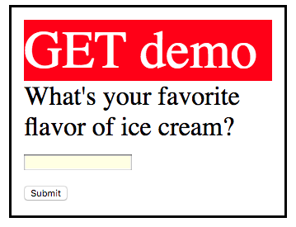

* 1. Experiment by adding padding and margin rules to the header selector. For example:

padding: 20px;

Or this:

margin: 20px;

**CLASS DISCUSSION:** Observe the impact of this. Now, in your own words, what’s the difference between padding and margin?

|  |
| --- |
|  |

## Try/Fix the application

1. Now, try the application. It doesn’t seem to be working quite right. The reason it does not work is that the input tag of type text does not have a name property. Add a name property so that the tag has a name property of favorite_flavor - like this:

<input type='text' id='favorite_flavor' name='favorite_flavor'><br>

1. Now, miraculously, the application works as follows:  
   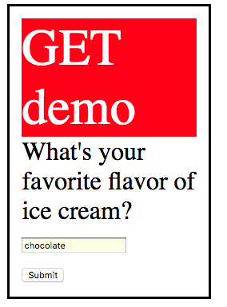
2. **CLASS DISCUSSION:** You just observed a difference between the “id” attribute and the “name” attribute. In this simple example, those attributes serve different purposes. What, in your own words, is the difference between the “id” and the “name” attribute?

|  |
| --- |
|  |

1. Now change the action and method of the form in index.html. The new method should be “post” and the new action should be 'http://misdemo.temple.edu/demo_post/handler/'
2. Change the text inside the header tag from “GET demo” to “POST demo”
3. Save and test your work. An example follows:

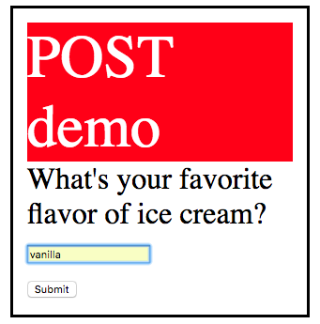

1. In this activity, you wrote some CSS rules. You observed the differences between different CSS selectors. You also observed the use of the following HTML attributes: action, method, id and name.

You also noted the difference between the CSS properties of margin and padding. You should note the other CSS properties used as well, as they will be used again this semester.

**CLASS DISCUSSION:** Upload your work to the class server and write down the full URL where index.html can be found, including the protocol, in the box below.

|  |
| --- |
|  |