Assignment: Quotes with Friends

In today’s class we learned how to send a text message with an API.
Your assignment is now to use that new knowledge in an application.

Instructions
- Starting with mis2402template03.zip, notice the “Share It with a friend” button on the Quote of the Day page. The idea here is that clicking on that button would allow you to send the daily quote to a friend in a text message. Notice that this page has a form on it with an id of “frm_quote_to_share”. The form has several hidden fields in it. The fields with a name attribute are the ones that will be serialized and sent to the text message API.
In our application we need a enter a friend’s cell phone number somewhere. Notice the nav link and wrapper called “My Friend” provided to hold that information. In that wrapper you have an input tag of type text with an id of “friend_phone”, and another input tag with an id of “friend_name”.
- Add a “Save” button to the “My Friend” page.
- Add a click event hander for this button. In this click handler do the following:
  - Clear all text that are in the “danger” and “success” spans that are next to the Save button.
  - Create variables to hold the friend_name and friend_phone data that is on the form. Assign data to those variables from the form inputs.
  - If friend_phone is not numeric, or is not 10 characters in length, report this error message using one of the provided span tags: “Please provide a 10 digit phone number."
  - If friend_name is empty, report this error message: “Please provide a name.”
  - If there are no problems with the data then write the name into the value of the “share_with_name” input tag, and the phone into the “phone” input tag. Report "Name and phone number have been saved!" when you do this.
- Back on the “Quote of the Day” page notice the “phone” input tag. If that is not filled out, you won’t be able to send the daily quote to that number when you click the “Share It with a friend” button. In that case, a suitable error message would be something like “Oops, you can’t share that quote. Please click on My Friend and provide a phone number”
- Now finish it. When “Share it with a friend” is clicked, put the text you want to send in to the hidden “message” tag. Use the $.post method to send the text message.
- Here’s a sample of what one text messages looks like on an iPhone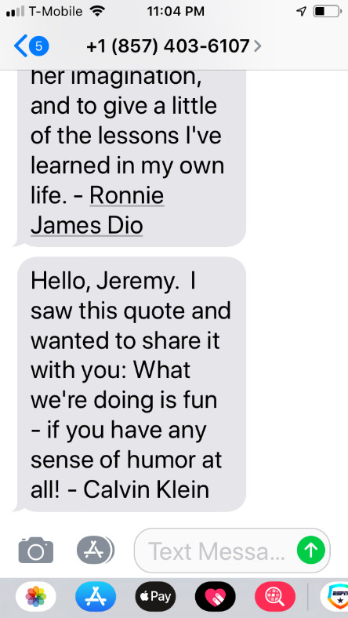.
Notice that the quote is prefixed with “Hello, [name-goes-here] I saw this quote and wanted to share it with you:”
Students are expected to reproduce this effect.
- Upload your work to the class server when you are done. Test it!
This assignment will be graded.

How will this assignment be graded?

Item | Point Value
All files / folders uploaded correctly | 10
Validation works on the “add friend” feature. Validation of both the name and phone number must be working. | 50
Text message is sent OK | 20
Text message is prefixed with “Hello” message (as illustrated in step 6) | 20

