In-class Exercise: Creating Schemas

Scenario 1: Inventory and Parts
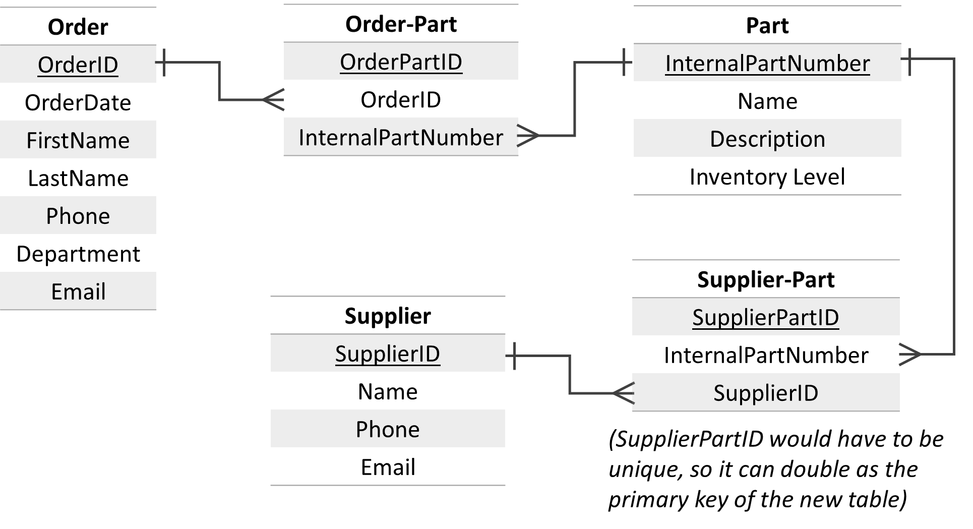
Scenario 2: Housing Authority
