Assignment #3: SQL Part 2 - Putting Information into a Database
Submission Instructions
Due: Friday, 3/2/2017 midnight.
- Complete and submit the assignment as a word or PDF document through Canvas>Assignments>To-Do.
  - There is no answer sheet for this assignment.
  - You can copy and paste the SQL statement for each question from MySQL Workbench to the empty space after each question
  - For the last question, you also need to copy and paste the result from MySQL Workbench.
- If you do not follow the instructions, your assignment will be counted late.

Evaluation
Your submission will be graded based on the correctness of the SQL statements that update the database according to each scenario.

For this assignment, you will finish building the contact management database for MarketCo that you started during ICA #6 - SQL Part 2. Therefore, you must complete the in-class activity before doing this assignment.
You built the Company table during the in-class activity. Now you will build the other three tables, populate them with data, and manipulate the data in those tables.
The schema name should be mxxws, where mxx is your MySQL user name. To refresh your memory – here is the schema for that database: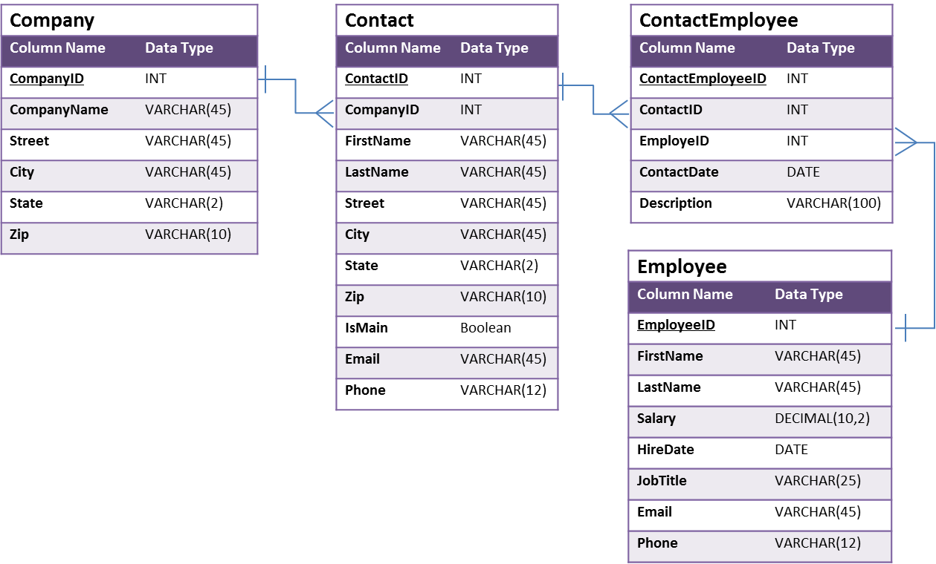
Create the rest of the contact management database by writing the statements that do each of the following items below. For each one: (1) execute them on your copy of the database, and (2) write the statements in the space:
- Statement to create the Contact table (one statement)

- Statement to create the Employee table (one statement)

- Statement to create the ContactEmployee table (one statement):
HINT: Use DATE as the datatype for ContactDate. It allows you to store the date in this format: YYYY-MM-DD (i.e., ‘2014-03-12’ for March 12, 2014). Make sure you surround your date values with single quotes.

- Statements that add the following two Companies to the Company table (there are two statements):
CompanyID | CompanyName | Street | City | State | Zip
110 | Urban Outfitters, Inc. | 5000 South Broad St. | Philadelphia | PA | 19112
111 | Toll Brothers | 250 Gibraltar Rd. | Horsham | PA | 19044

- Statements that add the following two Contacts to the Contact table (there are two statements):
ContactID | CompanyID | FirstName | LastName | Street | City | State | Zip | IsMain | Email | Phone
501 | 110 | Jack | Lee | 4777 Cameron Rd. | Buffalo | NY | 14209 | 1 | jlee@urbanout.com | 215-454-5500
502 | 111 | Bonnie | Johnson | 3600 Elk City Rd. | Ridley Park | PA | 19078 | 1 | bj@tollbrothers.com | 215-938-8000
Remember: IsMain is a Boolean value. A value of 1 means “yes,” and a value of 0 means “no.”)

- Statements that add the following two Employees to the Employee table (there are two statements):
EmployeeID | FirstName | LastName | Salary | HireDate | JobTitle | Email | Phone
1001 | Dianne | Connor | 85,000 | August 12, 2011 | Sales Manager | dconnor@marketco.com | 215-555-5679
1002 | Lesley | Bland | 70,000 | July 1, 2012 | Sales Representative | lbland@marketco.com | 215-555-5678
- Remember, date is stored as ‘YYYY-MM-DD’

- Statements that record the following contact events in the Contact-Employee table. Remember, a “contact event” occurs when an employee of MarketCo communicates with one of its customers (contact). MarketCo wants to keep track all contact between its own employees and its clients.
Contact: Bonnie Johnson
Employee: Lesley Bland
Date: February 5, 2018
Description: Emailed new marketing plan for approval
Contact: Jack Lee
Employee: Dianne Connor
Date: February 8, 2018
Description: Phone call to discuss pricing for advertising
Hints (there will be two statements):
- You must assign unique numbers for ContactEmployeeID – they can be anything you want as long as they are unique.
- Your ContactID and EmployeeID values will come from finding the right ID numbers associated with the Contact and Employee names in the appropriate tables.
- Remember, date is stored as ‘YYYY-MM-DD’

- In the Employee table, the statement that changes Lesley Bland’s phone number to 215-555-8800 (one statement).

- In the Company table, the statement that changes the name of “Urban Outfitters, Inc.” to “Urban Outfitters” (one statement).

- In ContactEmployee table, the statement that removes Dianne Connor’s contact event with Jack Lee (one statement).
HINT: Use the primary key of the ContactEmployee table to specify the correct record to remove.

And finally…
- Write the SQL SELECT query that displays the names of the employees that have contacted Toll Brothers (one statement). Run the SQL SELECT query in MySQL Workbench. Copy the results below as well.

