- Walk through the account creation process using this link:

https://support.sas.com/ctx3/sodareg/index.html?execution=e1s1

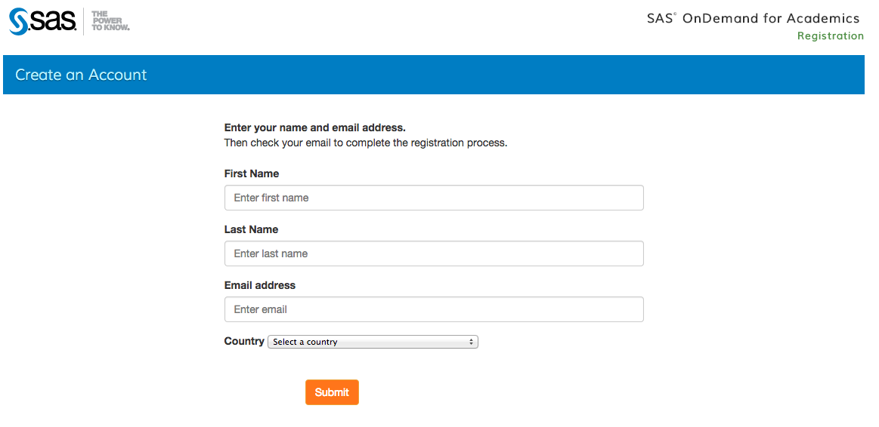

Enter your details and wait for SAS to send you a link with the registration.

- Pick a password:

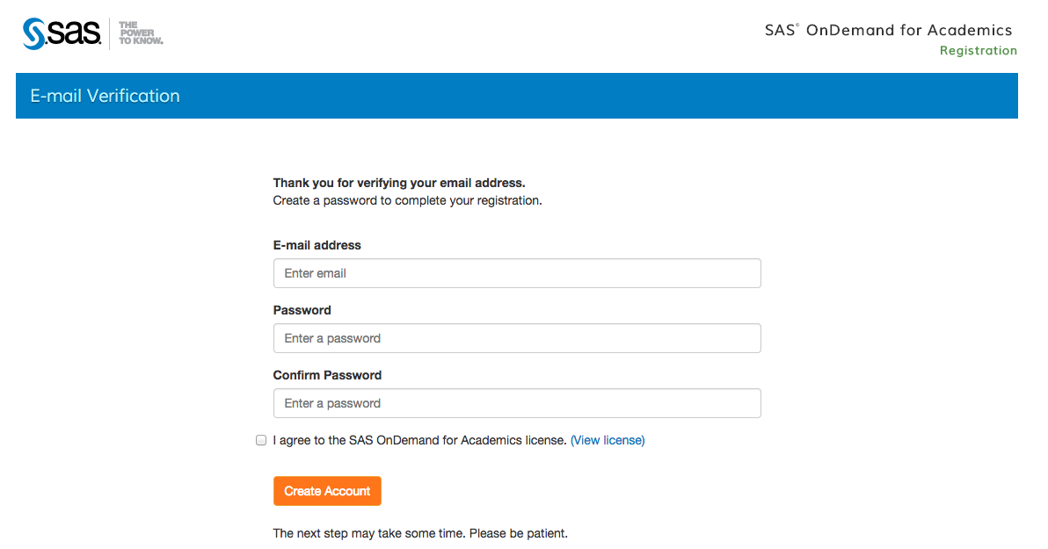

- After you have logged on to SAS you should see a screen like this:

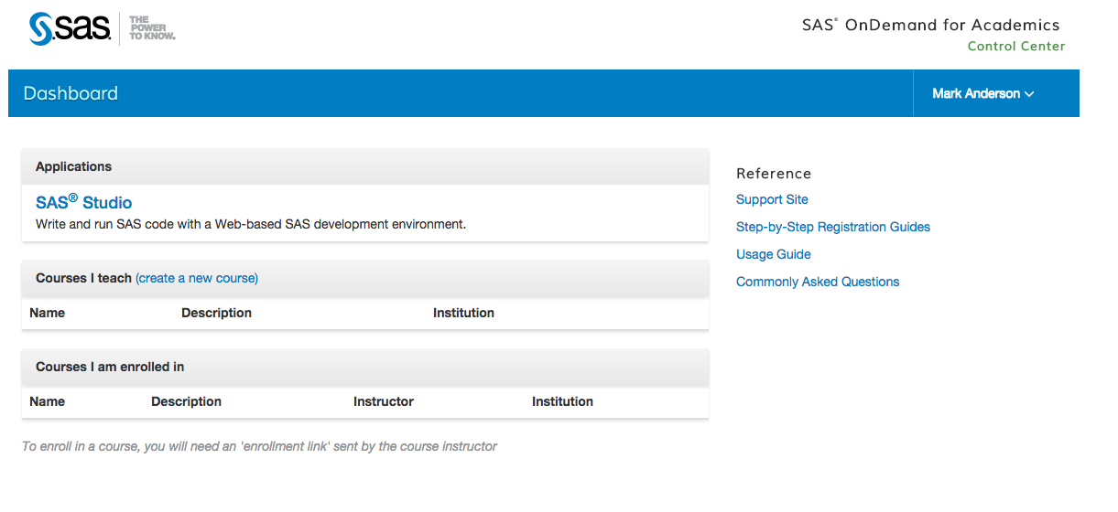

Next click on the following link to enroll yourself in the class:

https://odamid.oda.sas.com/SASODAControlCenter/enroll.html?enroll=2bb46e22-6f7f-4bdc-bc46-06797b44ad44

You should see a screen like this:
