In-Class Exercise Solution

Problem 1: Inventory and Parts
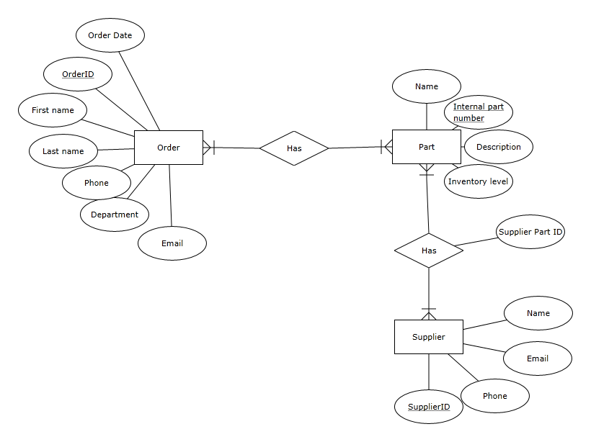

Problem 2: Housing Authority

